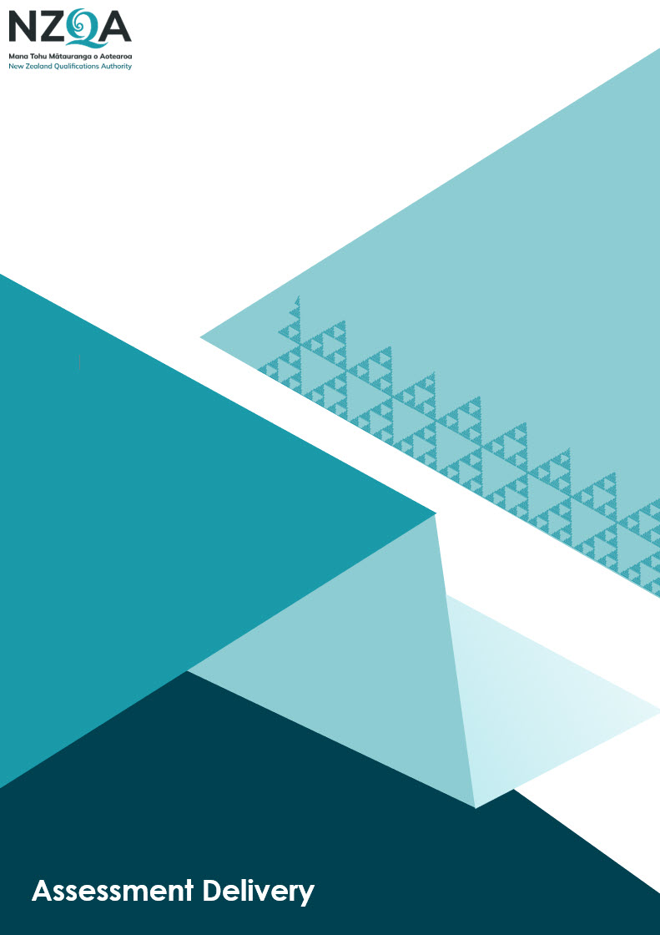

Examination Centre Memorandum of Understanding
2025 Examination Centre
Memorandum of Understanding

Purpose
A Memorandum of Understanding is a partnership agreement between a Kura Teina (school without an examination centre) and a Kura Tuakana (school with an examination centre) to ensure a suitable environment for NZQA all external NCEA and NZ Scholarship examinations for Kura Teina students.

Responsibility Clarity
The Principal’s Nominees (or equivalent representatives) from both the Kura Teina and Kura Tuakana must clearly understand the responsibilities set out in this document prior to signing the Memorandum of Understanding (MOU).

Digital Examination
If the Kura Teina intends to enter students for digital examinations, they must confirm how these will be managed in collaboration with the Kura Tuakana.

Kura Teina Responsibilities

Category | Responsibilities
Managing Entries | - Enter students with NZQA by 01 September.  - Manage examination clashes with Kura Tuakana.  - Indicate digital exam entries, submit late entries and rolls.  - Provide Kura Tuakana with complete data table including any digital entries (suggested format is Examination, exam code, full name, NSN).  - Request translated papers.  - Indicate students answering in Te Reo Māori.
Entering digital entries | - Make digital entries in your SMS and upload your datafile to NZQA by 01 September.  - Ensure the students have devices that are tested and meet NZQA’s specifications.  - Ensure students have headphones that have been tested if required for their examination.  - Familiarise the students with digital examinations.
Special Assessment Conditions (SAC) | - Submit SAC entries:  - Apply for special assessment conditions (SAC).  - For approved SAC:  - Attach all SAC conditions to examination sessions  - Identify resource needs, including computers and Examination Assistants  - Agree on who will supply any resources required and costs with Kura Tuakana.  - Provide names and contact details of all Exam Assistants and which candidate each is supporting.
Administration, Communication and Coordination | - Provide liaison contact(s) info (Principal's Nominee).  - Ensure students attend an examination briefing at the Kura Tuakana, including an orientation tour.  - Notify Kura Tuakana of any known student issues particularly health issues.  - Notify Kura Tuakana immediately of any late entries.  - Ensure students have a copy of their admission slips and IDs.  - Ensure every NZ Scholarship student(s) has photographic identification.

Kura Tuakana Responsibilities

Category | Responsibilities
Environment and Access | - Provide a safe, secure and suitable examination setting based on Kura Teina resource needs.  - Provide internet access and a digital supervisor(s) device(s).
Communication and Agreement | - Maintain contact between liaison person(s) and Exam Centre Manager.  - Request and agree on costs associated with providing the examination centre for the Kura Teina students.
Support and Preparation | - Facilitate SACs and manage exam clashes.  - Host student briefings and school orientation tours.

Please check with NZQA if you have any questions before signing this agreement. NZQA will confirm with both schools that the arrangements meet requirements.
Once signed, the Kura Teina emails the Agreement to examcentremanagement@nzqa.govt.nz before entries are made for end-of-year examinations.

Signature
Kura Teina
School / Kura Name
MOE Number
Name
Position
Signature
Date
Kura Tuakana
School / Kura Name
MOE Number
Name
Position
Signature
Date

