

Leading National Assessment Seminar 2026

17 February – 6 March 2026
Kaitakawaenga ki te Tumuaki me ngā Pouārahi | Principals’ Nominees and Senior Leaders

Pukapuka Aratohu | Handbook
Wāhanga Tohu Mātauranga | School Quality Assurance and Support
Contents

Contents
Review and Maintenance Programme 4
Assessment Matters updates in 2025 6
Co-requisite assessments 9
Results and Entries - data sharing update 12
Digital Assessment 15
Digital-first examinations 17
Paper by exception guidance – to support decision-making 20
Authenticity and the Conditions of Assessment 23
Guidance for Marking 27
Making Holistic Judgements when assessing against internally assessed standards 29
Intervention Framework 31
Moderation Practice 34
New Pūtake course on Moderation 38
Digital badges on Pūtake 39
Extension of Consent - Industry Skills Boards 40
Memoranda of Understanding – Third Party Arrangements 41
Special Assessment Conditions (SAC) Applications 43
Submitted Externals 45
Derived Grades 46
External Assessment Quality Assurance audits 50
Breaches of Assessment Rules in CAAs, TAPā, derived grade exams, and external exams 52
Principal’s Nominee Webinars 2026 57
School NZQA Provider Login Access – Quick Reference Guide 60
Your PN network 61
Appendix 63
2026 NZC NCEA Achievement Standards – Review and Maintenance Programme updates 64
Kua whakaputaina ngā whakahounga o ngā Paerewa Paetae me ngā rauemi aromatawai mō te TMoA 68

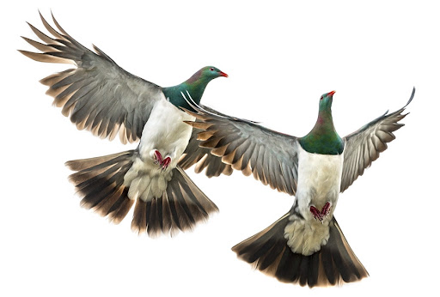

“Ko te manu ka kai i te miro, nōna te ngahere.
Ko te manu ka kai i te mātauranga, nōna te ao.
The bird that partakes of the berry, theirs is the forest.
The bird that partakes of knowledge, theirs is the world.”

Te Kere Ngataierua, Te Āti Haunui-a-Pāpārangi

NCEA Updates

Review and Maintenance Programme

Teachers must use revised Achievement Standards and supporting materials for assessment in 2026.

A number of standards and supporting materials have been updated for 2026 by the Ministry of Education. These updates are a result of the annual NCEA review and maintenance programme (RAMP). This year’s RAMP updates affect a number of New Zealand Curriculum (NZC) and Te Marautanga o Aotearoa (TMoA) subjects across NCEA Levels 1, 2, and 3.
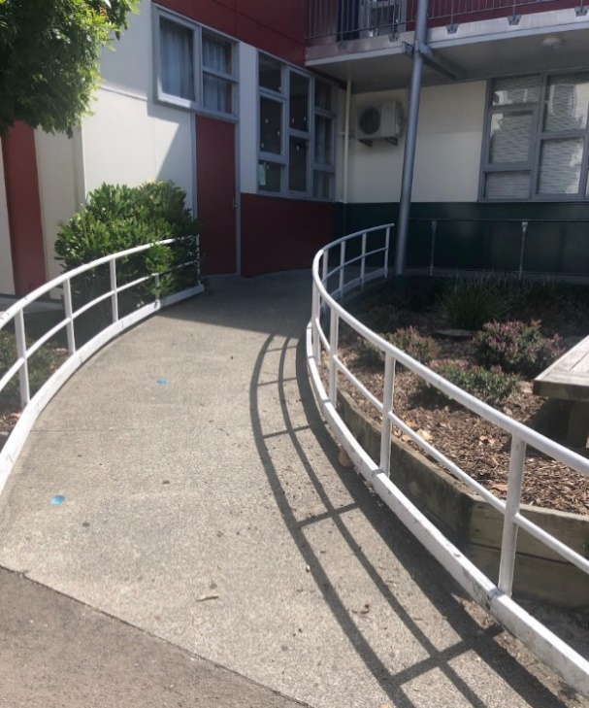
There are no changes to the competencies being assessed by the Achievement Standards. Most of the updates are very minor and have been made to improve clarity and interpretation.

Conditions of Assessment have been updated for all internal assessments | aromatawai ā-roto to provide clearer guidance around authenticity.

Where to direct teachers and kaiako:

- The appendix to this handbook has a summary of updates.
- All affected externally assessed Achievement Standards and supporting materials were made available as PDFs for planning purposes on the NCEA website in September 2025. These PDFs have now been removed and materials on the relevant subject pages have been updated for use in 2026.
- For externally assessed standards with changes to the method of assessment, Assessment Specifications | Tautuhinga Aromatawai are on the NZQA website, on subject pages.
- Sample assessment items will be published on NZQA subject pages by the end of April for Digital Technologies 92207, Geography 91934, and Social Studies 92050. A sample assessment schedule for Materials and Processing Technologies 92014 will be published.
- Full details are available here: https://ncea.education.govt.nz/whats-new/reviewed-nzc-tmoa-achievement-standards-and-assessment-materials-published-2026 (published 21/01/2026). and on NCEA.Education and NZQA subject pages.

Removal of exemplars for externals from before 2024.
- Previously published assessment materials from before 2024 must be used with caution! Always check the current standard and supporting materials.
- For Design and Visual Communication, 91338 and 91627; Earth and Space Science, 91413 and 91414; and Health, 91462 all exemplars preceding 2024 will be removed from the website at the end of April 2026. If teachers consider these still useful in their teaching, they should be downloaded and saved by the end of April.

Activity - Discuss:

- How do your teachers know where to look for subject resources?
  - When would they go to NCEA.Education?
  - When would they go to NZQA subject pages?

- How do you know if they’re using current materials?

- What are the implications of the RAMP updates:

- For you and your senior leadership team?

- For your curriculum leaders / Heads of Department / Teachers in Charge?

- For your subject teachers?

- For your ākonga?

- Are there any systems or processes you need to review because of the updates?

NCEA Updates

Assessment Matters updates in 2025


Circulars communicating important school assessment information and changes to assessment can be found on the NZQA website under Assessment Matters. They are also emailed to Principals’ Nominees and referred to in the EmaiLink.

Here are some key points from 2025 Assessment Matters:

5 December 2025:
Change of assessment method for Digital Technologies externally assessed standards in 2026
The Digital Common Assessment Tasks (DCATs) for Digital Technologies are now all end-of-year examinations:
- Level 1 92007: Design a digital technologies outcome.
- Level 2 91899: Present a summary of developing a digital outcome.
- Level 3 91909: Present a reflective analysis of developing a digital outcome.

2026 TAPā intra-year external assessment dates for Te Marautanga o Aotearoa (TMoA) and Te Reo Matatini me te Pāngarau (TRMPā), & end-of-year Te Ao Haka TAPā external assessments

Level 1 TMoA external assessments: on set dates between 8 and 17 September.

Te Reo Matatini me Te Pāngarau
- TAPā 1: between 18-29 May; Kete Manarua 1: Due on or before 29 May.
- TAPā 2: between 7-18 September; Kete Manarua 2: Due on or before 28 October.

Due date for TMoA Kete Manarua: on or before 28 October.

Te Ao Haka TAPā are now in the end-of-year examination timetable.
- If the school / kura is an exam centre, the ECM will manage the TAPā.
- TAPā will be digital-only, with paper backups available by exception.

7 November 2025:
Outcomes of the 2025 biennial consultation on the New Zealand Scholarship subject list
The following outcomes were endorsed by NZQA’s Technical Overview Group Assessment and agreed by the NZQA Board:
- Health and Physical Education to remain as a single subject.
- Agribusiness is not added to the list at this time.
- Business Studies is added to the list from 2027.
- Social Studies is not added to the list at this time.
- Lea Faka Tonga is not added to the list at this time.

The next review is planned for 2027, to determine subjects for inclusion or exclusion from 2029. Note: 2025 is the final year that Scholarship Latin was offered.

12 September 2025:
2026 Examination Timetable dates and intra-year Assessment Timetable
The end-of-year examination dates for 2026 have been pushed back a week to allow more time for teaching and learning in Term 4, and to enable ākonga to be better prepared for external assessments.
The 2026 End-of-Year Examination Timetable for NCEA and New Zealand Scholarship will run from Tuesday 10 November until Friday 4 December 2026.
Download the updated timetable

12 August 2025:
Changes to paper backups for digital NCEA examinations from 2025
From the 2025 external exams onward, personalised paper backups will no longer be provided for ākonga entered for NCEA digital examinations. Personalised paper backups will remain for NZ Scholarship examinations.

What does this mean?
- Accuracy of entries is critical as personalised paper backups will not be provided for ākonga entered for NCEA digital examinations. All entries for an individual candidate session need to be either digital or paper, not a combination of both.
- Special Assessment Conditions (SAC). Any paper or digital entries with reader/writer attached to the exam session as of 1 September will continue to receive an additional paper for the reader/writer to use. Ākonga requesting an Enlarged Paper SAC will receive a personalised version, regardless of whether they are entered for paper or digital. These papers are provided in addition to the general paper or digital buffer.
- Printed resource booklets will continue to be provided for all ākonga entered in a digital examination.

Digital buffer packs
An increased number of buffer packs equivalent to 15% of the number of ākonga entered, or 2 papers (whichever is the highest) will be provided to support ākonga in the event of device failure, or other circumstances preventing them from completing the examination digitally on the day. These are in addition to the general buffer packs.

Widespread disruption
In the event of widespread disruption to a digital examination, kura will not be expected to print additional papers for each ākonga.
- If there is a digital disruption that is significant and beyond the control of the ākonga, then Derived Grades at Scale will apply. This is the same process kura would follow for other widespread disruptions, such as significant weather events.
- Kura must report quality assured grades through their student management system (SMS) before the external examination period starts
- Optional printing: Principals’ Nominees, with support from Exam Centre Managers, may choose to print additional papers to enable ākonga to continue the examination on paper. Additional printing is at the cost of the kura.

Activity - True / False Quiz

- Principals’ Nominees must share Assessment Matters updates with relevant leaders and teachers
- From 2026, all Digital Technologies DCATs will be assessed as end-of-year examinations
- Level 1 Te Marautanga o Aotearoa external assessments will run between 8 and 17 September
- Te Reo Matatini me te Pāngarau (TAPā 2) assessments will take place between 7 and 18 September
- Te Ao Haka TAPā assessments will be digital-only, with paper backups available by exception
- Business Studies will be added to the New Zealand Scholarship subject list from 2027
- Assessment specifications for 2026 external assessments were released in October 2025
- Calculators are now permitted in Commerce external assessments
- From 2025, personalised paper backups will no longer be provided for NCEA digital examinations
- SAC must be attached to exam entries for SAC candidates by 1 September in order for candidates to receive personalised papers or additional papers for reader / writer use.

Activity - Consider:
What, if anything, do you need to communicate with the relevant staff?

Are there any systems or processes you need to review because of the updates?

NCEA Updates

Co-requisite assessments

CAAs for Literacy (Reading, Writing), Numeracy,
TAPā for Te Reo Matatini (32413 Te Reo Torohū) and Te Reo Pāngarau (32412)
18 – 29 May and 7 – 18 September

Kete Manarua for Te Reo Matatini (32415 Te Reo Whakaputa)
upload by 29 May and/or by 28 October

Kete Manarua for Te Reo Pāngarau (32412)
upload by 28 October

Update: You will not need to advise NZQA of your planned assessment dates for the co-requisite CAAs, TAPā, and Kete Manarua in 2026.
Update: Standard version updated to show alignment with new curriculum phases.

Reminder: How to complete the NCEA co-requisite requirement

Te Reo Matatini or Literacy options:
Note: The whole 10 credits must come from the same option.
- Literacy Reading 32403 and Literacy Writing 32405
- Te Reo Matatini Te Reo Torohū 32413 and Te Reo Whakaputa 32415
- 10 credits of additional standards for Literacy (including some with usage restrictions)
- 10 credits of additional standards for Te Reo Matatini.

Te Reo Pāngarau or Numeracy options:
- Te Reo Pāngarau 32412
- Numeracy 32406
- 10 credits of additional standards for Te Reo Pāngarau or Numeracy (including some with usage restrictions).
Core Generic standards eligibility restrictions
The standards with usage restrictions include the 266** series of standards.
These standards may only be used to meet the Co-requisite requirement:
- with ākonga who are enrolled full-time with tertiary education organisations.
- with ākonga who complete a qualification in alternative education providers, activity centres, specialist schools, teen-parent units, health schools, and youth justice facilities.
- by ākonga living in Niue, Tokelau, or the Cook Islands in the current academic year.
Ākonga in mainstream NZ schools and kura can only gain the Co-requisite through the dedicated standards (324**s) or from the approved achievement standard list, even if they have previously completed the 266** standards with an eligible provider.
Eligibility for standards with restricted usage requirements is based on ENROL data. Schools need to ensure their ENROL data is accurate to ensure eligibility. Schools should contact the Ministry of Education to confirm eligibility for individuals. NZQA receives a monthly file of eligible students from the Ministry of Education.

Co-requisite CAAs and TAPā are assessed digitally

Please note that these assessments are designed to be completed online.
To familiarise ākonga with the digital platform and the assessment, use the previous assessments available to them through their learner logins.

Only print a paper for an individual who requires it for a specific Special Assessment Condition.
- Do not print for a group of ākonga.
- Do not print ‘just in case’ someone wants it.
- Do not print for staff.

The printed PDF can be offered to candidates as an alternative method in exceptional circumstances and for completing the assessment if there is a significant interruption.
Schools are accountable for every printed copy of a CAA or TAPā; keep them secure.
If a copy is printed for Reader / Writer use, ensure it is returned to you after the assessment session to keep it secure.

Use the available resources

- NZQA Co-requisite hub – find information on running your CAAs in the new portal to your Provider Login including Preparation, Resources, Assessment Day and helpful reminders.
- NCEA Literacy and Numeracy resources for kaiako (NCEA.Education)
Resource Guides, Unpacking Co-requisite Outcomes, Case Studies, NCEA Co-Requisite Planning Resources, Literacy Strategies, Curated Resource Bank.

- Ngā Rauemi mō Te Reo Matatini me te Pāngarau i NCEA (NCEA.Education)
Aratohu Rauemi, E Angitu Ai Te Ākonga: Te Utauta Noho Takatū Tautokorua NCEA, Ētahi rauemi tautoko mō Te Reo Matatini me Te Pāngarau NCEA, Rangahau Pūaho mo Te Reo Matatini me te Pāngarau NCEA.

- Lessons from May 2025 CAA and TAPā quality assurance visits
Good practice observed by School Relationship Managers when visiting kura.

Activity - Discuss:

What worked well with your co-requisite assessments in 2025?

Are there any systems or processes you need to review before the CAAs and TAPā in 2026?
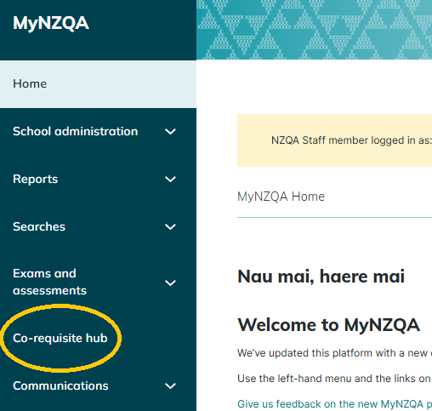
Administration update

Results and Entries - data sharing update

No more data files!

Transition from batch files to Application Programming Interface (API) for all Ākonga Management Systems (SMS)
NZQA is working with all SMS vendors to transition away from secondary batch processing to APIs, allowing your SMS to communicate directly with NZQA systems. Each vendor will have a different approach to implementing the API, and their instructions will vary accordingly.

Secondary Batch processing moved data in large files. The file was produced by the SMS then manually uploaded by the PN to the NZQA portal every month from April to December. It overwrote any prior submitted data.

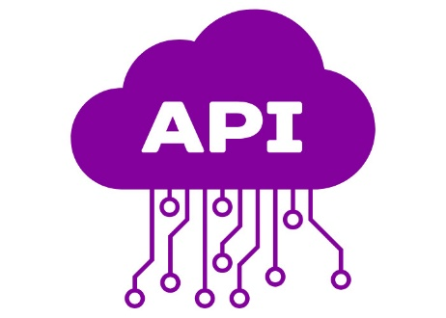
APIs enable smaller, on-demand data exchanges in near real-time – like creating an enrolment or submitting a result for one entry. The API is called automatically from the SMS once data is saved or approved to transmit (depending on the system and data). The API updates the data on NZQA systems straight away, and the success or error message is returned immediately to the calling system.

The benefits of the API include:
- no generation and manual uploading of batch files throughout the year
- immediate update of data at NZQA
- automatic transfer of a previous kura results for a transferring ākonga
- ability to continue to enter internal results through the SMS until late February, and no need to manually enter late results through the Add Result entry portal
- near real-time access for kura and ākonga to see the full range of results achieved by each ākonga.

Your SMS vendor will be able to confirm if their solution will be ready for when NZQA opens data submission links for the 2026 academic year in March.

Some key questions and answers:

- Help? What do I do? Your SMS vendor will contact you directly about the onboarding process. Please direct any queries to your SMS vendor in the first instance. If you have any questions for NZQA, please email schools@nzqa.govt.nz

- Where are the errors and warnings? These will be in your SMS, not in your NZQA portal. You will be able to view them in real time, without logging in to NZQA. Check both errors and warnings to see if they require action.

- How quickly can I change entries and results? Much faster than you could with data file processing. This will depend on how your SMS has implemented the API – it may be instant or it may take a little longer.

- What about updates to CAA / TAPā entries or digital exam entries? How long until they show up in NZQA’s digital assessment platform? Within 24 hours.

- Will it work for external results too? Yes. This will be ready for the May CAA / TAPā results.

- What about international ākonga? These entries must be correct. Class teachers must be aware of the intended assessment programme for the ākonga. If a result is entered for an internal standard, or an external entry in a CAA / TAPā, or an external entry after 1 September, the kura will be billed for NCEA assessment of the ākonga.

- What if I don’t want our data to go through instantly? Check with your SMS provider for detailed instructions for data transmission, including permissions for staff.

- What about ākonga who leave us / transfer to us?
- when ākonga leave your kura you will need to add the leaving date and reason to their enrolment
- the API will continue to allow you to load entries and results to that ākonga, for example as you continue to mark their submitted work, until the ākonga is enrolled with NZQA by another kura (by making an entry)
- when the ākonga enrols at a new kura, any results entered for the current year will be transferred automatically by NZQA and recorded under the new kura. However, any later results will have to be passed on to the new kura.
- only results will follow transferring ākonga. New internal entries, and all external entries will need to be made by the new kura.

- What about dual enrolments? There is no change in processes for ākonga who have an additional enrolment with Te Kura or a tertiary provider. Their main kura of enrolment will still be responsible for reporting results and for entries.

- What about late results? With the API, submissions of internal results close at the end of the following February. You will no longer have to login to the NZQA portal and use the Add Results application between December and the end of February. After February you will still need to contact NZQA to alter results and add late(r) internal results.

- Does this mean my results and entries will always get through? For the first week of September, the APIs will be disabled while exam preparation commences. External entries can still not be removed after 1 September.

Reminders:
- Assign standards to courses for transferring ākonga where possible, so that they are able to meet course endorsement requirements.
- Check external entries and methods of assessment for transferring ākonga.
- Ensure current entries for all ākonga include only assessments that are currently planned for them.

Activity - Consider and discuss:

- What are the implications of the API for how you manage entries and results at your kura?
  - Consider accuracy of data and quality assurance
  - Consider roles: teachers, HODs, PN, Data Manager, Head of Internationals

- What questions do you have for your SMS provider?

- What questions do you have about data management in general?
Assessment Updates

Digital Assessment

2026 digital examinations are indicated on the exam timetable:
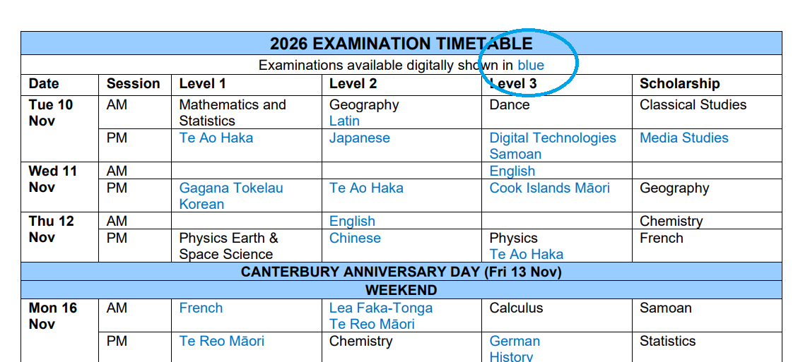

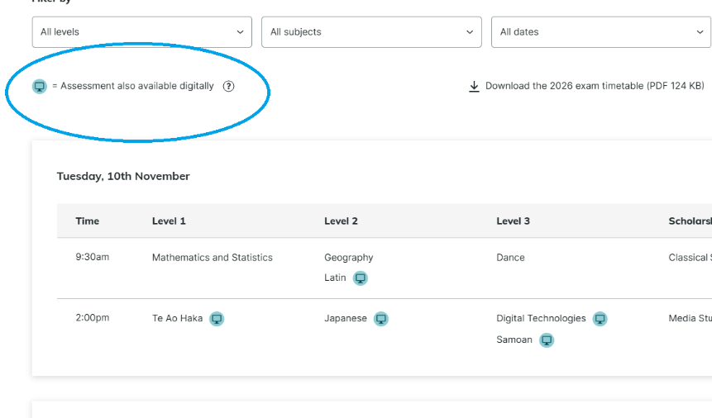

Polly 2026 Text-to-Speech Trial - Expressions of Interest
We are inviting schools and ECMs to participate in a trial of Polly Text-to-Speech (TTS), a tool that allows ākonga to listen to English text being read aloud in digital assessments. The trial is to determine if Polly can be included in some end-of-year external examinations.
Click here to download a document detailing how to express interest in the trial.
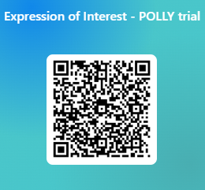
Expressions of Interest close on 20 February.

You can also use this QR code to access the form:

Assessment Updates

Digital-first examinations
NCEA Level 1 exams that are available digitally will be delivered digitally by default in 2026.
Although digital will become the standard approach, paper-based assessment will still be available when needed to support equity and maintain the integrity of assessment outcomes. This ensures that all ākonga can continue to participate confidently, regardless of individual circumstances or access to technology.
NZQA is continuing to develop a digital-first approach to examinations. This places ākonga at the centre of exam design and delivery. Digital exams offer more flexibility, faster processing times, and more consistent access for a wide range of ākonga. By modernising how assessments are delivered, we are helping to prepare ākonga for the digital environments they will encounter in further study, work, and everyday life.
In April 2025, the NZQA Board agreed that digital exams will become the default approach, with a phased rollout beginning in 2026. Feedback from the schools and insights from Level 1 will be considered before progressing the approach to Level 2 in 2027, and to Level 3 and Scholarship in 2028.
92% of schools and kura offered at least one exam digitally in 2025.
The proportion of ākonga participating in digital exams has steadily increased.
Year | Level | Total number of results where digital assessment is offered | Total number of Digital results | % of digital results in subjects offered digitally
2025 | 1 | 138,404 | 104,797 | 76%
2025 | 2 | 106,237 | 74,743 | 70%
2025 | 3 | 64,544 | 42,112 | 65%
 | Total | 309,185 | 221,652 | 72%

The data shows that the digital assessment platform is reliable.
Derived Grades At Scale related to digital exams:
- 2025 - 10 applications. 7 schools for an internet outage, others for localised events.
- 2024 – no applications due to network or power failures.
- 2023 – Assessment Master issue resulting in 8838 applications over three standards nationwide.
Individual applications related to digital exams:
- In 2025 - 30 (less than 1%) of a total of 3750 applications received.

What is happening in 2026:
In 2026, for all NCEA Level 1 external assessments where a digital assessment is available, the digital first, paper by exception guidelines will apply. Schools and kura will determine whether an individual ākonga, a cohort or whole kura is better suited to paper-based assessment over digital assessment. Guidelines have been drafted to support decision making.
We have three categories of exception:
- Individual ākonga exception: An individual’s ability to perform at their expected level would be negatively affected when completing an assessment in digital format.
- Cohort exception: A defined group of ākonga within a school or kura faces shared, consistent barriers that prevent digital assessment from being delivered equitably or without disadvantage. These barriers apply to the whole cohort (or a significant majority) rather than a few individuals.
- School or kura exception: A school or kura faces systemic barriers that prevent the reliable or equitable delivery of digital assessments. These barriers must be persistent, outside the school or kura direct control, and significant enough to disadvantage ākonga if digital assessment were required.

Please note: Special Assessment Conditions (SAC) take priority in determining assessment format. SAC must be attached to SAC entries by 1 September.
Please note: Any paper entries should be made before 1 September to allow ākonga to receive personalised papers.

Activity - consider and discuss:

How might you adapt the example guidelines on the next page to suit the needs of your
- ākonga?
- cohorts?
- kura?

Paper by exception guidance – to support decision-making
Decisions for paper-based assessment under the following circumstances:
 | Individual ākonga exception | Cohort exception | School or kura exception
Descriptor | An individual’s ability to perform at their expected level would be negatively affected when completing an assessment in digital format. | A defined group of ākonga within a school or kura faces shared, consistent barriers that prevent digital assessment from being delivered equitably or without disadvantage. These barriers apply to the whole cohort (or a significant majority) rather than a few individuals.  DRAFT EXAMPLE | A school or kura faces systemic barriers that prevent the reliable or equitable delivery of digital assessments. These barriers must be persistent, outside the school or kura direct control, and significant enough to disadvantage ākonga if digital assessment were required.
Decision Criteria | To be considered for paper-based assessment, the ākonga should meet at least one of the following conditions, supported by evidence:  - Documented impact on performance: confirmation that digital assessment would adversely affect the performance, engagement, or ability to demonstrate learning.  - Lack of access to a suitable device: The ākonga does not have reliable access to a digital device that meets the assessment requirements, and the school cannot provide an appropriate alternative.  - Misalignment with learning approach: learning has primarily taken place using paper-based materials, and shifting to a digital mode for assessment would create a disadvantage.  - Strong ākonga preference: The ākonga has expressed a strong preference for paper-based assessment. | To be considered for paper-based assessment, the cohort should meet at least one of the following conditions, supported by evidence:  - Consistent lack of access to suitable digital tools: The cohort does not have reliable access to devices or software necessary for digital assessment.  - Misalignment between teaching and learning modes: The cohort’s learning programme has been predominantly paper-based due to curriculum design, teaching approach, or resourcing, meaning that shifting to digital assessment would create clear disadvantage.  - Widespread digital capability challenges: The cohort shares a lack of digital literacy or familiarity with digital tools required for assessment, and the school cannot reasonably provide sufficient training prior to assessment. | To be considered for paper-based assessment, the school or kura should meet at least one of the following conditions, supported by evidence:  - Persistent internet or power connectivity issues.  - Frequent or prolonged outages or unreliable broadband that would disrupt scheduled assessments.  - Not have enough functioning laptops, desktops, or required software licenses to support all candidates undertaking assessments at the same time.  - Infrastructure limitations such as insufficient wireless coverage, low bandwidth, outdated hardware, or unstable network environments that inhibit simultaneous digital assessment delivery.
Decision-making steps | Schools should discuss with the ākonga:  - If digital assessment would negatively affect their performance or attendance.  - Whether a paper-based or alternative format is more appropriate. | The following considerations should be discussed:  DRAFT EXAMPLE  - A kaiako or department-level analysis of the cohort’s collective digital readiness, learning mode, and any demonstrated disadvantages in digital practice.  - Knowledge of insufficient device availability or access for the entire cohort.  - Confirmation that teaching and learning for the cohort has been delivered predominantly in a paper-based, not aligned with digital assessment. | The following considerations should be discussed:  - Known connectivity issues: e.g. persistent internet outages, insufficient bandwidth, or recurring power issues.  - Digital capability review shows a lack of sufficient devices, inadequate network infrastructure, or insufficient digital capacity to support assessment demand.  - Principal’s statement confirming the nature of the barriers, the impact on assessment delivery, and the steps taken to attempt to resolve or mitigate the issues.

Invitation for feedback on digital-by-default examinations
External Consultation Questions (feedback window closes mid-March).
The following questions have been sent via NZQA’s Secondary Qualifications Advisory Group (SQAG) for feedback from their sector groups. We invite any individual, school, kura or group to also complete the survey (link in heading above).
Consider also discussing these questions with your staff as part of your internal review.
Understanding needs and context | - What are the main challenges and risks (e.g. equity, integrity) you foresee with NZQA implementing this policy, and how could they be mitigated?  - What are the main reasons for ākonga / kura opting for paper when digital is possible?
Exception process (paper by exception) and eligibility criteria | - What situations should qualify for paper-based delivery under a digital first approach, and what evidence should be required?  - How should eligibility differ for individual learners versus school-wide applications?
Feasibility and implementation | - What barriers might affect implementation in your context, and what would help make the policy practical and effective?  - Are there scenarios where digital delivery would not be viable during exam windows?
Equity and inclusion | - How well would a paper-by-exception approach address equity for Māori, Pacific peoples, and other priority groups?  - Which learners in your context are most at risk of exclusion without careful design?
Final reflections | - Do you have any concerns about a Paper by Exception policy?  - Is there anything else you’d like to share that hasn’t been covered?

Assessment Practice: Authenticity

Authenticity and the Conditions of Assessment

Key points to note:
- The extent to which GenAI may be used, if at all, must be explicit in instructions to ākonga, and any use of GenAI must be acknowledged.
- The authenticity of ākonga work must be verified – using strategies that are standard-specific and task-specific.
- Evidence can be collected in different ways to suit a range of teaching and learning styles, and a range of contexts of teaching and learning.

The Conditions of Assessment (COA) across all Level 1 internally assessed standards have been updated to include clearer guidance about authenticity.

The revised CoA are available on NCEA.education. They provide guidelines for assessment against internally assessed Achievement Standards. This includes:
- specific requirements for all assessments against this Standard
- appropriate ways of, and conditions for, gathering evidence
- ensuring that evidence is authentic work.

Your own Assessment Policy and Conditions of Assessment must be explicit on authenticity and the use of GenAI.

Gathering evidence for internal assessment
Internal assessment provides flexibility in the collection of evidence. Evidence can be collected in different ways to suit a range of teaching and learning styles, as well as a range of teaching and learning contexts. Care needs to be taken to ensure ākonga have opportunities to present their best evidence against the Standard(s), free from unnecessary constraints.

It is recommended that the design of assessment reflects the ways ākonga have been learning. Collection of evidence for the internally assessed Standards could include, but is not restricted to, an extended task, an investigation, digital evidence (such as recorded interviews, blogs, photographs, or film), or a portfolio of evidence.

Effective assessment should suit the nature of the learning being assessed, provide opportunities to meet the diverse needs of all ākonga, and be valid and fair.

Ensuring work is authentic
Authentic evidence needs to be assured regardless of the method of collecting evidence. This must be in line with your policy and NZQA’s Rules.

The evidence assessed must be an accurate reflection of what the ākonga independently knows and can do, according to the Standard being assessed. Rely on your knowledge of how the work has been produced; do not rely solely on the use of AI-detection tools.

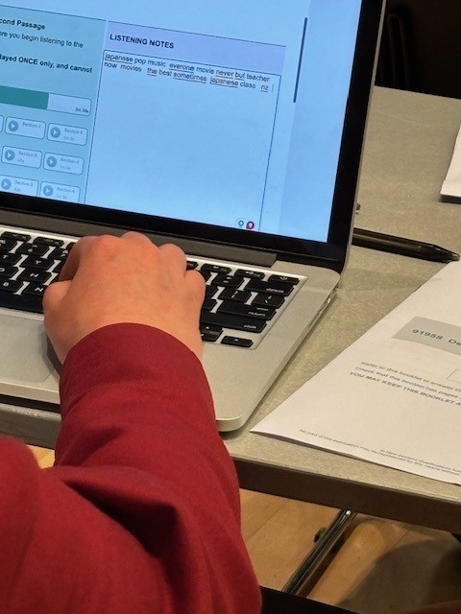
This includes
- evidence submitted as part of a group assessment,
- evidence produced outside of class time or without assessor supervision,
- and evidence produced with any use of GenAI tools.

GenAI use should be carefully considered in the context of the Standard being assessed and its Conditions of Assessment. It should be discussed with ākonga before the assessment, and its use must be acknowledged.

For example, an assignment carried out over several sessions could include:
- teacher guidance on the nature and extent of acceptable GenAI use, if any
- a record of teacher conversations
- conferencing with the ākonga at set milestones or checkpoints
- progress log details, such as photographs, drafts, or GenAI prompts.

GenAI translation tools
Guidance on what you need to consider when using translation tools with school-based assessment is coming soon. GenAI tools cannot be used for external assessment.

More on AI and assessment practice:
Guidance on the acceptable use of Artificial Intelligence - NZQA

If you suspect work is inauthentic:

- If kaiako have concerns about the authenticity of externally assessed work (including CAAs, TAPā, submissions and exams), you must send a detailed breach report to NZQA.

- If kaiako have concerns about the authenticity of internally assessed work, and/or school derived grade examinations, use your own authenticity policy. Ask your SRM for help if needed.
- If work is not authentic, you must give a grade of Not Achieved.
- An ākonga who has previously submitted inauthentic work should be allowed to participate in a Further Assessment Opportunity if one is offered.

Activity:

- Underline what’s new in the last two pages
- Highlight what you will need to monitor
- Circle anything to add to your staff and/or student assessment handbooks / communications
- Asterisk* what you need to discuss with your middle leaders.

Takeaways:
- If you haven’t monitored the work being produced, you can’t authenticate it.
- You must report an N grade if you don’t know the work is authentic.


Suggested reading:
Keeping up to date with current research and best practice with AI:
OECD (2026), OECD Digital Education Outlook 2026: Exploring Effective Uses of Generative AI in Education, OECD Publishing, Paris, https://doi.org/10.1787/062a7394-en.

Introduction:
Generative AI (GenAI) is reshaping the educational landscape, beyond teaching and learning. Unlike earlier waves of education technology, much of GenAI is freely accessible and largely used beyond institutional control due to its intuitiveness and versatility. The OECD Digital Education Outlook 2026 analyses emerging research that suggests GenAI can support learning when guided by clear teaching principles. However, if designed or used without pedagogical guidance, outsourcing tasks to GenAI simply enhances performance with no real learning gains. The Outlook highlights the benefits of GenAI as a tutor, partner and assistant, and synthesises experts’ evidence and insights on the design criteria that make it work for education.

Discuss:

- How has your Authenticity and GenAI policy changed over the last year?

- How do your teachers communicate Conditions of Assessment?

- How do your ākonga demonstrate that their work is their own?

- Is this transparent and trackable?

- What tools or practices would you recommend to others?

- What assessment methods / subjects / standards are teachers finding difficult to manage?

- What will you review or do differently in 2026?

Assessment Practice: Marking

Guidance for Marking
Marking approach – top-down or bottom-up?
Teachers have sought guidance from NZQA about differing approaches to making assessment judgements against standards. NZQA uses two distinct approaches for internally and externally assessed standards.
This section explains the reasons behind these differences and provides guidelines for teachers assessing internally assessed standards.

Why are there two approaches?
The distinction between NZQA’s approaches arises from differences in the design and delivery of internal and external assessments:
- Internally assessed standards are flexible and allow for varied forms of evidence, tailored to classroom contexts.
- External assessments are standardised and centrally marked at scale.
These differences need different marking strategies to ensure fairness, reliability, and consistency.

Key Differences in NZQA's Roles:
- Internal Assessment: NZQA moderates teacher judgments for internally assessed standards and provides feedback based on moderation outcomes.
- External Assessment: NZQA appoints and manages markers for externally assessed standards.

Internal Assessment – Bottom-Up Approach:
- Moderation: NZQA moderators review submitted evidence, providing feedback to teachers and schools.
- Standard and Assessment Design: Internally assessed standards allow for different forms of evidence. A bottom-up approach ensures all requirements of the standard are met, including evidence of the subject knowledge underpinning the standard, starting with Achievement, then Merit, and finally, Excellence.

External Assessment – Top-Down Approach:
- Assessment Design: Tasks are designed to allow candidates to meet requirements of standards at any level of achievement, starting with Excellence.
- Assessment Schedules: These unpack achievement criteria in the context of the task. Higher levels of achievement are qualitative, but Grade Score Marking introduces quantitative distinctions within grades.
- Marker Training: Markers start by looking for evidence of Excellence. If insufficient, they then look for Merit, and finally, Achievement. NZQA trains markers to apply the top-down approach consistently.

Guidance for Teachers – assessing against internally assessed standards
- Use a bottom-up approach to ensure all standard requirements are met.
- Confirm that ākonga demonstrate the subject knowledge required at the Achievement level before awarding merit, and that the merit requirements are met before awarding excellence.
- Avoid using a top-down approach for internal assessments, as it may result in awarding higher grades without sufficient foundational evidence.
- Always mark to the standard, not the task.

Quick Knowledge Check
- Which approach is used for internally assessed standards?
- Which approach is used for externally assessed standards?
- Why does NZQA use different approaches for internal vs external assessments?


Scenarios
For each scenario, discuss:
- What grade would you award using bottom-up?
- How would top-down differ?
- What evidence would you need to be confident in your judgement?

- James demonstrates excellent critical thinking but misses one foundational requirement.
- Matehaere shows clear understanding at the Achievement level in most areas, with a few deeper insights.
- Noema meets Merit in one section and Achievement in another but shows strong integration of ideas overall.

Suggestion: HODs carry out this activity in department meetings in Term 1.

Making Holistic Judgements when assessing against internally assessed standards

What is a Holistic Judgement?
A holistic judgement involves evaluating each piece of work as a whole, rather than checking off isolated parts or discrete components. It draws on your professional expertise to judge whether the overall quality, coherence and content of the evidence meets the criteria for Achieved, Merit, or Excellence.

Why Use Holistic Judgement?
Holistic judgement:
- supports authentic learning, creativity, and critical thinking
- allows ākonga to demonstrate understanding in diverse ways
- avoids fragmenting learning into overly specific tasks
- encourages deeper thinking and integration of ideas.

Key Elements of Holistic Judgements
To make valid, reliable and consistent judgements, teachers need:
- clear standards and criteria
- annotated exemplars showing different levels of achievement
- relevant expertise and experience to interpret ākonga work.

Making Holistic Judgements Teachers must:
- understand the standard and its criteria, and what is required at each level of achievement
- read the entire ākonga response, evaluating its overall quality, depth, coherence and insight
- use professional judgement to make a grade decision based on how well the ākonga response aligns with the requirements of the standard.
- identify evidence of relevant knowledge and use of critical skills that support the grade decision.

A Common Mistake to Avoid
A common mistake is assuming that meeting most of the requirements of the standard is enough. In fact, all requirements must be met—but the evidence can come from any part of the ākonga work. For example, if they don’t draw a conclusion in one part of an activity but do so in another, that still counts. You must see sufficient evidence that all the requirements have been met at the level of the grade awarded to be confident the ākonga would be able to repeat the performance with consistency.

Consider:

- How do you usually make holistic judgements?
- What strategies help ensure all standard requirements are met?
- How can holistic judgement support diverse ways ākonga demonstrate learning?

Tip: Evidence can come from different parts of the work—look at the whole picture.


Quality Assurance Update

Intervention Framework

Te Ara Tukutuku – School and Kura Intervention Framework
Supporting schools and kura to understand and deliver “What Good Looks Like.”

The School Quality Assurance and Support team will begin using Te Ara Tukutuku in 2026.


Te Ara Tukutuku, The Way / Path of the Tukutuku, underpins the reciprocal nature of our mahi, weaving back and forth between kura and schools and NZQA.

As a regulator, NZQA has a responsibility to protect the integrity of qualifications, ensure fairness for all learners, and maintain public confidence in New Zealand’s assessment and quality assurance system.

Te Ara Tukutuku sets out NZQA’s approach for responding to non-compliance in school and kura assessment and aromatawai practice. It provides a clear and consistent way of applying interventions, supporting you to strengthen assessment and aromatawai quality, meet national standards, and achieve equitable outcomes for all learners.

Regulatory Principles
Our approach will be built on NZQA’s regulatory principles:
- Impact-led – Focus on outcomes that matter most for learners and whānau, ensuring assessment decisions are valid, reliable, and trusted.
- Anticipatory – Identify risks early and respond proactively before issues escalate, supporting schools and kura to maintain strong internal systems.
- Adaptable – Tailor our response to each school or kura context, capability, and risk profile.

Regulatory Approach
To make informed, fair, and consistent decisions, we draw on multiple sources:
- Data-led risk identification, including moderation outcomes, MNAs, outlier analysis, compliance checks, external assessment quality assurance, and contextual knowledge.
- Respectful, collaborative relationships with schools and kura, underpinned by NZQA values - Respect, Rangatiratanga, Kotahitanga, Ngaiotanga, Kaitiakitanga, Whakapono me Manaakitanga.
- Flexible, proportionate assurance activities matched to the level of risk and the support needs of each school or kura.

What does this mean for you?
There is no change to the current inspecting, auditing and evaluation activities such as MNAs, visits, and annual moderation summaries. We will continue to use these processes to identify areas of concern and work with you to resolve them.

How and when the assessment practice at your kura is evaluated by NZQA will vary, based on a range of factors, including:

- completion of required actions from your previous Managing National Assessment (MNA) review.
- compliance with NZQA policies, processes and procedures, such as
  - external moderation requirements
  - documentation of internal quality assurance
  - consistency of Special Assessment Conditions (SAC) documentation
  - anomalies or outliers in data.
- concerns that arise between MNA and Quality Assurance visits, or ongoing unresolved issues.

‘Intervention’ refers to the steps NZQA will take, in partnership with your school or kura, to resolve any identified risks to the integrity of the qualification. It could mean:

- more or less frequent Quality Assurance visits and MNA reviews.
- a variation in what, when and how external moderation requirements must be met.
- for a significant issue a tailored plan will be developed to address the issue with clear timelines, specific actions required to resolve the non-compliance, clear NZQA and kura responsibilities and specific standards or conditions to be met.

Key questions
- How will I know if we require intervention?
Your SRM will get in touch.
- Where is my MNA report?
On your NZQA provider page
- How can I get extra visits and clearer requirements if I need them?
Talk to your SRM.

Quality Assurance Update

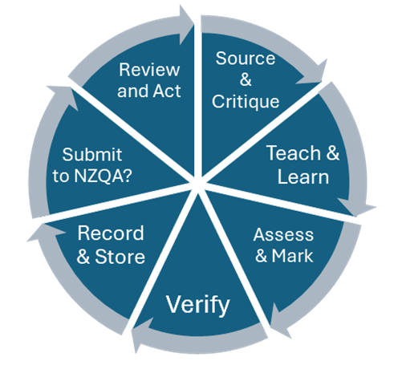
Moderation Practice
Internal moderation – reminders:
- When you send results to NZQA, you are saying they have been moderated.
- You need to monitor the completion and effectiveness of moderation.

Schools must undertake quality assurance to ensure that:
- all assessment material is critiqued and re-contextualised / modified as necessary, before use
- assessor judgements are consistent with the standard
- for each standard, a sufficient sample of each teacher's grade judgements is verified
- for each standard, assessment materials are retained, along with a selection of ākonga work following NZQA guidelines, for the purpose of external moderation, to provide exemplars and so the school can confirm the accuracy of results.
- all advice from external moderation is actioned before the materials are used again.

External Moderation in 2025

- Additional moderation was focused on Levels 2 & 3 standards, with approx. 800 standards selected.
  - The aim was for kura to use the opportunity to get feedback on work that had already been assessed in selected subjects, to strengthen assessor practice.
  - Where kura had previous issues with a standard, they were notified and asked to submit work from 2024 by end of Term 1, so they had feedback from moderators before assessing in 2025.
  - If an outcome was NC or NYC, kura were asked to complete an action plan and submit to their SRM. It was pleasing to see that many kura had already resolved issues and where issues hadn’t been resolved, detailed action plans were put in place.

- Tracking the submission of external moderation
  - Monthly reminders (from start of Term 2) were sent to kura that had reported results but not submitted moderation. This was triggered once 10 days had elapsed after results were reported.
  - Data analysis showed that generally submission of external moderation lagged significantly behind the reporting of results (for standards in the Moderation Plan).

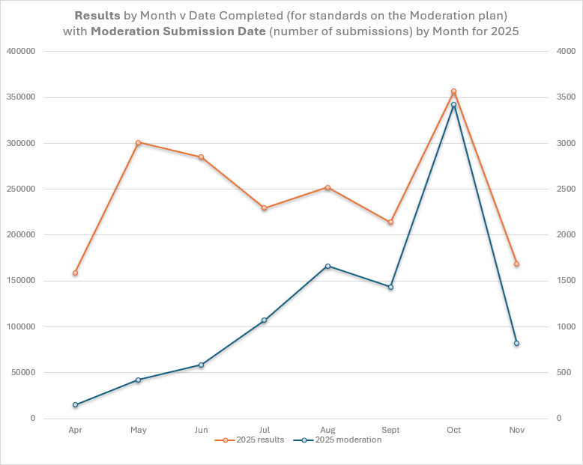

External Moderation in 2026 - Ordinary

At the end of the internal moderation process, any standards in the Moderation Plan must be submitted to NZQA. External moderation is a key part of internal moderation.
As Principal’s Nominee, you need to:

- Check the Moderation Plan and ensure teachers know what is in it.
- Request a change if a standard is not assessed this year.
- Check the completion of internal moderation before results are sent to NZQA.
- Track that, for standards in the Moderation Plan, moderation has been submitted. This is expected to be submitted within 10 days of results being recorded. Consider adding this as the final signed off step of internal moderation and putting a monthly reminder in your calendar.

- Following up moderation reports:
  - Promote the use of Queries/Appeals
  - Ensure Action Plans are developed in response to Not Consistent and Not Yet Consistent outcomes that address the issues noted in the report.
  - It is good practice to also document / follow up comments in a Consistent report. Use Consistent outcomes to collect benchmark samples and assist with building teacher practice.
  - External moderation response templates are available here.
  - If a moderator suggests an action, this should be in the Action Plan: e.g. use Pūtake, use national moderator reports and exemplars, use the clarification form, contact SRM to help find a new verifier, etc.
  - Ensure follow up actions are completed, monitored and evaluated.

Notes:
- 19 October is not the target date for submitting external moderation; it is the date that ensures that moderation reports can be returned before the end of the year. Late submission causes backlogs for moderators, slows reports, and affects the timeliness of responses to queries and appeals.
- We realise that some standards are not completed until after 19 October. If a submission will be late for this reason, let us know.
- Some moderation will be delayed because it needs to be moderated in hui.

Activity - Consider
- How consistent were your teachers in submitting external moderation on time in 2025?

- What will you do differently this year to improve monitoring and submission and resolving issues?

External moderation in 2026 - Confirmatory

We are expanding the use of ‘confirmatory moderation’ in 2026 to manage ongoing moderation issues, focusing on Level 2 and Level 3 standards.

In 2025, some schools and kura were required to submit some standards for confirmatory moderation. This occurred when NZQA had significant concerns about moderation outcomes. We requested specific standards to be sent to NZQA before results were returned to ākonga.

This meant that un-confirmed grades needed to be changed in response to the Moderator’s feedback (similar to L1 or L2 Visual Arts external standards verification).

Expectations & Processes
You will be notified if you are required to send standards for confirmatory moderation, and the details of the standard(s) and process to follow.

There will be an email like this:
Confirmatory moderation: Subject ASXXXXX

This standard has been selected because ....

When your school assesses this standard and the ākonga work has been marked and internally moderated you must:
- Email your SRM by Friday 13 March to confirm an indicative date for the assessment and submission of the moderation
- When the assessment is complete, send the attached spreadsheet with NSNs and the provisional grades, and email it to your School Relationship Manager (SRM)
- submit materials for external moderation promptly following the usual process
- on publication of the external moderation report, apply any necessary grade changes and use the feedback to adjust all relevant ākonga results for the standard, not just the material submitted (you may query and/or appeal the report if needed)
- complete the final grade column of the spreadsheet and email it to your SRM
- once your SRM has reviewed the moderation report and approved your final grades, report the results. We will contact you if further discussion is needed before grades can be accepted.

Do not submit results to NZQA until the confirmatory process is complete. If you do, you may need to revise or remove reported results. There is a possibility that ākonga will not get their grades.

Activity - Consider
Does this process make you think of any subject areas that need to improve their practices? If so, what could you do within your kura to support more accurate marking?
Assessor Support Update

New Pūtake course on Moderation

The new Pūtake course Using a Moderation Report will help you to improve understanding of and responses to external moderation. Use it in a staff meeting; encourage HODs to use it with their teams.


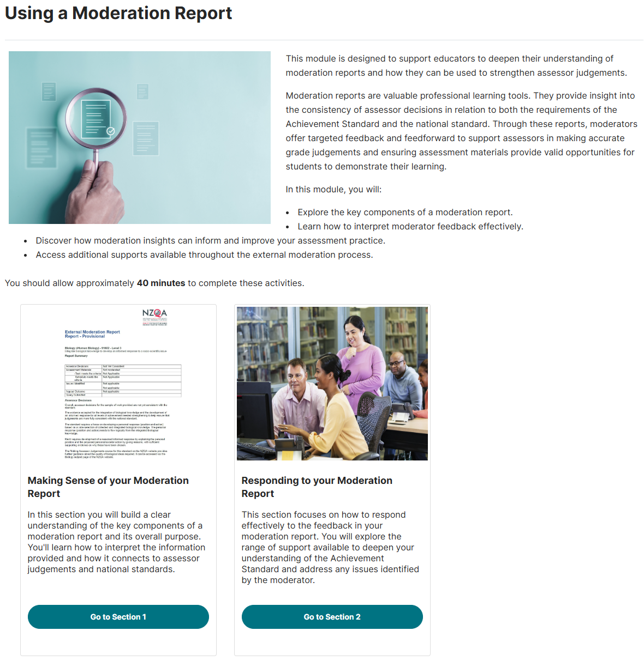
Assessor Support Update

Digital badges on Pūtake
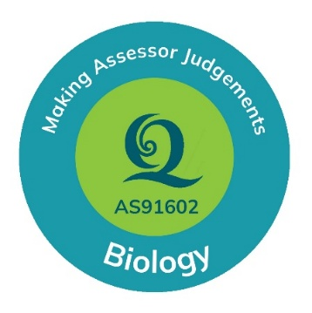
Digital badges are being introduced to Bite-sized Modules and Short Courses on Pūtake. Users will automatically receive a badge once they’ve completed all required activities within a module.
These will be rolled out in stages as resourcing allows, so not all modules will include badges immediately. Over time, badges will be added across our learning offerings to provide a clear, visual indicator of module completion.
For longer workshops, badges will also be available for individual sections. For example, in an Online Making Assessor Judgements workshop, each section covering a specific standard will award its own badge.
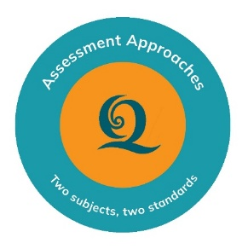
For teachers: Digital badges provide a clear, visual way for teachers to track their progress, recognise the learning they have completed, and plan their next steps. They can also be shared on platforms like LinkedIn or added to CVs and portfolios, offering a consistent and transparent way to showcase development.
For leaders: Digital badges may be useful for your teachers (especially beginning teachers) to include in their professional learning portfolios, to track participation in a course recommended by moderators or HODs, and in a record of assessment capability and leadership across your staff.
We highly recommend the Assessment Guidance courses on Pūtake, as well as the subject- and standard-specific courses.
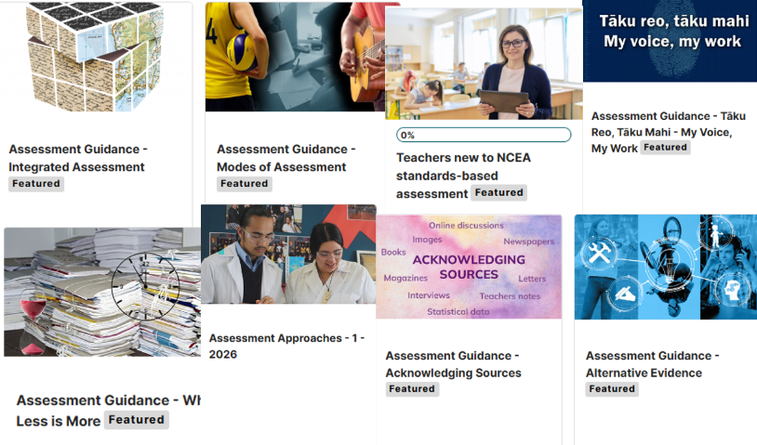
Ensure your teachers all have access and log in and explore!
Quality Assurance Update

Extension of Consent - Industry Skills Boards

Changes to Vocational Education and Training (VET) are intended to
- provide opportunities for people and communities to get ahead.​
- support New Zealand’s long-term productivity and economic development. ​
- ensure it is fiscally sound and represents good value for money.

So far:
- Ten polytechnics have been established and began operating in January 2026.
- Eight Industry Skills Boards (ISBs) began operating in January 2026, replacing Workforce Development Councils (WDCs).

Quality assurance within the VET system
NZQA approves and assures programmes, qualifications and micro credentials and retains a stewardship role relating to quality assurance.​
- Industry Skills Boards ensure industry needs are integrated into the design of programmes, qualifications and micro credentials:​
  - They develop industry qualifications and micro credentials and set skill standards​.
  - They endorse programmes developed by providers​.
  - They provide advice to the Tertiary Education Commission on funding.

During 2026 and 2027, the delivery and functions of Work-based learning (WBL) will move out of ISBs to Private Training Establishments (PTEs), wānanga or polytechnics.

The NZQA website is still being updated with recent changes. For any current queries about the best way to apply for consent to assess or any vocational standard moderation, use the relevant ISB moderation email below.

- Services ISB – moderation@servicesisb.nz
- Transport ISB – moderation@transportisb.nz
- Food and Fibre ISB – moderation@foodandfibreisb.nz
- Education, Health and Community ISB – moderation@ehcisb.nz
- Energy and Infrastructure ISB – moderation@energyinfra-skills.nz
- Construction and Specialist Trades ISB – moderation@cstisb.nz
- Electrotechnology, IT, and Creative ISB – moderation@etitcisb.nz
- Manufacturing and Engineering ISB – moderation@maeisb.nz
Quality Assurance Reminders

Memoranda of Understanding – Third Party Arrangements

If ākonga are being assessed by other providers, a Consent to Assess requirement is to upload Memoranda of Understanding to NZQA.

You will find all relevant information here: Sub-contracting - Third-party consent - NZQA

Common questions from 2025

- Where do I upload MOUs?
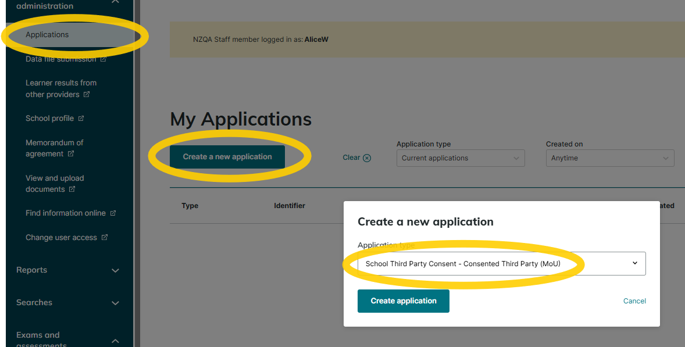
In the Provider Login new portal School administration / Applications / Create a new application / School Third Party Consent – Consented Third Party (MoU).

- Can I upload more than one MOU at a time?
No – each MOU must be uploaded individually

- Once I have uploaded the MOU do I need to do anything else?
No. Your MOU will be checked to ensure everything is included in the document and it is signed by both parties. If anything is missing anything you will be contacted to send the information.

- What happens if I forget to upload an MOU?
NZQA may withhold results reported until the MOU is received.

- Why is the provider’s code not available in the search engine?
A missing code means the provider does not have consent to assess.
- Some of our ākonga are being taught at another kura because we cannot offer a course. Do we need an MOU?
Yes. If you report results achieved at the other kura with your own provider code, you are breaching the Consent to Assess rules. Any standard that is reported with another provider code must have an MOU agreement.

Does this include Te Aho o Te Kura Pounamu (Te Kura)?
No because this is a special arrangement where ākonga are dual-enrolled.

Other third-party arrangements:
A subcontracting arrangement must be formalised with NZQA
- where a kura is contracting any unconsented organisation or individual who is not employed by their Board to teach and assess any course.
- where an ākonga is in an alternative education programme with an unconsented external provider who is assessing standards.


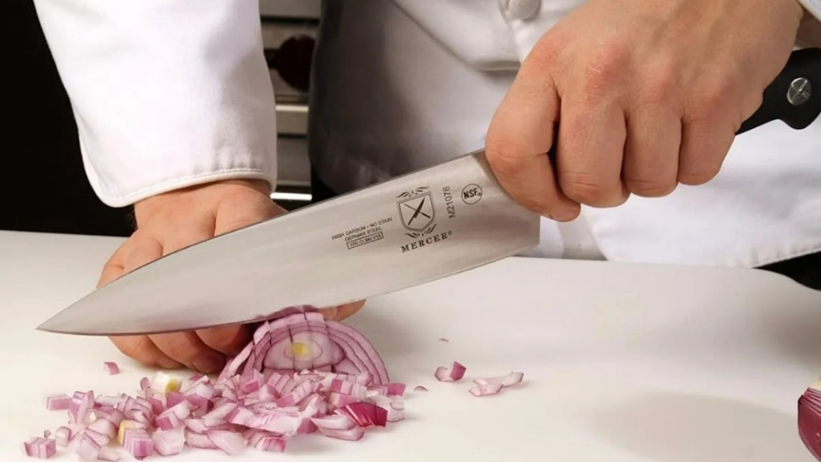
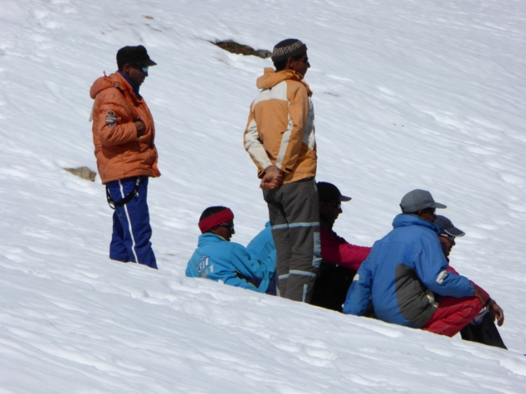
External Assessment Updates

Special Assessment Conditions (SAC) Applications

There are now two ways to apply for SAC provisions for any Year 11 – 13 ākonga.
This was announced in Assessment Matters on 5 February. There are no changes to the nature of the evidence required to support a SAC notification or approval application.

- The Notifications Gateway may be used for all ākonga
  - Supporting evidence does not have to be uploaded at the time of application.
  - The kura must have robust evidence-collection processes to make sure that decisions align with best‑practice outcomes for eligible ākonga. Evidence must be kept.
  - From 2026, School Relationship Managers will conduct audits of SAC evidence to confirm that documentation accurately reflects ākonga needs and learning profiles. Where concerns or anomalies arise, NZQA will undertake a risk‑based follow‑up process.
  - If you are required to submit evidence for the audit, you will be contacted directly by the NZQA SAC team in Term 1 or Term 2. Evidence from 2025 notifications will be requested. Ensure evidence is accessible and ready to submit if required. 50 – 100 schools and kura will be required to submit evidence.

- The Approvals Gateway may still be used for all ākonga
  - Supporting evidence must be uploaded at the time of application.
  - NZQA SAC experts and psychologists will assess the evidence and determine any SAC provisions that are required by the ākonga to improve access to equitable assessment.
  - Useful for complex cases where additional guidance is needed.
  - Particularly useful for new SENCOs, or in situations requiring NZQA input to ensure consistent, evidence-based decisions.
  - Further information can be found here.

Learning difficulties or physical limitations should not create barriers to ākonga access to assessment and qualifications. A range of provisions are available to support them.
SAC applications (notifications or approvals) are not required for co-requisite assessments but may be submitted to support kura decision-making.

NZQA SAC specialists will also conduct focused reviews with kura who have not yet accessed SAC. If you need support with SAC processes at any time, email sac@nzqa.govt.nz

Special Assessment Conditions include:
- Extra time to complete assessments.
- Someone to read the paper for them (a reader).
- Someone to whom they can dictate their answers (a writer).
- Separate accommodation when required.
- …and more.

Situations where an ākonga could access Special Assessment Conditions are:
- A known learning difficulty (dyslexia/dyspraxia/dyscalculia etc.)
- A persistent injury
- Illegible handwriting
- …and more.

Once SAC provisions have been notified to NZQA or approved by NZQA, they should be provided for both internal and external assessments as needed throughout the year. Kura are entitled to prioritise how they can provision diverse SAC needs, based on the resources they have available to them. SAC provisioning must be manageable and sustainable for the kura.

We encourage you to trial SAC early with each ākonga identified, to ensure that they meet their assessment needs in each subject.

If removing a barrier would enable an ākonga to access assessment, then they can probably access SAC. You can find more information on the Special Assessment Conditions pages of our website, or contact the team by emailing SAC@nzqa.govt.nz.

See the webinar schedule for SAC webinars in 2026.


Activity - Consider
What is your SAC evidence?
Where is your SAC evidence?
External Assessment processes

Submitted Externals

All submissions must be submitted by 28 October.

The exception to this is Level 3 Visual Art, now due by 2 November.
Please read Visual Art instructions carefully. Both Level 1 and Level 2 must be submitted digitally.

There are three types of submissions for external assessment:
- submitted through the new portal
- submitted through the old portal
- physical submission such as most Level 3 and Scholarship Visual Arts portfolios where material is couriered to NZQA for marking.

Submission instructions will be published on NZQA subject pages on 15 May. It is important for both Principal’s Nominees and teachers to be familiar with the instructions and the due date. Submission information such as file types and sizes can also be found in assessment specifications on the subject pages.

How to avoid problems with submissions:
- For both physical and digital submissions:
- ensure that ākonga check their work before it is submitted and that it matches what they want to submit.
- check that all ākonga with an entry have submitted work for marking.
- check that the work is authentic. If there are any concerns, then a detailed report of a potential breach must be made to NZQA. The work should still be submitted.

- For a physical submission:
- check everything is included – both ākonga work and the attendance roll.
- check the address on the courier label is correct.

- For a digital submission:
- retain a secure copy until the results are finalised in case there is an issue and NZQA has to go back to the kura for another copy.
- include only filetypes outlined in the submission instructions, as other filetypes may not be able to be marked.
- submit the correct type and number of files.
- check the material is complete, with no links to websites or cloud storage.
- check ākonga in videos are clearly identified by timestamps and/or descriptions.
External Assessment processes

Derived Grades

The Derived Grade process gives ākonga access to a grade when they are prevented from completing an exam or performing at their best by reasons beyond their control on the day of the exam.

Last year we saw an increase in applications asking for ‘compassionate consideration.’ Unfortunately, we cannot base our decisions on compassionate grounds. Decisions are based on evidence of a significant impact or impairment preventing the ākonga from sitting an exam or performing at their best.

What is good evidence?

- Ākonga describing their feelings is not good evidence.
Advise ākonga to explain how the event or medical illness has or will prevent them from sitting the exam or how it affected their performance.
For an event that has affected an individual’s mental wellbeing, a report from the ākonga support person or Guidance Counsellor is generally needed to attest to the application. A common example is when a parent has been recently diagnosed with cancer, often terminal. We receive a lot of medical records for the parent establishing the severity of their illness, but no evidence about how this has affected the ākonga. We cannot infer the impact on their mental wellbeing.


- For a medical application, a medical certificate on its own is often insufficient. Not all visits to a doctor generate eligible evidence for a derived grade. The description box in Section 2 of the application form must be completed by a registered professional within a timely manner, preferably at the time the ākonga is affected.

- A registered professional must be able to confirm that the temporary illness or injury had a significantly detrimental effect on ākonga performance or attendance. A certificate obtained well after the illness that states that they believe or it is their opinion that the ākonga was likely affected by the symptoms described is insufficient. Migraines are a typical example.
- Ākonga should take reasonable steps to obtain evidence and make an application in a timely manner. They should notify their Principal's Nominee at the time of the illness, exam (especially if it occurs during the exam) or if they can’t get to a doctor.

Ākonga taking responsibility – things that are within their control
Ākonga are expected to take responsibility for checking their entries, knowing the date and time of their exams, and notifying staff if something isn’t correct or if they’re unsure.
They should:
- check that all their entries are on their MyNZQA account.
- check that their admission slips have all their standards listed.
- organise themselves (and sometimes their family) so they get to the exam on time.
- put their hand up if they think something isn’t correct or is missing.

New Application Tool Enhancements
We welcome feedback about the application tool introduced in 2025, so that we can improve the user experience. If you have feedback, please send it to your SRM who will pass it onto the derived grades team. Or email: Team Mailbox Derived Grades derivedgrades@nzqa.govt.nz

National Representation Pre-approval
Pre-approved applications require a follow-up derived grade application. This isn’t a new requirement. The follow-up application provides us with the standards, grades and evidence of participation.

Pre-approval allows the ākonga and family to plan travel in advance of exams knowing that a derived grade application has already been approved. This is the only instance that the outcome of an approved derived grade application is given in advance.

Derived Grades at Scale (for a group of ākonga affected by the same event)
Descriptive evidence, including times of the event and when it occurs on the day, is essential.

- As soon as there is any indication that a derived grade at scale will be requested, kura must check that quality assured derived grades are available in the NZQA login.

- The derived grade at scale team is responsible for collecting all the evidence for all ākonga involved and will then advise the kura how to progress from there.

- If there is a death of an ākonga, or staff member, the kura should gather evidence of the ākonga affected and for how long.

Activity - Would you approve these applications for Derived Grades?

- During the English exam, the fire alarm activated and Andrew was required to leave the exam for approximately 15 minutes. On return, he found it difficult to regain focus and get back into the flow of writing. He became increasingly anxious about the interruption and felt that his ability to concentrate and complete the work was significantly affected. School endorsed*.

- Wikitoria claims she lost time in the exam to Wi-Fi issues, the supervisor not knowing the access code and not being offered extra time at the end of the exam due to the initial issues. The ECM has provided evidence that the Wi-Fi issue was resolved by 9.25am. Wikitoria left the exam at midday, completing the one paper in which she was entered. School did not endorse.

- Nicky is flying out to Australia to visit family. School endorsed.

- Robyn allegedly got a flat tire cycling to her exam. Too far to walk, parents at work. No evidence provided. School endorsed.

- Chris had the flu before his exams began. He went to the doctor and got a medical certificate. He had recovered by the time of his first exam. He applied for a derived grade because his preparation and study were impaired because he couldn’t focus and was fatigued. School endorsed.

- Amanda was sick during her exams over three days. She went to the doctor two weeks after the first exam she was applying for. The doctor said that Amanda was fine when she presented at the clinic and that she told the doctor that she was sick two weeks ago. School endorsed.


- Penny applied and was accepted to attend the Youth UN Assembly in New York in November. School endorsed.
(* NZQA does not inform ākonga if a school does not endorse an application; the derived grades team use it to help assess the evidence.)
External Assessment processes

External Assessment Quality Assurance audits

Quality Assurance of External Assessment Practice and Processes
SQAS will continue to visit schools and kura during the external assessment windows this year to review practice and processes to ensure kura are meeting their obligations under the Consent to Assess Rules.

Kura should expect a visit:
- within 3–5 years for the Common Assessment Activities (CAAs) and Tūmahi Aromatawai Pātahi (TAPā),
- within 3-5 years if there is also an exam centre at the kura,
- and a return visit within 1-2 years If issues are identified.

CAA and TAPā visits
The visits and observations review criteria are based on the Administrative and submission instructions for Literacy and Numeracy (link to 2025 version).
School Relationship Managers (SRMs) select kura. The SRM will observe the assessment in action and meet with the PN, a supervisor and ākonga. Your SRM will negotiate a date and time for the visit with you.

Exam Centre Visit
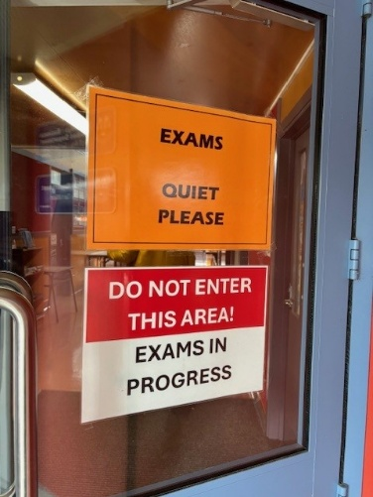
The intent of the visit is to review how well the kura provides resources and support to the exam centre team to ensure that all conditions of assessment are met. It is an extension of the Managing National Assessment (MNA) review, and as such the outcome is recorded in the kura report.

Kura are selected by their SRMs who take the following into consideration:
- The date of the last visit
- Issues identified from previous visits
- Requests from the Exam Centre Management team
- New exam centres
- The exam timetable.

The review is based on the PN and ECM roles and responsibilities table with the primary focus on the Principal’s Nominee (PN) responsibilities. Your SRM will meet with the PN and Exam Centre Manager (ECM) during the visit and may also ask to speak with an ākonga.

Our Findings
Overall, the team found that kura and PNs are effectively supporting ECMs and exam centre staff before, during and after the external exam period, and managing the co-requisite assessments effectively. We identified areas for improvement for some kura before, during, and after the assessments and exams.

Good administration of exam requirements helps exams run smoothly. This includes:

- Submitting entries on time, and checking that
  - each standard in an exam, for an individual candidate, is flagged the same way – either all-digital, or all paper.
  - SAC provisions are attached to entries by 1 September
  - if there are late entries, you also check that they are flagged correctly and SAC is attached where needed and keep your ECM up to date.

- Uploading and submitting work for submitted externals and checking that teachers have reviewed the work for authenticity, accurate uploading, and file accessibility.

- Supporting the ECM, and checking that
  - they have enough space to sort and store exam materials
  - they can do this in a space that meets NZQA security requirements
  - the ECM can contact the courier with updates about pick up requirements
  - the ECM is not left alone at the end of the day. Have a back-up plan if you can’t be there.
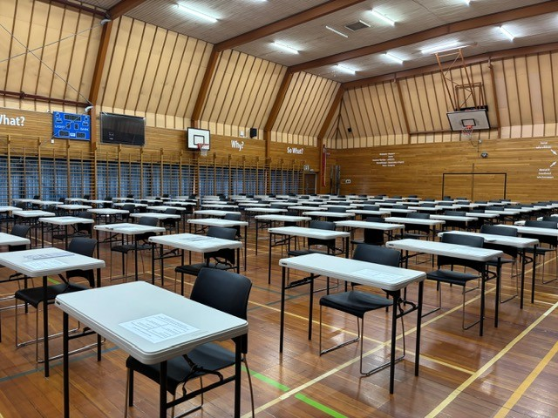
External Assessment processes

Breaches of Assessment Rules in CAAs, TAPā, derived grade exams, and external exams
Ākonga are less likely to breach the assessment rules when expectations are clear, the assessment rooms are settled, and supervisors are vigilant. Help to reduce the temptation to breach by setting up the conditions for authentic assessment.

Translation tools, Grammarly and Generative AI use

The use of generative AI, paraphrasing tools, or other tools that can automatically generate content, such as Grammarly, are not permitted in any NCEA external assessments. This includes co-requisite and end-of-year assessments.


Before an assessment begins, any extensions must be turned off or removed from the device to prevent the use of AI. Instructions for removing extensions can be found on our website: Device and browser specific set up instructions.

The use of generative AI tools during an external assessment is a breach of exam conditions. The standard breach investigation process applies. Results will be withheld where the use of generative AI (such as Grammarly) is identified and advantage is identified, including where its use was unintentional.

If an ākonga is identified as using generative AI during an external assessment, they must still be given the opportunity to complete the assessment. A breach report must be submitted to NZQA outlining any evidence of how the tool may have advantaged them.

Activity: Consider

- How much do you and your teachers know about the use of Gen AI tools by your ākonga? (ChatGPT, Grammarly, translation tools…?)

- How much do you and your teachers know about how your ākonga access these tools? (browser extensions, downloaded apps, websites, VPNs)

- What do you need to know / learn / communicate / discuss / review?
How to help prevent breaches of the assessment rules in external assessments

School breaches:
A school breach occurs when a teacher or exam centre contractor does something to jeopardise the validity of the assessment. To help prevent these:
- Ensure teachers don’t enter the exam room, unless by arrangement with the ECM (e.g. in an emergency)
- Ensure teachers don’t do anything to compromise authenticity. Avoid over-scaffolding, templates, giving notes that ākonga might copy and include in their submissions.
- Ensure teachers know they can’t talk to ākonga during exam toilet breaks.

In case of disruption
- If something happens to disrupt an ākonga or class during a co-requisite assessment, ensure you follow the administration guide and work with your School Relationship Manager, or call NZQA directly to seek advice. Do not enable ākonga to continue the assessment later in the same day or week, or in the next week.

Submitted work:
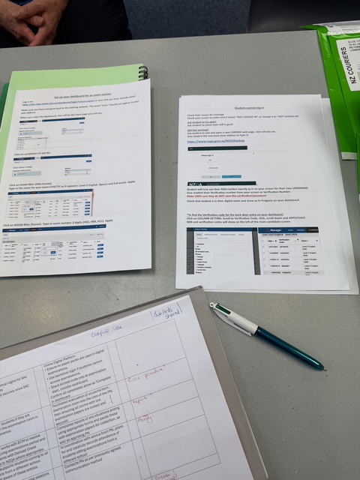
- Ensure teachers review ākonga work – checking that work is authentic, and submitting a breach report if there is doubt, with evidence such as the revision history included.
- If a student has handed in or uploaded work for marking, it must be submitted.
- Use document checkpoints where Assessment Specifications require close supervision and the assessment is over an extended period and ensure consistent practice where there is more than one teacher assessing the same submitted standard.
- Ensure the current assessment specifications are used, to prevent the use of unauthorized material or tools.

Before the exam or assessment
- Store papers securely.
- Cover things on walls or remove them.
- Ensure all supervising staff have been briefed and are aware of emergency evacuation procedures.
- Check the clock can be read from everywhere in the room.
- Ensure there is adequate spacing between desks – at least 1.5 metres between ākonga.
- A supervisor should have a clear line of sight so that they can actively supervise what each ākonga is doing at their desk. Well-spaced desks have room for a supervisor to move around easily, with no cramped areas.
- Ensure staff are available to check and clear calculators.
- Ensure staff know not to communicate with ākonga if they are required to move from a place of performance to a place for the written component of their exam, or if they are sequestered between exams due to a clash.
- Check that the toilets designated for candidate use have nothing hidden in them.

Entry to the assessment room
- You or the ECM decide where ākonga should sit. Avoid seating potentially disruptive ākonga together.
- Ākonga should enter the room in an orderly manner. Go slowly enough so that you can check that only permitted materials are brought in. No phones in pockets!
- Give explicit instructions not to use translation tools and non-embedded writing tools.

Active invigilation
- Active invigilation means being able to see what every candidate is doing. Supervisors need to be able to see every screen from behind, and what every ākonga is doing during the assessment.
- Check all tabs are closed except the assessment platform.
- Check there are no pop-ups or unexpected icons showing.

If you suspect a breach
- Have suitable staff available to deal with any disruption
- If there is any visual evidence, take a photo – e.g. notes, screen popup, unauthorized device or programme, notes written on hand.
- Fill in the purple form, noting the time, your name, and including all evidence. Email it to breaches@nzqa.govt.nz as soon as possible.
- Act on evidence as it arises – e.g. remove notes when they are first seen.
- Always allow ākonga to complete the exam if they wish to and speak to them afterwards if needed.

After the assessment
- Check PDFs are complete before submitting (scan every page, including ones not written on).
- Use the Results Confirmation process after co-requisite assessments if you feel ākonga results do not match their kura-based assessments. Ākonga cannot request this themselves.
- Store completed papers securely.

Activity:
Highlight anything in the information above that you need to emphasise at your kura
    - before the next co-requisite assessments
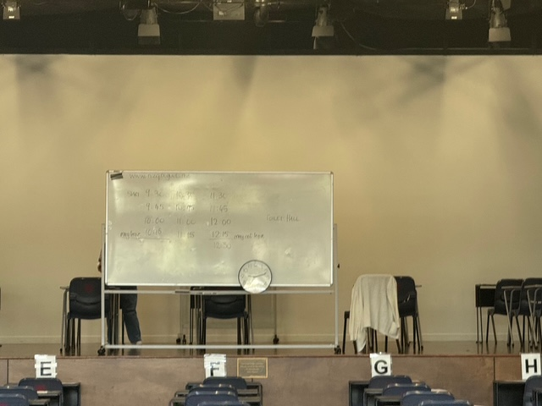
    - before the next school derived grade exams
    - before the next external exams.
Activity: “Stop the Breach”
Consider when to use this activity with your staff - before co-requisite assessments? school exams? external exams?

For each scenario listed:
- Is this a breach risk?
- What should the PN do at the time?
- What should happen next?

Scenarios
- A CAA supervisor suggests letting an ākonga keep writing after the lunch break because they were upset in the morning session.
- An ākonga received extra time but did not have SAC conditions approved.
- An ākonga is quietly admitted to an exam after 45 minutes as they were being told off by the DP.
- A teacher asks if they can clarify the instructions for ākonga mid-exam.
- An ākonga goes to the toilets on the other side of the school because the designated exam toilets are gross.
- A teacher hasn’t reviewed submitted work before the deadline. The HOD submitted anyway.
- An ākonga wrote their submission in class in Chinese, then used a translation tool to ensure their English could be understood by the marker.
- A CAA Writer clarified with the ākonga what they wanted to say in answer to a question.
- In a derived grade exam, an ākonga is found with a Google doc open with a practice essay on it.
- The WiFi stopped working on Friday afternoon, so the DP allowed ākonga to continue the Numeracy CAA first thing on Monday morning.
- An exam supervisor asks you to pull an ākonga out of the hall because they are found using a cell phone.

PN decisions affect the validity of results, not just logistics.
If you wouldn’t defend it to NZQA in writing, don’t allow it.
PN Support

Principal’s Nominee Webinars 2026
Presented by your School Relationship Managers in School Quality Assurance and Support

All presentations and supporting materials are available in this Google Drive. You will need to be logged into a Google account to access the Drive. The first session in each series will be recorded this year and be available in the Drive.
There is no need to sign up – just log in to the session that suits you. If there is more than one session for the Content, the seminar is repeated – there is no need to attend more than one. You are welcome to share invitations with others on your staff.
PN priorities at the start of each term will cover the key dates and processes for each term.
Kura PN priorities will be in Te Reo Māori.
Content | Audience | Dates and links | Agenda
Term 1 PN priorities | PN | - Tues 10 Feb 3.30 – 4.15  - Thurs 12 Feb 3.30 – 4.15 | - Mark books, entries, courses, data  - Monitoring quality assurance  - Reports, self-review
Term 1 Kura PN priorities | PN | - Weds 11 Feb 3.30 – 4.15 | - Mark books, entries, courses, data  - Monitoring quality assurance  - Reports, self-review
Leading National Assessment seminar – Online | If you missed the in-person LNA | - Tues 10 Mar 2.30 – 4 | - Leading National Assessment seminar content
Special Assessment Conditions (SAC) | SENCO  PN | - Tues 17 Mar 11 – 11.45  - Thurs 19 Mar 3.30 – 4.15 | - Questions & answers for new PNs, SENCOs  - Introduction to SAC  - Making applications / notifications  - Evidence & record-keeping
Data & entries Q&A | PN  Data Manager | - Tues 24 Mar 3.30 – 4.15  - Thurs 26 Mar 3.30 – 4.15 | - 2026 courses, entries  - Using the API to submit entries & results  - 2025 cleanup
Literacy & Numeracy and Te Reo Matatini me Te Pāngarau | CAA & TAPā responsibility | - Tues 31 Mar 3.30 – 4.15  - Wed 1 Apr 3.30 – 4.15 | - Common Assessment Activities / Tūmahi Aromatawai Pātahi  - Preparing for the CAAs & TAPā
Term 2 PN priorities | PN | - Tues 21 Apr 3.30 – 4.15  - Thurs 23 Apr 3.30 – 4.15 | - Monitoring moderation  - Following up on MNA action items  - CAAs & TAPā
Term 2 Kura PN priorities | PN | - Wed 22 Apr 3.30 – 4.15 | - Monitoring moderation  - Following up on MNA action items  - CAAs & TAPā  - Data errors & warnings
Digital assessment platform basics | Assessment Master Admin. | - Tues 5 May 3.30 – 4.15  - Thurs 7 May 3.30 – 4.15 | - Common Assessment Activities / Tūmahi Aromatawai Pātahi  - Demonstrate key functions and any updated features
Submitting external moderation | PN / HODs | - Tues 9 Jun 3.30 – 4.15  - Thurs 11 Jun 3.30 – 4.15 | - Monitoring moderation  - Submitting external moderation  - Following up on moderation feedback
Special Assessment Conditions (SAC) | SENCO  PN | - Tues 23 Jun 11 – 11.45  - Thurs 25 Jun 3.30 – 4.15 | - SAC and exams  - Making entries, attaching conditions, preparations for kura and external exams
Term 3 PN priorities | PN | - Tues 21 Jul 3.30 – 4.15  - Thurs 23 Jul 3.30 – 4.15 | - CAAs & TAPā results  - External entries  - Monitoring moderation  - Planning for kura exams
Term 3 Kura PN priorities | PN | - Wed 22 Jul 3.30 – 4.15 | - CAAs & TAPā  - External entries  - Monitoring moderation  - Planning for kura exams
Running Derived Grade exams | PN  DP | - Tues 11 Aug 3.30 – 4.15  - Thurs 13 Aug 3.30 – 4.15 | - Quality Assurance requirements  - Examination conditions
CAAs, TAPā, and Assessment Master | CAA & TAPā responsibility, Assessment Master Admin. | - Tues 18 Aug 3.30 – 4.15  - Thurs 20 Aug 3.30 – 4.15 | - Common Assessment Activities / Tūmahi Aromatawai Pātahi  - For new PNs and curriculum leaders  - Key functions and any updated features
September 1 deadline – external entries | PN  Data Manager | - Tues 25 Aug 3.30 – 4.15 | - What to check for  - Dealing with errors and warnings
Term 4 PN priorities | PN | - Tues 13 Oct 3.30 – 4.15  - Thurs 15 Oct 3.30 – 4.15 | - Entry & data checks  - Exam processes  - Quality Assurance – DGs, external moderation
Term 4 Kura PN priorities | PN | - Wed 14 Oct 3.30 – 4.15 | - Entry & data checks  - Exam processes  - Quality Assurance – DGs, external moderation
Submitted portfolios / kete manarua | PN / HODs | - Tues 20 Oct 3.30 – 4.15  - Thurs 22 Oct 3.30 – 4.15 | - Saving, uploading, submitting portfolios & kete manarua
Exams | PN | - Tues 27 Oct 3.30 – 4.15  - Thurs 29 Oct 3.30 – 4.15 | - Working with your ECM  - Exam processes – DGs, Breaches  - Exam conditions – the PN role
Term 4 PN wrap-up | PN | - Tues 17 Nov 3.30 – 4.15  - Thurs 19 Nov 3.30 – 4.15 | - 1 December data deadline  - Review Quality Assurance completion
Term 4 Kura PN wrap-up | PN | - Wed 18 Nov 3.30 – 4.15 | - 1 December data deadline  - Review Quality Assurance completion
Results and Data Q&A – 2026 | PN  Data Manager | - Thurs 3 Dec 3.30 – 4.15 | - Accessing results  - Adding late results  - Reviews & Reconsiderations  - Reports and statistics  - Qualifications and awards
Results and Data Q&A – 2027 | PN  Data Manager | - Fri 15 Jan 2027 10 – 10.45  - Tues 19 Jan 2027 12 – 12.45  - Thurs 21 Jan 2027 2 – 2.45 | - Accessing results  - Adding late results  - Reviews & Reconsiderations  - Reports and statistics  - Qualifications and awards

School NZQA Provider Login Access – Quick Reference Guide
Access to the various sections of each Provider Login page is granted by the kura Education Sector Logon (ESL) authoriser. Staff can hold multiple roles.
PN Support

Your PN network

The PN role involves significant leadership within your kura. There is support available to assist you with leadership, management, administration, and assessment expertise.

People:
- Your School Relationship Manager
- The Data team will be in touch in March to confirm your 2026 data manager. In the meantime, if you have data-related questions, please contact Schools@nzqa.govt.nz
- ANZPNN – Aotearoa New Zealand Principals’ Nominee network – anzpnn@gmail.com
- PN Facebook page
- Other PNs – listed by kura name under Administration in your Provider Login

Clusters:
- PNs in some regions meet regularly to share practice and common issues. Is this something you would like to be involved in? Could you organise it?

Resources:
- 2026 Online PN sessions
- Resources for Principals’ Nominees
- Pūtake (NZQA’s Learning Management System)
- Myths about NCEA Assessment The Myths have been updated for clarity. Check them against your school assessment policies and practices.

Reminders:
- Special Assessment Conditions (SAC) notification process
- EmaiLink lives in Publications on the NZQA Website
- Assessment Matters lives in Publications too - important updates
- Check ncea.education.govt.nz for NCEA updates from the Ministry of Education
- Consider joining the Aotearoa New Zealand Principal’s Nominee Network anzpnn@gmail.com

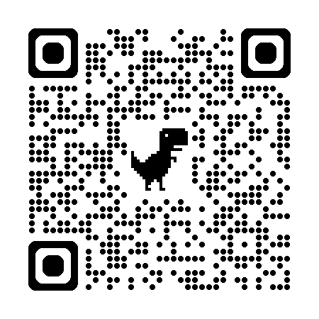
NZQA Annual School and Kura Pulse Check Survey
- Survey closes Friday 13 March.
- You were sent the link and a PDF of the survey questions on 10 Feb to help you to complete it with your team.

LNA Seminar Evaluation
- Please complete this evaluation before you leave today.
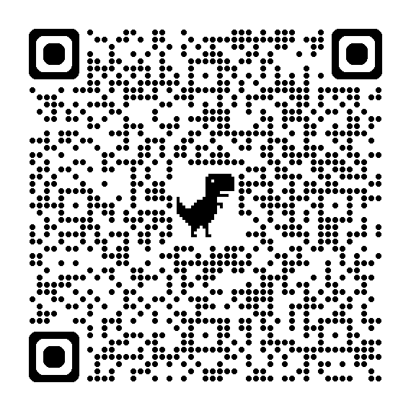



Appendix

The answers

Assessment Matters True / False quiz: They’re all True!

Derived Grades scenarios: They’re all declined!
- Andrew - fire alarms and evacuations are handled as a standard operating procedure by exam centre staff and extra time is provided for the loss of time in the room.
- Wikitoria - the issue was resolved before the exam began and there was enough time to complete the one paper.
- Nicky - visiting friends, family/whānau is considered a personal matter and well within her responsibility. This is the same as a family going on holiday during term time.
- Robyn - evidence must support the application. Furthermore, Robyn needs to take responsibility to ensure she can arrive at an exam on time and factor in the unexpected. (This is why there’s a 30 minute buffer at the start).
- Chris - derived grades do not compensate for the loss of study and preparation time.
- Amanda - medical evidence should be gathered at the time or reasonably soon after the event or illness. In this case, the doctor could only say what she reported to them as the illness had passed. If an ākonga is ill during the exam, then they should immediately see the PN afterwards; likewise if they cannot get to a doctor in a timely manner.
- Penny – doesn’t meet the criteria of being selected by a national organisation or sport. Ākonga apply rather than going through a selection process for this.

2026 NZC NCEA Achievement Standards – Review and Maintenance Programme updates

Full details are available here: https://ncea.education.govt.nz/whats-new/reviewed-nzc-tmoa-achievement-standards-and-assessment-materials-published-2026 and on NCEA.Education and NZQA subject pages.
EN = Explanatory Note, SLO = Subject Learning Outcome

Learning Area | Standard | Changes
Co-requisite Literacy and Numeracy
Literacy Reading | 32403 | Standard versions updated to show alignment with new curriculum phases.
Literacy Writing | 32405
Numeracy | 32406

NOTE: CONDITIONS OF ASSESSMENT UPDATED ACROSS ALL INTERNAL STANDARDS TO PROVIDE CLEARER GUIDANCE AROUND AUTHENTICITY.

Learning Area | Level |  |  | Standard | Changes
English
English | 1 |  |  | 91924 | Assessment Activity 1.1c example texts
 | 2 |  |  | 91101 | Assessment Activities
 | 3 |  |  | 91475 | Assessment Activities
Te Reo Māori
Te Reo Māori | 1 |  |  | 92095 | Standard - EN1 and EN4 updated
 | 1 |  |  | 92092, 92093, 92094, 92095 | Unpacking, Assessment Activities, Assessment Schedules, Course Outline
 | 2 |  |  | 91285, 91288 | Assessment Activities
 | 3 |  |  | 91650, 91651, 91654 | Assessment Activities
New Zealand Sign Language
New Zealand Sign Language | 1 |  |  | 92355 | Unpacking
 | 2 |  |  | 91799, 91800, 91801, 91802 | Assessment Activities
 | 2 |  |  | 91802 | EN6 updated
 | 3 |  |  | 91822, 91823, 91824, 91825 | Assessment Activities
The Arts
Dance | 1 |  |  | 91939 | EN5 updated
Drama | 1 |  |  | 91940, 91941, 91942, 91943 | Unpacking
Music | 1 |  |  | 91949 | SLO
Te Ao Haka | 1 |  |  | 91976, 91977, 91978, 91979 | EN updates in each standard. Also, Conditions of Assessment, Unpacking, Assessment Activities, Assessment Schedules.
 | 2 |  |  | 91980, 91981, 91982, 91983 | EN updates in each standard. Also, Conditions of Assessment, Unpacking, Assessment Activities, Assessment Schedules, Unpacking.
 | 3 |  |  | 91987 | EN3 updated
Visual Art | 1 |  |  | 91912 | EN1 updated
 | 1 |  |  | 91912, 91913 | Unpacking, Assessment Activities, Assessment Schedules, SLOs, Course Outlines
Health and Physical Education
Health Studies |  | 1 |  | 92008 | Assessment Activities
 |  | 1 |  | 92011 | Unpacking
Health Education |  | 3 |  | 91462 | EN2 updated
Physical Education |  | 1 |  | 92016, 92017, 92018, 92019 | EN updates in each standard. Also Unpacking, Assessment Activities, Assessment Schedules, SLOs, Course Outlines
Learning Languages
Gagana Sāmoa |  | 1 |  | 92032 | Unpacking
 |  | 2 |  | 91144, 91145, 91147 | Assessment Activities
 |  | 2 |  | 91147 | EN5 updated
 |  | 3 |  | 91564, 91565, 91567 | Assessment Activities
Gagana Tokelau |  | 1 |  | 92347 | Unpacking
Lea Faka-Tonga |  | 1 |  | 92036 | Unpacking
 |  | 2 |  | 91675, 91676, 91678 | Assessment Activities
 |  | 2 |  | 91678 | EN5 updated
 |  | 3 |  | 91680, 91681, 91683 | Assessment Activities
Te Re Māori Kūki ‘Airani |  | 1 |  | 92040 | Unpacking
 |  | 2 |  | 91114, 91115, 91117 | Assessment Activities
 |  | 2 |  | 91117 | EN5 updated
 |  | 3 |  | 91539, 91540, 91542 | Assessment Activities
Vagahau Niue |  | 1 |  | 92351 | Unpacking
French |  | 1 |  | 91964 | Unpacking, over all Vocabulary List
 |  | 2 |  | 91119, 91120, 91122 | Assessment Activities, over all Vocabulary List
 |  | 2 |  | 91122 | EN5 updated
 |  | 3 |  | 91544, 91545, 91547 | Assessment Activities
German |  | 1 |  | 91968 | Unpacking
 |  | 2 |  | 91124, 91125, 91127 | Assessment Activities
 |  | 2 |  | 91127 | EN5 updated
 |  | 3 |  | 91549, 91550, 91552 | Assessment Activities, over all Vocabulary List
Spanish |  | 1 |  | 91927 | Unpacking
 |  | 2 |  | 91149, 91150, 91152 | Assessment Activities
 |  | 2 |  | 91152 | EN5 updated
 |  | 3 |  | 91569, 91570, 91572 | Assessment Activities
Chinese (Mandarin) |  | 1 |  | 91952 | Unpacking
 |  | 2 |  | 91109, 91110 | Assessment Activities
 |  | 2 |  | 91112 | EN5 updated, and Assessment Activities
 |  | 3 |  | 91534, 91535, 91537 | Assessment Activities
Japanese |  | 1 |  | 91956 | Unpacking, over all Vocabulary List
 |  | 2 |  | 91134, 91135, 91137 | Assessment Activities
 |  | 2 |  | 91137 | EN5 updated
 |  | 3 |  | 91554, 91555, 91557 | Assessment Activities
Korean |  | 1 |  | 91960 | Unpacking
 |  | 2 |  | 91139, 91140, 91142 | Assessment Activities
 |  | 2 |  | 91143 | EN5 updated
 |  | 3 |  | 91559, 91569, 91562 | Assessment Activities
Mathematics and Statistics
Mathematics and Statistics |  | 1 |  | 91944 | Unpacking, Assessment Activities, SLOs
Science
Agricultural and Horticultural Science |  |  | 2 | 91293 | EN3 updated, Assessment Activities
Biology |  |  | 3 | 91604 | Assessment Activity
Chemistry and Biology |  |  | 1 | 92023 | Unpacking
Earth and Space Science |  |  | 3 | 91413, 91414 | EN3 updated in each
Physics, Earth and Space Science |  |  | 1 | 92044, 92045 | Unpacking, and further 92045 updates to Conditions of Assessment
Science |  |  | 1 | 91923 | Unpacking
Social Sciences
Commerce |  |  | 1 | 92029 | Unpacking
Economics |  |  | 2 | 91227 | Assessment Activity
Geography |  |  | 1 | 91934 | EN4 updated, and Unpacking
History |  |  | 3 | 91434 | EN2 updated, and Assessment Activities
Psychology |  |  | 2 | 91846 | EN2 updated, Conditions of Assessment, Assessment Activities
 |  |  | 3 | 91873, 91874 | Conditions of Assessment for 91874, and combined Assessment Activity
Social Studies |  |  | 1 | 92048 | Assessment Activities, Course Outlines
 |  |  | 1 | 92050 | EN1 updated, Unpacking, Course Outlines
 |  |  | 2 | 91280 | EN2 updated, Assessment Activities
 |  |  | 3 | 91597, 91600 | EN2 updated in each, Assessment Activities
Technology
Digital Technologies |  |  | 1 | 92007 | EN2, 4 updated, Unpacking
 |  |  | 2 | 91890 | Further update to Conditions of Assessment
Design and Visual Communication |  |  | 2 | 91338 | EN2, 3, 7, 8, 10 updates
 |  |  | 3 | 92167 | EN2, 3, 5 updated
Materials and Processing Technology |  |  | 1 | 92014 | EN1, 4, 5 updated, Unpacking

Kua whakaputaina ngā whakahounga o ngā Paerewa Paetae me ngā rauemi aromatawai mō te TMoA

Kua whakahoua ētahi paerewa me ngā rauemi tautoko mō te tau 2026. I hua mai ēnei whakahounga i te arotakenga NCEA ā-tau me te hōtaka whakatikatika (RAMP). Ko ngā whakahounga RAMP o te tau nei ka whai pānga ki ētahi o ngā kaupapa ako o te New Zealand Curriculum (NZC) me Te Marautanga o Aotearoa (TMoA), puta noa i ngā Taumata 1, 2, me te 3 o te NCEA.

Me mātua whakamahi e ngā kaiako me ngā whareako NCEA ngā paerewa kua whakahoungia, tae noa atu ki ngā rauemi tautoko, mō ngā aromatawai i te tau 2026.

Kāore he panonitanga ki ngā pūkenga matua ka aromatawaitia i ngā Paerewa Paetae. Ko te nuinga o ngā panonitanga he moroiti, ā, kua pērātia kia mārama ake, kia pai ake hoki te whakamāoritanga. He mea nui kia mōhiotia kua whakahoua ngā Tikanga Aromatawai mō ngā aromatawai ā-roto katoa e mārama ake ai ngā kupu tohutohu mō te motuhēhēnga. Assessment Specifications - NZQA

NCEA.Education.govt.nz - https://ncea.education.govt.nz/whats-new/reviewed-nzc-tmoa-achievement-standards-and-assessment-materials-published-2026

Ngā Tikanga Aromatawai mō ngā Aromatawai ā-roto kia mārama ake ngā aratohu e pā ana ki te motuhēhēnga o ngā mahi.

Te wāhi e kitea ai ngā whakahounga Paerewa me ngā rauemi
- Taumata 1 NZC me ngā kaupapa ako o TMoA:
  - E wātea ana ngā Tikanga Aromatawai mō ngā paerewa paetae ā-roto katoa o te Taumata 1 ki te ripa e kīia nei ko Te Aromatawai, mō ia whārangi ako.
  - Ko ētahi atu kaupapa ako kua whakahoua nei ngā RAMP, ko: Te Ao Haka, Te Reo Māori, Te Reo Rangatira, Hauora me te Pāngarau.
- Ngā Taumata 2 me te 3 o TMoA: E wātea ana ngā rawa me ngā rauemi ki ngā kaiako ināianei ki te paetukutuku NCEA. Ka whai wāhi atu ki tērā, ko: Te Reo Rangatira, Ngā Mahi a te Rēhia, Toi Ataata, Toi Puoro, Tikanga ā-Iwi, Hangarau, Hauora, Pāngarau, me te Pūtaiao.
- Level 1-3 Te Ao Haka: E wātea ana ngā whakahounga o te tau 2026 i ngā whārangi ako o Te Ao Haka e hāngai ana i te paetukutuku NCEA. Ka wātea ngā rauemi ataata ki te paetukutuku hei Te Wāhanga 2 hei tautoko i ngā panonitanga o Te Ao Haka. E wātea ana tētahi whakarāpopotonga o ngā panonitanga ki te wāhanga o ngā Panonitanga Hou i te whārangi ako o Te Ao Haka me ia paerewa paetae o TAH.
- Kua whakahoua ngā paerewa o Te Reo Matatini me te Pāngarau e mārama ake ai ōna kai, ā, kua whakahoua te paetukutuku NCEA ki ngā hononga ki ngā putanga hou katoa.
- Katoa ngā PDF mō ngā mahi whakamahere kua unuhia i te whārangi NCEA.Ed.

