**Achievement standards:**

**A competence to mastery to exceptional model**

**Problem Definition**

The Review of Achievement Standards has caused education professionals to question and review several widely held points of view and understandings that we have held for a decade or two, since the implementation of NCEA. One still lacking any resolution, or any agreed position, is how we define excellence in relation to achievement assessed against achievement standards, and following that, how we define achievement and merit.

Attempts to do so generally focus on the standard-specific criteria to be met for the award of each grade, or in terms of the proportion of the cohort that should be achieving at each grade level. There is also a point of view that the definitions are subject-specific and it is not appropriate to have definitions that umbrella all learning areas.

The problem is: what word or words should be used to discriminate between different levels of achievement so that a proficient reader will be assisted to identify excellence responses from merit responses, and those from achieved responses? How can an achieved grade be reframed as a desirable result that is credible, something a student can be proud of achieving? What is excellence if it is an outcome that can be achieved by a large proportion of a cohort?

**Why do anything?**

Merit and Excellence grades formed part of the NCEA package to recognise higher level performance: Merit - above and beyond Achievement, and Excellence – above and beyond Merit. These were among the purposes for introducing an Excellence grade:

* motivating the most able students to do their best;
* providing recognition for outstanding achievement;
* discriminating high achieving candidates for selective purposes;
* enhancing the credibility of the qualification.

Fulfilling these purposes requires that Excellence be an attainable but limited grade.

Excellence has now become the goal for many students, particularly for many internally assessed standards. While this is very acceptable as a ***goal***, many students expect and do receive it, and not doing so has become regarded by some as failure. This lowers the standing of Merit. It also lowers the standing of Excellence, as it no longer discriminates good from superior performance. *When achievement represented as superior becomes the norm, the assessment standard is faulty and requires review.* For the grade to fulfil its purposes, Excellence needs to return to a prestigious position, recognising high achievement above mainstream standards.

**Framing Achievement, Merit and Excellence**

This paper reflects back and builds on the notion of competency, which underpinned the original concept of the qualifications framework. A person who has achieved an assessment standard has demonstrated competency in the knowledge and skills assessed through the standard. They have demonstrated the knowledge and skills required to perform at the level assessed through the standard, and to move on to the next stage of learning.

Higher degrees of achievement or performance (at the same level) might then be described as having mastered the knowledge and skills being assessed, moving on to exceptional performance by learners who are able to demonstrate impressive and unusual knowledge and skills.

Table 1 presents a model of *Competence to Mastery to Exceptional* to guide making assessment judgements against achievement standards. It proposes definitions and graduate profiles, and suggests activities that reflect these, drawing on the Depth of Knowledge levels 2 to 4. DOK Level 1 is defined as recollection and reproduction. It is rooted in simple exercises and procedures requiring students to remember facts, terms and formulae. DOK Level 2 is defined as knowledge application. It requires students to choose appropriate ways to apply information to solve questions, which is the expectation for achievement. DOK Level 3 may be equated to Merit and DOK Level 4 to Excellence.

Achievement at higher curriculum levels (NCEA Levels 2 and 3) may be defined by the same, or similar, descriptors, applied to knowledge and skills of higher levels of difficulty and complexity.

Different sets of descriptors might be more appropriate for some bodies of knowledge. The major discriminating feature of the descriptors is the use of the word *‘exceptional’* at excellence. This stresses that while excellence does not equate to perfection, it is a quality of performance a small proportion of any cohort will be expected to achieve.

‘Merit’ descriptors show a higher and broader range of qualitative descriptors than ‘Achieved’. ‘Merit’ judgements could rely upon the increasing complexity and number of descriptors.

‘Achieved’ attempts to convey the sense of competence; that the learner has displayed evidence of learning and that a degree of emergence is still acceptable.

How these descriptors might be reflected in the achievement criteria of the standards will differ from standard to standard, depending on the significant learning that is being assessed. Overall, the intent is to assess the differences in the quality of student responses.

**Implications of defining/re-defining A, M and E**

Defining, or re-defining, what we mean by achievement, merit, and excellence has implications for the development of achievement standards, the design of assessment activities, teaching and preparing students for assessment, and for making assessment judgements.

New standards must set criteria that:

* are consistent with and reflect the agreed definitions and graduate profiles for each grade
* clearly discriminate performances that are qualitatively different.

Assessment activities must be designed to ensure they provide adequate opportunities for all students to demonstrate qualitatively different levels of performance.

Implicit in the standards is that students can produce the required evidence on their own, without assistance (unless the standard says otherwise). This has significant implications for teaching practice and the preparation of students for assessment.

Markers/assessors must apply the principles of aromatawai and assessment when making judgements of student evidence against the standard. They need to be assured that the evidence is all the student’s own work (authenticity), and be confident the student could reproduce the same outcome again (sufficiency).

*Table 1: Competence to mastery to exceptional model*

|  |  |  |  |
| --- | --- | --- | --- |
|  | **Achievement** | **Achievement with**  **Merit** | **Achievement with Excellence** |
|  | **Competence** | **Mastery** | **Exceptional** |
| **Definition** | Having the required knowledge, skills and abilities to successfully and/or efficiently perform critical functions or tasks in a defined setting. | Having control or superiority over a particular activity, or command or grasp of a subject. | Having the required knowledge and skills to an extremely high degree (extraordinary), enabling impressive performance that sets them apart. |
| **Graduate Profile** | A learner who has demonstrated competency has achieved the outcomes of the significant learning at the relevant curriculum level. They may show evidence of ongoing development of knowledge and skills, but overall, have sufficient knowledge and understanding to progress to the next step on their pathway. | A learner who has demonstrated mastery has shown a thorough and advanced understanding of all aspects of the significant learning with no obvious deficiencies. They are able to apply their knowledge and skills with a high level of proficiency in different contexts. | A learner who has demonstrated an exceptional level of performance has an intuitive grasp of what is required. They are able to think critically, provide evidence and rationale to support their fresh ideas, and consistently respond to any given context in unusual ways. |
| **Sample Activities[1]** | Identify and summarise the major events in a narrative.  Use context cues to identify the meaning of unfamiliar words.  Solve routine multiple-step problems.  Describe the cause/effect of a particular event.  Identify patterns in events or behaviour.  Formulate a routine problem using given data and conditions.  Organise, represent and interpret data. | Support ideas with details and examples.  Use voice appropriate to the purpose and audience.  Identify research questions and design investigations for a scientific problem.  Develop a scientific model for a complex situation.  Determine the author’s purpose and describe how it affects the interpretation of a reading selection.  Apply a concept in other contexts. | Specify a problem, analyse data, and report results and/or solutions.  Apply mathematical model to illuminate a problem or situation.  Analyse and synthesise information from multiple sources.  Discuss and illustrate how common themes are found across texts from different cultures.  Design a mathematical model to inform and solve a practical or abstract situation. |

Table 2 provides further examples of the types of activity falling under each grade level, combining the DOK levels with Bloom’s Cognitive Process Dimensions, largely ignoring DOK Level 1 and beginning at DOK Level 2 representing Achievement.

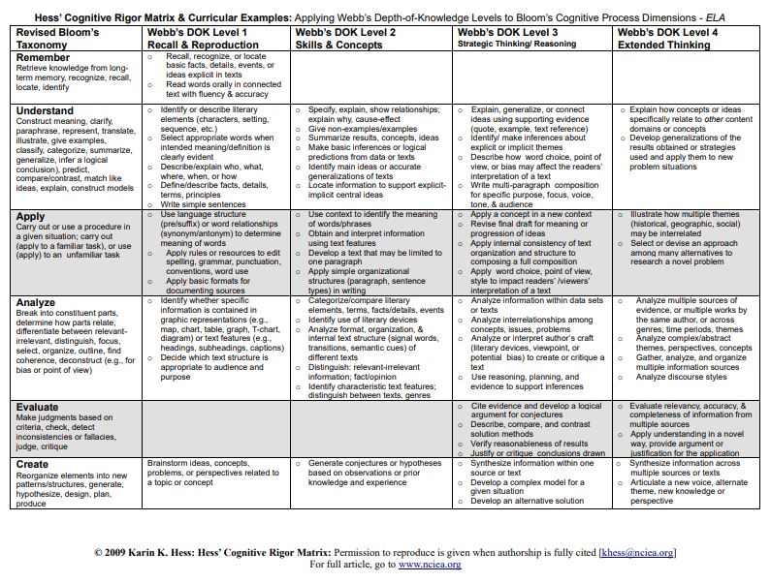*Table 2:*

1. Depth of Knowledge (DOK) Levels; Webb, Norman L. and others. “Web Alignment Tool” 24 July 2005. Wisconsin Center of Educational Research. University of Wisconsin-Madison. 2 Feb. 2006.