

**Kaupapa Māori Kura Leaders**

**NCEA Seminar**

**2019**



Kei ngā Tumu Whakarae o ngā Kura Māori

**2019 Kaupapa Māori Kura Leaders NCEA Seminar**

Nau mai, haere mai, whakakūiti mai rā.

This seminar seeks to enhance NZQA’s engagement with Kaupapa Māori kura, establish what achievement equity issues currently exist, share best practice and improve NZQA’s service delivery to better meet their needs and explore equity of access and outcomes for Māori Students in Kura.

We aim to give you the opportunity to discuss management of assessment practice that supports current and future needs of students, and contributes to addressing equity of NCEA outcomes, with reference to:

* Appropriate Course Design
* Credible Assessment Outcomes
* Equitable Access to Qualifications
* Evaluation of Achievement Outcomes

NZQA appreciates the work that you do and hopes that the seminar will provide information, guidance and resources that may assist you in your role in leading assessment.

We also hope that the seminar will be an opportunity for you to meet staff from other schools and serve as a valuable means of developing collegial support for one another.

Nei me ngā mihi

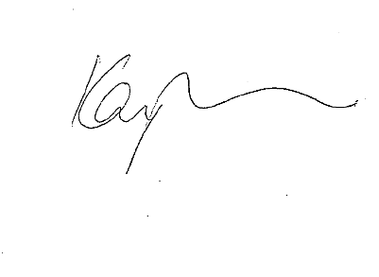

Kay Wilson

Manager

School Quality Assurance & Liaison

**PROGRAMME AND RESOURCES**

**Session 1:**

* ***Appropriate Course Design*** *- I want programmes that provide a pathway*
* ***Credible Assessment Outcomes*** *- I want valid, verifiable, authentic assessment*

**Session 2:**

* ***Equitable Access to Qualifications*** *- I want opportunity for achievement*
* ***Evaluation of Achievement Outcomes*** *– I want feedback that leads to improvement*

Page

**Activity Sheets**

Appropriate Course Design 4

Learning Context – Equitable Access 5 - 7

Derived Grades 8

Special Assessment Conditions 9

Principal’s Nominee Activity Sheet 10

Student Scenarios 11

**Best Practice Tips** 12

**Additional Information**

How can I check consent? 13 - 16

Memorandum of Understanding 17 – 19

Exam Centre Memorandum of Understanding 20 - 21

Derived Grades 22 - 24

How to apply for translated papers 25 – 26

Translated Papers 27 - 28

Role of the Principal’s Nominee 29

Principal’s Nominee Activity Sheet 30

Four seasons of the PN’s Year 31-33

The PN’s year in Paradise 34– 36

Using the NZQA provider Login pages 37 – 39

Managing the collection of evidence 40

Self-Review Tool 41 - 42

2019 Internal Moderation Cover Sheet 43 - 44

**Activity 1: Appropriate Course Design**

Discuss the following:

1. What programmes can you currently offer?
2. What would you ideally be able to offer these ākonga?

Complete the table below:

1. What are the barriers that will prevent or limit the ideal programmes happening?
2. How could these barriers be addressed? Who can support this?

|  |  |  |  |  |
| --- | --- | --- | --- | --- |
| **Potential Barrier** | **Who is involved and who can assist in addressing this barrier?** | | | |
| **Kura** | **Ministry of Education** | **NZQA** | **Other** |
| Example:  Is the course University Approved | ✓ |  | ✓ |  |
|  |  |  |  |  |
|  |  |  |  |  |
|  |  |  |  |  |
|  |  |  |  |  |
|  |  |  |  |  |
|  |  |  |  |  |

**Activity 2: Learning Context – Equitable Access**

**Learning Context – Waka ama**

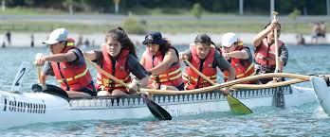

**Identify possible learning and skills development you want to include:**

* *Working together*
* *Calculating the cost to travel to competition*
* *Nutritional needs for the team*
* *Planning and evaluating a training routine*
* *Participate in physical activity*
* *Appreciating the environment used for training/the competition*
* *Requesting permission to attend competition*
* *Making a budget for the team’s trip/food for team while away*
* *Safe food handling procedures*
* *Reporting back to the kura on the competition*

**Identify possible standards to assess students against and collect evidence for. Decide which standards you have access to expertise to assess and are manageable for student/teacher workload**

Mathematics - Number 91029

Accounting - Budgets 90981

Home Economics 90956

Home Economics 90959

English - Creative writing 90952

English - Formal Wring 90953

English - Visual Language 90855

Physical Education 90962, 90964

Science 90951

**How are you going to collect the evidence:**

Portfolio

Checklist

Observation and checklist

Video/recording

Written task/activity

Presentation

**Learning Context**

**Identify possible learning and skills development you want to include.**

**Identify possible standards to assess students against/collect evidence for.**

**How are you going to collect the evidence?**

**Learning Context**

**Identify possible learning and skills development you want to include.**

**Identify possible standards to assess students against/collect evidence for.**

**How are you going to collect the evidence?**

**Activity 3: Derived Grades / Special Assessment Conditions**

Derived Grade True /False

|  |  |  |
| --- | --- | --- |
| True/False |  |  |
|  | A student can apply for a derived grade if they miss an examination because they are sick |  |
|  | All derived grade applications must be supported by medical evidence from a doctor |  |
|  | The school approves derived grades |  |
|  | A student selected for a national sports team that coincides with their exams will need to miss their exam |  |
|  | We do not run practice examinations therefore we cannot provide a derived grade |  |
|  | A student can choose the examinations they want to apply a derived grade for |  |
|  | If the student sits the exam and a DG is approved – the grade reported will be what they achieve in the exam |  |
|  | A derived grade be declined |  |

**Special Assessment Conditions (SAC)**

**(Go to pigeonhole to complete the SAC questionnaire)**

SAC assists fair and equitable assessment by removing barriers in assessment situations for otherwise capable students.

**SAC Categories**

|  |  |
| --- | --- |
| * **Sensory**   + Vision   + Deafness | * **Physical**   + Injury   + Long term physical condition   + Handwriting that cannot be read (illegible) |
| * **Medical**   + Long term illness or condition   + Concussion   + Diabetes   + Mental health concerns | * **Learning**   + Difficulties in reading   + Difficulties in writing   + Difficulties in completing work in a limited time |

**SAC Entitlements**

**This depends on the circumstances, but can include:**

* Someone to read the exam questions (a Reader)
* Someone to write the student’s answers (a Writer)
* Student may use a Computer
* Student may have Extra Time
* Student may have Rest Breaks
* Student may have Separate Accommodation
* Student may have the exam printed on Enlarged Paper

**SAC: Where to start**

* Do you have students who may be eligible under the Sensory, Medical or Physical categories?
* Do you have students with illegible handwriting who could benefit from the use of a Computer/Writer?
* Do you know of students with a history of learning difficulties who may be eligible?

**SAC: How to apply**

* Applications are made online through the NZQA School Login.
* You will need to collect evidence to support the application.
* There is support to help you with all of this. Contact:
  + your SRM
  + [sac@nzqa.govt.nz](mailto:sac@nzqa.govt.nz)
  + phone 0800697296 and ask for Gabe Sorensen or Paul Smith.

**Activity 4: Principal’s Nominee Activity**

Self-Review form for Effective Leadership of Assessment for Qualifications

|  |  |  |
| --- | --- | --- |
| If your school has effective leadership of assessment for qualifications | Ae/Kao | Action if kao |
| Everyone recognises that the Principal’s Nominee’s role is to guard the school’s integrity in relation to assessment for qualifications. |  |  |
| You understand and value the Principal’s Nominee role. |  |  |
| Parts of the role may be delegated, to share responsibility and ensure effectiveness. |  |  |
| Everyone understands who is responsible for leading and managing each aspect of the Principal’s Nominee role. |  |  |
| You provide sufficient resources to ensure all those involved in the Principal’s Nominee role can act effectively. |  |  |
| The Principal’s Nominee ensures practices comply with NZQA rules and requirements  . |  |  |
| Teachers and subject leaders work collaboratively with the Principal’s Nominee to achieve credible results. |  |  |
| The Principal’s Nominee is responsible for ensuring staff carry out their duties effectively and for all communication with NZQA in relation to these duties. |  |  |
| Communication is clear between students, parents, teachers, subject leaders and the Principal’s Nominee. |  |  |
| Succession planning occurs. |  |  |

**Activity 5: Student Scenarios**

Scenario

This is Ariana, an academic student planning to study medicine. She is a kura leader, involved in kapa haka and waka ama. In year 12 she was a member of the team that competed in the Regional Whakataetae Kapa Haka. Her kaiako did not assess her for Maori Performing Art standards, but she would have achieved an excellence for the Level 3 *Perform a Bracket* standard. This would have enabled her to get an Excellence endorsed Level 2 NCEA Certificate.

What is the potential impact of this on Ariana?

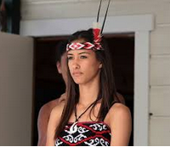

Scenario

These are Wiremu, Tiaki and Kauri

If Wiremu, who is year 13, did not have all his internally assessed standards results reported in the 1 December final file submission,

what would be the impact on him?

Tiaki and Kauri are Year 11 students sitting Te Reo Maori and Science external exams at another examination centre.

What would be the potential impact if their external entry for Science was not signalled as a translated paper and the Te Reo examination entry was late (made on 1 November)?

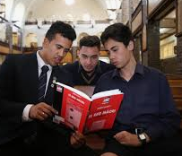

Scenario

Maiawhitia is an outstanding student, who is particularly bright and very good with his oral work. His writing has always been extremely difficult to read, especially under time constraints. His kura has made allowances for this by giving him extra time, getting him to do practical assessments such as Toi Ataata and letting him do written work with a computer. This year, Maiawhitia is doing some Level 3 Science externals as he is wanting to study Dentistry at Otago University and there are some compulsory external standards required for him before he can do the necessary Health Sciences course next year.

Could Maiawhitia benefit from SAC and what would happen if he falls ill the day before hisScience externals?



**Best Practice Tips**

Ᾱnei ētahi tauira o te mahi aromatawai pai ake. The following are examples of Best Practice from surveyed kura.

**Appropriate course design:** *I want programmes that provide a pathway/Te ara whakamua.*

Kura with appropriate course design:

* provide quality, well-informed career advice to their ākonga and whānau
* have strong relationships with outside providers including other kura, wānanga, technical institutes and universities
* modify the NZQA MOU template to meet their own specific requirements, including agreed deadlines for results reporting by the provider
* meet regularly with kura teina to reinforce and support quality assurance processes
* report all results using the appropriate provider code.

**Credible assessment outcomes:** *I want valid, verifiable and authentic assessment/Ko te tika me te pono.*

Kura with credible assessment outcomes:

* provide time and resources for kaiako to meet subject experts from beyond the kura for internal moderation purposes
* use online verifiers, especially in hard to staff subjects
* require their kaiako to use subject experts from within and beyond the kura to verify mahi ākonga
* have kaiako who belong to local and national associations
* request standards for external moderation through the external moderation application, so that feedback can be received for targeted standards.

**Equitable access to qualifications:** *I want opportunity for achievement/Ko te mana ōrite.*

Kura with equitable access to qualifications:

* allow kaiako from different subject areas to collaborate on contextualising learning and assessment
* submit internally assessed results to NZQA on a monthly basis so ākonga and whānau can check on progress and identify data errors which are rectified
* require kaiako to meet their assessment deadlines
* ensure that all internal results are either reported or entries are withdrawn by the 1st December
* have kaiako who are experts at designing their own assessment tasks
* support new kaiako to be experts at assessment and moderation.

**Evaluation of achievement outcomes:** I want feedback that leads to improvement/Mā te urupare ka ora ai.

Kura with evaluation of achievement outcomes:

* use achievement data to develop and reflect on assessment programmes
* ensure their teina are academically prepared for NCEA studies in the wharekura
* ensure all NCEA kaiako conduct consistent assessment and moderation practice which is reinforced through scheduled kaiako wharekura hui
* use effective self-review processes which involve whānau, kaiako and ākonga input.

**How can I check what standards I have consent for?**

**Option 1**

Using the NZQA website to check the standard.

[www.nzqa.govt.nz](http://www.nzqa.govt.nz)

* Go to *Qualifications & Standards* at the top of the page then click on *Standards* in the drop down.
* Click on *Search the Directory of Assessment Standards.*
* Put in the standard number you want and *Search*.
* Click on *View Education Organisation with Consent to Assess*.

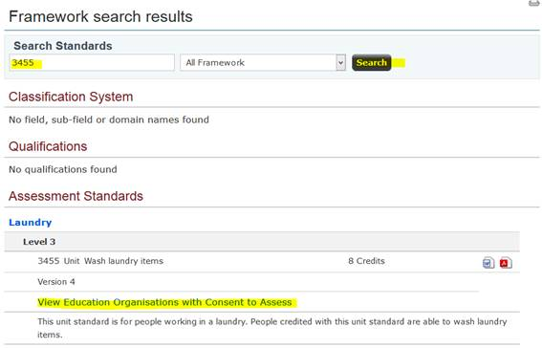

* Click on your region, or type in your name or code in search word and see if you are listed.

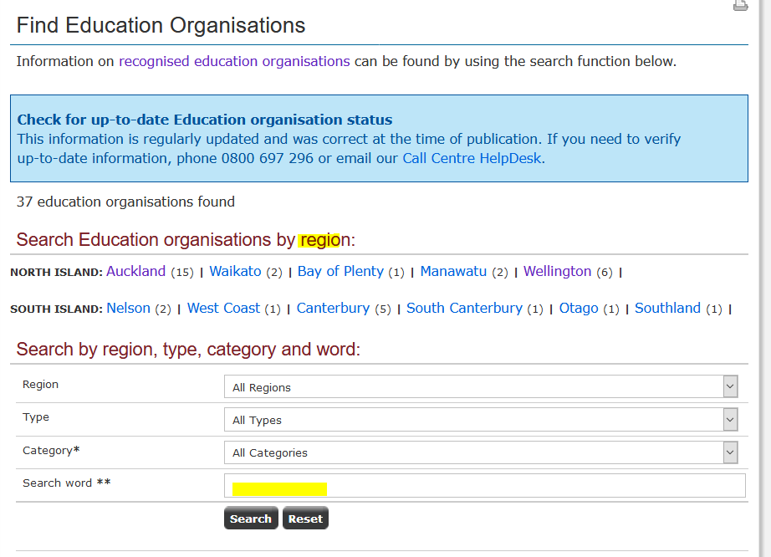

**Option 2**

Using your organisation page on the NZQA website.

* Click on *Find an education organisation*.

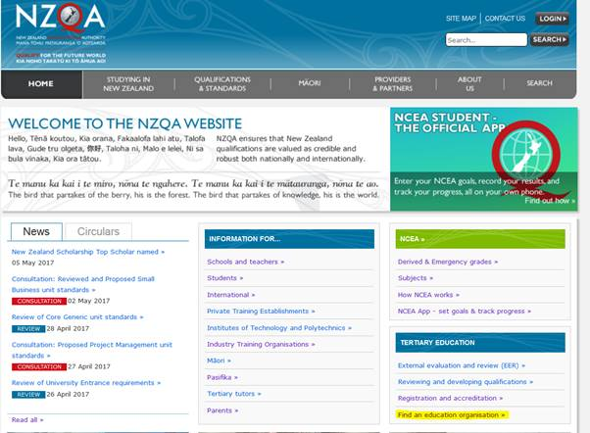

* In *Search word* put your school name or code and *Search.*
* Click *View details*.

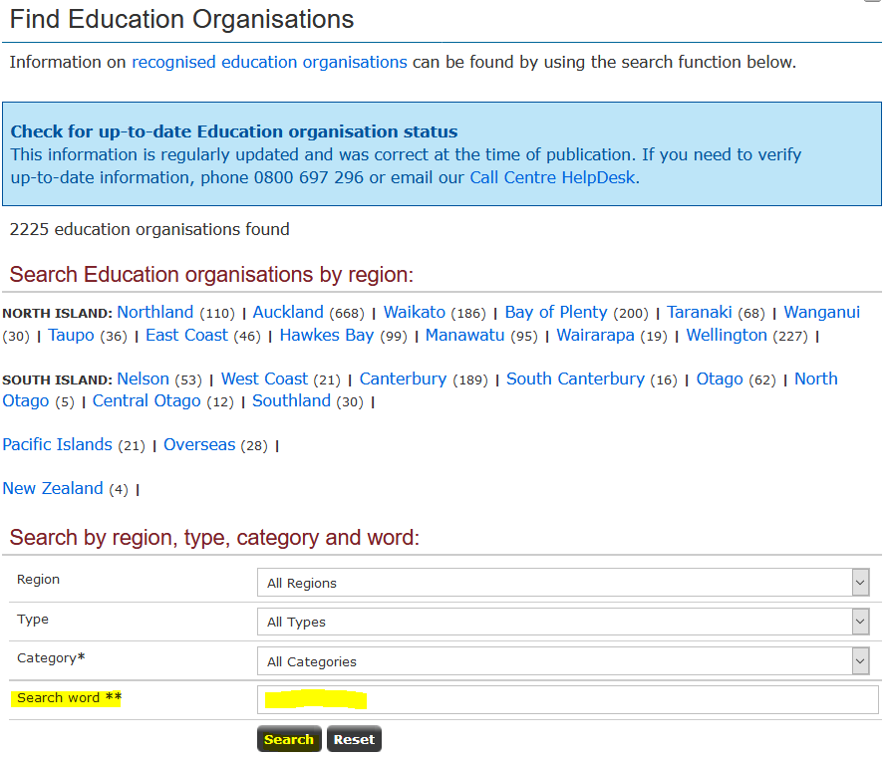

* Click on *these standards and groups of standards* to see what you have consent for.

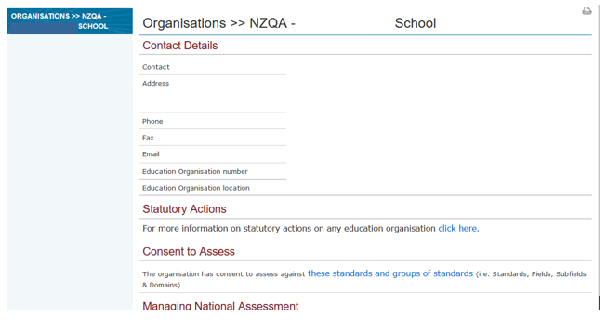

* Note: You have to know what Sub-field/Domain the standard is in. Some staff find this way useful if they are thinking of changing a course but have no particular standards in mind so want to see what they have consent for in that area.

**Option 3**

Using your Provider Login

* In your Provider login click on *Reports and Consent to Assess*.
* Note: As with Option 2 you have to know what Sub-field/Domain the standard is in. Some staff find this way useful if they are thinking of changing a course but have no particular standards in mind so want to see what they have consent for in that area.

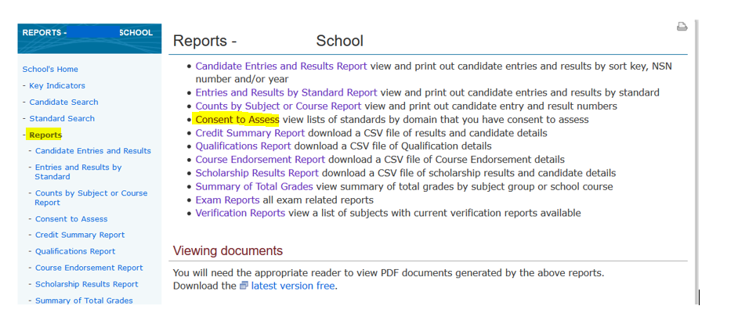

**Option 4**

Using your NZQA Consent File (High Security)

* In your Provider login go to *File Downloads and Searches*
* Click on *File Downloads*.

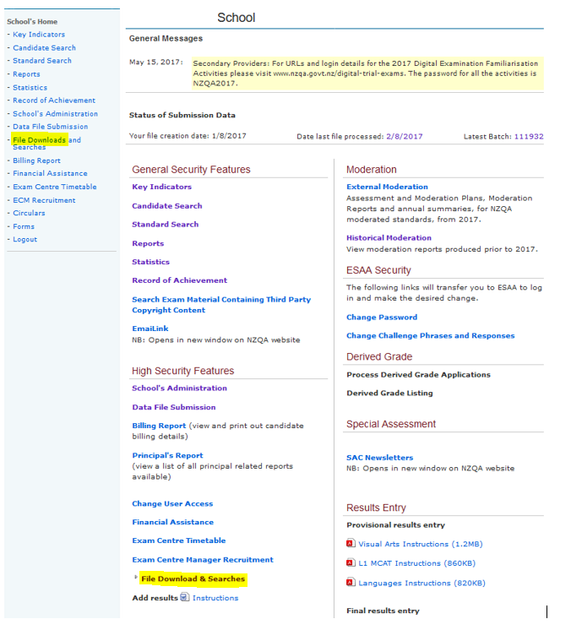

* Click on *consents.txt* to download a file which you should be putting into your student management system (SMS) at least once a year to ensure it has up to date data on your consents.

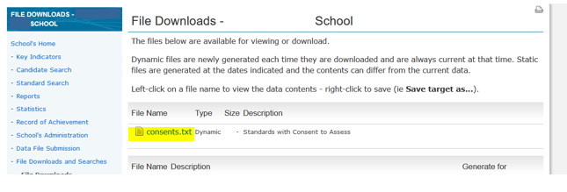

* Open the file to list all the standards you have consent for. The first column is your code XXX and location 01 and then the standards are listed.

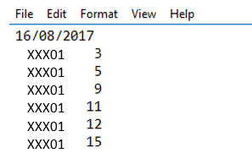

* You can go through the Edit tab and find and type in the standard you want or scroll down to it

**Memorandum of Understanding**

The following is a draft template for a Memorandum of Understanding (MOU) that could be used between a school and an accredited/consented external provider (which may be another school). It is a suggestion only and should be adapted to suit specific arrangements negotiated between the school and the outside provider. To protect all parties it is advisable for the MOU to be agreed and signed before delivery of any standards commences.

1. This Memorandum is between *(the school and its provider code)* and *(the external provider and its provider code)*. The following arrangements have been agreed between *(the school)* and *(the external provider)* to enable the students of *(the school)* to be taught and assessed against standards in the domains listed below for which *(the external provider)* has NZQA Accreditation/Consent to Assess.

The standard(s) to be assessed are as follows:

*(Insert standards here):*

1. *(The external provider)* as provider of professional services to *(the school)*, ensures that the required standards of teaching, assessment, moderation and quality assurance are maintained by agreeing to:
   1. provide qualified staff competent with NZ Qualifications Framework (NZQF) procedures to deliver courses and assess students for the standards relating to the courses delivered
   2. have quality management systems to oversee and deliver courses or programmes of learning that lead to the assessment of the standards
   3. ensure that the standards are assessed according to NZQA requirements
   4. have quality management systems in place for assessment and moderation procedures
   5. have procedures for regular and timely reporting of results to the school and ensure that final results will be reported to the school by *(date) ____________________________*
   6. have administrative responsibility for the enrolment of students in their courses
   7. have responsibility for the welfare of students while under their supervision
   8. have responsibility for health and safety *(Schools should ensure these align with the school’s health and safety, and welfare expectations)*
   9. have responsibility for reporting the attendance and progress of students while attending courses
   10. have the responsibility for managing student appeals.
   11. the external provider gives permission for the new school to report results using its provider code for students transferring between schools
2. *(The school)*, as the receiver of academic services from *(the external provider)*, ensures that:
   1. it has verified whether (the external provider) has consent to assess the standards specified above
   2. it has procedures to collect fees from students and enter them for NZQF qualifications.
   3. it has procedures for the entry of candidates to NZQF qualifications
   4. it has the responsibility for student welfare when travelling to and from *(the external provider)*
   5. it *(or stipulate the particular person)* will oversee the functions of this Memorandum of Understanding
   6. it will pay *(the external provider)* the agreed sum of *(financial details) (when and under what terms.*
3. Termination and Amendment of this Agreement
   1. This agreement will be in place from *(date)* until *(date): ________________________*
   2. This agreement will be reviewed annually for effectiveness by *(date*): _____________________
   3. Any amendments to the provision of this agreement must be in writing and signed by both parties.
4. Dispute Resolution
   1. In the event of any dispute or controversy arising out of, or relating to this Agreement, the two parties agree to exercise their best efforts to resolve the dispute as soon as possible. The parties shall, without delay, continue to perform their respective obligations under this Agreement that are not affected by the dispute.
   2. In the event of any dispute or controversy arising out of, or relating to this Agreement, the protection of students will not be compromised in any way.
   3. In the event of this arrangement being terminated, the students will be protected financially through *(add agreed arrangements here)*.

Signed for and on behalf of *(the school)* by its authorised agent:

Date: __________________________________________________

Signed for and on behalf of *(the external provider)* by its authorised agent:

Date: __________________________________________________

|  |  |  |  |
| --- | --- | --- | --- |
|  | **CHECKLIST FOR MEMORANDUM OF UNDERSTANDING** | | |
|  | | Clause | Possible risk if not included: |
| Names of the parties to the agreement | |  |  |
| Specific standards being assessed (number, title, version) | |  |  |
| **Consent checked for the standards being offered** | |  |  |
| Who manages the quality assurance systems | |  |  |
| Who is responsible for on-going monitoring | |  |  |
| **Are assessment procedures noted in the MOU e.g. appeals, late procedures etc** | |  |  |
| **Are internal moderation arrangements noted in the MOU** | |  |  |
| **Are external moderation arrangements noted in the MOU** | |  |  |
| **Who is responsible for candidate entries** | |  |  |
| **Who reports results or other information to NZQA** | |  |  |
| **Who is responsible for fee payment** | |  |  |
| Date and format for reporting | |  |  |
| **Who looks after administration such as student enrolment, student welfare, decisions relating to progress, assessment, etc.** | |  |  |
| **Agreement about financial arrangements and provision of resources (physical and human)** | |  |  |
| Method of resolving any differences which might arise between the two parties | |  |  |
| Means by which students are protected should the arrangement terminate | |  |  |

**Note: In every instance where any element is missing from an MOU, a potential risk may exist**

**Exam Centre Memorandum of Understanding**

An Exam Centre Memorandum of Understanding (MOU) is the partnership agreement between a Kura Teina (school without an exam centre) and Kura Tuakana (school with an exam centre) to ensure that the Kura Teina students have a suitable external examination environment.

The Principal’s Nominees or equivalent from the Kura Tuakana and the Kura Teina must be clear about their responsibilities before signing the MOU.

**The Kura Tuakana’s responsibilities are to:**

* provide a safe, secure and suitable environment for the operation of the NCEA and NZ Scholarship examinations, based on the information and resource needs of the Kura Teina
* ensure there are clear lines of communication between both Principal's Nominees or equivalent liaison persons and the Exam Centre Manager
* agree and request payment of any costs associated with providing the exam centre for the Kura Teina students
* ensure that candidates from the Kura Teina are invited to and attend an exam briefing before the examinations. This will need to include an orientation tour of the school facilities.

**The Kura Teina responsibilities are:**

**Managing Entries**

* Enter students with NZQA for all external NCEA and NZ Scholarship examinations (by web entry) or datafile by 1 September.
* In addition, they must, by the due dates in the Key Dates Calendar:
  + apply for special assessment conditions for any candidates that may require them
  + request translated papers
  + indicate students answering in Te Reo Maori
  + manage exam clashes in consultation with the Kura Tuakana
  + indicate entries in digital examinations
  + submit late entries and provide Late Entry Attendance Rolls
* Provide the Kura Tuakana with a detailed copy of all the relevant entry information listed above. (Suggested format is Examination, exam code, full name, NSN).

**Ensuring approved special Assessment Conditions are provided**

* Attach all conditions to examination sessions
* Identify any resource requirements including computers and examination assistants
* Provide details of these to the exam centre
* Agree with the Kura Tuakana who supplies any resources required and costs
* Provide the names and contact details of all Examination assistants and which candidate each is supporting.

**Supporting smooth operation of the exam centre**

* Advise the Kura Tuakana of the name and contact details of the Principal's Nominee or equivalent liaison person
* Ensure students attend an exam briefing at the Kura Tuakana before the exams, including an orientation tour of the Kura Tuakana
* Advise the Kura Tuakana of any known student issues particularly health issues
* Advise the Kura Tuakana immediately of any late entries
* Provide a staff member to
  + escort all candidates to the Kura Tuakana for each exam session
  + ensure all students have a copy of their admission slip when they arrive for any examination
  + confirm the students’ identities with the Exam Centre Manager
  + ensure every NZ Scholarship candidate has photographic identification
  + remain until the last student leaves each exam session to manage any issues including escorting their clash candidates to and from the toilet.

Please check with NZQA if you have any questions before signing this agreement. NZQA will confirm with both schools that the arrangements meet requirements.

**For the Kura Teina**

_________________________________________________________________________

(Name of School) (MOE Number)

_________________________________________________________________________

(Name) (Signature) (Position) (Date)

**For the Kura Tuakana**

_________________________________________________________________________

(Name of School) (MOE Number)

_________________________________________________________________________

(Name) (Signature) (Position) (Date)

**What is a derived grade?**

Derived Grades are for students who suffer from an illness, trauma or misadventure that happens at the time of the NZQA examinations where a student:

* has been unable to attend an NZQA external examination
* has been unable to submit a completed externally assessed portfolio
* believe their performance has been significantly impaired even when they attended the examination
* have been selected for national representation in a sport or cultural event.

**Approved reasons** include:

* a temporary acute illness
* a sudden and significant change to a long-term illness occurring at the time of the examinations
* trauma – a deeply disturbing or distressing experience
* misadventure - an exceptional circumstance or event beyond a student’s control.

Candidates should sit the examination wherever possible.

The school provides a grade based on **pre-existing authentic, standard-specific evidence** (such as practice exams or formal tests) produced during the year by the candidate for the derived grade.

**The temporary illness, injury, trauma or serious event must occur just before (within a week of a students first examination) or during the examinations,**

Examples of a temporary illness, trauma or event include:

* gastroenteritis, chickenpox, chest infection
* hospitalisation of a parent with a serious medical condition
* death of a grandparent or close relative
* flooding causing a bridge closure with no alternative route for candidate to get to their examination.

Candidates must provide evidence **gathered at the time they were unwell** to confirm their illness and its negative effect. The temporary illness, trauma or other serious event must be of a **significant nature**. The following are not normally grounds for a derived grade:

* minor ailments e.g. minor coughs or cold
* stress or anxiety due to having to sit examinations
* parents being on holiday
* day-to-day family disturbances or school-based disturbances

**Significant conditions or events after 1 October** might be accepted. The candidate must demonstrate that **effective** preparation was not possible.

Significant conditions or events could include:

* a life-threatening illness e.g. meningitis diagnosis
* accident causing a concussion diagnosis
* hospitalisation for a serious medical condition
* death of close family member e.g. parent/sibling.

**How do candidates apply?**

* There is a derived grade application form [derived grade application form (PDF, 433KB)](https://www.nzqa.govt.nz/assets/qualifications-and-standards/qualifications/ncea/2018-derived-grade-application-form.pdf)
* Evidence supporting the application must be provided with the application,
* The Principal's Nominee enters the application information and derived grades using the online facility
* Applications should be made **as soon as possible** and must be by the closing date in early December.

**What evidence needs to be provided?**

* The author of any supporting evidence needs to be **independent** and **suitably qualified.** They must state how the student has been significantly affected and the period of time to be covered (from when to when).
* Supporting evidence needs to confirm a medical diagnosis from a consultation or an event happening.
* Medical applications must be supported with a **timely visit** to a health professional.

Some possible examples of evidence that can be used to support an application include:

|  |  |
| --- | --- |
| **Medical Evidence (Section B)** | **Trauma/Misadventure (Section C)** |
| Hospital discharge  Report or certificate from a registered independent medical professional eg   * Doctor * Doctor’s practice nurse * school nurse   Attestation from Principal’s Nominee or Exam Centre Manager eg that student vomited/fainted in an examination. | Police or traffic report  Social Worker  Counsellor  Newspaper report  Order of service or death notice  Confirmation from PN that relative died |

**Long-term illness, ongoing conditions or trauma?**

Any illness or chronic condition or trauma being present and/or managed that has been affecting a candidate prior to 1 October is regarded as ongoing and does not meet the eligibility criteria except where there is a documented current and significant change to their condition/illness. The change must be documented by a registered professional at the time of the examinations.

Examples of long-term and ongoing illnesses and conditions include:

* concussion, physical disability
* anxiety and depression
* anorexia nervosa and other eating disorders)
* chronic relapsing conditions (e.g., glandular fever, ME)
* ongoing personal trauma.

These conditions are usually managed through [special assessment conditions](https://www.nzqa.govt.nz/providers-partners/assessment-and-moderation-of-standards/managing-national-assessment-in-schools/special-assessment-conditions/) to mitigate the effect of the condition, and/or modifying the candidate's assessment programme to support them to get well.

Derived Grade True /False

|  |  |  |
| --- | --- | --- |
| True/False |  |  |
| False | A student can apply for a derived grade if they miss an examination because they are sick | Derived grades are for candidates who **just before or during the examinations,** suffer**:**   * a temporary illness or injury * trauma (i.e. a deeply distressing or disturbing experience) * misadventure (i.e. an event beyond their control).   That results in them being   * unable to attend an examination or submit a completed portfolio * attending an examination session and believe their performance was significantly affected |
| False | All derived grade applications must be supported by medical evidence from a doctor | The evidence provided will depend on the circumstances of the application. Evidence to support an application needs to be independent and from a suitably qualified person, where appropriate, and can include:   * A report or certificate from a registered independent professional eg   + doctor   + doctor’s practice nurse   + school nurse   + counsellor   + social worker * Hospital discharge * Attestation from Principal’s Nominee or Exam Centre Manager (eg that student vomited/fainted at examination. * Police or traffic report * Order of funeral service or death notice |
| False | The school approves derived grades | NZQA Derived Grade Team approves derived grade applications. NZQA evaluates applications based on the information and evidence provided by the school against the derived grade eligibility criteria. |
| False | A student selected for a national sports team that coincides with their exams will need to miss their exam | A student can apply for a derived grade if they are selected by the registered national body to represent their country during the examinations.  This is a preapproval process – with a separate application form.  Applications must be made to NZQA by 1 November |
| False | We do not run practice examinations therefore we cannot provide a derived grade | The derived grade reported to NZQA must be based on (or *derived* from) **pre-existing authentic, standard-specific evidence** produced during the year by the candidate.  This can come from practice exams, class tests or evidence gathered during the year provided it is authentic and covers the whole standard. |
| True | A student can choose the examinations they want to apply a derived grade for | Candidates can choose **not to apply** for a derived grade for a standard where a Not Achieved grade will be reported. The school should advise the candidate if there is a valid grade available and what that grade is. |
| False | If the student sits the exam and a DG is approved – the grade reported will be what they achieve in the exam | Where the candidate’s derived grade application is approved, and they also sat the examination the grade reported will be the better of the derived grade provided by the school, or what the candidate achieved in by sitting will be reported. |
| True | A derived grade be declined | NZQA reserves the right to decline derived grade applications that do not meet the eligibility criteria. The candidate and Principal’s Nominee are informed in writing of a declined decision.  A declined decision can be appealed. The process to appeal a declined decision is provided in the notification to the candidate that their application is declined. |

**Applying for Translated Papers**

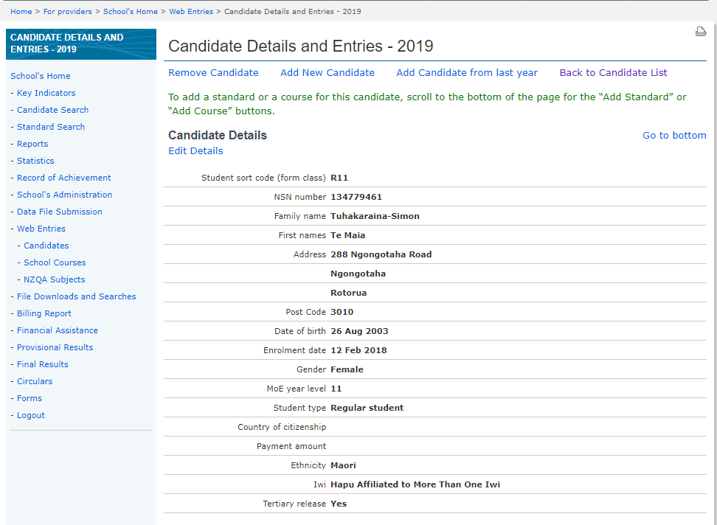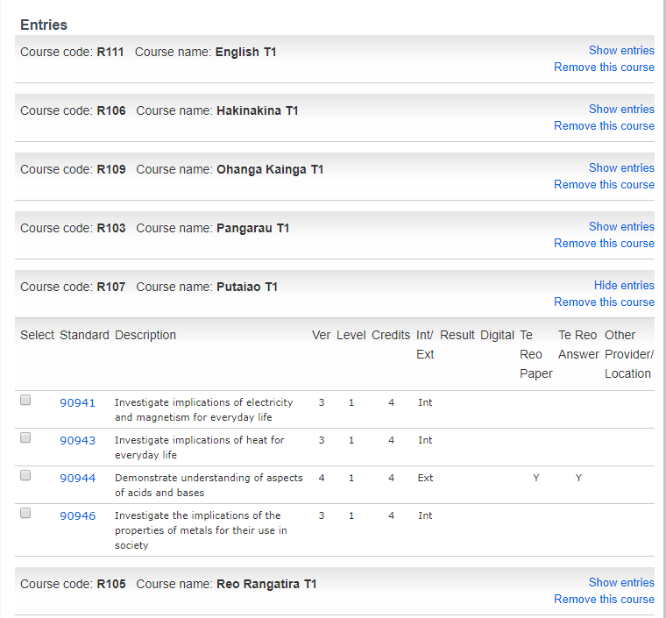



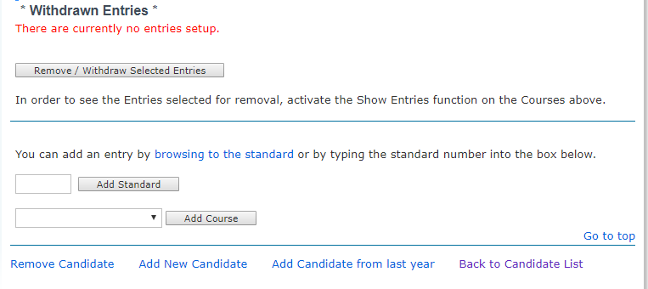



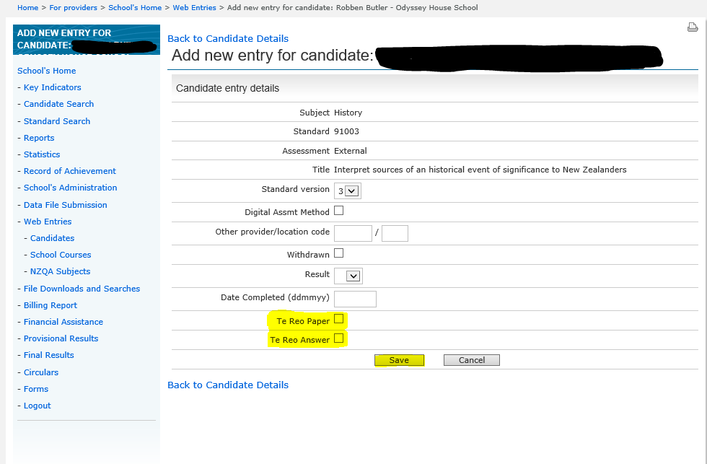

Students must have the correct flags set against their entries by 1 August data file. We recommend you set these flags in earlier data file submissions.

There are two types of flags:

* *Te Reo Māori paper flag for* candidates who would like a paper translated into Te Reo Māori for a standard;

and

* *Te Reo Māori answer flag* for candidates who will answer wholly or partly in Te Reo Māori.

# **Te Reo Māori translation subjects**

Schools must request translations of examinations and make entries for translated examinations through their SMS by the set date on NZQA's annual key dates.

Subjects for which translations can be requested are listed below.

|  |  |  |  |  |
| --- | --- | --- | --- | --- |
| **NCEA Subject** | | **Translated Paper** | **Answer in te reo Māori** | **Comment** |
| Accounting | | Y | Y |  |
| Agricultural and Horticultural Science | | Y | Y |  |
| Art History | | Y | Y |  |
| Biology | | Y | Y |  |
| Business Studies | | Y | Y |  |
| Calculus - Level 3 | | Y | Y |  |
| Chemistry | | Y | Y |  |
| Chinese | | Y | Some | Level 1  English parts of questions and instructions will be translated. Candidates may answer in their choice of English, te reo Māori and/or the target language. Level 2 - 3  English parts of questions and instructions will be translated. Candidates may answer in English or te reo Māori for the Listening and Reading standards. The Writing standard must be answered in the target language. |
| Classical Studies | | Y | Y |  |
| Cook Islands Māori | | N | Some | No exam, although material submitted for listening and reading may be in either Cook Islands Māori or te reo Māori. |
| Dance | | Y | Y |  |
| Drama | | Y | Y |  |
| Earth and Space Science | | Y | Y |  |
| Economics | | Y | Y |  |
| Education for Sustainability | | Y | Y | Level 3  No exam, although materials may be submitted in te reo Māori. |
| English | | N | N |  |
| French | | Y | Some | Level 1  English parts of questions and instructions will be translated. Candidates may answer in their choice of English, te reo Māori and/or the target language.  Level 2 - 3 English parts of questions and instructions will be translated. Candidates may answer in English or te reo Māori for the Listening and Reading standards. The Writing standard must be answered in the target language. |
| Geography | | Y | Y |  |
| German | | Y | Some | Level 1  English parts of questions and instructions will be translated. Candidates may answer in their choice of English, te reo Māori and/or the target language.  Level 2 - 3 English parts of questions and instructions will be translated. Candidates may answer in English or te reo Māori for the Listening and Reading standards. The Writing standard must be answered in the target language. |
| Health | | Y | Y |  |
| History | | Y | Y |  |
| Home Economics | | Y | Y |  |
| Japanese | | Y | Some | Level 1  English parts of questions and instructions will be translated. Candidates may answer in their choice of English, te reo Māori and/or the target language.  Level 2 - 3 English parts of questions and instructions will be translated. Candidates may answer in English or te reo Māori for the Listening and Reading standards. The Writing standard must be answered in the target language. |
| Korean | | N | Y | No exam, although material submitted for listening and reading may be in te reo Māori. |
| Latin | | N | N |  |
| Lea Faka-Tonga | | N | Y | No exam, although material submitted for listening and reading may be in te reo Māori. |
| Making Music – Level 3 | | Y | Y |  |
| Mathematics and Statistics – Levels 1 and 2 | | Y | Y |  |
| Media Studies | | Y | Y |  |
| Music – Levels 1 and 2 | | Y | Y |  |
| Music Studies – Level 3 | | Y | Y |  |
| Physics | | Y | Y |  |
| Psychology - Level 3 | | Y | Y |  |
| Samoan | | Y | Some | Level 1  English parts of questions and instructions will be translated. Candidates may answer in their choice of English, te reo Māori and/or the target language.  Level 2 - 3 English parts of questions and instructions will be translated. Candidates may answer in English or te reo Māori for the Listening and Reading standards. The Writing standard must be answered in the target language. |
| Science - Level 1 | | Y | Y |  |
| Social Studies | | Y | Y |  |
| Spanish | | Y | Some | Level 1  English parts of questions and instructions will be translated. Candidates may answer in their choice of English, te reo Māori and/or the target language.  Level 2 - 3 English parts of questions and instructions will be translated. Candidates may answer in English or te reo Māori for the Listening and Reading standards. The Writing standard must be answered in the target language. |
| Statistics - Level 3 | | Y | Y |  |
| Te Reo Māori | | Not applicable | Not applicable | Exam translated; answers required in te reo Māori. |
| Te Reo Rangatira | | Not applicable | Not applicable | Exam translated; answers required in te reo Māori. |
| Technology - Levels 1, 2, and 3 | Generic Technology | N | Y | No exam, although material submitted may be in te reo Māori. |
| Design and Visual   Communication | N | Y | No exam, although material submitted may be in te reo Māori. |
| Digital   Technologies | N | Y | No exam, although material submitted may be in te reo Māori. |
| Visual Arts | | N | Y | No exam, although material submitted may be in te reo Māori, |

|  |  |  |  |
| --- | --- | --- | --- |
| **Scholarship Subject** | **Translated Paper** | **Answer in te reo Māori** | **Comment** |
| SCHL - Accounting | Y | Y |  |
| SCHL - Art History | Y | Y |  |
| SCHL – Agricultural and Horticultural Science | Y | Y |  |
| SCHL - Biology | Y | Y |  |
| SCHL - Calculus | Y | Y |  |
| SCHL - Chemistry | Y | Y |  |
| SCHL - Chinese | Y | N | Only instructions will be translated. |
| SCHL - Classical Studies | Y | Y |  |
| SCHL – Dance | N | Y | Performance exam with no exam paper, material submitted may be in te reo Māori. |
| SCHL - Design | N | Y | No exam, although material submitted may be in te reo Māori. |
| SCHL - Design and Visual Communication | N | Y | No exam, although material submitted may be in te reo Māori. |
| SCHL - Drama | N | Y | Performance exam with no exam paper, although material submitted may be in te reo Māori. |
| SCHL - Earth and Space Science | Y | Y |  |
| SCHL - Economics | Y | Y |  |
| SCHL - English | N | N |  |
| SCHL - French | Y | N | Only instructions will be translated. |
| SCHL - Geography | Y | Y |  |
| SCHL - German | Y | N | Only instructions will be translated. |
| SCHL - Health and Physical Education | N | Y | No exam, although material submitted may be in te reo Māori. |
| SCHL - History | Y | Y |  |
| SCHL - Japanese | Y | N | Only instructions will be translated. |
| SCHL - Latin | N | N |  |
| SCHL - Media Studies | Y | Y |  |
| SCHL - Music Studies | Y | Y |  |
| SCHL - Painting | N | Y | No exam, although material submitted may be in te reo Māori. |
| SCHL - Photography | N | Y | No exam, although material submitted may be in te reo Māori. |
| SCHL - Physics | Y | Y |  |
| SCHL - Printmaking | N | Y | No exam, although material submitted may be in te reo Māori. |
| SCH - Samoan | N | N |  |
| SCHL - Science | Y | Y |  |
| SCH - Sculpture | N | Y | No exam, although material submitted may be in te reo Māori. |
| SCHL - Spanish | Y | N | Only instructions will be translated. |
| SCHL - Statistics | Y | Y |  |
| SCHL – Te Reo Māori | Not applicable | Not applicable | Exam translated; answers required in te reo Māori. |
| SCHL – Te Reo Rangatira | Not applicable | Not applicable | Exam translated; answers required in te reo Māori. |
| SCHL - Technology | N | Y | No exam, although material submitted may be in te reo Māori. |

## **Role of Principal’s Nominee**

|  |  |  |
| --- | --- | --- |
| On an annual basis, the Principal of a School with Consent to Assess must nominate a staff member to be the Principal's Nominee.  The Principal’s Nominee must carry out the following duties: | * Assessment Practice * Moderation * Data * Communication | Responsibility in my school |
| 1. maintaining and monitoring quality assurance practices within the School to ensure the validity and credibility of assessment for qualifications; |  |  |
| 1. reporting internal assessment results for all qualifications after [internal moderation](http://www.nzqa.govt.nz/providers-partners/assessment-and-moderation/managing-national-assessment-in-schools/secondary-moderation/internal-moderation/) has been completed; |  |  |
| 1. ensuring the integrity of assessment data submitted to NZQA, including Candidate eligibility, reported results and Candidate entries for external assessment |  |  |
| 1. ensuring that assessment data including Candidate information is forwarded to NZQA to meet published deadlines; |  |  |
| 1. considering and making applications to NZQA on behalf of Candidates for special assessment conditions; |  |  |
| 1. ensuring the School engages in and complies with the [external moderation](http://www.nzqa.govt.nz/providers-partners/assessment-and-moderation/managing-national-assessment-in-schools/secondary-moderation/external-moderation/) process and that issues identified by the external moderation process are addressed in a timely manner; |  |  |
| 1. developing and managing the school’s [Breaches of the Rules for internal assessment](http://www.nzqa.govt.nz/about-us/our-role/legislation/nzqa-rules/expired-rules/assessment-including-examination-rules-2016/6/6/), and appeals process; |  |  |
| 1. managing derived grade applications to NZQA on behalf of Candidates; |  |  |
| 1. liaising with and supporting the School’s staff and [examination centre manager](http://www.nzqa.govt.nz/about-us/our-role/legislation/nzqa-rules/expired-rules/assessment-including-examination-rules-2016/7/1/2/) to ensure that the integrity of external assessment is not compromised; |  |  |
| 1. ensuring the availability of suitable accommodation and equipment for the conduct of all external assessments; |  |  |
| 1. maintaining the currency of the school’s assessment policy and procedures to reflect NZQA requirements and communicating them to staff, students and families; |  |  |
| 1. responding to NZQA communications and requests for information; and |  |  |
| 1. facilitating NZQA visits and reviews |  |  |
| While other School staff may assist the Principal’s Nominee to ensure all aspects of the role are completed, the Principal’s Nominee remains responsible for ensuring those staff members carry out their duties appropriately, and for all communication with NZQA. | | |

[Nomination of Principal’s Nominee](http://www.nzqa.govt.nz/about-us/our-role/legislation/nzqa-rules/assessment-including-examination-rules-2018/4/) (Assessment Rule 4)

[Role of Principal’s Nominee](http://www.nzqa.govt.nz/providers-partners/assessment-and-moderation/managing-national-assessment-in-schools/the-principal-s-nominee/principal-s-nominee-seminars/)

**Principal’s Nominee Activity - some examples**

Self-Review form for Effective Leadership of Assessment for Qualifications

|  |  |  |
| --- | --- | --- |
| If your school has effective leadership of assessment for qualifications | Ae/Kao | Action if kao |
| * Everyone recognises that the Principal’s Nominee’s role is to guard the school’s integrity in relation to assessment for qualifications. |  | maintaining and monitoring quality assurance practices within the School to ensure the validity and credibility of assessment for qualifications |
| * You understand and value the Principal’s Nominee role. |  | Ensure that the Principal’s Nominee has status in the school, and this is understood by all stake holders |
| * Parts of the role may be delegated, to share responsibility and ensure effectiveness. |  | For example, a data person who could be responsible for ensuring that assessment data including Candidate information is forwarded to NZQA to meet published deadlines |
| * Everyone understands who is responsible for leading and managing each aspect of the Principal’s Nominee role. |  | This includes internal and external moderation and maintaining and monitoring quality assurance practices within the School to ensure the validity and credibility of assessment for qualifications; |
| * You provide sufficient resources to ensure all those involved in the Principal’s Nominee role can act effectively. |  | eg readers or writers for internal assessment |
| * The Principal’s Nominee ensures practices comply with NZQA rules and requirements. |  | eg Teachers have a clear understanding of resubmissions and further assessment opportunities, appeals and breeches |
| * Teachers and subject leaders work collaboratively with the Principal’s Nominee to achieve credible results. |  | Reporting internal assessment results for all qualifications after [internal moderation](http://www.nzqa.govt.nz/providers-partners/assessment-and-moderation/managing-national-assessment-in-schools/secondary-moderation/internal-moderation/) has been completed |
| * The Principal’s Nominee is responsible for ensuring staff carry out their duties effectively and for all communication with NZQA in relation to these duties. |  | Maintaining the currency of the school’s assessment policy and procedures to reflect NZQA requirements and communicating them to staff, students and families |
| * Communication is clear between students, parents, teachers, subject leaders and the Principal’s Nominee. |  | Ensuring everyone is informed regarding their roles and responsibilities |
| * Succession planning occurs. |  | Back up person, exit interview |

**Credible Assessment Practice**

Valid, verifiable, authentic results

Ensuring Authenticity

Further Assessment Opportunities

Resubmission

Gathering Evidence methods

Special Assessment Conditions

School Policy and procedures

Appeals/extensions

Evidence for derived grades

Review

**External Assessment**

Accurate entries

Late entries process

Derived Grades

Exam Centre Management

Portfolio submission

Verified Grades subjects

Review

**External Moderation**

Assessment Plan preparation

Moderation Plan

Moderation submission

Storage of student work

Random selection

Follow up to external moderation

Review

**Internal Moderation processes**

Critiquing

Verification process

Purposeful selection for verification

Documenting of internal moderation

Monitoring by SMT of internal moderation

Review

**Reporting of Assessment results**

Reporting Not Achieved

Internal entries all have a result

Memorandum of understanding (MOUs) are in place

Use of correct provider code

Monthly file submissions

Accuracy checks

Review

Four

Seasons

of the

PNs year

**The PN’s year in Paradise**

# Action items for Principal's Nominee by calendar month

Although each school has its own administrative arrangements, this information is provided as a guide to the role of Principal's Nominee.

The [calendar of Key Dates](http://www.nzqa.govt.nz/about-us/events/key-dates-for-schools/)  and [special assessment conditions timeline](http://www.nzqa.govt.nz/providers-partners/assessment-and-moderation/managing-national-assessment-in-schools/special-assessment-conditions/timeline/) are published each year by NZQA and should be referred to for specific dates.

A [File Submission](http://www.nzqa.govt.nz/providers-partners/assessment-and-moderation/managing-national-assessment-in-schools/managing-school-data/data-submission-to-nzqa/) is due by the first day of the month starting from April.

Moderation dates are always the first day of the month. Schools need to check the date for submission on their moderation plan and add this to their calendar along with a reminder to follow up on external moderation with action plans as necessary.

|  |  |
| --- | --- |
|  | ***Action Items*** |
| ***January*** | * Enter late internal results from the previous year via the Add Results facility of the NZQA Provider login * Check that portfolios submitted to NZQA for External Assessment, other than Level 3 Visual Arts, have been returned to school * After results release return portfolios (or any other external assessment material sent to school by NZQA) to candidates * Download results file from the File Downloads section of the NZQA Provider login after release of external results * Download school consents file from the File Downloads section of the NZQA Provider login for loading into the school's student management system (SMS) * Download from the SMS provider the [Standards File](http://www.nzqa.govt.nz/providers-partners/assessment-and-moderation/managing-national-assessment-in-schools/managing-school-data/data-submission-to-nzqa/#Standards%20File)  for the current year * Apply for [credit inclusion](http://www.nzqa.govt.nz/about-us/our-role/legislation/nzqa-rules/assessment-including-examination-rules-2017/8/9/) for students who need credits to complete qualification(s) * Remind staff that [Cut Scores](http://www.nzqa.govt.nz/ncea/subjects/cut-scores/) are available for external standards * Download school's National Qualifications statistics and Principal's Report when available * Check that all teachers who have left have had their [access](http://www.nzqa.govt.nz/providers-partners/assessment-and-moderation/managing-national-assessment-in-schools/managing-school-data/) to the school's secure area removed * Ensure new Learning Support staff (e.g. SENCO) have [access](http://www.nzqa.govt.nz/providers-partners/assessment-and-moderation/managing-national-assessment-in-schools/managing-school-data/) to the Special Assessment section of the school's NZQA Provider login * Check with Learning Support staff that SAC applications for first time candidates are being submitted * Review [procedures and documentation for internal assessment processes](http://www.nzqa.govt.nz/providers-partners/assessment-and-moderation/managing-national-assessment-in-schools/secondary-moderation/) * Remind staff to complete [Teacher Surveys](http://www.nzqa.govt.nz/audience-pages/secondary-schools-and-teachers/exam-surveys/) on previous year's examinations * Check, and where necessary, update organisation and contact details held by NZQA * Ensure students and staff are aware of the closing date for [reviews and reconsiderations](http://www.nzqa.govt.nz/ncea/ncea-results/reviews-and-reconsiderations/) of NCEA external scripts |
| ***February*** | * Familiarise yourself with the [calendar of Key Dates](http://www.nzqa.govt.nz/about-us/events/key-dates-for-schools/) * Remind Learning Support staff that the facility for [Special assessment conditions (SAC)](http://www.nzqa.govt.nz/providers-partners/assessment-and-moderation/managing-national-assessment-in-schools/special-assessment-conditions/guidelines-for-schools/) roll-over and changes of existing entitlements is open and that the first deadline for First Time Ever SAC applications for candidates with learning disorders is the end of term 1 * Ensure readers and writers are trained to be [examination assistants](http://www.nzqa.govt.nz/providers-partners/assessment-and-moderation/managing-national-assessment-in-schools/special-assessment-conditions/role-of-the-reader-and-writer/) * Establish markbooks ensuring that the [school has consent to assess for the standards](http://www.nzqa.govt.nz/providers-partners/approval-accreditation-and-registration/secondary-school-consent-to-assess/) being offered. Remind teachers to check assessment specifications for standards offered and review [exclusions](http://www.nzqa.govt.nz/qualifications-standards/standards/standards-exclusion-list/) * [Check external examination calendar for clashes](http://www.nzqa.govt.nz/ncea/ncea-exams-and-portfolios/external/national-secondary-examinations-timetable/) so that candidates are aware of any impact of their course choices. In particular, be aware of three way clashes and clashes that involve Scholarship. Amend student courses if appropriate * Check NZQA Provider login for [External Moderation](http://www.nzqa.govt.nz/providers-partners/assessment-and-moderation/managing-national-assessment-in-schools/secondary-moderation/external-moderation/) plan. Inform relevant staff of standards selected for moderation and how/when material will be collated and submitted. Notify School Relationship Manager of any issues * Ensure course outlines reflect the intended assessment programme * Check the [accuracy of the student information held on the SMS](http://www.nzqa.govt.nz/providers-partners/assessment-and-moderation/managing-national-assessment-in-schools/managing-school-data/candidate-information/) including twins, name changes, names with special characters and student addresses * Scholarship results release * Publish assessment procedures for both staff and students * Check MOUs are in place for outside providers * [PN seminars](http://www.nzqa.govt.nz/providers-partners/assessment-and-moderation/managing-national-assessment-in-schools/the-principal-s-nominee/principal-s-nominee-seminars/) start * Provide new staff with [access](http://www.nzqa.govt.nz/providers-partners/assessment-and-moderation/managing-national-assessment-in-schools/managing-school-data/) to the  NZQA Provider login (done by the school's EPA) * Complete entry of any previous year's internal results via the website before the link closes 28 February * Make sure students and staff are aware of the closing date for [reviews and reconsiderations](http://www.nzqa.govt.nz/ncea/ncea-results/reviews-and-reconsiderations/) of Scholarship scripts – Deadline 1 March |
| ***March*** | * Web Entry Schools' access opens to enter candidate and course information * Check accuracy of markbooks for external and internal standards, including versions, against the school's consent to assess before first File Submission * Ensure that student details and course information are correct on the SMS. Check [course names](http://www.nzqa.govt.nz/providers-partners/assessment-and-moderation/managing-national-assessment-in-schools/course-endorsement/#Course%20names) against guidelines * Distribute NZQA candidate information sheets * Remind Learning Support staff that roll-over and changed applications for use of [SAC](http://www.nzqa.govt.nz/providers-partners/assessment-and-moderation/managing-national-assessment-in-schools/special-assessment-conditions/guidelines-for-schools/) close end of term 1 * Check if new Examination Centre Manager will be required |
| ***April*** | * First [File Submission to NZQA](http://www.nzqa.govt.nz/providers-partners/assessment-and-moderation/managing-national-assessment-in-schools/managing-school-data/data-submission-to-nzqa/) * [Check Batch Information](http://www.nzqa.govt.nz/providers-partners/assessment-and-moderation/managing-national-assessment-in-schools/managing-school-data/data-submission-to-nzqa/#Data%20Accuracy%20and%20Checks) after file submission * Check Key Indicators from Provider login * Remind Learning Support staff that the first deadline for First Time Ever SAC applications for candidates with learning disorders is the end of term 1 * Advertise to staff that [Assessment reports](http://www.nzqa.govt.nz/ncea/subjects/) are available for previous year's external assessment on Subject Resource pages * Public release of statistics * Establish the school timing for payment of fees for International Students only * Check entries for candidates undertaking study with Te Aho o Te Kura Pounamu (The Correspondence School), a Health School or other provider |
| ***May*** | * [File Submission to NZQA](http://www.nzqa.govt.nz/providers-partners/assessment-and-moderation/managing-national-assessment-in-schools/managing-school-data/data-submission-to-nzqa/) * [Check Batch Information](http://www.nzqa.govt.nz/providers-partners/assessment-and-moderation/managing-national-assessment-in-schools/managing-school-data/data-submission-to-nzqa/#Data%20Accuracy%20and%20Checks) after File Submission * Check Key Indicators from Provider login * Nominate an [Examination Centre Manager](http://www.nzqa.govt.nz/about-us/our-role/legislation/nzqa-rules/assessment-including-examination-rules-2017/7/1/2/) through the Provider login Examination Centre Manager Recruitment link |
| ***June*** | * [File Submission to NZQA](http://www.nzqa.govt.nz/providers-partners/assessment-and-moderation/managing-national-assessment-in-schools/managing-school-data/data-submission-to-nzqa/). Data from this file is used to prepare NSN cards * [Check Batch Information](http://www.nzqa.govt.nz/providers-partners/assessment-and-moderation/managing-national-assessment-in-schools/managing-school-data/data-submission-to-nzqa/#Data%20Accuracy%20and%20Checks) after File Submission * Check Key Indicators from Provider login * Check NSN cards and information have been received from NZQA. Distribute to candidates * Make application to NZQA for candidates seeking mid-year entry to University. Contact your SRM * Complete Memorandum of Agreement for Rebate online * Ensure application for an [Examination Centre Manager](http://www.nzqa.govt.nz/2/) is completed through the Provider login Examination Centre Manager Recruitment link |
| ***July*** | * [File Submission to NZQA](http://www.nzqa.govt.nz/providers-partners/assessment-and-moderation/managing-national-assessment-in-schools/managing-school-data/data-submission-to-nzqa/). Ensure all external entries for SAC candidates have been made * [Check Batch Information](http://www.nzqa.govt.nz/providers-partners/assessment-and-moderation/managing-national-assessment-in-schools/managing-school-data/data-submission-to-nzqa/#Data%20Accuracy%20and%20Checks) after File Submission * Check Key Indicators from Provider login * Submit materials for externally assessed verified languages (Cook Island Māori, Korean and Lea Faka-Tonga) standards for pre-assessment critique by end of term * Remind Learning Support staff that applications for the use of [SAC](http://www.nzqa.govt.nz/providers-partners/assessment-and-moderation/managing-national-assessment-in-schools/special-assessment-conditions/guidelines-for-schools/) by students in external assessment opens. These applications can only be processed if the external entries have been made for the SAC candidates * Check all entries with requests for translated te reo Māori papers or answers in te reo Māori have been flagged |
| ***August*** | * [File Submission to NZQA including te reo Māori translation requests](http://www.nzqa.govt.nz/providers-partners/assessment-and-moderation/managing-national-assessment-in-schools/managing-school-data/data-submission-to-nzqa/). Information from this file is used to determine the quantity of papers that need to be printed * [Check Batch Information](http://www.nzqa.govt.nz/providers-partners/assessment-and-moderation/managing-national-assessment-in-schools/managing-school-data/data-submission-to-nzqa/#Data%20Accuracy%20and%20Checks) after File Submission * Check Key Indicators from Provider login * Advise NZQA of MCAT assessment day and the number of booklets required * Verify all external entries in preparation for September submission file * Remind Learning Support staff of the mid-August deadline for SAC applications for Specific Learning Disorders and that the ability to attach SAC for external assessment closes late August * School collect International Student fees |
| ***September*** | * [File Submission to NZQA](http://www.nzqa.govt.nz/providers-partners/assessment-and-moderation/managing-national-assessment-in-schools/managing-school-data/data-submission-to-nzqa/) – ensure entries for external standards are accurate, including digital entries. No withdrawals from externals standards possible after 1 September as personalised papers are printed from this data * [Check Batch Information](http://www.nzqa.govt.nz/providers-partners/assessment-and-moderation/managing-national-assessment-in-schools/managing-school-data/data-submission-to-nzqa/#Data%20Accuracy%20and%20Checks) after File Submission * Check Key Indicators from Provider login * Make all subsequent external entries using the [Late External Entry Process](http://www.nzqa.govt.nz/providers-partners/assessment-and-moderation/managing-national-assessment-in-schools/managing-school-data/making-entries-for-candidates/#Late%20entries). Check with Learning Support staff if any are for SAC candidates. Ensure conditions are attached to their exam sessions * Organise readers, writers and supervisors for SAC candidates for school and NZQA examinations, and ensure they are trained * Organise final collection of fees for International Students only * Arrange meeting with Examination Centre Manager * Organise arrangements and accommodation for candidates with two-way examination clashes. Contact your SRM for the letter and organisation for any three-way clashes * International Student fee payment to NZQA * Remind Learning Support staff that the final deadline for SAC applications for Specific Learning Disorders is the end of Term 3 * Administer Level 1 MCAT * Submit [Request to Change Examination Centre](http://www.nzqa.govt.nz/providers-partners/assessment-and-moderation/managing-national-assessment-in-schools/examination-management/request-to-change-examination-centre/) forms as applicable |
| ***October*** | * [File Submission to NZQA](http://www.nzqa.govt.nz/providers-partners/assessment-and-moderation/managing-national-assessment-in-schools/managing-school-data/data-submission-to-nzqa/) * [Check Batch Information](http://www.nzqa.govt.nz/providers-partners/assessment-and-moderation/managing-national-assessment-in-schools/managing-school-data/data-submission-to-nzqa/#Data%20Accuracy%20and%20Checks) after File Submission * Check Key Indicators from Provider login * [SAC](http://www.nzqa.govt.nz/providers-partners/assessment-and-moderation/managing-national-assessment-in-schools/special-assessment-conditions/guidelines-for-schools/) applications for next year's first time candidates open * Make late external entries using the [Late External Entry Process.](http://www.nzqa.govt.nz/providers-partners/assessment-and-moderation/managing-national-assessment-in-schools/managing-school-data/making-entries-for-candidates/#Late%20entries) Check with Learning Support staff if any are for SAC candidates. Ensure conditions are attached to their exam sessions * Check Billing File. * Candidate Admission slips received from NZQA, for distribution to candidates * Meet with Examination Centre Manager to confirm [accommodation for external examinations](http://www.nzqa.govt.nz/providers-partners/assessment-and-moderation/managing-national-assessment-in-schools/examination-management/working-with-ecm/) * Finalise [SAC](http://www.nzqa.govt.nz/providers-partners/assessment-and-moderation/managing-national-assessment-in-schools/special-assessment-conditions/guidelines-for-schools/#Data%20Accuracy%20and%20Checks) accommodation and allocation of examination assistants such as readers, writers and supervisors with ECM. Ensure late entries for SAC candidates are included * Finalise arrangements to accommodate Examination Clashes and send copies of three-way clash letters to SRM * Applications for [Derived Grades](http://www.nzqa.govt.nz/providers-partners/assessment-and-moderation/managing-national-assessment-in-schools/derived-grades/information-for-principal-s-nominees/) open mid-October * Organise portfolios for submission for external assessment * Enter provisional grades through the Provisional Results link of the Provider login for MCAT, Level 1 and 2 Visual Arts and Cook Island Maori entries * Submit material for verification of MCAT, Level 1 and 2 Visual Arts and Verified Languages (Cook Island Māori, Korean and Lea Faka-Tonga) * Submit [Request to Change Examination Centre](http://www.nzqa.govt.nz/providers-partners/assessment-and-moderation/managing-national-assessment-in-schools/examination-management/request-to-change-examination-centre/) forms as applicable * Arrange [Staff and Student Examination Briefings](http://www.nzqa.govt.nz/providers-partners/assessment-and-moderation/managing-national-assessment-in-schools/examination-management/briefing-school-staff/) |
| ***November*** | * [File Submission to NZQA](http://www.nzqa.govt.nz/providers-partners/assessment-and-moderation/managing-national-assessment-in-schools/managing-school-data/data-submission-to-nzqa/) * [Check Batch Information](http://www.nzqa.govt.nz/providers-partners/assessment-and-moderation/managing-national-assessment-in-schools/managing-school-data/data-submission-to-nzqa/#Data%20Accuracy%20and%20Checks) after File Submission * Check Key Indicators from Provider login * Submit  portfolios for external assessment * [Hold Staff and Student Examination Briefings](http://www.nzqa.govt.nz/providers-partners/assessment-and-moderation/managing-national-assessment-in-schools/examination-management/briefing-school-staff/) * Distribute admission slips to candidates and ensure they check entries * Print and sign new admission slips for candidates who have had late entries * Any address changes after the 1 December contact NZQA directly * Prepare late entry lists for Examination Centre Manager * Encourage students to register to access their records on line * Verify that all internal results have been subject to the school's internal moderation process for reporting to NZQA and accurately recorded on the SMS * Enter Final Grades through the Final Results link of the Provider login for Level 1 and 2 Visual Art, MCAT and Cook Island Māori * Check that results from other providers have been reported with the external provider's number * Check that results for candidates studying with Te Aho o Te Kura Pounamu and a Health School have been reported * Continue to process late financial assistance applications * Check student names to ensure that these are correct for certificate printing |
| ***December*** | * Final [File Submission to NZQA](http://www.nzqa.govt.nz/providers-partners/assessment-and-moderation/managing-national-assessment-in-schools/managing-school-data/data-submission-to-nzqa/) - no withdrawals from internal standards after this date. Data file submission link closes * [Check Batch Information](http://www.nzqa.govt.nz/providers-partners/assessment-and-moderation/managing-national-assessment-in-schools/managing-school-data/data-submission-to-nzqa/#Data%20Accuracy%20and%20Checks) after File Submission * Check Key Indicators from Provider login * Review external examination processes with Examination Centre Manager * Access for reporting late internal assessment results through the Add Results link of the Provider login opens * Applications for [Derived Grades](http://www.nzqa.govt.nz/providers-partners/assessment-and-moderation/managing-national-assessment-in-schools/derived-grades/information-for-principal-s-nominees/) close early December * Complete SAC [Use of a Computer in Examinations](http://www.nzqa.govt.nz/audience-pages/secondary-schools-and-teachers/forms/) forms and give to the Examinations Centre Manager once examinations finish * Collect SAC use schedule and exam attendance register from ECM and discuss with Learning Support staff * Remove access to school secure area for staff who are leaving * Ensure that NZQA has up-to-date school contact details in the event that this information is needed after school closure * Remind staff to complete [Teacher Surveys](http://www.nzqa.govt.nz/audience-pages/secondary-schools-and-teachers/exam-surveys/) on external examinations |

**Secure Provider Login**

IMPORTANT impact of entries without consent

Messages from NZQA

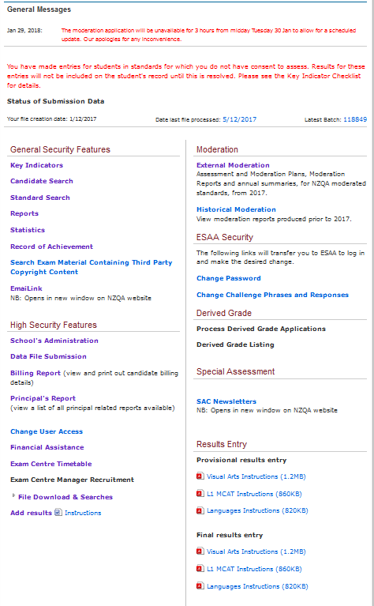

Need authorisation access

Other school contacts

Memorandum with NZQA

Extensions to consent

File uploads

Check data file submission for errors

For externally verified subjects

Consents file, MCAT, Results

For results after 1 December

Individualised to school

Manage staff access

Exam material

Courses/ Standards

Historical

VERY USEFUL

(see pg 37)

IMPORTANT

Opens when exams start. Restricted access

To access the Mod App

**Key Indicators**

Useful for comparing entries in last two two entry files

Shows external standards where number of entries are significantly different to previous years

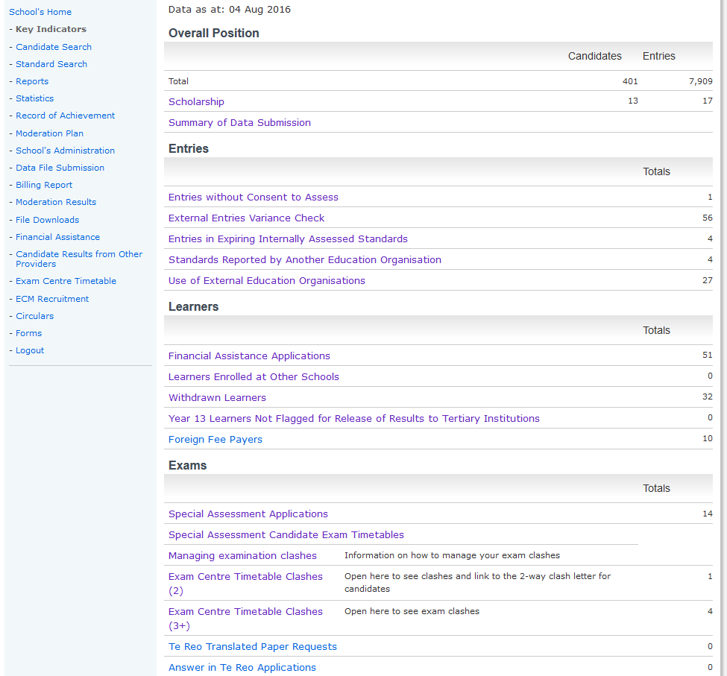

Check that the students you expect are listed and status of application

Check that the students you expect are listed

Check that the students you expect are listed

Check where you are using someone elses provider code

If students are not flagged Tertiary Institutions may not be able to accept them

Students will not get the results if there is no consent to assess

Read before looking at clashes below. School manages 2 way clashes

NZQA manages 3 way clashes – contact your SRM

Check that the students and standards you expect are listed

Check who is using your provider code

Useful for planning ahead

**REPORTS**

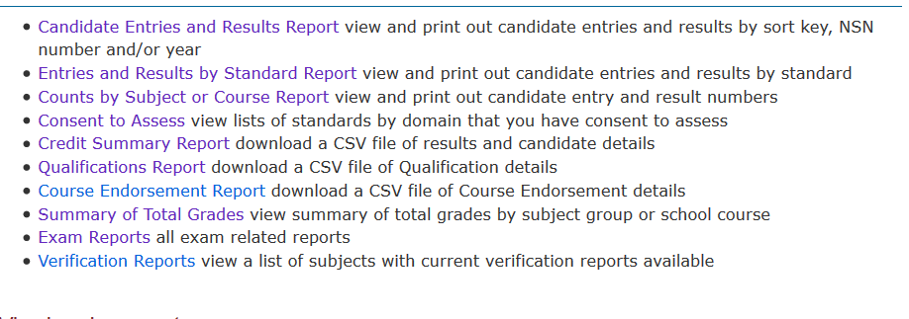

**NZQA PUBLIC SITE - SCHOOLS AND TEACHES**

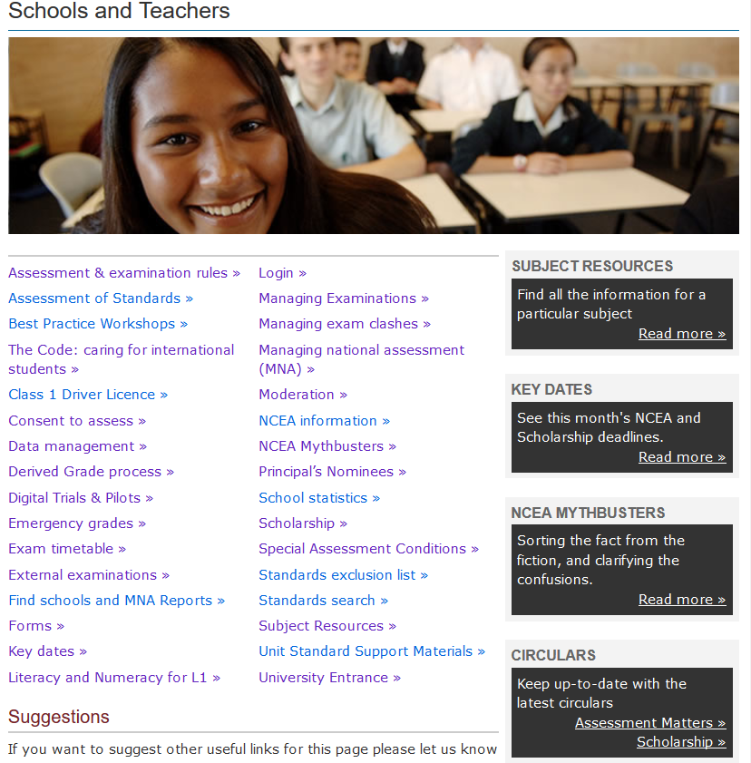

****Managing the collection of evidence

|  |  |  |  |  |  |  |  |  |  |  |  |  |  |  |  |  |  |  |  |  |  |  |  |  |  |  |  |
| --- | --- | --- | --- | --- | --- | --- | --- | --- | --- | --- | --- | --- | --- | --- | --- | --- | --- | --- | --- | --- | --- | --- | --- | --- | --- | --- | --- |
| **Subject:** **______________________ AS No:** ____________________  **(Proposed) Method of collection**   |  |  |  | | --- | --- | --- | | **School / Assessor has consent to assess** |  |  | | **Policy and Procedure for evidence gathering**   * Up to date and covered by this collection method. * Communicated and understood by teachers for consistent practice. * Communicated and understood by parents and students. |  |  | | **Collection methods ensure evidence has:** | **Details of how this will be done** | **Further actions** | | **Validity**   * Against standard and assessment conditions. |  |  | | **Authenticity**   * Prevention processes. * Monitoring processes during assessment and during marking. |  |  | | **Verification**   * Follows/Allows school internal moderation process * Sufficient evidence supplied for each learner. |  |  | | **Storage and retrieval** |  |  | | * Material available for external moderation. * Privacy. * Security. * Benchmarks. * Digital evidence policy and management. system in place. |  |  | | **Does the evidence-gathering method allow students to supply authentic best evidence?**  **Does the plan allow teachers to collect sufficient verifiable valid evidence?** |  |  | |

# Self-Review Tool - Leading and Managing the Gathering Evidence:

How can I further develop best practice to manage evidence collection in my school?

|  |  |
| --- | --- |
| **Stakeholders** | **ACTION** |
| **Policy and Procedures**   1. Does the school have a policy/procedure providing guidance on evidence collection? 2. What processes are expected for the collection of evidence? 3. How does the school review that expectations for evidence collection is followed in departments? 4. What staff development has been held to assist teachers to understand:  * The schools’ policy and procedures for evidence collection * Best practice for the collection of evidence  1. What process is used to ascertain if a new/different evidence collection method proposed by a teacher will ensure valid, authentic, verifiable and sufficient evidence is gathered 2. What is the school policy on equity of access? |  |
| **Senior Management (including Principal’s Nominee)**   1. Have all teachers, students and parents been informed about the school’s policy and processes for collection of evidence? 2. How do we ensure all teachers, students and parents have a common understanding of the school’s policy and processes for the collection of evidence? 3. What practices ensure the validity, authenticity and verifiability of evidence collected? 4. Is there equity of access ie technology, opportunity for different modes of assessment for all students? 5. What processes are used to monitor the collection of evidence from assessment activities outside of the classroom/school to ensure consent to assess and health and safety requirements are met? |  |
| **Subject Leaders of Learning Areas (HOD/TIC)**   1. How do you know that all learning areas following school policy and process for the collection of evidence? 2. Does departmental review include a check to ensure evidence collected meets school policy/procedures in terms of validity, authenticity, verification and storage? 3. What is the process for leaders of learning areas to inform SMT/PN that their management of the collection of student evidence meets school policy/procedures in terms of validity, authenticity, verification and storage? |  |
| **Classroom Teachers**   1. How do you know teachers follow school policies and procedures for the collection of evidence? 2. How does the school know that teacher’s collection of evidence meets the school’s validity, authenticity, verifiability and storage requirements? 3. Are evidence collection methods consistent with the standard’s conditions of assessment? 4. Do teachers brief/teach students about appropriate and authentic evidence and presentation for assessment? 5. Do teachers follow checkpoint processes to monitor collection of evidence, storage and authenticity in long term assessment activities? 6. How do teachers meet the schools’ equity expectations? |  |
| **Students**   1. Do all students understand the expectations of gathering evidence that is authentic and storage of internal assessment activities? 2. How does the school help students to understand evidence gathered must be authentic and appropriate storage? 3. Are students aware of the potential consequences if their work is deemed to be not authentic? 4. What processes are in place to assist students to report breaches of rules for assessment opportunities? Is this process working? |  |
| **Parents/Whānau**   1. Are parents/guardians aware of the appropriate support they can give to their children when helping them with assessment activities? 2. Are parents aware of the potential consequences if their children’s work is deemed to be not authentic? 3. How are parents/whanau informed of these requirements? |  |

|  |  |
| --- | --- |
| **PLANNING TOOL FOR Integrated Learning Context, naturally occurring evidence or Digital** | |
| What do we want to assess? |  |
| What do we want students to  demonstrate? |  |
| How do we want students to present assessment evidence? Both themselves and their work? |  |
| What would be acceptable, valid and authentic in a standards-based environment? |  |
| When are we going to assess? |  |
| Who would assess? |  |
| How would this be managed? |  |
| Who will design ‘valid’ assessment activities? |  |
| How do we know that teachers understand grade boundaries, conditions of assessment and clarification documents? |  |
| What is our school philosophy around gathering evidence and how does it fit? |  |
| When does gathering evidence cease? |  |
| Does our school digital policy cover storage, evidence collection? |  |

***School logo / Name***

**INTERNAL MODERATION COVER SHEET 2019**

**NZQA** [***Assessment Rules***](https://www.nzqa.govt.nz/about-us/our-role/legislation/nzqa-rules/assessment-including-examination-rules-2019/1/)**require that schools must report to NZQA only those internal assessment results which have been subject to an** [**internal moderation process**](http://www.nzqa.govt.nz/providers-partners/assessment-and-moderation/managing-national-assessment-in-schools/secondary-moderation/external-moderation/internal-moderation/)**.**

**Faculty/Department: ________________ Teacher in Charge of Assessment: _____________**

**Assessors: _______________________ __________________________ _________________________**

|  |  |  |  |  |  |  |  |  |  |  |  |  |  |
| --- | --- | --- | --- | --- | --- | --- | --- | --- | --- | --- | --- | --- | --- |
| **Section A: Complete information on the assessment *before any teaching*** | | | | | | | | | | | | | |
| **Course Title:** |  | | | | | **Standard Number:** | | **Version:** | | | | | |
| **Standard Title:** | Critiquers role is to do this and use these tools to check assessment is valid | | | | | | | | | | | | |
| **Credits:** | | **NZQF Level:** | | | **The school has consent to assess this standard** | | | | | **Yes** | | **No** | |
| **Source of Materials:** **Commercial / Own / TKI / NZQA / Subject Association / Other:** | | | | | | | | | | | | | |
| **Section B: Critique assessment materials *before any assessing*** | | | | | | | | | | | | | |
| **The critiquing process is to ensure that the assessment materials meet the requirements specified in the standard and provide the opportunity for students to present authentic evidence at all grades.** | | | | | | | | | | | | | |
| **Before use the assessment materials have been checked against:** | | | | | | | | | | | | | |
| The current moderator report and clarification of the standard document  **Critiquer** -has standard assessment knowledge/experience | | | | | | | | | | | **Yes** | | **No** |
| The conditions of assessment | | | | | | | | | | | **Yes** | | **No** |
| Any external moderation feedback | | | | | | | | | | | **Yes** | | **No** |
| The standard is unchanged and the task has been previously critiqued, | | | | | | | | | | | **Yes** | | **No** |
| ***If yes, no further critiquing required.*** | | | | | | | | | | | | | |
| The assessment is consistent with the explanatory notes/learning/context/curriculum level | | | | | | | | | | | **Yes** | | **No** |
| The assessment allows students to achieve **all** requirements and grades of the standard | | | | | | | | | | | **Yes** | | **No** |
| Assessment schedule is consistent with the standard and clarifications documents | | | | | | | | | | | **Yes** | | **No** |
| Instructions are consistent with the standard explanatory notes/range statements  Verifiers role is to do this and for a sufficient, purposefully selected sample of student work | | | | | | | | | | | **Yes** | | **No** |
| Judgement/sufficiency statements clearly describe performance levels for each grade, e.g. quality & length | | | | | | | | | | | **Yes** | | **No** |
| Evidence statements allow for a range of acceptable answers with specific examples for each grade (A/M/E) | | | | | | | | | | | **Yes** | | **No** |
| Student instructions are clear and language is appropriate | | | | | | | | | | | **Yes** | | **No** |
| Registered standard number, version, title, level and credits are given. | | | | | | | | | | | **Yes** | | **No** |
| **Critiquers’ Name:**  **Verifier**-is a subject specialist with standard specific knowledge | | | | **School:** | | | | | **Date:** | | | | |
| **Section C: Verify sufficient teacher judgements *before reporting results* PTO** | | | | | | | | | | | | | |
| **The verification process is to ensure that any teacher judgements are consistent with the standard before they are reported to NZQA.** | | | | | | | | | | | | | |
| **Verifier Name:** | | | **School:** | | | | **Position:** | | **Date:** | | | | |
| Evidence of verification is available overleaf, attached or **at location (specify**): | | | | | | | | | | | | | |
| **I have sighted evidence critiquing and verification processes completed for this standard.** | | | | | | | | | | | | | |
| **Signed: Position:** | | | | | | | | | **Date:** | | | | |
| **Section D: Retain samples and review assessment materials *after results are reported*** | | | | | | | | | | | | | |
| Results loaded into student management system: | | | | | | | | | **Date:** | | | | |
| Assessment materials and student work are stored ready for external moderation | | | | | | | | | | | **Yes** | | **No** |
| **Location or file path:** | | | | | | | | | | | | | |
| The school’s random selection procedure has been used to select work for external moderation (if required). | | | | | | | | | | | **Yes** | | **No** |
| Assessment materials have been reviewed in response to feedback. | | | | | | | | | | | **Yes** | | **No** |
| New benchmark samples have been annotated and/or existing examples of grade boundary decisions have been updated. | | | | | | | | | | | **Yes** | | **No** |

|  |  |  |  |  |
| --- | --- | --- | --- | --- |
| **SECTION C: VERIFICATION OF EVIDENCE USING STRATEGIC SELECTION** | | | | |
| **Strategic selection of samples of work is based on the experience of the assessor(s), external moderation history, and the previous use of the task. The sample size can be sufficient, purposeful (at grade boundaries) or minimal.** | | | | |
| Student’s Name | **Marker’s**  **Grade** | **Verifier’s**  **Grade** | **Grade**  **Reported** | **Summary of discussion comments or location of these comments:** |
|  |  |  |  |  |
|  |  | Verification process by a subject specialist with standards specific knowledge (at the curriculum level).  The verification “discussion” should be documented.  HOD/SLT monitor the robustness of the verification process   * Appropriate verifier used * Purposeful strategic selection (grade boundaries and those unsure) * Sufficient samples that confident consistent with the standard and across classes * Discussion on grade boundaries documented |  |  |
|  |  |  |  |  |
|  |  |  |  |  |
|  |  |  |  |  |
|  |  |  |  |  |
|  |  |  |  |  |
| ***Complete all columns. Add extra rows as required. Where appropriate, it is good practice to indicate a grade’s proximity to a boundary.*** | | | | |