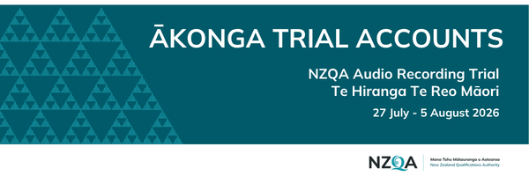

Tēnā koe

Please complete the table below and return it to us by Tuesday 21 July 2026.

This information is required to enable us to set up the trial accounts in advance of the audio trial and ensure everything is ready before testing begins.

Kura name:
Tutor name:
Tutor email address:

Name | NSN

Please return your completed form and email it to aromatawai.maori@nzqa.govt.nz

