Legal Studies Assessment Support Material
Unit standard | 27839
Title | Explain concepts of justice
Level | 2 | Credits | 4 | Version | 3
Page 3 of 1
Page 3 of 1

Ākonga/Learner Guidelines
Introduction
People credited with this unit standard are able to explain concepts of justice.
Award of Grades
- For an award with Achieved, concepts of justice are explained, with supporting detail, in terms of the purpose of justice and/or how it can be achieved, using actual examples. Actual examples refer to actual events from New Zealand or overseas, past or present. Concepts of justice may include – utilitarian, retributive, restorative, distributive, social, tikanga Māori (marae).
- For an award with Merit the explanation of two concepts of justice is demonstrated by selecting actual example(s) and applying relevant supporting detail that may include but is not limited to any one of:
- particular facts and legislation;
- past or present events;
- case studies, examples, statistics;
- news media reports.
- For award with Excellence the fully developed explanation of two concepts of justice is demonstrated by:
- selecting and applying a range of relevant supporting detail to actual examples;
- communicating clear conclusions.
Fully developed refers to being accurate, detailed, and well researched.
News media refers to factual reporting and journalistic narratives in print media, broadcast media and the internet.
Conditions of Assessment
Assessors will set the conditions of assessment as appropriate.
Assessment activity
Task One
Read the following extract from an article which appeared in the Sydney Morning Herald. Use the article as a starting point for a description of retributive justice. You should refer to:
- The purpose of retributive justice.
- The process involved in retributive justice.
- Relevant supporting detail.
- Actual examples of how a retributive justice approach has been applied. These examples must be drawn from actual events from New Zealand or overseas, past or present.
'Eye for an eye' punishment postponed
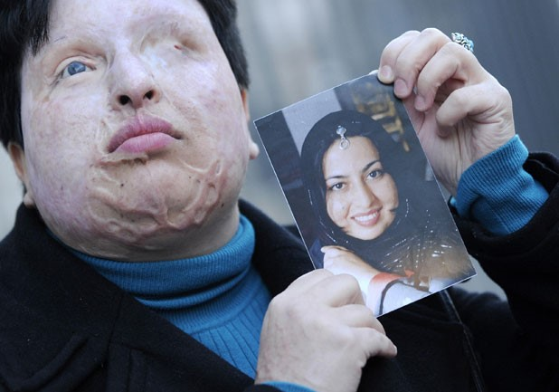
STEALING BEAUTY: This picture, taken in Barcelona,shows Iranian Ameneh Bahrami holding a photograph of herself before she was blinded by a man who threw acid in her face.

The court-ordered blinding of an Iranian man as punishment for throwing acid on a woman who spurned him has been postponed, but heated debate over his crime and such "eye for an eye" punishments continues.
Majid Movahedi was due to be made unconscious in a prison hospital in Tehran on Saturday and acid was to be dropped into his eyes by his victim, Ameneh Bahrami. Bahrami, an engineer, was blinded and severely disfigured after Movahedi threw a bucket of acid in her face in 2004 for rejecting his marriage proposals.
But Movahedi received an eleventh-hour reprieve on Friday night, the Iranian news agency ISNA reported. While Iranian authorities did not say why the sentence was not carried out, the country had been under international pressure to stop it from going ahead. Groups like Amnesty International argued that the sentence was "a cruel and inhuman punishment amounting to torture.”
But others in Iran feared that "forgiveness", the other legal choice open to Bahrami, would only encourage similar crimes. "There's no doubt public opinion inside Iran has been stirred up," Iranian women's rights activist Asieh Amini told Time magazine. "There's been a huge outpouring of sympathy for both of them, and this puts pressure on the government."
Bahrami herself pushed for qesas - a form of retributive justice under Sharia law. "I've suffered so much in these years but now I am really happy…I want people like him to know that they will suffer forever if they cause someone such suffering.”
In December, an Iranian court ruled that a man was to lose an eye and an ear after he blinded another man and burnt his ear in an acid attack. The month before, the Iranian Supreme Court upheld a ruling that ordered a man undergo the same "eye for an eye" punishment, after he blinded his lover's husband by throwing acid in his face. Neither sentence is known to have been carried out.
In Saudi Arabia in August, a man was sentenced to have his spinal cord severed after he paralysed another man by attacking him with a cleaver. But doctors charged with carrying out the medical procedure refused to operate on the man, saying "inflicting such harm is not possible".
Task Two
Read the following extract from a BBC article. Use the article as a starting point for a description of restorative justice. You should refer to:
- The purpose of restorative justice.
- The process involved in restorative justice.
- Relevant facts or events, legislation, case law, media reports.
- Actual examples of how a retributive justice approach has been applied. These examples must be drawn from actual events from New Zealand or overseas, past or present.
Restorative justice hailed 'success' in Cambridgeshire
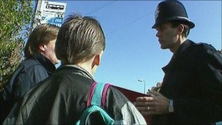
Restorative justice for minor offenders has been used in England since the beginning of 2011.As part of the restorative project, youth offenders who caused criminal damage to a window agreed to clean all the windows on the house. A 16-year-old shoplifter who stole goods to the value of £3 had to clean 100 shopping baskets and a 12-year-old who caused £75 worth of damage to a car had to send a written apology, and the parents paid for damage.
Inspector Human said that the system saved "a massive amount of time" when compared to arrest and punishment through the courts. "We can get the same outcome, in a very short time, at the scene. The motive for introducing restorative justice is because it's about doing the right thing for the victim.”

