Supported Learning Assessment Support Material
Unit standard | 29299
Title | Access and use facilities and services in the community
Level | 1 | Credits | 5 | Version | 3

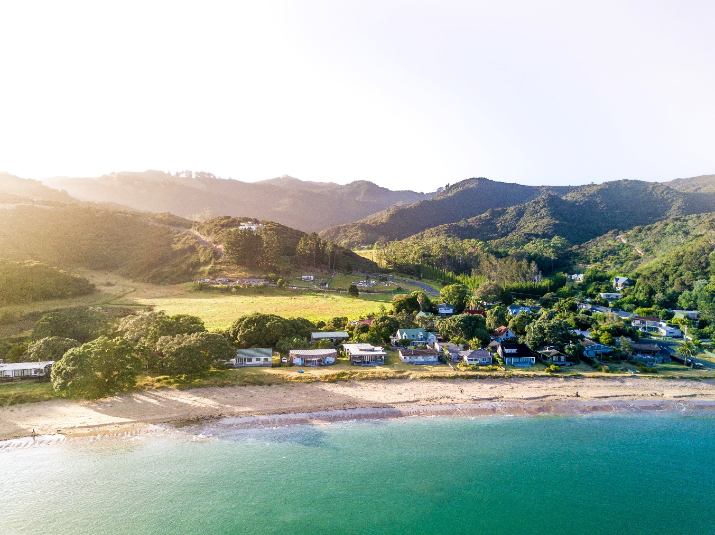

Assessor Guidelines
The following guidelines are supplied to enable assessors to carry out valid and consistent assessment using this internal assessment resource.
- See Generic Resources and Guidelines at https://www.nzqa.govt.nz/providers-partners/assessment-and-moderation-of-standards/assessment-of-standards/generic-resources/

GENERAL
- This unit standard is intended for ākonga/learners with learning disabilities, including those with intellectual disability. They are people who require support with their learning either through additional resources, specialised equipment or adapted teaching programmes.
- People credited with this unit standard are able to access and use facilities and services in the community (Supported Learning).

GUIDANCE INFORMATION
- This unit standard may contribute to the New Zealand Certificate in Skills for Living for Supported Learners (Level 1) [Ref: 2853].
- This unit standard will be carried out in situations that are limited in range, repetitive and familiar, and employed within closely defined contexts.
- The assessor must be satisfied that the candidate can demonstrate competence against the unit standard, with minimal support towards increased independence.
- The candidate may require a longer period of learning than the 40 learning hours of teaching and learning, as determined by the 4 credits assigned to this unit standard.
- This unit standard may be assessed in conjunction with other Supported Learning unit standards to allow for integrated assessment. The assessment should be integrated into a meaningful social, cultural, family/whānau, community and/or work context.
- Assessments involve using a variety of methods that gives the learner the opportunity to show competence. It is recommended that the collection of evidence is naturally occurring, in real life contexts, and collected over an extended timeframe. It may be oral or written, or practical evidence.
- The assessor must be satisfied that the naturally occurring evidence can be attributed to the candidate. A verifier’s checklist is acceptable if accompanied by evidence that includes examples from the candidate’s performance.
- Assessments may involve the use of digital technology – internet, laptop/iPad/tablet/cell phone, and augmentative communication, where appropriate for the learner and context.

ASSESSMENT
- The assessments must be at Level 1 of the New Zealand Qualifications and Credentials Framework (NZQCF). For information go to The Level descriptors for the NZQCF - https://www2.nzqa.govt.nz/qualifications-and-standards/about-new-zealand-qualifications-credentials-framework/level-descriptors-nzqcf/
- The assessors must be satisfied that the candidate can demonstrate competence against the unit standard, with minimal support towards increased independence. The assessor must sign an attestation in the Ākonga/learner Guidelines to confirm that all the work done is the candidate’s own.
- To ensure assessment conditions and assessor judgement are consistent and fair, assessors must be Supported Learning teachers who understand the assessment requirements. Learning support and/or teacher aides may be used to support a candidate with gathering and verifying of evidence.
- This resource exemplifies assessment of learning for one unit standard. However, it is highly recommended that this standard be assessed in conjunction with other Supported Learning unit standards to allow for a thematic approach. This would make the learning more meaningful to candidates in their own social, cultural, family/whanau, community and/or work contexts.
- This assessment resource provides examples of how assessments could be presented. These assessment tasks may need to be altered to suit the learning styles and additional needs of the learner.
- Sample answers have been developed to guide assessors. However, it is important to note that candidate’s answers will vary depending on the individual. Assessors should also be aware that sample answers are not provided for all questions, and that they may need to develop their own examples for some assessment parts.

GATHERING OF EVIDENCE
- A variety of approaches should be considered for the gathering of evidence, which may involve the use of digital technology – internet; laptop/ tablet e.g. iPad/cell phone, and augmentative communication; and use of a reader/writer or enlarged print, where appropriate for the learner and context.
- All evidence such as videos, audio, pictures etc. must be attached to the candidate’s paper-based copy of the Ākonga/learner Guidelines, when moderation is required, thus verifying the candidate’s own work. If the candidate is unable to record the answers on their paper-based copy, their Supported Learning Teacher or Teacher aide must do so. If the candidate is part of a group when carrying out tasks, the assessment evidence must reflect the candidate’s ability to achieve each task independently.
- Evidence collected for this assessment can be attributed to the candidate through its natural occurrence, in real life contexts and collected over an extended timeframe. A verifiers checklist is acceptable if accompanied by evidence that includes examples from the candidate’s performance.

BEFORE THE ASSESSMENT
Over the weeks prior to this assessment, candidates must have had sufficient teaching and learning opportunities to be familiar with the following:
- Facilities – buildings or equipment that are provided for a particular purpose, e.g. public swimming pool, library, sports facilities, parks, playgrounds, educational facilities, social clubs, supermarkets.

- Services – organisations or people outside of schools that provide help or meet needs in the community e.g. medical services, income support, family planning, disability organisations, support groups, hairdressers, cafés, transport services, post office.

PRE-ASSESSMENT ACTIVITY
To prepare learners for the assessment, an activity immediately before the assessment task is recommended. This could be setting the scene and providing a scenario which assist learners to relate the assessment task to a meaningful, real context.
Learners may also need terminology or concepts unpacked for them, so they have a better understanding of what is required. However, pre-assessment activities tasks may not lead the learner to the answers. Learners must still independently demonstrate their competency against this standard.

Evidence and Judgement Guidance
Unit standard | 29299
Title | Access and use facilities and services in the community
Level | 1 | Credits | 5 | Version | 3

Outcome 1
Access and use facilities and services in the community
Range: Facilities may include but are not limited to – public swimming pool, library, sports facilities, social clubs; educational facilities, parks, playgrounds, supermarkets.

Services may include but are not limited to – medical services, income support, family planning, disability organisations, support group, transport facilities, hairdressers.
  - 1.1 Facilities and services in the community are described in terms of their purpose.
Range: evidence of three facilities and two services.
- Evidence for Achievement | - Judgements for Achievement
Part 1  Three facilities and two services are described in terms of their purpose in the community. | Purpose described, reflects the function of the community facilities and services, relevant to the ākonga/learner.
  - 1.2 Community facilities and services are accessed and actively used to meet specified needs.
Range: evidence of three facilities/services; must include at least one facility and one service.
- Evidence for Achievement | - Judgements for Achievement
Part 2  Evidence of three facilities/services accessed and actively used to meet a specific need. | Three facilities/services were accessed and actively used by the ākonga/learner to meet their specified need/s.  Evidence must show at least one facility and one service.

Examples provided for ākonga/learners in the SG are included in the AG in blue. Additional examples are provided in red in the AG for the assessor. These examples are not necessarily representative of the general expectation of ākonga/learner ability. They are designed to help explain the requirements of the task and provide ideas for planning and teaching.
Access and use facilities and services in the community
Instructions for the ākonga/learner:
- Do ALL parts of this assessment.
- Ask your assessor if you need help to understand something better.
- Answer in a way that is easiest for you (e.g. drawing, recording voice memos, speaking to your helper, taking photos).
Conditions of Assessment

- You will complete Part One of the assessment (with support if required).
- You will complete Part Two of the assessment with the assessor.
- This assessment will take place over a timeframe set by the assessor.
- Assessments must be carried out in situations that are limited in range, repetitive, and familiar and employed within closely defined contexts. They must be conducted in authentic situations that are relevant to the ākonga/learner’s day-to-day living that may include but is not limited to workplace, educational setting or within the community.

Access and use facilities and services in the community
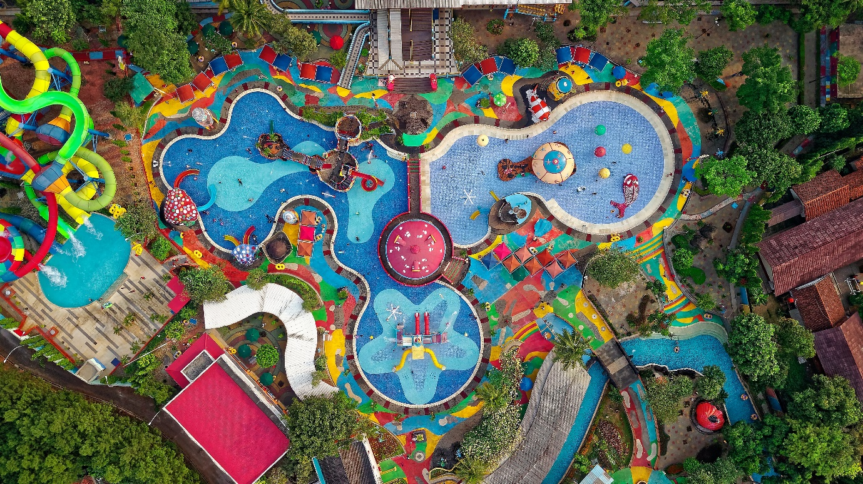

ASSESSMENT

Assessment Task
This assessment task has two parts. You will be asked to:

Assessment – Part 1

Examples of different kinds of community facilities and services:
FACILITIES | SERVICES
 | 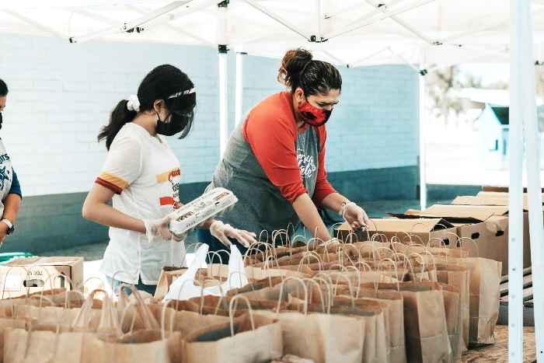
 | 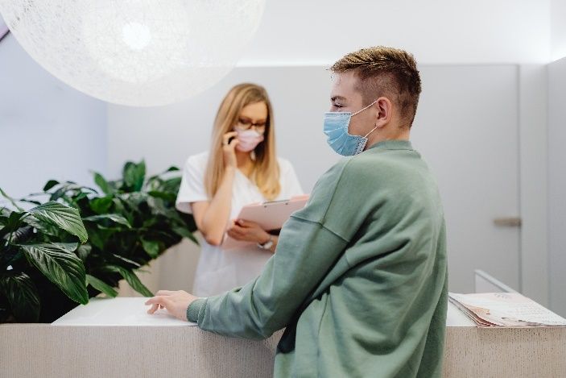
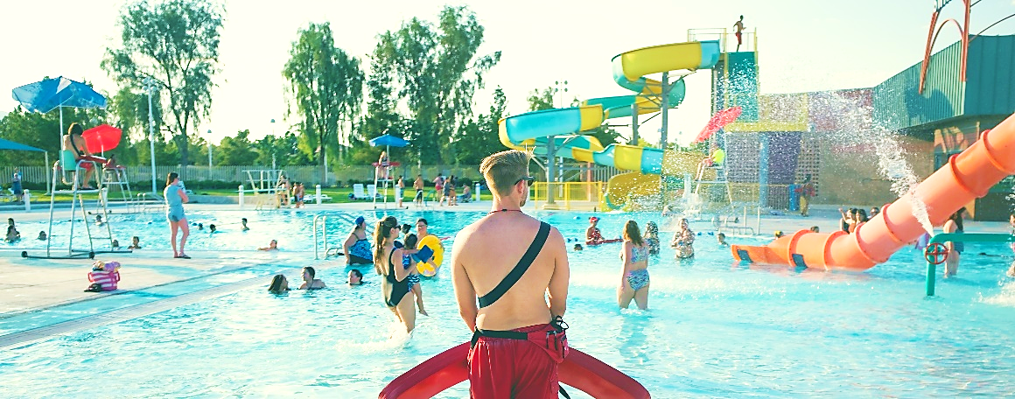 | 

What are some of the facilities and services in your community?
Facilities are places, buildings or equipment that are provided for a particular purpose, e.g. public swimming pools, libraries (school or public), sports facilities, social clubs, supermarkets.

- Name three facilities in your community and describe what their purpose is for each.
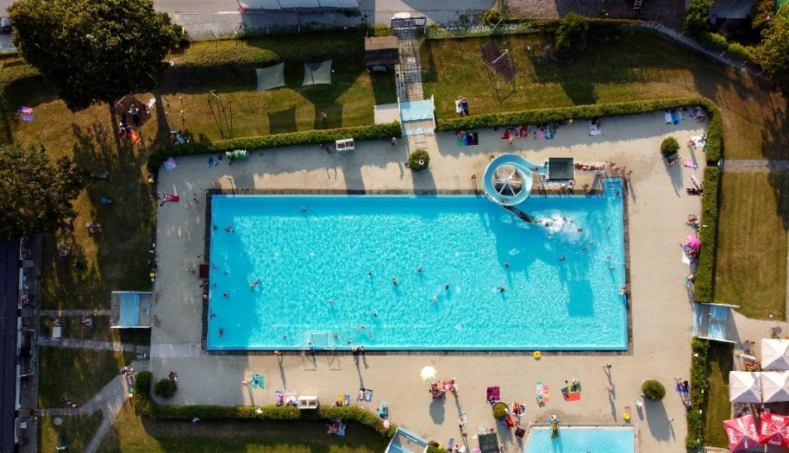
Example
Facility: Big Wave Aquatic Centre
What is the purpose of this facility?
- for swimming lessons
- for swimming sports
- for fitness, for fun/leisure
- for parties

Facility 1:
Local community Library on Journey Road
What is the purpose of this facility?
- to borrow books
- to study
- to find out information
- for a quiet and safe place to go
- to use the computer
- to read
Facility 2:

What is the purpose of this facility?

Facility 3:

What is the purpose of this facility?

Services are organisations or people that provide help or meet needs in the community e.g. medical services, income support, family planning, disability organisations, support groups, hairdressers, cafés.

- Name two services in your community and describe what the purpose is for each.

Example:
Service: Accident and Emergency
What is the purpose of this service?
- to treat accidents and emergencies
- for health advice
- for medications and vaccinations
- to see a doctor or a nurse
Service 1:
Local Citizen’s Advice Bureau on Main Street.
What is the purpose of this service?
- for advice about big decisions
- for legal advice
- for advice about right and responsibilities at work
- for advice about rights and responsibilities as a citizen
- for advice about rights and responsibilities as a tenant
Service 2:

What is the purpose of this service?

Assessment – Part 2
For this part of the assessment you need to:
Access and actively use three facilities and services (in total) in your community. You need to include at least one facility and one service.
You will need to collect evidence to show that you have accessed and actively used these facilities and services.
When you have accessed and actively used these facilities and services, you need to update the table on the next page.
2a. You need to decide which three facilities and services in your community you are going to access and use. At least one must be a facility and at least one has to be service.
Korero (discuss) your ideas with your group and then with the teacher and make some decisions about where you are going to go and which facilities or services you are going to access and use – and what the purpose of the visit will be.
You will also need to be plan things like how you will get there, and who will go with you. Once you have decided everything, record the details below:
Which three local facilities and services (at least one of each) are you going to access and actively use, and what is the purpose of the visit?
1.
2.
3.
2b. For this assessment you need evidence that you have accessed and used these facilities and services. Think about what evidence could be collected to prove this.
  An email from the facility or service manager. |   A reflection on your experience in your journal.
  A receipt from facility or service accessed. |   A video of you accessing service or facility.

What kind of evidence could you collect that would show that you have accessed and actively used these three local facilities and services?
1.
2.
3.

Your assessor needs to complete this part with you or for you to verify that you accessed and actively used three facilities and services (at least one of each).
1.
Name & address of the facility or service:

Is this a community facility or a community service?

Date(s) facility or service accessed:

Purpose of the visit to the facility or service:

Evidence that the facility or services was actively used to meet specific needs:

Assessor name: ___________________ Signature: _____________________ Date: ________
2.
Name & address of the facility or service:

Is this a community facility or a community service?

Date(s) facility or service accessed:

Purpose of the visit to the facility or service:

Evidence that the facility or services was actively used to meet specific needs:

Assessor name: ___________________ Signature: _____________________ Date: ________
3.
Name & address of the facility or service:

Is this a community facility or a community service?

Date(s) facility or service accessed:

Purpose of the visit to the facility or service:

Evidence that the facility or services was actively used to meet specific needs:

Assessor name: ___________________ Signature: _____________________ Date: ________

OUTCOMES AND PERFORMANCE CRITERIA

Outcome 1: Access and use facilities and services in the community.

Performance criteria:
1.1 - Facilities and services in the community are described in terms of their purpose.
Range: Evidence of three facilities and two services is required.

1.2 - Community facilities and services are accessed and actively used to meet specified needs.
Range: Evidence of a total of three facilities/services; must include at least one facility and one service.

ĀKONGA/LEARNER EVIDENCE – Name:_____________________________
Describe the purpose of facilities and services.  Facilities and services in the community are described in terms of their purpose.  Description of the purpose of three facilities and two services. | Access and actively use local facilities and services.  Community facilities and services are accessed and actively used to meet specified needs.  Evidence of a total of three facilities/services, which must include at least one facility and one service.
Achieved ☐ Not Achieved ☐ | Achieved ☐ Not Achieved ☐

Overall Performance Outcome: Achieved ☐ Not Achieved ☐
Overall comments:

Assessor’s Attestation:
I confirm the following:
- the ākonga/learner has adequacy of knowledge and performance.
- the assessment complied with relevant health and safety practices.
- the ākonga/learner’s likely repeatable competence in the future.

Assessor Name: |  | Assessor Signature:
Date: |  | Position Held:

