Supported Learning Assessment Support Material
Unit standard | 29299
Title | Access and use facilities and services in the community
Level | 1 | Credits | 5 | Version | 3

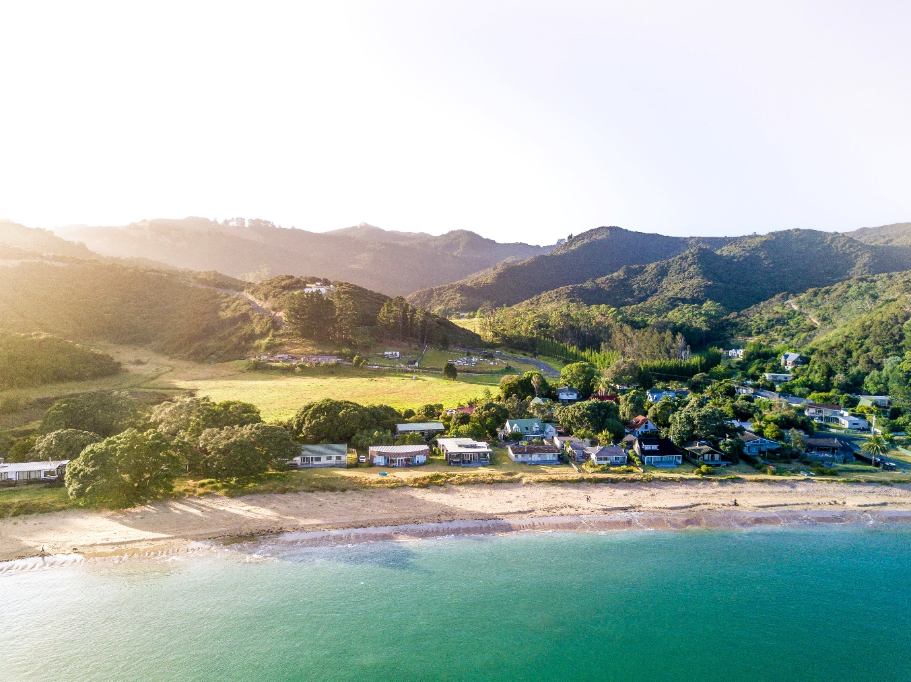

Ākonga/learner Guidelines
ĀKONGA/LEARNER’S INFORMATION
First and last name
NSN number
Date

Access and use facilities and services in the community

Instructions for the ākonga/learner:
- Do ALL parts of this assessment.
- Ask your assessor if you need help to understand something better.
- Answer in a way that is easiest for you (e.g. drawing, recording voice memos, speaking to your helper, taking photos).

Conditions of Assessment
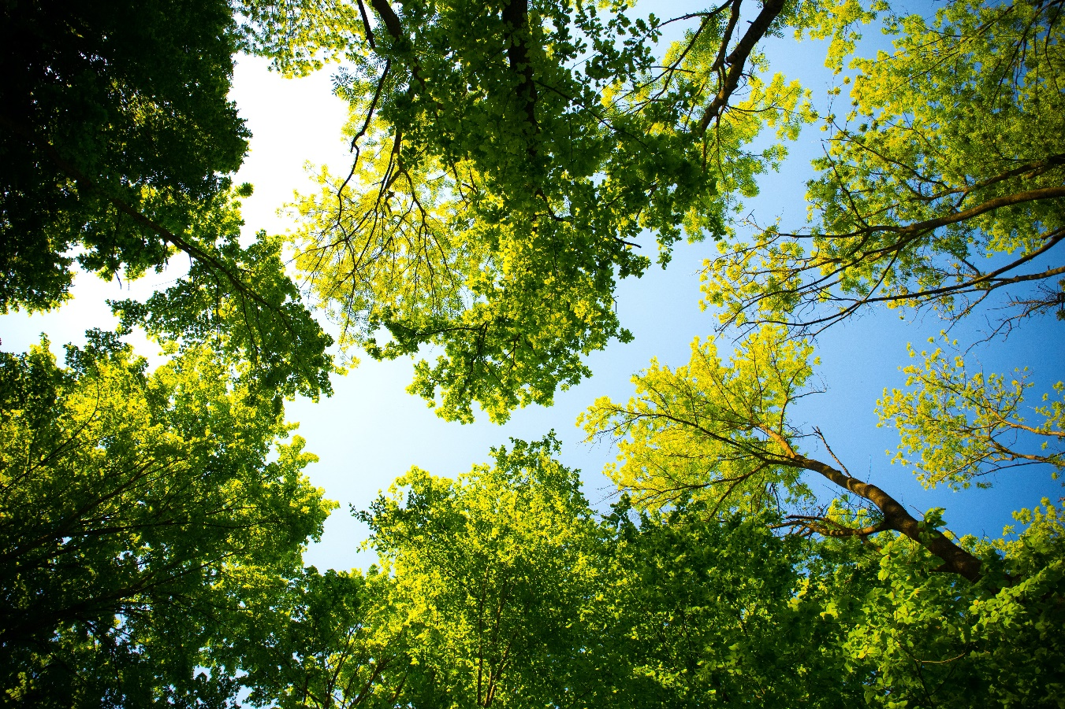
- You will complete Part One of the assessment (with support if required).
- You will complete Part Two of the assessment with the assessor.
- This assessment will take place over a timeframe set by the assessor.
- Assessments must be carried out in situations that are limited in range, repetitive, and familiar and employed within closely defined contexts. They must be conducted in authentic situations that are relevant to the ākonga/learner’s day-to-day living that may include but is not limited to workplace, educational setting or within the community.

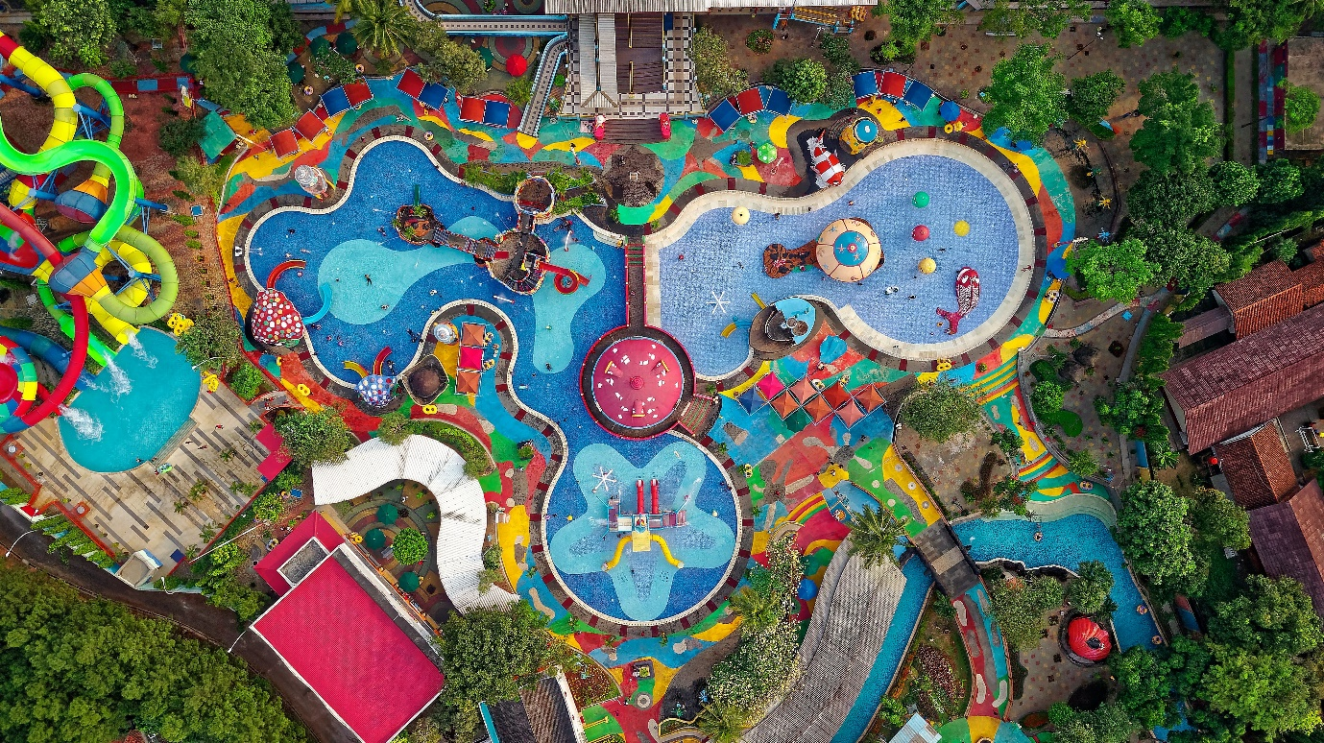
Access and use facilities and services in the community

Assessment Task
This assessment task has two parts. You will be asked to:

Assessment – Part 1

Examples of different kinds of community facilities and services:
FACILITIES | SERVICES
 | 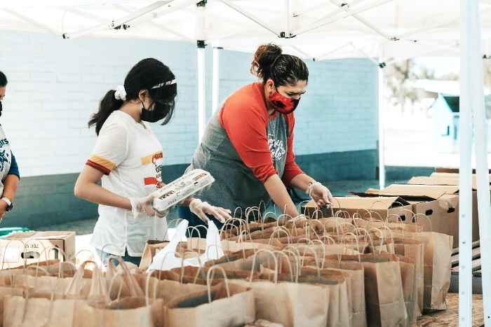
 | 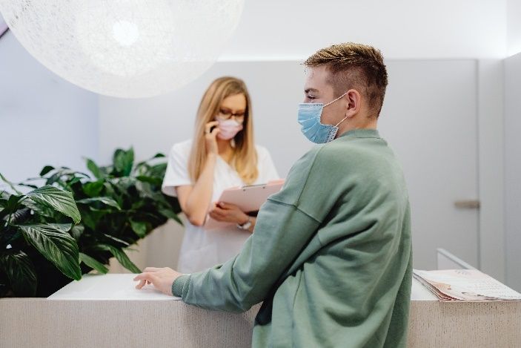
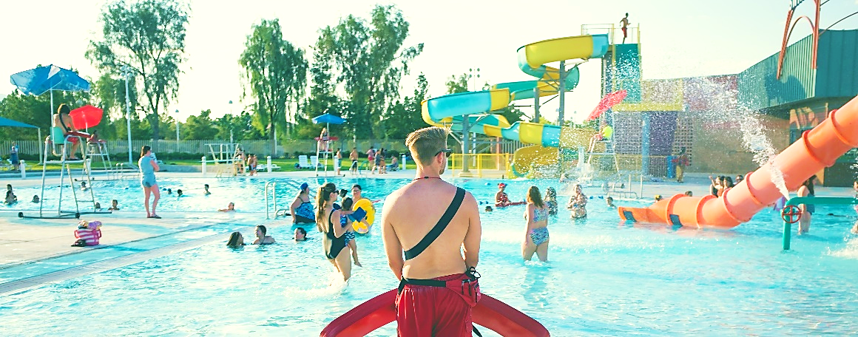 | 
What are some of facilities and services in your community?
Facilities are places, buildings or equipment that are provided for a particular purpose e.g. public swimming pools, libraries (school or public), sports facilities, social clubs, supermarkets.

- Name three facilities in your community and describe what their purpose is for each.
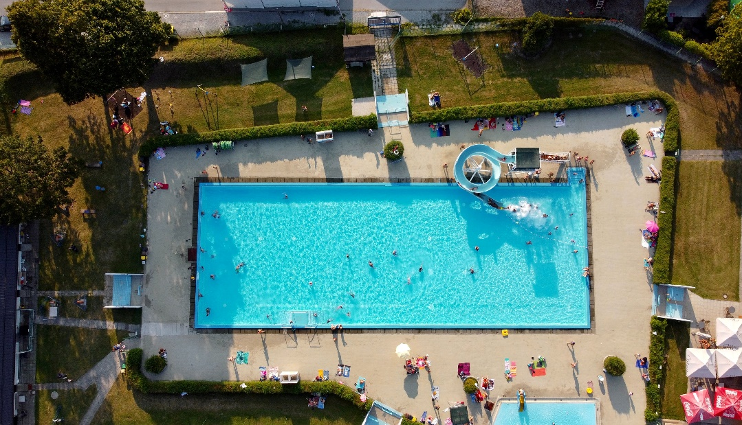
Example:
Facility: Big Wave Aquatic Centre
What is the purpose of this facility?
- for swimming lessons
- for swimming sports
- for fitness, for fun/leisure
- for parties

Facility 1:

What is the purpose of this facility?

Facility 2:

What is the purpose of this facility?

Facility 3:

What is the purpose of this facility?

Services are organisations or people that provide help or meet needs in the community e.g. medical services, income support, family planning, disability organisations, support groups, hairdressers, cafés.

- Name two services in your community and describe what the purpose is for each.

Example:
Service: Accident and Emergency
What is the purpose of this service?
- to treat accidents and emergencies
- for health advice
- for medications and vaccinations
- to see a doctor or a nurse
Service 1:

What is the purpose of this service?
Service 2:

What is the purpose of this service?

Assessment – Part 2
For this part of the assessment you need to:
Access and actively use three facilities and services (in total) in your community. You need to include at least one facility and one service.
You will need to collect evidence to show that you have accessed and actively used these facilities and services.
When you have accessed and actively used these facilities and services, you need to update the table on the next page.
2a. You need to decide which three facilities and services in your community you are going to access and use. At least one must be a facility and at least one has to be service.
Korero (discuss) your ideas with your group and then with the teacher and make some decisions about where you are going to go and which facilities or services you are going to access and use – and what the purpose of the visit will be.
You will also need to be plan things like how you will get there, and who will go with you. Once you have decided everything, record the details below:
Which three local facilities and services (at least one of each) are you going to access and actively use, and what is the purpose of the visit?
1.
2.
3.
2b. For this assessment you need evidence that you have accessed and used these facilities and services. Think about what evidence could be collected to prove this.
  An email from the facility or service manager. |   A reflection on your experience in your journal.
  A receipt from facility or service accessed. |   A video of you accessing service or facility.

What kind of evidence could you collect that would show that you have accessed and actively used these three local facilities and services?
1.
2.
3.
Your assessor needs to complete this part with you or for you to verify that you accessed and actively used three facilities and services (at least one of each).
1.
Name & address of the facility or service:

Is this a community facility or a community service?

Date(s) facility or service accessed:

Purpose of the visit to the facility or service:

Evidence that the facility or services was actively used to meet specific needs:

Assessor name: ___________________ Signature: _____________________ Date: ________
2.
Name & address of the facility or service:

Is this a community facility or a community service?

Date(s) facility or service accessed:

Purpose of the visit to the facility or service:

Evidence that the facility or services was actively used to meet specific needs:

Assessor name: ___________________ Signature: _____________________ Date: ________
3.
Name & address of the facility or service:

Is this a community facility or a community service?

Date(s) facility or service accessed:

Purpose of the visit to the facility or service:

Evidence that the facility or services was actively used to meet specific needs:

Assessor name: ___________________ Signature: _____________________ Date: ________

OUTCOMES AND PERFORMANCE CRITERIA

Outcome 1: Access and use facilities and services in the community.

Performance criteria:
1.1 - Facilities and services in the community are described in terms of their purpose.
Range: Evidence of three facilities and two services is required.

1.2 - Community facilities and services are accessed and actively used to meet specified needs.
Range: Evidence of a total of three facilities/services; must include at least one facility and one service.

ĀKONGA/LEARNER EVIDENCE – Name:_____________________________
Describe the purpose of facilities and services.  Facilities and services in the community are described in terms of their purpose.  Description of the purpose of three facilities and two services. | Access and actively use local facilities and services.  Community facilities and services are accessed and actively used to meet specified needs.  Evidence of a total of three facilities/services, which must include at least one facility and one service.
Achieved ☐ Not Achieved ☐ | Achieved ☐ Not Achieved ☐

Overall Performance Outcome: Achieved ☐ Not Achieved ☐
Overall comments:

Assessor’s Attestation:
I confirm the following:
- the ākonga/learner has adequacy of knowledge and performance.
- the assessment complied with relevant health and safety practices.
- the ākonga/learner’s likely repeatable competence in the future.

Assessor Name: |  | Assessor Signature:
Date: |  | Position Held:

