Supported Learning Assessment Support Material
Unit standard | 29301
Title | Demonstrate strategies to ensure personal safety
Level | 1 | Credits | 4 | Version | 3



Ākonga/learner Guidelines
ĀKONGA/LEARNER’S INFORMATION
First and last name
NSN number
Date

Demonstrate strategies to ensure personal safety
Instructions for the ākonga/learner
- Do ALL parts of this assessment.
- Ask your assessor if you need help to understand something better.
- Answer in a way that is easiest for you (e.g. drawing, recording voice memos, speaking to your helper, taking photos).

Conditions of Assessment

- Part One of the assessment will be done by the ākonga/learner (with support if necessary).
- Part Two of the assessment will be verified by the assessor.
- The assessment will take place over a timeframe set by the assessor.
- Before the assessment tasks, an introduction to the assessment should be given, based on prior learning.
- Assessments must be carried out in situations that are limited in range, repetitive, and familiar and employed within closely defined contexts. They must be conducted in authentic situations that are relevant to the ākonga/learner’s day-to-day living that may include but is not limited to workplace, educational setting or within the community.

Demonstrate strategies to ensure personal safety


Assessment Task
This assessment task has two parts. You need to:

Assessment – Part 1
1a. Below are examples of situations where personal safety can be an issue. You can use the pictures below to help you think of situations where your safety might be at risk.
 |  | 
 |  | 
 | 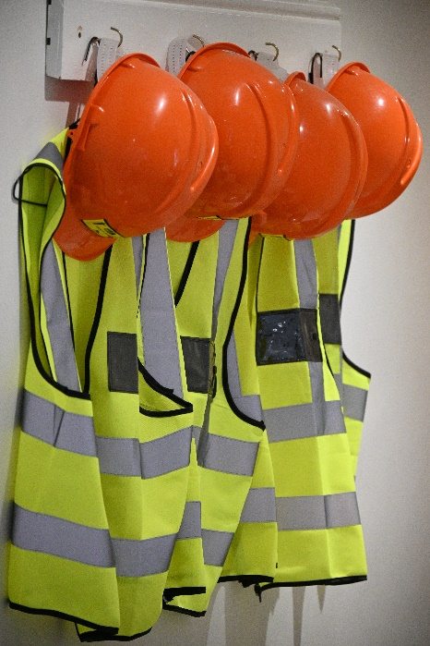 | 
1b. Identify four different situations where your personal safety might be at risk.
Situation 1: | Situation 2:
Situation 3: | Situation 4:

1c. Complete the table below, where you need to identify two strategies or ways to maintain personal safety in each of the four situations.
- Identify strategies that are realistic and appropriate to you.
Situation | Strategies
Example:  A day at the beach. | Strategy 1:  I will apply sunscreen and wear a hat to avoid getting sunburnt.  Strategy 2:  I will swim between the flags at the patrolled end of the beach, so I don’t get into trouble in the water.
Situation 1: | Strategy 1:  Strategy 2:
Situation 2: | Strategy 1:  Strategy 2:
Situation 3: | Strategy 1:  Strategy 2:
Situation 4: | Strategy 1:  Strategy 2:

1d. There are different ways you could record how you maintained personal safety, e.g.
  Keeping notes on your device |   Keep a journal or diary
  Regular reporting to your teacher |   Photo or video evidence
Plan how you will record your efforts to maintain your safety:
Plan for recording evidence of you using safety strategies for Situation 1: | Plan for recording evidence of you using safety strategies for Situation 2:
Plan for recording evidence of you using safety strategies for Situation 3: | Plan for recording evidence of you using safety strategies for Situation 4:

Assessment – Part 2
For this part of the assessment you need to demonstrate one strategy you used to maintain your safety for each of the four situations:
Situation | Strategy use | Completed by | Comments on ākonga/learner performance
Example:  A day at the beach. | Strategy:  I applied sunscreen and wore a hat to avoid getting sunburnt. | Evidence:  Photos and Teacher observation.  Verified by: Natalie Adams (Teacher)  Date: 23/08/23 | Assessor Notes.  Hone supplied photographs of him wearing a hat at the beach and applying sunscreen. His teacher aide observed him regularly reapplying sunscreen. They also noted that he kept his hat on during his time at the beach.  Hone supplied photographs taken of him swimming between the flags.
Situation 1. | Strategy used: | Evidence:  Verified by:  Date: | Assessor Notes:
Situation 2. | Strategy used: | Evidence:  Verified by:  Date: | Assessor Notes:
Situation 3. | Strategy used: | Evidence:  Verified by:  Date: | Assessor Notes:
Situation 4. | Strategy used: | Evidence:  Verified by:  Date: | Assessor Notes:

OUTCOMES AND PERFORMANCE CRITERIA

Outcome 1: Demonstrate strategies to ensure personal safety.
Range: personal safety may include but is not limited to – ICT, community, environmental, financial, emotional.

Performance criteria:
1.1 - Strategies are identified in terms of personal safety in specified situations.
Range: Evidence of two strategies for each of four situations.

1.2 - Strategies for personal safety demonstrated are appropriate to specified situations.
Range: Evidence of one for each of four situations.

ĀKONGA/LEARNER EVIDENCE - Name: ________________________
Strategies identified -  Strategies are identified in terms of personal safety in specified situations.  Evidence of two appropriate personal safety strategies identified for each of four situations. | Strategies demonstrated-  Strategies for personal safety demonstrated are appropriate to specified situations.  Evidence of one appropriate personal safety strategy used in each of four situations.
Achieved ☐ Not Achieved ☐ | Achieved ☐ Not Achieved ☐

Overall Performance Outcome: Achieved ☐ Not Achieved ☐
  - Assessor’s Attestation:
I confirm the following:
- the ākonga/learner has adequacy of knowledge and performance.
- the assessment complied with relevant health and safety practices.
- the ākonga/learner’s likely repeatable competence in the future.

Assessor Name: |  | Assessor Signature:
Date: |  | Position Held:

