**Supported Learning Assessment Support Material**

|  |  |  |  |  |  |
| --- | --- | --- | --- | --- | --- |
| **Unit standard** | 29304 | | | | |
| **Title** | Describe elements of own culture, and basic rights and responsibilities of residing in Aotearoa New Zealand | | | | |
| **Level** | 1 | **Credits** | 4 | **Version** | 4 |

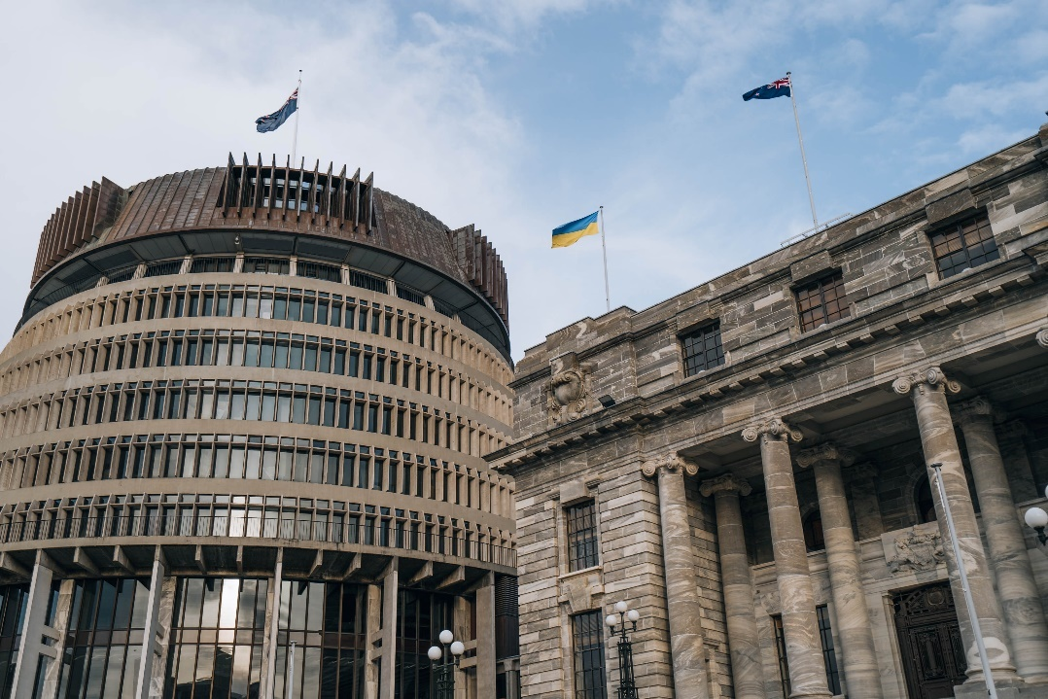

Assessor Guidelines

|  |
| --- |
| The following guidelines are supplied to enable assessors to carry out valid and consistent assessment using this internal assessment resource.   1. See Generic Resources and Guidelines at <https://www.nzqa.govt.nz/providers-partners/assessment-and-moderation-of-standards/assessment-of-standards/generic-resources/> |

|  |
| --- |
| GENERAL   1. This unit standard is intended for ākonga/learners with learning disabilities, including those with intellectual disability. They are people who require support with their learning either through additional resources, specialised equipment or adapted teaching programmes. 2. This unit standard contributes to the *New Zealand Certificate in Skills for Living for Supported Learners (Level 1)* [Ref: 2853].   ASSESSMENT   1. The assessments must be at Level 1 of the New Zealand Qualifications and Credentials Framework (NZQCF). For information go to The Level descriptors for the NZQCF - <https://www2.nzqa.govt.nz/qualifications-and-standards/about-new-zealand-qualifications-credentials-framework/level-descriptors-nzqcf/> 2. The assessors must be satisfied that the ākonga/learner can demonstrate competence against the unit standard, with minimal support towards increased independence. The assessor must sign an attestation in the Ākonga/learner Guidelines to confirm that all the work done is the ākonga/learner’s own. 3. To ensure assessment conditions and assessor judgement are consistent and fair, assessors must be Supported Learning teachers who understand the assessment requirements. Learning support and/or teacher aides may be used to support a ākonga/learner with gathering and verifying of evidence. 4. This resource exemplifies assessment of one unit standard. However, it is highly recommended that this standard be conducted in conjunction with other Supported Learning unit standards to allow for a thematic approach. This would make the learning more meaningful to ākonga/learner in their own social, cultural, family/whanau, community and/or work contexts. 5. This assessment resource provides examples of how assessments could be presented. These assessment tasks may need to be altered to suit the learning styles and additional needs of the learner. 6. Sample answers have been developed to guide assessors. However, it is important to note that ākonga/learners’ answers will vary depending on the individual. Assessors should also be aware that sample answers are not provided for all questions, and that they may need to develop their own examples for some assessment parts.   GATHERING OF EVIDENCE   1. A variety of approaches should be considered for the gathering of evidence, which may involve the use of digital technology – internet; laptop/ tablet e.g. iPad/cell phone, and augmentative communication; and use of a reader/writer or enlarged print, where appropriate for the ākonga/learner and context. 2. All evidence such as videos, audio, pictures etc. must be attached to the ākonga/learner’s paper-based copy of the Ākonga/learner Guidelines, when moderation is required, thus verifying the ākonga/learner’s own work. If the ākonga/learner is unable to record the answers on their paper-based copy, their Supported Learning Teacher or Teacher aide must do so. If the ākonga/learner is part of a group when carrying out tasks, the assessment evidence must reflect the candidate’s ability to achieve each task independently. 3. Evidence collected for this assessment can be attributed to the ākonga/learner through its natural occurrence, in real life contexts and collected over an extended timeframe. A verifiers checklist is acceptable if accompanied by evidence that includes examples from the ākonga/learner’s performance. |
| BEFORE THE ASSESSMENT  Over the weeks prior to this assessment, ākonga/learners should have had sufficient teaching and learning opportunities to be familiar with the following:   * Different ethnic groups and cultures in Aotearoa New Zealand * Cultural practices of different ethnic groups. * Tikanga – general behaviour guidelines for daily life and behaviour in Māori culture. * Bicultural practice – the cultural attitudes, customs and daily protocols inherent in the underlying principles of the Treaty of Waitangi. * The basic human rights of citizens of Aotearoa New Zealand. The responsibilities of citizens of Aotearoa New Zealand. |
| PRE-ASSESSMENT ACTIVITY  To prepare ākonga/learners for the assessment, an activity immediately before the assessment task is recommended. This could be setting the scene and providing a scenario which assist ākonga/learners to relate the assessment task to a meaningful, real context.  Ākonga/learners may also need terminology or concepts unpacked for them, so they have a better understanding of what is required. However, pre-assessment activities tasks may not lead the ākonga/learner to the answers. Ākonga/learners must still independently demonstrate their competency against this standard. |

**Evidence and Judgement Guidance**

|  |  |  |  |  |  |  |
| --- | --- | --- | --- | --- | --- | --- |
| **Unit standard** | 29304 | | | | | |
| **Title** | Describe elements of own culture, and basic rights and responsibilities of residing in Aotearoa New Zealand | | | | | |
| **Level** | 1 | **Credits** | 4 | | **Version** | 4 |
| Outcome 1 **Describe elements of own culture, and basic rights and responsibilities of residing in Aotearoa New Zealand** | | | | | | | |
| 1.1 Own culture is described in terms of family history/whakapapa and cultural practices.  Range: cultural practices may include but are not limited to – tikanga, celebrations, traditions, religion, food, language, dress; evidence of four cultural practices. | | | | | | | |
| Evidence for Achievement | | | | Judgements for Achievement | | | |
| **Part 1**  Own culture is described in terms of:   * Family history/whakapapa * **Four** different cultural practices   See sample answers for description of family/history whakapapa and four cultural practices. | | | | The ākonga/learner described their own culture by:   * giving a brief overview of their family history or whakapapa * outlining **four** different cultural practices that are identified by the cultural group that they belong to. | | | |
| 1.2 Basic human rights are described in terms of being a citizen of Aotearoa New Zealand, and a consumer of health and consumer services.  Range: basic human rights may include but are not limited to – equality, disability rights, education, voting, income support, the right to have passport; evidence of two basic human rights. | | | | | | | |
| Evidence for Achievement | | | | Judgements for Achievement | | | |
| **Part 2**  Description of **two** basic human rights that apply to citizens of Aotearoa New Zealand, and those who use health and consumer services in Aotearoa New Zealand.  *See sample answers for description of two basic rights.* | | | | The ākonga/learner identified **two** basic human rights that citizens of Aotearoa New Zealand have and accurately described what these human rights are about. | | | |
| 1.3 Basic responsibilities are described in terms of being a citizen of Aotearoa New Zealand.  Range: evidence of one responsibility from each of – abiding and upholding laws, bicultural practices, environmental sustainability. | | | | | | | |
| Evidence for Achievement | | | | Judgements for Achievement | | | |
| **Part 3**  Description of **three** of the following responsibilities of citizens of Aotearoa New Zealand:   * abiding and upholding laws * bicultural practices * environmental sustainability   *See sample answers for three responsibilities.* | | | | The ākonga/learner accurately described the following **three** responsibilities that citizens of Aotearoa New Zealand have:   * abiding and upholding laws * bicultural practices * environmental sustainability | | | |

**Describe elements of own culture, and basic rights and responsibilities of residing in Aotearoa New Zealand**

**Instructions for the ākonga/learner**

|  |
| --- |
| 1. **Do ALL parts of this assessment.** 2. **Ask your assessor if you need help to understand something better.** 3. **Answer in a way that is easiest for you (e.g. drawing, recording voice memos, speaking to your helper, taking photos).** |

|  |  |
| --- | --- |
| Conditions of Assessment | |
| * The assessment will be done by the ākonga/learner. * The assessment will take place over a timeframe set by the assessor. * Assessments should be carried out in situations that are limited in range, repetitive, and familiar and employed within closely defined contexts. They should be conducted in authentic situations that are relevant to the ākonga/learner’s day-to-day living that may include but is not limited to workplace, educational setting or within the community. |

**Describe elements of own culture, and basic rights and responsibilities of residing in Aotearoa New Zealand**

Assessment Task

This assessment task has three parts. You will be asked to:

*The assessment contains an example for the candidate to follow. For the assessor, a further example is provided in red.

Assessment – Part 1

|  |
| --- |
| **CULTURE**  Culture is about a group of people that share similar beliefs about the world and have a similar way of doing things. Culture usually comes from the family group that we belong to, the country that we live in, or the activities we engage in. |

**1a.** What is your culture?

|  |
| --- |
| I am Indian. My family and I follow Indian traditions and culture. |
|  |
|  |
|  |

**1b.** Describe your family history (whakapapa). You should include:

* where your parents and grandparents are from
* when your family first came to Aotearoa New Zealand
* what part of Aotearoa New Zealand, or iwi and hapū you are from
* anything else you think is important here (about your family)

|  |
| --- |
| All my family is from India. I come from a family of doctors and nurses. My |
| parents moved to Aotearoa New Zealand to study at university. I was born in |
| Wellington, Aotearoa New Zealand. |
|  |
|  |

|  |
| --- |
| Cultural practices  Cultural practices might be related to food, language, dress, celebrations, traditions, customs (tikanga), music, e.g. Most Cambodian people are Buddhist. When there is something important happening in their lives (like doing a test), they go to the temple to pray for blessings. |

**1c**. Describe **four** cultural practices that you do as part of your culture.

|  |
| --- |
| Cultural practice 1:Food  **What is this cultural practice about?** |
| Our culture encourages sharing food and eating together. We wash our hands and |
| then eat with our fingers – touching our food is part of the experience. It tastes |
| better! |
|  |
|  |
| Cultural practice 2:  **What is this cultural practice about?** |
|  |
|  |
|  |

|  |
| --- |
| Cultural practice 3:  **What is this cultural practice about?** |
|  |
|  |
|  |

|  |
| --- |
| Cultural practice 4:  **What is this cultural practice about?** |
|  |
|  |
|  |

**Assessment – Part 2**

**2.** Describe **two** basic human rights that people who live in Aotearoa New Zealand have.

|  |  |  |  |  |  |  |  |  |  |  |  |  |
| --- | --- | --- | --- | --- | --- | --- | --- | --- | --- | --- | --- | --- |
| A human right is something that all people are given. These rights are for all people who live in Aotearoa New Zealand. These rights relate to:   |  |  |  | | --- | --- | --- | | **Equity** | **Disability rights** | **Two people looking at a computer screen  Description automatically generated with medium confidenceVoting** | | **Income Support** | **The right to a passport**   | **Any other human rights that are acknowledged by the Aotearoa New Zealand government.** | |  |  |  | |  |  |  | |

*For the assessor, an example is provided in red.

|  |
| --- |
| **Basic human right 1:** Equity  **What is this basic human right about?** |
| Any citizen of Aotearoa New Zealand, no matter what their social, cultural, or |
| economic background, has the right to work, have an adequate standard of living, |
| and the right to education without discrimination |
|  |
|  |
|  |
|  |
|  |
|  |
|  |
| **Basic human right 2:**  **What is this human right about?** | |
|  | |
|  | |
|  | |
|  | |
|  | |
|  | |
|  | |
|  | |
|  | |
|  | |

**Assessment Part 3**

In this part, you will describe the basic responsibilities that people who live in Aotearoa New Zealand have.

|  |
| --- |
| **What is a responsibility?**  A responsibility is something that you should do or a way you should behave. There are three key responsibilities that all New Zealanders have:   1. Following all Aotearoa New Zealand laws 2. Using bicultural practices (having attitudes, customs, and practices that respect the relationship between Māori and other cultures) 3. Looking after the environment |

*For the assessor, an example is provided in red.

|  |
| --- |
| **3a. Following all Aotearoa New Zealand laws** |
| Why should people follow all Aotearoa New Zealand laws? Give an example. |
| We need to follow the laws of Aotearoa New Zealand because they protect our, |
| rights safety, and freedoms. An example is that it is law to wear a helmet when |
| I ride a bike. This is a law that protects my safety. |
|  |
| **3b. Bicultural practices** |
| Why should people use bicultural practices? Give an example. |
|  |
|  |
|  |
|  |
|  |
| **3c. Looking after the environment** |
| Why should people look after the environment? Give an example. |
|  |
|  |

|  |  |  |  |
| --- | --- | --- | --- |
|  | | | |
| **OUTCOMES AND PERFORMANCE CRITERIA**  **Outcome 1**: Describe elements of own culture, and basic rights and responsibilities of being a citizen of Aotearoa New Zealand.  **Performance criteria:**  **1.1** - Own culture is described in terms of family history/whakapapa and cultural practices.  **Range**: Cultural practices may include but are not limited to – tikanga, celebrations, traditions, religion, food, language, dress; **evidence of four cultural practices**.  **1.2** - Basic human rights are described in terms of being a citizen of Aotearoa New Zealand, and a consumer of health and consumer services.  **Range**: basic human rights may include but are not limited to – equality, disability rights, education, voting, income support, the right to have a passport; **evidence of two basic human rights.**    **1.3** - Basic responsibilities are described in terms of being a citizen of Aotearoa New Zealand.  **Range**: **Evidence of one responsibility from each of – abiding and upholding laws, bicultural practices, environmental sustainability.**  **ĀKONGA/LEARNER EVIDENCE -** Name**:_____________________________**   |  |  |  |  |  | | --- | --- | --- | --- | --- | | **1.1**  Own culture is described in terms of family history/whakapapa and cultural practices.  *Cultural practices may include but are not limited to – tikanga, celebrations, traditions, religion, food, language, dress;* ***evidence of four cultural practices****.* | | **1.2**  Basic human rights are described in terms of being a citizen of Aotearoa New Zealand, and a consumer of health and consumer services.  *Basic human rights may include but are not limited to – equality, disability rights, education, voting, income support, the right to have a passport;* ***evidence of two basic human rights.*** | **1.3**  Basic responsibilities are described in terms of being a citizen of Aotearoa New Zealand.  ***Evidence of one responsibility from each of – abiding and upholding laws, bicultural practices, environmental sustainability.*** | Assessor Grade | |  |  |  |  |  | |  |  |  |  |  | | | | |
| **Overall Performance Outcome: Achieved  Not Achieved** | | | |
| Overall comments: Maria was able to give answers that related to her own life, family, and culture. She were able to describe basic human rights of Aotearoa New Zealand and give examples. Maria was able to describe the responsibilities of Aotearoa New Zealand citizen and give some examples. Throughout this assessment, I (the assessor), scribed the candidate’s verbal responses. The assessment was completed over three separate sessions. | | | |
| Assessor’s Attestation:  As assessor of this unit standard, I confirm that:   * the assessment complied with relevant health and safety, and legislative requirements * the candidate has met the unit standard requirements * it is likely that the candidate has repeatable competence in the future. | | | |
| **Assessor Name:** |  | **Assessor Signature:** |  |
| **Date:** |  | **Position Held:** |  |