Supported Learning Assessment Support Material
Unit standard | 29307
Title | Use functional literacy skills in a range of day-to-day contexts
Level | 1 | Credits | 5 | Version | 3


Assessor Guidelines
The following guidelines are supplied to enable assessors to carry out valid and consistent assessment using this internal assessment resource.
- See Generic Resources and Guidelines at https://www.nzqa.govt.nz/providers-partners/assessment-and-moderation-of-standards/assessment-of-standards/generic-resources/

GENERAL
- This unit standard is intended for ākonga/learners with learning disabilities, including those with intellectual disability. They are people who require support with their learning either through additional resources, specialised equipment or adapted teaching programmes.
- This unit standard contributes to the New Zealand Certificate in Skills for Living for Supported Learners (Level 1) [Ref: 2853].

ASSESSMENT
- The assessments must be at Level 1 of the New Zealand Qualifications and Credentials Framework (NZQCF). For information go to The Level descriptors for the NZQCF - https://www2.nzqa.govt.nz/qualifications-and-standards/about-new-zealand-qualifications-credentials-framework/level-descriptors-nzqcf/
- The assessors must be satisfied that the ākonga/learner can demonstrate competence against the unit standard, with minimal support towards increased independence. The assessor must sign an attestation in the Ākonga/learner Guidelines to confirm that all the work done is the ākonga/learner’s own.
- To ensure assessment conditions and assessor judgement are consistent and fair, assessors must be Supported Learning teachers who understand the assessment requirements. Learning support and/or teacher aides may be used to support a ākonga/learner with gathering and verifying of evidence.
- This resource exemplifies assessment of learning for one unit standard. However, it is highly recommended that this standard be assessed in conjunction with other Supported Learning unit standards to allow for a thematic approach. This would make the learning more meaningful to ākonga/learners in their own social, cultural, family/whanau, community and/or work contexts.
- This assessment resource provides examples of how assessments could be presented. These assessment tasks may need to be altered to suit the learning styles and additional needs of the ākonga /learner.
- Sample answers have been developed to guide assessors. However, it is important to note that ākonga/learner’s answers will vary depending on the individual. Assessors should also be aware that sample answers are not provided for all questions, and that they may need to develop their own examples for some assessment parts.

GATHERING OF EVIDENCE
- A variety of approaches should be considered for the gathering of evidence, which may involve the use of digital technology – internet; laptop/ tablet e.g. iPad/cell phone, and augmentative communication; and use of a reader/writer or enlarged print, where appropriate for the learner and context.
- All evidence such as videos, audio, pictures etc. must be attached to the ākonga/learner’s paper-based copy of the Ākonga/learner Guidelines when moderation is required, thus verifying the ākonga/learner’s own work. If the ākonga/learner is unable to record the answers on their paper-based copy, their Supported Learning Teacher or Teacher aide must do so. If the ākonga/learner is part of a group when carrying out tasks, the assessment must reflect the ākonga/learner’s ability to achieve each task independently.
- Evidence collected for this assessment can be attributed to the ākonga/learner through its natural occurrence, in real life contexts and collected over an extended timeframe. A verifiers checklist is acceptable if accompanied by evidence that includes examples from the ākonga/learner’s performance.
- Two ākonga/learners may be assessed simultaneously, but each ākonga/learner must fulfil the requirements of the unit standard independently.
- Evidence of ‘speaking’ to achieve this standard has not been stipulated to allow achievement by ākonga/learners who use augmentative communication.
- For the purpose of this standard, a reader writer can be used to assist the ākonga/learner in assessment.

BEFORE THE ASSESSMENT
Over the weeks prior to this assessment, ākonga/learners must have had sufficient teaching and learning opportunities to be familiar with the following:
- Day to day literacy skills that may include but are not limited to:
- reading
- writing
- listening
- visual literacy
- speaking
- Literacy tasks that may include but are not limited to:
- report writing
- diaries
- research
- expressing opinion
- Literacy tasks appropriate for different contexts such as:
- daily living
- diaries
- research
- expressing opinion

PRE-ASSESSMENT ACTIVITY
To prepare ākonga/learners for the assessment, an activity immediately before the assessment task is recommended. This could be setting the scene and providing a scenario which assist learners to relate the assessment task to a meaningful, real context.
Ākonga/earners may also need terminology or concepts unpacked for them, so they have a better understanding of what is required. However, pre-assessment activities tasks may not lead the ākonga/learner to the answers. Ākonga /learners must still independently demonstrate their competency against this standard.

Evidence and Judgement Guidance

Unit standard | 29307
Title | Use functional literacy skills in a range of day-to-day contexts
Level | 1 | Credits | 5 | Version | 3

Outcome 1
Use functional literacy skills in a range of day-to-day contexts
Range: literacy skills must include – speaking, reading, writing; and may include but are not limited to – listening, visual literacy;
contexts may include but are not limited to – daily living activities, recreation, community, work, education.
  - 1.1 Literacy skills are applied to carry out tasks in a clear, specific manner appropriate to the learner, purpose and contexts.
Range: evidence of two literacy skills for each of four different contexts. At least one context must be in a formal situation.
- Evidence for Achievement | - Judgements for Achievement
Part 1 – 4  Application of two different literacy skills to carry out day to day tasks in four different contexts. At least one context in a formal situation.  See sample answers for one task in four different contexts. | The ākonga/learner accurately applied two literacy skills in each of four different day-to-day contexts.  The ākonga/learner applied the following skills at least once over all four contexts:  - speaking  - reading  - writing  and at least one of the contexts is a formal situation

Use functional literacy skills in a range of day-to-day contexts

Instructions for the ākonga/learner:

- Do ALL parts of this assessment.
- Ask your assessor if you need help to understand something better.
- Answer in a way that is easiest for you (e.g. drawing, recording voice memos, speaking to your helper, taking photos).

Conditions of Assessment
 | - All parts of the assessment will be carried out by the ākonga/learner.  - The assessment will take place over a timeframe set by the assessor.  - Before the assessment tasks, an introduction to the assessment should be given, using the examples provided.  - Assessments must be carried out in situations that are limited in range, repetitive, and familiar and employed within closely defined contexts. They must be conducted in authentic situations that are relevant to the ākonga/learner’s day-to-day living that may include but is not limited to workplace, educational setting or within the community.

Use functional literacy skills in a range of day-to-day contexts



Assessment Task
This assessment task has four parts. You will be asked to:
Apply two literacy skills in each of day-to-day tasks for each of the following four contexts.

Assessment Task

Throughout the assessment, you must use the following literacy skills at least once:
- Speaking
- Reading
- Writing

You can use other literacy skills in this assessment such as listening and visual literacy.

One of the contexts must be a formal situation. This means that the context is for an important or official occasion. Your teacher can help you to decide what occasion would be formal.

*The assessor will use the following table to make sure that the ākonga/learner has completed all required elements of this assessment task.
 | - Speaking | - Reading | - Writing | - Other | - Formal  - Yes/No
  - Daily living
  - Recreation
  - Work or education
  - Community

Assessment - Part 1
Use two different literacy skills to carry out tasks in your daily life
Examples could be:
- Follow a recipe   |   - Message someone |   - Chat about the holidays
For the assessor, an example is provided in red.
Complete the following table to describe the literacy skill, the context and the evidence of the skill being applied. You may need help completing the table and collecting your evidence.
- Describe what you did and why | - Literacy skill used (speaking, reading, writing, other) | - Evidence of the skill being applied
Task 1: Communicating with my Mum.  Date: 13th June 2022  I wrote a text to my Mum to tell her about our trip and that we made it back to school safely, because she wanted to know what time we got back so she could pick me up. |   Writing | I took a screenshot of the messages, and my Mum took a screenshot of them from her phone as well.
Task 2:

Date:

Assessment - Part 2
Use two different literacy skills to carry out tasks in your recreation activities.
Examples could be:

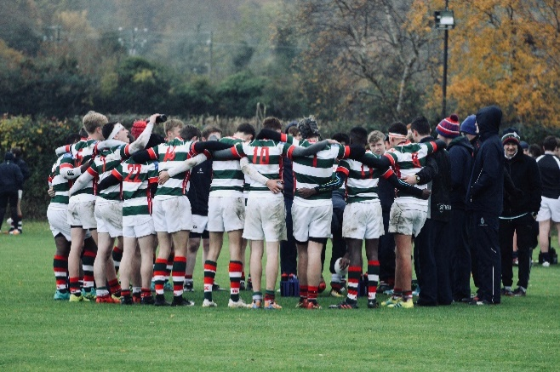  - Playing a game or a sport |   - A hobby | 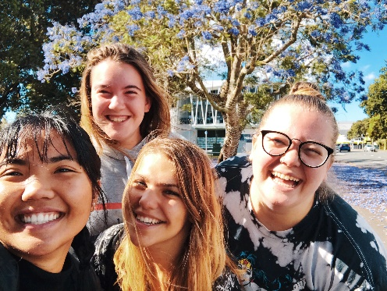  - A social outing
For the assessor, an example is provided in red.
Complete the following table to describe the literacy skill, the context and the evidence of the skill being applied. You may need help completing the table and collecting your evidence.
Describe what you did and why. | Literacy skill used (speaking, reading, writing, other) | Evidence of the skill being applied
Task 1: Playing Rugby with my team.  Date: 19th May 2022  I read part of the school newsletter to my friends, because our team won a game and it was in the newsletter. |   Reading | I got my Rugby teammate to video me reading the newsletter and my teacher helped me to upload it to my learner profile on the computer.
Task 2:

Date:

Assessment - Part 3
Use two different literacy skills to carry out tasks in your work or for your education
Examples could be:

  - Present work to your class |   - Go on an educational trip |   - Complete a job application
For the assessor, an example is provided in red.
Complete the following table to describe the literacy skill, the context and the evidence of the skill being applied. You may need help completing the table and collecting your evidence.
- Describe the task. (what you did and why) | - Literacy skill used (speaking, reading, writing, other) | - Evidence of the skill being applied
Task 1: Presenting research to my class school. (formal)  Date: 3rd March 2022  I researched my Turangawaewae, my place of belonging, and told my class five interesting facts about the place where I was born. |   Speaking | My teacher videoed the presentation that I did to the class. When I watched the video, I could see that I looked at my audience when I was speaking. I spoke clearly.
Task 2:

Date:

Assessment – Part 4
Use two different literacy skills to carry out tasks in your community
Examples could be:
Using public transport   |   Going to a church service | Taking part in a community event  
For the assessor, an example is provided in red.
Complete the following table to describe the literacy skill, the context and the evidence of the skill being applied. You may need help completing the table and collecting your evidence.
Describe what you did and why | Literacy skill used (speaking, reading, writing, other) | Evidence of the skill being applied
Task 1: Attend church service  Date: 11th December 2022  I attended church on Sunday and listened to what the pastor had to say. I was able to answer questions on the service, talk about what he said with my family and follow instructions given in the service. |   Listening | My tutor asked me some questions about the service. She also emailed my pastor to verify my answers.
Task 2:

Date:

OUTCOMES AND PERFORMANCE CRITERIA
Outcome 1: Use functional literacy skills in a range of day-to-day contexts

Range: Literacy skills must include – speaking, reading, writing; and may include but are not limited to – listening, visual literacy; contexts may include but are not limited to – daily living activities, recreation, community, work, education.

Performance Criteria
1.1: Literacy skills are applied to carry out tasks in a clear, specific manner appropriate to the learner, purpose and contexts.

Range: Tasks may include but are not limited to – interviews, expressing opinion, research, report writing, diaries; two different pieces of evidence for each of four different contexts; at least one context must be in a formal situation.

ĀKONGA /LEARNER EVIDENCE - Name:_____________________________
Context 1 -Formal/Informal  Two pieces of evidence of literacy skills applied to carry out tasks in a clear, specific manner appropriate to the learner, purpose and context. |  | Context 2 -  Formal/Informal  Two pieces of evidence of literacy skills applied to carry out tasks in a clear, specific manner appropriate to the learner, purpose and context. | Context 3 -  Formal/Informal  Two pieces of evidence of literacy skills applied to carry out tasks in a clear, specific manner appropriate to the learner, purpose and context. | Context 4 -  Formal/Informal  Two pieces of evidence of literacy skills applied to carry out tasks in a clear, specific manner appropriate to the learner, purpose and context. | Assessor Grade

Overall Performance Outcome: Achieved ☐ Not Achieved☐
  - Assessor’s Attestation:
I confirm the following:
- the ākonga/learner has adequacy of knowledge and performance
- the assessment complied with relevant health and safety, and legislative requirements
- the ākonga/learner’s likely repeatable competence in the future.
Overall comments:
Assessor Name: |  | Assessor Signature:
Date: |  | Position Held:

