**Supported Learning Assessment Support Material**

|  |  |  |  |  |  |
| --- | --- | --- | --- | --- | --- |
| **Unit standard** | 29308 | | | | |
| **Title** | Use functional numeracy skills in a range of day-to-day contexts | | | | |
| **Level** | 1 | **Credits** | 5 | **Version** | 3 |

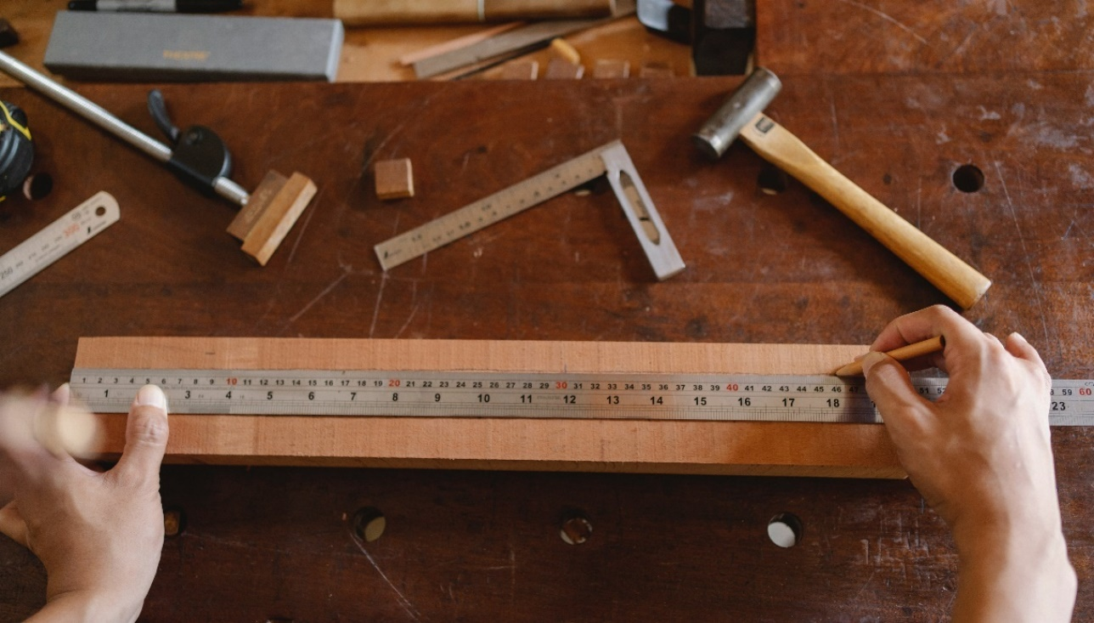

# Assessor Guidelines

|  |
| --- |
| The following guidelines are supplied to enable assessors to carry out valid and consistent assessment using this internal assessment resource.   1. See Generic Resources and Guidelines at <https://www.nzqa.govt.nz/providers-partners/assessment-and-moderation-of-standards/assessment-of-standards/generic-resources/> |

|  |
| --- |
| GENERAL   1. This unit standard is intended for ākonga/learners with learning disabilities, including those with intellectual disability. They are people who require support with their learning either through additional resources, specialised equipment or adapted teaching programmes. 2. This unit standard contributes to the *New Zealand Certificate in Skills for Living for Supported Learner s (Level 1)* [Ref: 2853].   ASSESSMENT   1. The assessments must be at Level 1 of the New Zealand Qualifications and Credentials Framework (NZQCF). For information go to The Level descriptors for the NZQCF - <https://www2.nzqa.govt.nz/qualifications-and-standards/about-new-zealand-qualifications-credentials-framework/level-descriptors-nzqcf/> 2. The assessors must be satisfied that the ākonga/learner can demonstrate competence against the unit standard, with minimal support towards increased independence. The assessor must sign an attestation in the Ākonga/learner Guidelines to confirm that all the work done is the ākonga/learner ’s own. 3. To ensure assessment conditions and assessor judgement are consistent and fair, assessors must be Supported Learning teachers who understand the assessment requirements. Learning support and/or teacher aides may be used to support a ākonga/learner with gathering and verifying of evidence. 4. This resource exemplifies assessment of learning for one unit standard. However, it is highly recommended that this standard be assessed in conjunction with other Supported Learning unit standards to allow for a thematic approach. This would make the learning more meaningful to ākonga/learners in their own social, cultural, family/whanau, community and/or work contexts. 5. This assessment resource provides examples of how assessments could be presented. These assessment tasks may need to be altered to suit the learning styles and additional needs of the ākonga/learner. 6. Sample answers have been developed to guide assessors. However, it is important to note that ākonga/learner ’s answers will vary depending on the individual. Assessors should also be aware that sample answers are not provided for all questions, and that they may need to develop their own examples for some assessment parts.   GATHERING OF EVIDENCE   1. A variety of approaches should be considered for the gathering of evidence, which may involve the use of digital technology – internet; laptop/ tablet e.g. iPad/cell phone, and augmentative communication; and use of a reader/writer or enlarged print, where appropriate for the ākonga/learner and context. 2. All evidence such as videos, audio, pictures etc. must be attached to the ākonga/learner’s paper-based copy of the Ākonga/learner Guidelines, when moderation is required, thus verifying the ākonga/learner’s own work. If the ākonga/learner is unable to record the answers on their paper-based copy, their Supported Learning Teacher or Teacher aide must do so. If the ākonga/learner is part of a group when carrying out tasks, the assessment evidence must reflect the ākonga/learner’s ability to achieve each task independently. 3. Evidence collected for this assessment can be attributed to the ākonga/learner through its natural occurrence, in real life contexts and collected over an extended timeframe. A verifiers checklist is acceptable if accompanied by evidence that includes examples from the ākonga/learner’s performance. |

|  |
| --- |
| BEFORE THE ASSESSMENT  Over the weeks prior to this assessment, ākonga/learners must have had sufficient teaching and learning opportunities to be familiar with the following:   * Number skills - * addition, subtraction, multiplication, division * statistics, sequences, comparisons * Measurement * Time * Contexts – * daily living activities (what the ākonga/learner does at home) * community * work * education * recreation   PRE-ASSESSMENT ACTIVITY  To prepare ākonga/learners for the assessment, an activity immediately before the assessment task is recommended. This could be setting the scene and providing a scenario which assist ākonga/learners to relate the assessment task to a meaningful, real context.  Ākonga/learners may also need terminology or concepts unpacked for them, so they have a better understanding of what is required. However, pre-assessment activities tasks may not lead the ākonga/learner to the answers. Ākonga/learners must still independently demonstrate their competency against this standard. |

# Evidence and Judgement Guidance

|  |  |  |  |  |  |
| --- | --- | --- | --- | --- | --- |
| **Unit standard** | 29308 | | | | |
| **Title** | Use functional numeracy skills in a range of day-to-day contexts | | | | |
| **Level** | 1 | **Credits** | 5 | **Version** | 3 |

# 

|  |  |
| --- | --- |
| Outcome 1: Use functional numeracy skills in a range of day-to-day contexts. Range*:* numeracy skills must include number (addition, subtraction, multiplication, division), measurement, time; and may include but are not limited to – statistics, sequences, comparisons;  contexts may include but are not limited to – daily living activities, community, work, education, recreation. | |
| 1.1 Numeracy skills are applied in a range of day-to-day tasks.  Range:evidence of **two** numeracy skills for each of four different contexts. | |
| Evidence for Achievement | Judgements for Achievement |
| **Part 1 - 4**  Application of **two** different numeracy skills to carry out day-to-day tasks in **four** different contexts.  See guidelines for how ākonga/learners should present evidence of application. | The ākonga/learner accurately applied **two** numeracy skills in each of **four** different contexts.  The ākonga/learner applied the following numeracy skills at least once over all four contexts:   * Number skills (addition, subtraction, multiplication, division) * Measurement * Time |

# Use functional numeracy skills in a range of day-to-day contexts

**Instructions for the ākonga/learner:**

|  |
| --- |
| 1. **Do ALL parts of this assessment.** 2. **Ask your assessor if you need help to understand something better.** 3. **Answer in a way that is easiest for you (e.g. drawing, recording voice memos, speaking to your helper, taking photos).** |

|  |  |
| --- | --- |
| Conditions of Assessment | |
|  | * The assessment will be done by the ākonga/learner. * The assessment will take place over a timeframe set by the assessor. * Before the assessment tasks, an introduction to the assessment should be given, using the examples provided. * Assessments must be carried out in situations that are limited in range, repetitive, and familiar and employed within closely defined contexts. They must be conducted in authentic situations that are relevant to the ākonga/learner’s day-to-day living that may include but is not limited to workplace, educational setting or within the community. |

# Use functional numeracy skills in a range of day-to-day contexts

**Assessment Task**

This assessment task has **four** parts. You will be asked to apply **two** numeracy skills in each of the following **four** contexts:

Assessment Task

Throughout the assessment, you must use the following numeracy skills at least once:

1. Number skills (including addition, subtraction, multiplication, and division)
2. A group of people in a classroom

   Description automatically generated with medium confidenceMeasurement
3. Time

You can also use the following numeracy skills:

1. Statistics
2. Sequences
3. Comparisons
4. Any other valid numeracy skill

Ākonga/learners should ask their teacher to show them examples on how to apply these skills and how to show what they have done.

*The assessor will use the following table to make sure that the ākonga/learner has completed all required elements of this assessment task.

|  |  |  |  |  |
| --- | --- | --- | --- | --- |
| Context | Numeracy Skills | Measurement | Time | Other |
| Daily life |  |  |  |  |
| Community |  |  |  |  |
| Work or education |  |  |  |  |
| Recreation |  |  |  |  |
| Other |  |  |  |  |

Note to assessors: It is important that ākonga/learners use calculations in their evidence, and do not just state facts. The following table provides examples of ākonga/learners should approach calculations.

|  |  |  |
| --- | --- | --- |
| Type of calculation | Not a calculation x | A calculation ✓ |
| **Numeracy skills:** | Saying a fact  Example: I bought two oranges for $3. | Doing difficult calculations  Example: I bought two oranges for $1.50 each. These cost $3.00 altogether. |
| **Measurement:**   | Saying how long or heavy something is  Example: I am 1.58 cm tall. | Measuring the length or weight of something.  Example: I measured my friend’s height with a tape measure. She is 1.63 cm tall. |
| **Time:** | Saying how long it took you to do something  Example: The cake took 45 minutes to bake. | Calculating how long something took  Example: I started baking a cake at 9:30 and finished at 10:46. It took me 1 hour and 16 minutes to bake the cake. |

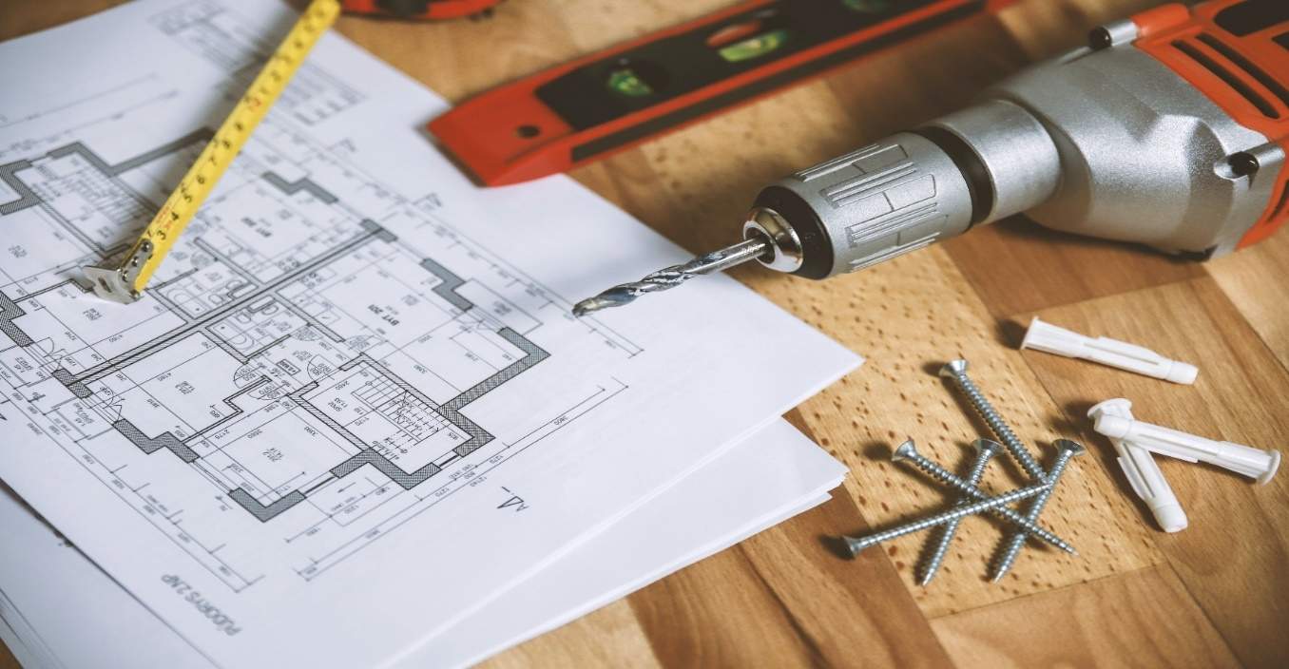

Assessment – Part 1

Use **two** different numeracy skills to carry out tasks in your **daily life**. Examples of tasks where you could use numeracy skills in your daily life include:

|  |  |
| --- | --- |
| **A person cooking in the kitchen  Description automatically generatedCooking food** | **Gardening** |
| **Being on time** | **Helping around the house** |

The ākonga/learner will use the following table to show the skills that they used, and the evidence they provided.

|  |  |  |
| --- | --- | --- |
| **Explain the day-to-day task** | **Explain the numeracy skill used. You must use the following skills at least once:**   * **A number skill** * **Measurement** * **Time** | **Explain how you provided evidence of using this skill** |
| **Task 1:** |  |  |
| **Task 2:** |  |  |

Assessment – Part 2

Use **two** different numeracy skills to carry out tasks inthe **community**. Examples of tasks where you could use numeracy skills in the community include:

|  |  |
| --- | --- |
| **Shopping** | **Attend a community event, like a parade** |
|   **Using transportation, like a train or bus** | **Going to restaurants or cafes** |

The ākonga/learner will use the following table to show the skills that they used, and the evidence they provided.

|  |  |  |  |
| --- | --- | --- | --- |
| **Explain the day-to-day task** |  | **Explain the numeracy skill used. You must use the following skills at least once:**   * **A number skill** * **Measurement** * **Time** | **Explain how you provided evidence of using this skill** |
| **Task 1:** |  |  |  |
| **Task 2:** |  |  |  |

Assessment – Part 3

Use **two** different numeracy skills to carry out tasks at work or your **place of study**. Examples of tasks where you could use numeracy skills at work or place of study include:

|  |  |
| --- | --- |
|   **Calculating the cost of something** | **Counting stock** |
| **Calculating how long something will take** | **Measuring liquids or other items** |

The ākonga/learner will use the following table to show the skills that they used, and the evidence they provided.

|  |  |  |
| --- | --- | --- |
| **Explain the day-to-day task** | **Explain the numeracy skill used. You must use the following skills at least once:**   * **A number skill** * **Measurement** * **Time** | **Explain how you provided evidence of using this skill** |
| **Task 1:** |  |  |
| **Task 2:** |  |  |

Assessment – Part 4

Use **two** different numeracy skills to carry out tasks during your **free time**. Examples of tasks where you could use numeracy skills during your free time include:

|  |  |
| --- | --- |
| **At sports events** | **At a community or religious group** |
| **As you are enjoying a hobby, passion, or interest** |   **When you are with your friends** |

The ākonga/learner will use the following table to show the skills that they used, and the evidence they provided:

|  |  |  |  |  |  |  |
| --- | --- | --- | --- | --- | --- | --- |
| **Explain the day-to-day task** | | **Explain the numeracy skill used. You must use the following skills at least once:**   * **A number skill** * **Measurement** * **Time** | | | **Explain how you provided evidence of using this skill** | |
| **Task 1:** | |  | | |  | |
| **Task 2:** | |  | | |  | |
| **OUTCOMES AND PERFORMANCE CRITERIA**  **Outcome 1: Use functional numeracy skills in a range of day-to-day contexts**  **Range:** Numeracy skills must include number (addition, subtraction, multiplication, division), measurement, time; and may include but are not limited to – statistics, sequences, comparisons; contexts may include but are not limited to – daily living activities, community, work, education, recreation.  **Performance Criteria:**  **1.1 -** Numeracy skills are applied to carry out day-to-day tasks.  **Range: Evidence of two numeracy skills for each of the four different contexts.**  **ĀKONGA/LEARNER EVIDENCE -** Name:**_____________________________**   |  |  |  |  |  | | --- | --- | --- | --- | --- | | **Context 1**  ***Evidence of two numeracy skills****.* | **Context 2**  ***Evidence of two numeracy skills****.* | **Context 3**  ***Evidence of two numeracy skills****.* | **Context 4**  ***Evidence of two numeracy skills****.* | Assessor Grade | |  |  |  |  |  | | | | | | |
| **Overall Performance Outcome: Achieved  Not Achieved** | | | | | | |
| Assessor’s Attestation:  I confirm the following:   * the ākonga/learner has adequacy of knowledge and performance * the assessment complied with relevant health and safety, and legislative requirements * the ākonga/learner’s likely repeatable competence in the future. | | | | | | |
| **Overall comments** | | | | | | |
| **Assessor Name:** |  | | **Assessor Signature:** |  | | |
| **Date:** |  | | **Position Held:** |  | | |