**Supported Learning Assessment Support Material**

|  |  |  |  |  |  |
| --- | --- | --- | --- | --- | --- |
| **Unit standard** | 29309 | | | | |
| **Title** | Plan a personal work pathway | | | | |
| **Level** | 1 | **Credits** | 4 | **Version** | 3 |

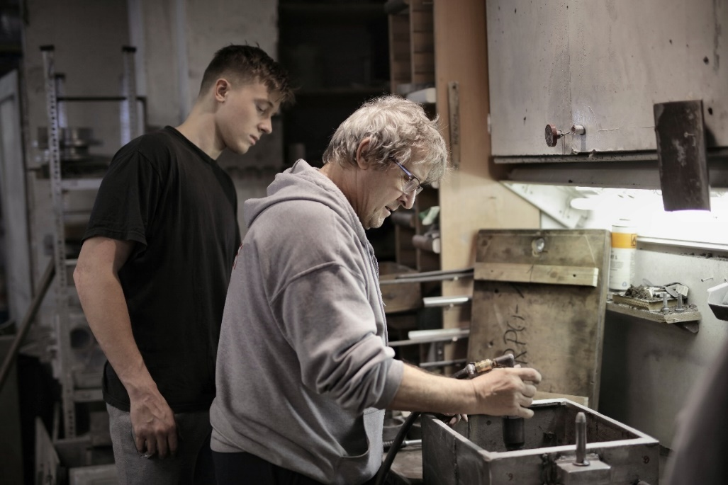

Assessor Guidelines

|  |
| --- |
| The following guidelines are supplied to enable assessors to carry out valid and consistent assessment using this internal assessment resource.   1. See Generic Resources and Guidelines at <https://www.nzqa.govt.nz/providers-partners/assessment-and-moderation-of-standards/assessment-of-standards/generic-resources/> |

|  |
| --- |
| GENERAL   1. This unit standard is intended for ākonga/learners with learning disabilities, including those with intellectual disability. They are people who require support with their learning either through additional resources, specialised equipment or adapted teaching programmes. 2. This unit standard contributes to the *New Zealand Certificate in Skills for Living for Supported Learners (Level 1)* [Ref: 2853].   ASSESSMENT   1. The assessments must be at Level 1 of the New Zealand Qualifications and Credentials Framework (NZQCF). For information go to The Level descriptors for the NZQCF - <https://www2.nzqa.govt.nz/qualifications-and-standards/about-new-zealand-qualifications-credentials-framework/level-descriptors-nzqcf/> 2. The assessors must be satisfied that the ākonga/learner can demonstrate competence against the unit standard, with minimal support towards increased independence. The assessor must sign an attestation in the Ākonga/Learner Guidelines to confirm that all the work done is the ākonga/learner ’s own. 3. To ensure assessment conditions and assessor judgement are consistent and fair, assessors must be Supported Learning teachers who understand the assessment requirements. Learning support and/or teacher aides may be used to support a ākonga/learner with gathering and verifying of evidence. 4. This resource exemplifies assessment of learning for one unit standard. However, it is highly recommended that this standard be assessed in conjunction with other Supported Learning unit standards to allow for a thematic approach. This would make the learning more meaningful to ākonga/learners in their own social, cultural, family/whanau, community and/or work contexts. 5. This assessment resource provides examples of how assessments could be presented. These assessment tasks may need to be altered to suit the learning styles and additional needs of the learner. 6. Sample answers have been developed to guide assessors. However, it is important to note that ākonga/learner’s answers will vary depending on the individual. Assessors should also be aware that sample answers are not provided for all questions, and that they may need to develop their own examples for some assessment parts.   GATHERING OF EVIDENCE   1. A variety of approaches should be considered for the gathering of evidence, which may involve the use of digital technology – internet; laptop/ tablet e.g. iPad/cell phone, and augmentative communication; and use of a reader/writer or enlarged print, where appropriate for the learner and context. 2. All evidence such as videos, audio, pictures etc. must be attached to the ākonga/learner ’s paper-based copy of the Learner Guidelines, when moderation is required, thus verifying the ākonga/learner ’s own work. If the ākonga/learner is unable to record the answers on their paper-based copy, their Supported Learning Teacher or Teacher aide must do so. If the ākonga/learner is part of a group when carrying out tasks, the assessment evidence must reflect the ākonga/learner ’s ability to achieve each task independently. 3. Evidence collected for this assessment can be attributed to the ākonga/learner through its natural occurrence, in real life contexts and collected over an extended timeframe. A verifiers checklist is acceptable, if accompanied by evidence that includes examples from the ākonga/learner ’s performance. |

|  |
| --- |
| BEFORE THE ASSESSMENT  Over the weeks prior to this assessment, ākonga/learner s must have had sufficient teaching and learning opportunities to be familiar with the following:   * A work pathway – a set of goals towards desired employment. Employment can be voluntary or paid. |

|  |
| --- |
| PRE-ASSESSMENT ACTIVITY  To prepare ākonga/learners for the assessment, an activity immediately before the assessment task is recommended. This could be setting the scene and providing a scenario which assist learners to relate the assessment task to a meaningful, real context.  Ākonga/learners may also need terminology or concepts unpacked for them, so they have a better understanding of what is required. However, pre-assessment activities tasks must not lead the learner to the answers. Learners must still independently demonstrate their competency against this standard. |

|  |  |  |  |  |  |
| --- | --- | --- | --- | --- | --- |
| **Unit standard** | 29309 | | | | |
| **Title** | Plan a personal work pathway | | | | |
| **Level** | 1 | **Credits** | 4 | **Version** | 3 |

Evidence and Judgement Guidance

|  |  |
| --- | --- |
| Outcome 1Plan a personal work pathway | |
| 1.1 Workplace goals are identified in terms of the desired outcomes, realistic and appropriate to ākonga/learner ’s own personal circumstances. | |
| Evidence for Achievement | Judgements for Achievement |
| **Part 1**  Identification of at least **two** workplace goals. | Each goal is:   * related to the ākonga/learner ’s desired outcomes * realistic and appropriate to the ākonga/learner ’s own personal circumstances. |
| 1.2 Work pathway is informed by research.  Range: research may include but is not limited to – identification of personal attributes, skills and interest; exploration or aspirations; work experiences; onsite visits;  internet search, face to face interviews; evidence of three different types of research for two goals. | |
| Evidence for Achievement | Judgements for Achievement |
| **Part 2**  **Three** different types of research are completed for **two** goals in order to inform the ākonga/learner ’s work pathway.  See sample answers for one type of research. | Findings from each type of research are relevant, appropriate and informs the career pathway. |
| 1.3 Goals within planned pathway are broken down into achievable steps.  Range: evidence of at least three steps for each identified goal. | |
| Evidence for Achievement | Judgements for Achievement |
| **Part 3**  Each of **two** goals within the ākonga/learner’s work pathway are broken down into at least **three** achievable steps.  See sample answers for one goal broken down into three steps. | The identified steps are appropriate to the ākonga/learner, relevant to the work pathway, and make the pathway potentially successful. |

**Plan a personal work pathway**

**Instructions for the ākonga/learner:**

|  |
| --- |
| 1. **Do ALL parts of this assessment.** 2. **Ask your assessor if you need help to understand something better.** 3. **Answer in a way that is easiest for you (e.g. drawing, recording voice memos, speaking to your helper, taking photos).** |

|  |
| --- |
| Conditions of Assessment |
| * A person holding a plant    Description automatically generated with low confidencePart One of the assessment will be done in conjunction with the assessor. * Parts Two and Three of the assessment will be carried out by the ākonga/learner. * The assessment will take place over a timeframe set by the assessor. * Assessments must be carried out in situations that are limited in range, repetitive, and familiar and employed within closely defined contexts. They must be conducted in authentic situations that are relevant to the ākonga/learner ’s day-to-day living that may include but is not limited to workplace, educational setting or within the community. |

**Plan a personal work pathway**

Assessment Task

This assessment task has three parts. You will be asked to:

Assessment – Part 1

*\*The assessment contains an example for the ākonga/learner to follow.*

1. Identify at least two goals that relate to a job that you want to do. This could be:

* a position you want to have at a workplace
* something you want to learn at a workplace; and/or
* tasks you want to do in a workplace.

|  |
| --- |
| * Select goals that are: * realistic and appropriate to who you are * based on an actual workplace where you want to get a job. |

|  |
| --- |
| **Example:**  I want to work on a farm, like my uncle.  I have two main goals:   1. Getting permanent work as an assistant on a farm. 2. Learning how to drive a quad bike and a tractor. |

**My workplace goals:**

|  |
| --- |
| **Goal 1** |
| **Goal 2:** |

Assessment – Part 2

Do at least **three** types of research to develop a work pathway for the goals you selected in **Part 1**.

Write the results of your research in the table below.

*\*The assessment contains an example for the ākonga/learner to follow. For the assessor, a further example is provided in red.*

|  |  |
| --- | --- |
| Name: | Research on work pathway |
| Example:  Type of research 1:  Talking to people face-to-face | What did you find out from the research that you did?  I decided to talk to my uncle who is a dairy farmer. He said that to work on a farm, I should start of doing part time work on a farm. He said that after a few months of doing part time work, I should have the skills I need to apply for full time work as an assistant. |
| How did the research help you with your work pathway?  I now know that it would be better to do some part time work before I start to look for full time work as a farm assistant. My uncle has said I can do some part time work on his farm. |
| **Type of research 1:**  Searching the internet | **What did you find out from the research that you did?**  I found out that there was a Level 3 Barista course that runs at the local Polytechnic. |
| **How did the research help you with your work pathway?**  I think that I would like to apply for this course. It will give me the coffee making skills that I need to get a job in a café. |

Assessment – Part 3

So far, you have:

* selected at least two goals that you want to achieve at a specific workplace
* researched each of these goals related to a job you want to do.

In this part of the assessment, you will need to break down the goals in your work pathway into three or more achievable steps. An achievable step is one that you can do easily.

Complete the following table for each of the goals that you selected in **Part 1**.

Use the research you did in **Part 2** to help you break each goal into achievable steps.

**Example:**

*\*The assessment contains an example for the ākonga/learner to follow. For the assessor, a further example is provided in red.*



|  |  |
| --- | --- |
| Goal: | Getting permanent work as an assistant on a farm |
| **Step 1:** | Firstly, I will do some volunteer work on my uncle’s farm for the next three months. I will work there every Saturday and Sunday so I can see what working on a dairy farm is like. |
| **Step 2:** | Next, I will make a CV. I will include the good qualities that I have and also include that I have worked on a farm for three months. |
| **Step 3:** | Lastly, I will apply for jobs using TradeMe Jobs and Seek. I will also ask my uncle if he knows anyone who needs a fulltime farm assistant. |



|  |  |
| --- | --- |
| **Goal 1:** | I want to know how to make coffee using a coffee machine. |
| Step 1: | I will try to get more work experience in a café and watch the barista making coffees. |
| Step 2 | I will apply for the barista course where I will learn to make coffee. |
| Step 3: | My sister has a coffee machine at her whare/flat. I will ask if I can practice making coffees for her and her flatmates. |

|  |  |
| --- | --- |
| **Goal 2:** |  |
| Step 1: |  |
| Step 2: |  |
| Step 3: |  |

|  |  |  |  |  |  |  |  |  |  |  |  |
| --- | --- | --- | --- | --- | --- | --- | --- | --- | --- | --- | --- |
| **OUTCOMES AND PERFORMANCE CRITERIA**  **Outcome 1:** **Plan a personal work pathway.**  **Performance criteria:**  **1.1** - Work place goals are identified in terms of the desired outcomes, realistic and appropriate to ākonga/learner ’s own personal circumstances.  **1.2** - Work pathway is informed by research.  **Range:** Research may include but is not limited to – identification of personal attributes, skills and interest; exploration of aspirations; work experience; onsite visits; internet search, face to face interviews; **evidence of three different types of research for two goals**.  **1.3** - Goals within planned pathway are broken down into achievable steps.  **Range: Evidence of at least three steps for each goal identified.**  **ĀKONGA/ LEARNER EVIDENCE -** Name:**_____________________________**   |  |  |  |  | | --- | --- | --- | --- | | **1.1**  Workplace goals are identified in terms of the desired outcomes, realistic and appropriate to ākonga/learner ’s own personal circumstances. | **1.2**  Work pathway is informed by research.  Research may include but is not limited to – identification of personal attributes, skills and interest; exploration of aspirations; work experience; onsite visits; internet search, face to face interviews;  ***evidence of three different types of research for two goals.*** | **1.2**  Goals within planned pathway are broken down into achievable steps.  ***Evidence of at least three steps for each goal.*** | Assessor Grade | |  |  |  |  | | | | |
| **Overall Performance Outcome: Achieved  Not Achieved** | | | |
| Assessor’s Attestation:  I confirm the following:   * the ākonga/learner has adequacy of knowledge and performance * the assessment complied with relevant health and safety, and legislative requirements * the ākonga/learner’s likely repeatable competence in the future. | | | |
| **Overall comments**  Joe research and developed clear goals and a sensible pathway that is relevant and achievable. He is keen to put the steps into action now. | | | |
| **Name:** |  | **Signature:** |  |
| **Date:** |  | **Position Held:** |  |