Supported Learning Assessment Support Material

Unit standard | 29310
Title | Apply basic skills and practices in a workplace context
Level | 1 | Credits | 8 | Version | 3



Ākonga/learner Guidelines
ĀKONGA/LEARNER’S INFORMATION
First and last name
NSN number
Date
Apply basic skills and practices in workplace context
Instructions for the ākonga/learner:
- Do ALL parts of this assessment.
- Ask your assessor if you need help to understand something better.
- Answer in a way that is easiest for you (e.g. drawing, recording voice memos, speaking to your helper, taking photos).
Conditions of Assessment

- You will complete all parts of the assessment (with support if required).
- Part Two of the assessment will be completed by the workplace supervisor.
- The assessment will take place over a timeframe set by the assessor.
- Assessments should be carried out in situations that are limited in range, repetitive, and familiar and employed within closely defined contexts. They should be conducted in authentic situations that are relevant to the ākonga/learner’s day-to-day living that may include but is not limited to workplace setting or within the community.

Apply basic skills and practices in workplace context



Assessment Task
You will carry out this assessment at your place of work:
- Complete Part 1 and Part 2 on your own (with support if required).
- Your supervisor or manager will need to complete Part 3 with you or for you.
This assessment task has three parts:

Apply basic skills and practices in workplace context
For this assessment you need to apply basic skills and expected practices in a workplace context, whilst complying with Health and Safety practices. The workplace context should be beyond the school gates and may include but is not limited to – voluntary, community, and paid employment.

Assessment – Part 1
1a. Please record some information about your place of work:

What is the name of your place of work? What type of organisation is it?
For example: ‘Pete’s Pets’, which is a pet store.

What is your job title or role at work? What kinds of duties do you have?
For example: Customer Service. I have to greet the customers, help them to find what they are looking for, make recommendations, and process payment for their purchases.

What is the name and role of the manager or supervisor who will be your assessor?
For example: Peter Rutherford, Manager ‘Pete’s Pets’.

To pass this assessment you will need evidence of five different applications are required, which includes at least one skill and one practice.
‘Skills’ refer to those specific to the job, place of work or specified duties. Examples of these specific skills may include but are not limited to – word processing, setting a table, visual communication, sweeping floors, using a photocopier, asking for help. ‘Skills’ are sometimes only relevant for a particular kind of job or at a particular workplace.
‘Practices’ refer to how duties are carried out at the place of work. Examples of expected practices may include but are not limited to – workplace expectations for start and finish times, how to comply with workplace rules, how to communicate appropriately in the workplace, being familiar with your role and responsibilities. ‘Practices’ can be thought of as expectations in terms of qualities employees should have, and ways of working or professional behaviour expected of employees.

1b. Different jobs require different skills. To get you started thinking about the different kinds of skills people use in different jobs, see if you can match up which skills are needed for which jobs:
SKILLS |  | JOBS
Driving a forklift |  | Gardening and mowing lawns
Use a camera to take photos |  | Sales assistant
Using a lawn mower |  | Photographer
Cleaning paint brushes |  | Warehouse forklift operator
Washing dishes |  | Kitchen hand
Operating a cash register |  | Restaurant server
Setting a table |  | Painter

1c. What are some skills you might need for jobs like the ones in the photos below?

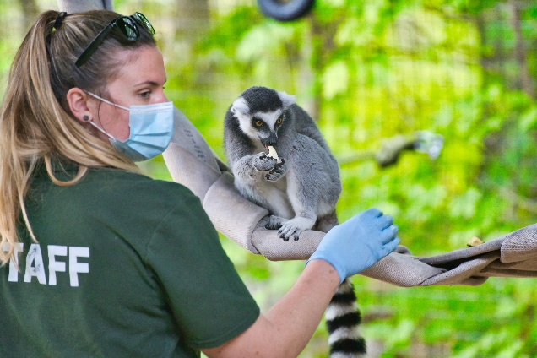 |  | 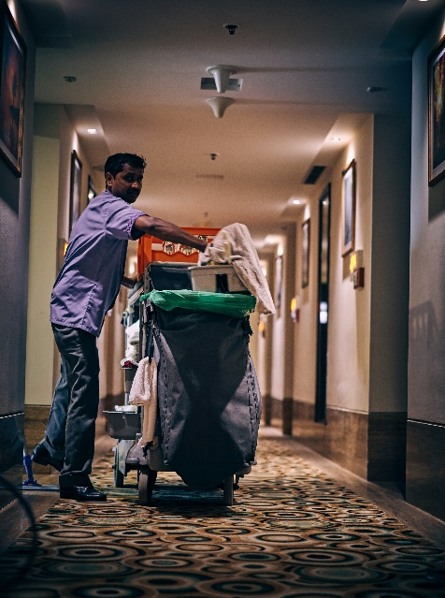
 |  | 

For example: make coffee; use a cash register, restock shelves, weigh ingredients, sew on buttons, vacuum, change bed linen, write a list on the white board, or greet people.

1d. To get you started thinking about different kinds of practices (the expected qualities or ways of working for volunteers and employees) please complete the word find below:

O | N | J | U | N | E | T | R | U | S | T | W | O | R | T | H | Y
R | N | C | P | O | L | F | O | C | U | S | E | D | B | K | I | M
G | C | O | L | L | B | O | R | A | T | I | V | E | M | R | A | U
A | P | O | S | I | T | I | V | E | Y | L | D | N | E | I | R | F
N | L | P | A | O | E | T | P | O | L | C | E | A | R | I | S | O
I | C | E | R | D | S | L | E | P | O | L | N | I | E | N | U | D
S | O | R | E | D | C | A | E | T | Y | U | T | R | S | N | R | E
E | N | A | L | E | F | U | C | I | A | F | H | E | P | O | I | T
D | S | T | I | N | L | P | R | M | L | T | U | S | E | V | A | A
C | I | I | A | I | E | A | E | I | E | H | S | P | C | A | F | C
O | S | V | B | M | X | T | A | S | O | G | I | O | T | T | T | I
N | T | E | L | R | I | I | T | T | E | U | A | N | F | I | R | D
F | E | B | E | E | B | E | I | I | N | O | S | S | U | V | K | E
I | N | C | M | T | L | N | V | C | K | H | T | I | L | E | I | D
D | T | H | D | E | E | T | E | I | E | T | I | B | E | F | N | I
E | R | R | E | D | H | O | N | E | S | T | C | L | N | A | D | A
N | D | I | L | H | E | L | P | F | U | L | E | E | V | A | R | B
T | P | S | L | P | R | O | F | E | S | S | I | O | N | A | L | E

Enthusiastic | Patient | Focused | Thoughtful | Trustworthy | Cooperative
Determined | Curious | Respectful | Kind | Friendly | Positive
Helpful | Responsible | Consistent | Loyal | Organised | Reliable
Fair | Honest | Optimistic | Flexible | Confident | Friendly
Innovative | Dedicated | Brave | Creative | Professional | Collaborative

1e. What might be some expected practices for jobs like the ones in the photos?

 |  | 

For example: work well in a team, be on time, follow safety rules, ask questions if you’re unsure, be hard-working, have good communication skills, or tidy up before you leave.

1f. Brainstorm some of the different kinds of skills needed for your role at your workplace.

1g. Brainstorm different kinds of practices expected of you in your role at your workplace.

Assessment – Part 2
2a. Identify skills and practices you need for your role at your workplace.
My role at ____________________________________________________________________
is ___________________________________________________________________________
Skills I need to use to do my job include: | Expected practices at my workplace include:
For example, using the 3D printer, cleaning and topping up our machines, or folding the napkins and setting the tables. | For example, starting my shift on time, wearing a high-vis safety vest, owning up if I make mistakes, being honest, or being respectful to everyone.

2b. For this assessment you need evidence that you have applied at least five different basic skills and expected practices. Think about what evidence could be collected of your mahi/work.
  Feedback or report from your manager |   Keep a work log, or journal
  Regular reporting to your supervisor | 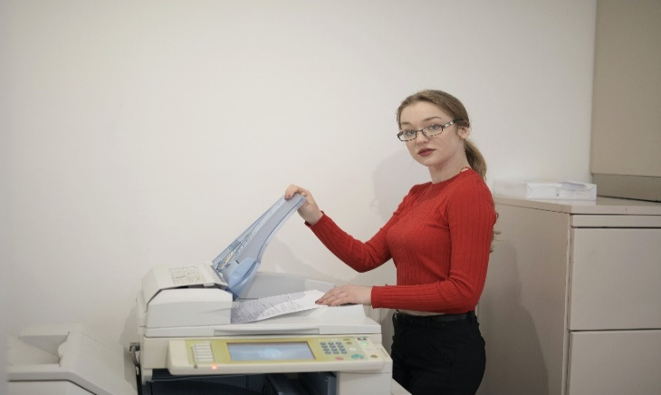  Photo/video evidence of your mahi/work

2c. Evidence may include a work log, workplace feedback, and/or attestation by the employer. What kind of evidence could be collected for these skills and expected practices?
Skills and expected practices | Is it a skill or an expected practice?  Highlight/circle one | What kind of evidence could be collected for these example skills and expected practices?
Top up petrol and oil in the machinery. | SPECIFIC SKILL  or  EXPECTED PRACTICE | - Photo or video evidence  - work log or journal  - workplace feedback or report  - something else:  ___________________________________________
Write down or record customer orders. | SPECIFIC SKILL  or  EXPECTED PRACTICE | - Photo or video evidence  - work log or journal  - workplace feedback or report  - something else:  ___________________________________________
Co-operate with others. | SPECIFIC SKILL  or  EXPECTED PRACTICE | - Photo or video evidence  - work log or journal  - workplace feedback or report  - something else:  ___________________________________________
Ask questions if unsure. | SPECIFIC SKILL  or  EXPECTED PRACTICE | - Photo or video evidence  - work log or journal  - workplace feedback or report  - something else:  ___________________________________________

Assessment – Part 3
3a. You now need to discuss and decide with your supervisor or manager which five different basic skills and expected practices (at least one each) they will look to verify you have applied in a workplace context (in accordance with workplace requirements and the Health and Safety at Work Act 2015). The plan can be recorded here:

To be completed with the supervisor or manager who will verify your mahi/work.
Which specific skills and expected practices are going to be assessed? | Are they skills or practices? | What kind of evidence will be collected in relation to the application of these skills and expected practices? | Verifier to initial and date to confirm this plan
 | SPECIFIC SKILL  or  EXPECTED PRACTICE | - photo or video evidence  - work log or journal  - workplace feedback or report  - something else:
 | SPECIFIC SKILL  or  EXPECTED PRACTICE | - photo or video evidence  - work log or journal  - workplace feedback or report  - something else:
 | SPECIFIC SKILL  or  EXPECTED PRACTICE | - photo or video evidence  - work log or journal  - workplace feedback or report  - something else:
 | SPECIFIC SKILL  or  EXPECTED PRACTICE | - photo or video evidence  - work log or journal  - workplace feedback or report  - something else:
 | SPECIFIC SKILL  or  EXPECTED PRACTICE | - photo or video evidence  - work log or journal  - workplace feedback or report  - something else:

3b. Your supervisor or manager needs to verify that there is evidence of at least five different basic skills and expected practices (at least one each) which have been applied in a workplace context, and that health and safety practices have been applied in accordance with workplace requirements and the Health and Safety at Work Act 2015.

Verification to be completed by the supervisor or manager.

Specific skills and expected practices successfully demonstrated in accordance with workplace requirements and the Health and Safety at Work Act 2015 | Specific skills or expected practices? | What kind of evidence has been collected in relation to the application of these skills and expected practices? | Initial and date to verify these skills and practices have been successfully demonstrated
 | SPECIFIC SKILL  or  EXPECTED PRACTICE | - photo or video evidence  - work log or journal  - workplace feedback or report  - something else:
 | SPECIFIC SKILL  or  EXPECTED PRACTICE | - photo or video evidence  - work log or journal  - workplace feedback or report  - something else:
 | SPECIFIC SKILL  or  EXPECTED PRACTICE | - photo or video evidence  - work log or journal  - workplace feedback or report  - something else:
 | SPECIFIC SKILL  or  EXPECTED PRACTICE | - photo or video evidence  - work log or journal  - workplace feedback or report  - something else:
 | SPECIFIC SKILL  or  EXPECTED PRACTICE | - photo or video evidence  - work log or journal  - workplace feedback or report  - something else:
Supervisor or manager to sign:
I verify that there is evidence of at least five different basic skills and expected practices (at least one each) which have been applied in a workplace context, and that health and safety practices have been applied in accordance with workplace requirements and the Health and Safety at Work Act 2015.
Supervisor or manager signature and date: ____________________________________________
Employee signature:______________________________________________________________

OUTCOMES AND PERFORMANCE CRITERIA

Outcome 1: Apply basic skills and practices in a workplace context.
Range: workplace context may include but is not limited to – voluntary, community, paid employment.

Performance criteria:
  - Basic skills and practices, including completing allocated tasks, are applied in accordance with the instructions received.
Range: evidence of five different applications are required, which includes at least one skill and one practice.

1.2 Health and safety practices are applied in accordance with workplace requirements and the Health and Safety at Work Act 2015.

ĀKONGA/LEARNER EVIDENCE - Name: _____________________________________

Workplace supervisor or manager has verified that there is evidence of at least five different basic skills and expected practices (at least one each) which have been applied in a workplace context. | Workplace supervisor or manager has verified that health and safety practices have been applied in accordance with workplace requirements and the Health and Safety at Work Act 2015.
Achieved ☐ Not Achieved ☐ | Achieved ☐ Not Achieved ☐

Overall Performance Outcome: Achieved ☐ Not Achieved ☐
  - Assessor’s Attestation:
I confirm the following:
- the ākonga/learner has adequacy of knowledge and performance.
- the assessment complied with relevant health and safety, and legislative requirements.
- the ākonga/learner’s likely repeatable competence in the future.
Overall comments

Name: |  | Signature:
Date: |  | Position Held:

