**Supported Learning Assessment Support Material**

|  |  |  |  |  |  |
| --- | --- | --- | --- | --- | --- |
| **Unit standard** | 29311 | | | | |
| **Title** | Act in accordance with the basic rights and responsibilities needed for work | | | | |
| **Level** | 1 | **Credits** | 8 | **Version** | 3 |

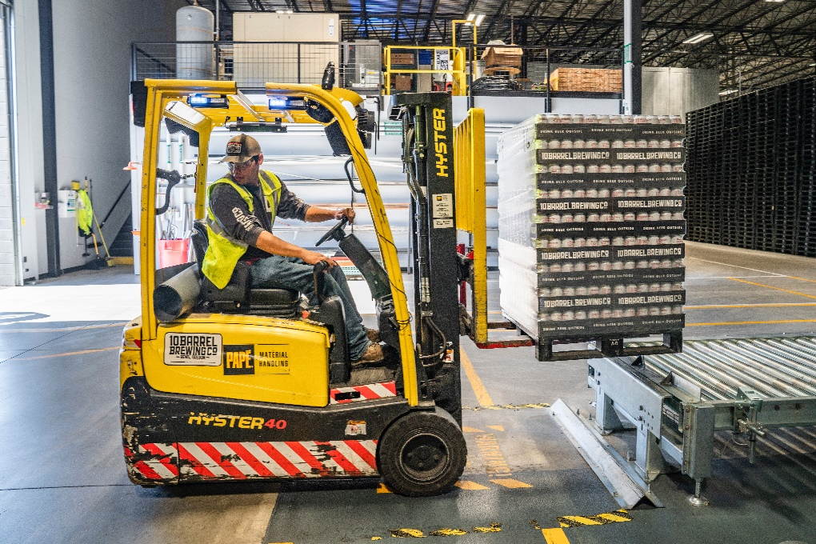

Assessor Guidelines

|  |
| --- |
| The following guidelines are supplied to enable assessors to carry out valid and consistent assessment using this internal assessment resource.   1. See Generic Resources and Guidelines at <https://www.nzqa.govt.nz/providers-partners/assessment-and-moderation-of-standards/assessment-of-standards/generic-resources/> |

|  |
| --- |
| GENERAL   1. This unit standard is intended for ākonga/learners with learning disabilities, including those with intellectual disability. They are people who require support with their learning either through additional resources, specialised equipment or adapted teaching programmes. 2. This unit standard contributes to the *New Zealand Certificate in Skills for Living for Supported Learners (Level 1)* [Ref: 2853].   ASSESSMENT   1. The assessments must be at Level 1 of the New Zealand Qualifications and Credentials Framework (NZQCF). For information go to The Level descriptors for the NZQCF - <https://www2.nzqa.govt.nz/qualifications-and-standards/about-new-zealand-qualifications-credentials-framework/level-descriptors-nzqcf/> 2. The assessors must be satisfied that the ākonga/learner can demonstrate competence against the unit standard, with minimal support towards increased independence. The assessor must sign an attestation in the Ākonga/learner Guidelines to confirm that all the work done is the ākonga/learner’s own. 3. To ensure assessment conditions and assessor judgement are consistent and fair, assessors must be Supported Learning teachers who understand the assessment requirements. Learning support and/or teacher aides may be used to support a ākonga/learner with gathering and verifying of evidence. 4. This resource exemplifies assessment of learning for one unit standard. However, it is highly recommended that this standard be assessed in conjunction with other Supported Learning unit standards to allow for a thematic approach. This would make the learning more meaningful to ākonga/learners in their own social, cultural, family/whanau, community and/or work contexts. 5. This assessment resource provides examples of how assessments could be presented. These assessment tasks may need to be altered to suit the learning styles and additional needs of the ākonga/learner. 6. Sample answers have been developed to guide assessors. However, it is important to note that ākonga/learner’s answers will vary depending on the individual. Assessors should also be aware that sample answers are not provided for all questions, and that they may need to develop their own examples for some assessment parts.   GATHERING OF EVIDENCE   1. A variety of approaches should be considered for the gathering of evidence, which may involve the use of digital technology – internet; laptop/ tablet e.g. iPad/cell phone, and augmentative communication; and use of a reader/writer or enlarged print, where appropriate for the ākonga/learner and context. 2. All evidence such as videos, audio, pictures etc. must be attached to the ākonga/learner’s paper-based copy of the Ākonga/learner Guidelines, when moderation is required, thus verifying the ākonga/learner’s own work. If the ākonga/learner is unable to record the answers on their paper-based copy, their Supported Learning Teacher or Teacher aide must do so. If the ākonga/learner is part of a group when carrying out tasks, the assessment evidence must reflect the ākonga/learner’s ability to achieve each task independently. 3. Evidence collected for this assessment can be attributed to the ākonga/learner through its natural occurrence, in real life contexts and collected over an extended timeframe. A verifiers checklist is acceptable if accompanied by evidence that includes examples from the ākonga/learner’s performance. 4. For evidence requirement 1.2, evidence of demonstration of basic responsibilities and requirements can be verified by the workplace supervisor. This may include a work log, workplace feedback, and/or attestation by the employer.   **REFERENCES**   1. Work and Your Rights in NZ – People First, www.peoplefirst.org.nz/   The Health and Safety in Employment Act 1992 (under reform).  Employment Relations Act 2000. |

|  |
| --- |
| BEFORE THE ASSESSMENT  Over the weeks prior to this assessment, ākonga/learners must have had sufficient teaching and learning opportunities to be familiar with the following:   * Basic rights of an employee identified in accordance with the employment relations Act 2000 and employee agreements and contracts. These may include: * Provision of a safe working environment * Induction and support * Fair treatment of employees * Being paid at least the minimum wage rate * Rest and meal breaks * Sick Leave * Bereavement Leave * Basic responsibilities needed for work – the roles, duties, and the functions that an employee is accountable for as stated by the employer. These may include: * Being punctual * Explaining absences * Adhering to agreed hours of work * Completion of tasks * Following work policies and procedures * Behaving reasonably * Acting in good faith and with honesty. * Keeping themselves and others safe. |

|  |
| --- |
| PRE-ASSESSMENT ACTIVITY  To prepare ākonga/learners for the assessment, an activity immediately before the assessment task is recommended. This could be setting the scene and providing a scenario which assist ākonga/learners to relate the assessment task to a meaningful, real context.  Ākonga/learners may also need terminology or concepts unpacked for them, so they have a better understanding of what is required. However, pre-assessment activities tasks may not lead the ākonga/learner to the answers. Ākonga/learners must still independently demonstrate their competency against this standard. |

**Evidence and Judgement** **Guidance**

|  |  |  |  |  |  |
| --- | --- | --- | --- | --- | --- |
| **Unit standard** | 29311 | | | | |
| **Title** | Act in accordance with the basic rights and responsibilities needed for work | | | | |
| **Level** | 1 | **Credits** | 8 | **Version** | 3 |

|  |  |
| --- | --- |
| Outcome 1Act in accordance with the basic rights and responsibilities needed for work | |
| 1.1 Basic employee rights are identified in accordance with the Employment Relations Act 2000 and employment agreement  Range: may include but are not limited to – provision of a safe working environment, induction and support, fair treatment of employees. | |
| Evidence for Achievement | Judgements for Achievement |
| **Part 1**  At least **four employee** **rights** are identified in accordance with the ākonga/learner’s specific employment agreement for their workplace. | The **four rights** identified are in accordance with the Employment Relations Act 2000 and a workplace agreement in Aotearoa New Zealand. |
| 1.2 Work responsibilities demonstrated are relevant to the specific workplace and in accordance with the basic rights of an employee.  Range*:* may include but are not limited to – being punctual, explaining absences, following workplace protocol. | |
| Evidence for Achievement | Judgements for Achievement |
| **Part 2**  Ākonga/learner identifies **responsibilities** employers can expect from employees in their workplace.  **Part 3**  Workplace supervisor verifies that the ākonga/learner has demonstrated at least **four agreed workplace responsibilities**. | The **four** **responsibilities** that are evidenced are relevant to the ākonga/learners place of work and in accordance with the basic of rights of an employee.  Evidence is verified by a workplace supervisor. |

**Act in accordance with the basic rights and responsibilities needed for work**

|  |
| --- |
| **Instructions for the ākonga/learner:** |

|  |
| --- |
| 1. **Do ALL parts of this assessment.** 2. **Ask your assessor if you need help to understand something better.** 3. **Answer in a way that is easiest for you (e.g. drawing, recording voice memos, speaking to your helper, taking photos).** |

|  |  |
| --- | --- |
| **Conditions of Assessment** | |
|  | * You will complete all parts of the assessment (with support if required). * Part Two of the assessment will be completed by the workplace supervisor. * The assessment will take place over a timeframe set by the assessor. * Assessments should be carried out in situations that are limited in range, repetitive, and familiar and employed within closely defined contexts. They should be conducted in authentic situations that are relevant to the ākonga/learner’s day-to-day living that may include but is not limited to workplace setting or within the community. |

**Act in accordance with the basic rights and responsibilities needed for work**

**Assessment Task**

You will carry out this assessment at your place of work:

* Complete Part 1 and Part 2 on your own (with support if required).
* The supervisor or manager will need to complete Part 3 with or for the ākonga/learner.

This assessment task has three parts:

Examples provided for learners in the SG are included in the AG in blue. Additional examples are provided in red in the AG for the assessor. These examples are not necessarily representative of the general expectation of learner ability. They are designed to help explain the requirements of the task and provide ideas for planning and teaching.

**Act in accordance with the basic rights and responsibilities needed for work**

**Assessment – Part 1**

For this assessment you need to **identify at least four basic employee rights** in accordance with the Employment Relations Act 2000 and your employment agreement and you need to **demonstrate at least four work responsibilities** relevant to your workplace context.

**1a.** The **workplace context** should be beyond the school gates and may include but is not limited to – voluntary, community, and paid employment. Please record some information about your place of work and your role:

What is the name of your place of work? What type of organisation is it?

|  |
| --- |
| *For example: ‘Pete’s Pets’, which is a pet store.* |

What is your job title or role at work? What kinds of duties do you have?

|  |
| --- |
| *For example: Customer Service. I have to greet the customers, help them to find what they are looking for, make recommendations, and process payment for their purchases.* |

What is the name and role of the manager or supervisor who will be your assessor?

|  |
| --- |
| *For example: Peter Rutherford, Manager ‘Pete’s Pets’.* |

**‘Rights’** are **freedoms you are entitled to**. Examples of **employee** **rights** may include but are not limited to – provision of a safe working environment, induction and support, and fair treatment as an employee. **Your rights are protected by law**.

**‘Work responsibilities’** are **expectations the employer has of you as an employee** in relation to your role, and in accordance with your employment agreement. Examples of ‘work responsibilities may include but are not limited to – being punctual, explaining absences, following workplace protocol, and being respectful.

These activities are not required to pass the assessment, but to get you started thinking about what we mean by **‘rights’**.

**1b.** Create a poster or collage of the difference between **‘wants’ and ‘needs’**. For example, a kitten might be something you would like, but it’s not something you need.

**1c.** If you were working as a cleaner, what sorts of things might you need and what would you want that wasn’t necessary but would be great to have?

Put a circle around the items that might be needed to work as a house cleaner and put a cross through the items you think are nice to have, but not necessary for the job.

**1d.** Thinking about your workplace and your job, what are the kinds of ‘wants’ and ‘needs’ you have?

|  |  |
| --- | --- |
| **WANTS** | **NEEDS** |
| *For example: your favourite music playing.* | *For example: equipment and safety gear.* |

**1e.** Think about the kinds of **‘rights’** employees have. Share your ideas with a partner.

**1f.** Carry out some research into employee rights and the Employment Relations Act 2000 and note some of the resources used:

|  |
| --- |
| *e.g. Employment New Zealand Learning Modules* <https://employment.elearning.ac.nz> |

**1g.** What are some of your **rights** as an employee? Please **identify at least four basic employee rights** in accordance with the Employment Relations Act 2000 and your employment agreement:

|  |
| --- |
| **1.** |
| **2.** |
| **3.** |
| **4.** |

**Assessment – Part 2**

For this assessment you need to demonstrate **at least four work responsibilities** relevant to your workplace context.

**2a.** Think about the sort of **responsibilities** people might have as employees. Work with a partner or in a small group to brainstorm some of the different kinds of **responsibilities** employees have that employers might expect.

|  |
| --- |
|  |

**2b.** Circle or highlight below any **responsibilities** that your employer expects of you in terms of your current role with them:

|  |  |  |
| --- | --- | --- |
| GET TO WORK ON TIME | ACT IN GOOD FAITH | BE HONEST |
| WEAR SAFETY GEAR | RESPECT PRIVACY | SAY IF YOU WILL BE AWAY |
| STAY FOCUSED ON TASK | BEHAVE REASONABLY | WEAR A UNIFORM |
| BE RESPECTFUL | KEEP OTHERS SAFE | FOLLOW PROCEDURES |

**2c.** For this assessment you need **evidence** that you have **demonstrated at least four responsibilities** relevant to your workplace context. Think about what evidence could be collected of your mahi/work.

|  |  |
| --- | --- |
| **A person sitting at a table with a computer  Description automatically generatedFeedback or report from your manager** | **A person writing on a paper  Description automatically generated with low confidenceKeep a work log, or journal** |
| **A person and person looking at a folder  Description automatically generatedRegular reporting to your supervisor** | **A person in a red shirt  Description automatically generatedPhoto/video evidence of your mahi/work** |

**2d.** Evidence may include a work log, workplace feedback, and/or attestation by the employer. What kind of evidence could be collected to show demonstration of these responsibilities?

|  |  |
| --- | --- |
| **Workplace responsibilities** | **What kind of evidence could be collected for these example skills and expected practices?** |
| *Wear the correct PPE (Personal Professional Equipment) safety gear when at work and working.* | * Photo or video evidence  * work log or journal * workplace feedback or report * something else:   ___________________________________________ |
| *Be careful in your mahi (work) so that your work is of a high quality.* | * Photo or video evidence * work log or journal * workplace feedback or report * something else:   **Positive customer feedback**  ___________________________________________ |
| *Act in good faith, being honest, having integrity, and working without hidden motives.* | * Photo or video evidence * work log or journal * workplace feedback or report  * something else:   ___________________________________________ |
| *Work the negotiated days and hours (starting and finishing on time and taking breaks as agreed).* | * Photo or video evidence * work log or journal  * workplace feedback or report * something else:   ___________________________________________ |

**Assessment – Part 3**

**3a.** You now need **to discuss and decide with your supervisor or manager** which **four responsibilities** they will look to verify that you have applied in a workplace context. **The plan can be recorded here**:

To be completed **with** the supervisor or manager who will verify your mahi/work.

|  |  |  |
| --- | --- | --- |
| **Which responsibilities are going to be assessed?** | **What evidence will be collected to show you have demonstrated these responsibilities?** | **Verifier to initial and date to confirm this plan** |
|  | * photo or video evidence * work log or journal * workplace feedback or report * something else: |  |
|  | * photo or video evidence * work log or journal * workplace feedback or report * something else: |  |
|  | * photo or video evidence * work log or journal * workplace feedback or report * something else: |  |
|  | * photo or video evidence * work log or journal * workplace feedback or report * something else: |  |

Supervisor/manager signature and date: _______________________________________

Employee signature:_______________________________________________________

**3b.** **Your supervisor or manager needs to verify that there is evidence that you have demonstrated at least four agreed workplace responsibilities.**

**Verification to be completed by the supervisor or manager.**

|  |  |  |
| --- | --- | --- |
| **Which workplace responsibilities were assessed?** | **What evidence will be collected to show these responsibilities were demonstrated?** | **Verifier to initial and date to confirm responsibilities demonstrated** |
|  | * photo or video evidence * work log or journal * workplace feedback or report * something else: |  |
|  | * photo or video evidence * work log or journal * workplace feedback or report * something else: |  |
|  | * photo or video evidence * work log or journal * workplace feedback or report * something else: |  |
|  | * photo or video evidence * work log or journal * workplace feedback or report * something else: |  |

**Supervisor or manager to sign:**

*I verify that there is evidence of at least four responsibilities have been demonstrated in the workplace context.*

Supervisor or manager signature and date: _____________________________________

Employee signature:___________________________________

|  |  |  |  |  |  |  |  |
| --- | --- | --- | --- | --- | --- | --- | --- |
| **OUTCOMES AND PERFORMANCE CRITERIA**  **Outcome 1:** Act in accordance with the basic rights and responsibilities needed for work.  **Performance criteria:**   * 1. Basic employee rights are identified in accordance with the Employment Relations Act 2000 and employment agreement. Range may include but are not limited to – provision of a safe working environment, induction and support, fair treatment of employees; **four rights are identified**.   **1.2** Work responsibilities demonstrated are relevant to the specific workplace and in accordance with the basic rights of an employee. Range responsibilities may include but are not limited to – being punctual, explaining absences, following workplace protocol; **four responsibilities are demonstrated.**  **ĀKONGA/LEARNER EVIDENCE** - Name: _____________________________________   |  |  | | --- | --- | | **At least four basic employee rights have been identified in accordance with the Employment Relations Act 2000 and employment agreement.** | **At least four work responsibilities relevant to the specific workplace and in accordance with the basic rights of an employee, have been demonstrated.** | | Achieved  Not Achieved | Achieved  Not Achieved | | | | |
| **Overall Performance Outcome: Achieved  Not Achieved** | | | |
| **Assessor’s Attestation:**  I confirm the following:   * the ākonga/learner has adequacy of knowledge and performance. * the assessment complied with relevant health and safety, and legislative requirements. * the ākonga/learner’s likely repeatable competence in the future. | | | |
| **Overall comments** | | | |
| **Name:** |  | **Signature:** |  |
| **Date:** |  | **Position Held:** |  |