Supported Learning Assessment Support Material

Unit standard | 32929
Title | Maintain routines in a limited range of repetitive and familiar situations within defined contexts
Level | 1 | Credits | 5 | Version | 1



Ākonga/learner Guidelines
ĀKONGA/LEARNER’S INFORMATION
First and last name
NSN number
Date

Maintain routines to a limited range of repetitive and familiar activities within defined contexts
Instructions for the ākonga/learner
- Do ALL parts of this assessment.
- Ask your assessor if you need help to understand something better.
- Answer in a way that is easiest for you (e.g. drawing, recording voice memos, speaking to your helper, taking photos).

Conditions of Assessment
 | You will complete Part One of the assessment (with support if required).  Part Two of the assessment will be carried out with the assessor.  The assessor will specify the timeframe each routine in the assessment needs to be maintained over.  The assessor will unpack examples provided before you start the assessment tasks.  The assessor will make sure assessments are carried out in authentic situations that are relevant to your day-today living, limited in range, repetitive, and within closely defined contexts. Settings could include workplace, educational setting or within the community.


Maintain routines to a limited range of repetitive and familiar activities within defined contexts

Assessment Task
This assessment task as two parts. You will be asked to:

Assessment – Part 1
1a. Routines are commonplace tasks, chores, or duties performed at regular intervals, e.g. daily or weekly. You might have these routines at home, work, school, with whānau/family, with your friends or out in the local community. Some examples of routines people might have include having a shower, making the bed, getting a haircut, shaving, training in the gym, sports practice, drama rehearsals, or going to a class or course regularly. There are more examples here:

  Daily mindful meditation |   Visit the library on Tuesdays |   Eat a salad every day
Get to my classes on time   |   Youth group on Fridays | 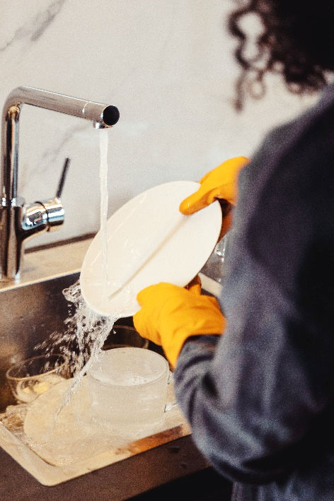  Wash the dishes each day
  Brush my teeth twice a day |   Swim two days a week | 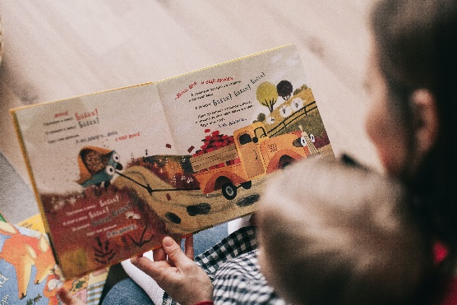  Read before bed each night

1b. Make notes (in words or pictures) of some of the routines you already have…

Some of the routines you have might just be patterns of behaviour that you have picked up for no particular reason. It might not matter if you changed those routines. For example, you might always put your left shoe on before your right shoe, but it probably wouldn’t matter if you switched them. Other routines are required because it is essential, for example you might always walk home the same way each day, and you have to do that because otherwise you might not remember the way.

For this assessment, you need to:
- Identify five routines which you have require or have a need for in different situations.
- Consider any health and safety risks, and how to address any of these issues.
- Identify at least one strategy per routine that would support you to manage your time well.
- Demonstrate that you can maintain (keep up) these routines for at least a month or up to six months, depending on the type of routine.
- Have evidence that you have demonstrated these five routines safely, using strategies to support you to manage time, and that the routines supported your needs in different situations.

Putting our classroom devices on to charge after using them, which would mean I would be less frustrated by them running out of battery.
Eating lunch every day because it would help me have energy for the rest of the day.
Ideas for ROUTINES that would help me to meet my needs.
1b. Since you need to identify routines in terms of purpose or need, start by thinking about your needs, and brainstorm ideas for routines that could help you to meet your needs.

1c. Review the ideas you came up with for 1b. (above) and circle or highlight the five routines you are going to demonstrate which will help you to meet your needs.
1d. Are there any health and safety risks you need take into consideration for your routines? Below are some of the health and safety risks that might need to be considered for different routines. Add your routines and any potential risks there might be and how you will address them.
ROUTINE | POTENTIAL RISK | HOW TO ADDRESS RISK
Catch the bus to school. | Catch the wrong bus. | Nan to take me to the bus.
Playing basketball at the park. | Getting home late. | Set an alarm for leaving time.
Charging device after use. | Dropping device. | Put device down then plug it in.

1e. Sometimes it is difficult to keep going with new routines. Korero/discuss with the people around you, the different strategies you could use to help you to maintain your routines. Use the kupu/words below to complete the cloze exercise. Fill in the gaps with some of the strategies people use to maintain routines.

One strategy you can use to help you maintain routines is to make a __________-_____________ to keep track of your progress. Another thing you can do is to get someone to support you to limit ___________________________ so you can stay focused. You might want to ________________ what order each of the steps should go in for some of the routines. You could also set some __________________ and decide how you are going to _____________________________ your success. You could ____________________________ the most important tasks. For some routines, you might
need to set a _____________________ so you know how long you have been working – or you might like to set an ___________________ so you know when to start or finish.
PRIORITISE | PLAN | DISTRACTIONS
GOALS | CELEBRATE | TIMER
STAR-CHART | STEPS | ALARM

You need to maintain these routines over a period of time and have evidence that you have demonstrated them in accordance with health and safety practice. You also need to show that you have used strategies to support effective time management. Consider how you will record this evidence, for example:

  Keep notes on your device |   Keep a journal or diary
  Regular reporting to your teacher |   Photo or video evidence

1f. What are some other ways you can think of that you could use to collect evidence for this assessment?

Contexts and situations

A ‘situation’ is a set of circumstances or a location/place). For each of your chosen routines you need to think about whether there are any risks to health and safety that you would need to work around. You also need to identify strategies that you can use to help you to maintain your routines.

FIVE  ROUTINES | PURPOSE/NEED MET BY ROUTINE | CONTEXT/SITUATION FOR THE ROUTINE | HEALTH & SAFETY CONSIDERATIONS | STRATEGIES TO MAINTAIN ROUTINE | EVIDENCE YOU WILL COLLECT
Example:  Greeting classmates when I first see them each day. | Purpose/Need:  Building better relationships with people in my class. | Context/Situation:  Classroom at school. | Health & Safety:  Might upset someone if I am too loud, so I will stand back from them. | Strategies:  Stand by the door so I can greet people as they enter the classroom. | Evidence:  The teacher aide can take a video clip of me greeting people.
Routine 1: | Purpose/Need: | Context/Situation: | Health & Safety: | Strategies: | Evidence:
Routine 2: | Purpose/Need: | Context/Situation: | Health & Safety: | Strategies: | Evidence:
Routine 3: | Purpose/Need: | Context/Situation: | Health & Safety: | Strategies: | Evidence:
Routine 4: | Purpose/Need: | Context/Situation: | Health & Safety: | Strategies: | Evidence:
Routine 5: | Purpose/Need: | Context/Situation: | Health & Safety: | Strategies: | Evidence:

2b. Now you need to put your plan into action. Your assessor will need to sign off the following:
- Five routines identified in terms of purpose and need.
- The five routines were demonstrated and maintained in accordance with health and safety practices.
- Strategies were identified to help manage time and maintain each of the routines.
- These routines were maintained over a period of time to show time management.

ĀKONGA/LEARNER HAS IDENTIFIED FIVE ROUTINES  IN TERMS OF PURPOSE/NEED |  | ROUTINE CARRIED OUT  IN ACCORDANCE WITH  HEALTH & SAFETY PRACTICES | STRATEGIES IDENTIFIED  TO MANAGE TIME AND  MAINTAIN ROUTINE | EVIDENCE THAT ROUTINES MANAGED OVER A PERIOD OF TIME TO SHOW TIME MANAGEMENT
Routine 1: ākonga/learner has identified routine in terms of purpose/need: |  | Routine carried out in accordance with health & safety practices: | Strategies identified to manage time and maintain routine: | Evidence routines managed over a period of time to show time management:
Routine 2: ākonga/learner has identified routine in terms of purpose/need: |  | Routine carried out in accordance with health & safety practices: | Strategies identified to manage time and maintain routine: | Evidence that routines managed over a period of time to show time management:
Routine 3: ākonga/learner has identified routine in terms of purpose/need: |  | Routine carried out in accordance with health & safety practices: | Strategies identified to manage time and maintain routine: | Evidence routines managed over a period of time to show time management:
Routine 4: ākonga/learner has identified routine in terms of purpose/need: |  | Routine carried out in accordance with health & safety practices: | Strategies identified to manage time and maintain routine: | Evidence routines managed over a period of time to show time management:
Routine 5: ākonga/learner has identified routine in terms of purpose/need: |  | Routine carried out in accordance with health & safety practices: | Strategies identified to manage time and maintain routine: | Evidence routines managed over a period of time to show time management:

Assessor Name, Signature and Date:

________________________________________________________________________________________

OUTCOMES AND PERFORMANCE CRITERIA

Outcome 1: Maintain routines in a limited range of repetitive and familiar situations within defined contexts.

Range: Contexts for routines may include but are not limited to – home, work, study, family/whānau, social, community.

Performance Criteria:

1.1 - Routines are identified in terms of purpose and/or need.
Range: Evidence of five routines is required.

1.2 - Routines are demonstrated to meet the purpose in accordance with health and safety practices.
Range: Evidence of five routines in different situations is required.

1.3 - Strategies to maintain routines are identified to show time management.
Range: Evidence of one strategy for each identified routine.

1.4 - Routines identified are maintained over a period of time to show time management.

ĀKONGA/LEARNER EVIDENCE - Name: ________________________
Purpose/Needs - Routines are identified in terms of purpose and need.  Evidence that purpose and/or need established for each of the five routines. | Health & Safety - Routines are demonstrated to meet the purpose in accordance with health and safety practices.  Evidence of five routines established safely in different situations. | Strategies -  Strategies to maintain routines are identified to show time management.  Evidence at least one strategy used to manage time effectively for each of five routines. | Routines demonstrated -  Routines identified are maintained over a period of time to show time management.  Evidence that routines have been maintained over time.
Achieved ☐ Not Achieved ☐ | Achieved ☐ Not Achieved ☐ | Achieved ☐ Not Achieved ☐ | Achieved ☐ Not Achieved ☐

Overall Performance Outcome: Achieved ☐ Not Achieved ☐
Overall comments:

  - Assessor’s Attestation:
I confirm the following:
- the ākonga/learner has adequacy of knowledge and performance.
- the assessment complied with relevant health and safety practices.
- the ākonga/learner’s likely repeatable competence in the future.

Assessor  Name: |  | Assessor Signature:
Date: |  | Position Held:

