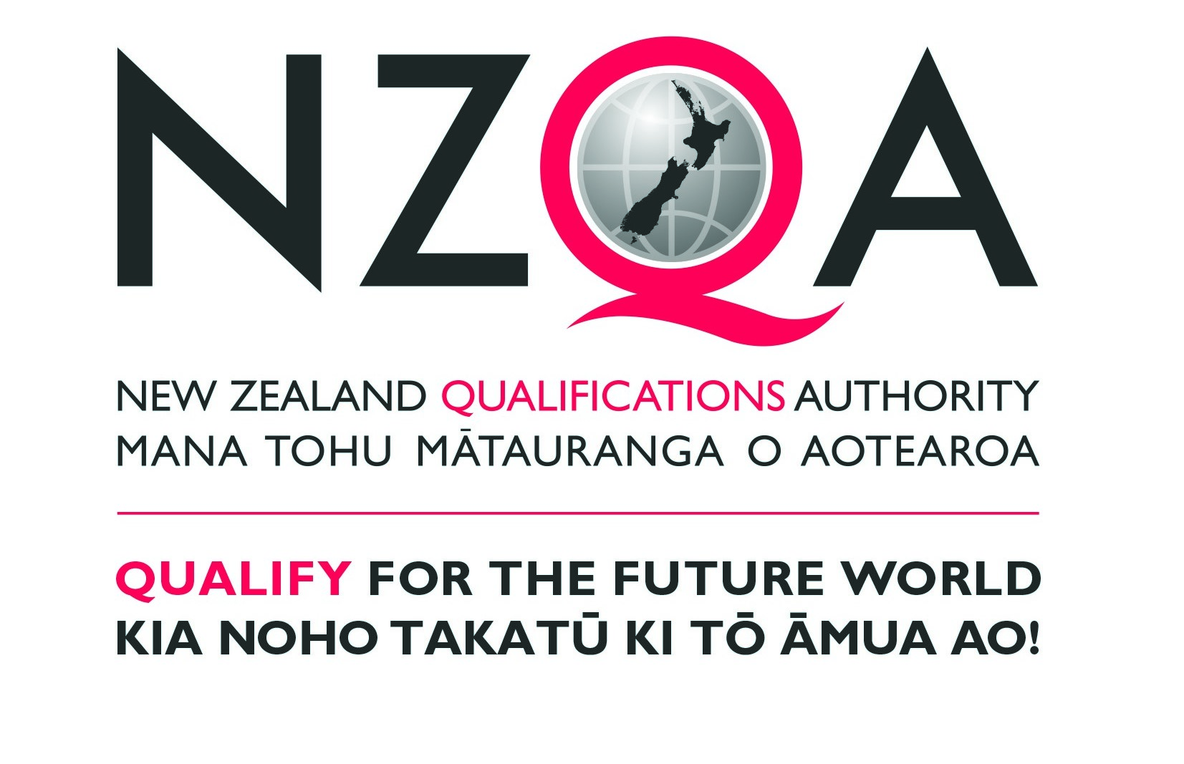

Feedback form for issues with unit standards

NZQA invites you to give feedback on any NZQA-managed unit standards your organisation has assessed against.

This feedback can inform interpretation guidelines and/or be used when standards are reviewed.

Please email this form to National Qualifications Services at nqs@nzqa.govt.nz or Māori Qualifications Services at mqs@nzqa.govt.nz.

Organisation name:
Contact name:
Contact email:
Date:

Unit  standard number | Interpretation issue(s)  Please specify explanatory/special note, outcome/element, evidence requirements/performance criterion, credit, level etc and the nature of the issue(s). | Suggested solution(s)

