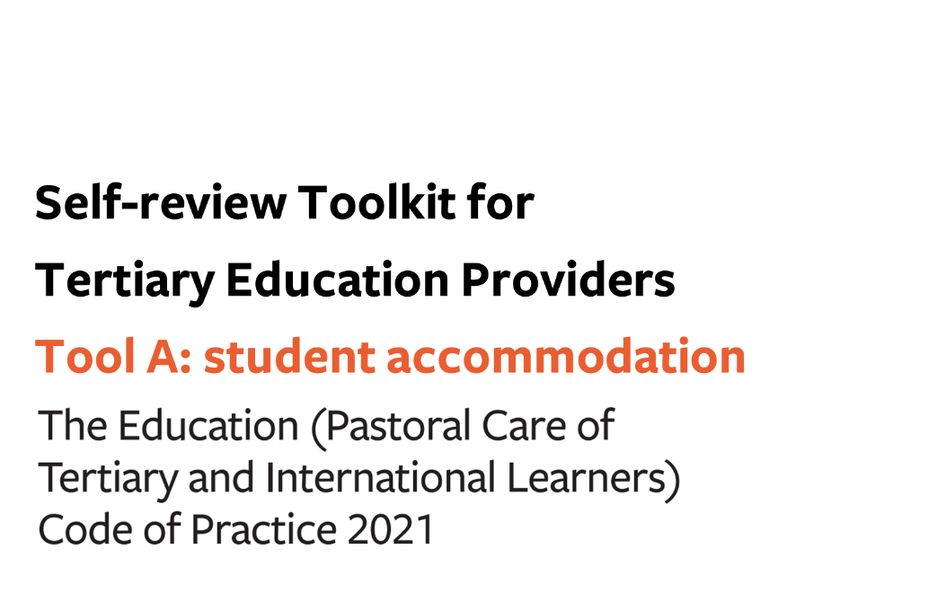
Contents
Tool A: gap analysis – student accommodation 3
Additional wellbeing and safety practices in tertiary student accommodation (in relation to domestic and international tertiary learners) 4
Outcome 5: A positive, supportive and inclusive environment in student accommodation 4
Outcome 6: Accommodation administrative practices and contracts 10
Outcome 7: Student accommodation facilities and services 14

Tool A: gap analysis – student accommodation

This optional tool sets out the areas of practice you need to review to check your compliance with the Code.
You can use this tool to help you:
- Prepare for a gap analysis, by identifying the information you need to evidence your compliance with the Code at each clause
- Make sense of your gathered information, by noting any gaps in your current practice and/or evidence of current practice.

KEY
COMPLIANT | - We have the required practices in place  - We have sufficient evidence on which to make judgements about the effectiveness of our practices
GAP (in evidence) | - We have the required practices in place but…  - …we have limited evidence on which to make judgements about the effectiveness of those practices
GAP (in practice) | - We do not have the required practices in place

You may combine this part with the others of Tool A relating to All Tertiary Education Providers (Outcomes 1-4) and/or International Learners (Outcomes 8-12).

Use the links below to download any additional pages as required:
- All Tertiary Education Providers
- International Tertiary Learners

Additional wellbeing and safety practices in tertiary student accommodation (in relation to domestic and international tertiary learners)

Outcome 5: A positive, supportive and inclusive environment in student accommodation
Providers must ensure that student accommodation promotes and fosters a supportive and inclusive community which support the wellbeing and safety of residents.

Phase in the gap analysis process: | PREPARE | MAKE SENSE
Key required processes | Information we can gather to use as evidence of our compliance with this clause | COMPLIANT | GAP  (in evidence) | GAP  (in practice)
Process 1: Information and promotional activities

Clause 24 (1).
Providers must ensure student accommodation has practices for –
- ensuring residents receive clear, sufficient, accurate and transparent information and advice about the type and nature of student accommodation and services provided; and
- using information provided by prospective residents at the time of application, to help plan their transition into student accommodation; and
- working with residents to develop and provide information and tools that help residents understand their responsibilities within a communal living environment, including those relating to diversity; and
- providing residents with learning and peer support, and information on –
  - self-care and positive wellbeing and safety; and
  - how to access wellbeing services on campus and in the community; and
  - how to provide peer support to other residents; and
- providing residents with information and advice on what action to take in an emergency and the mechanisms for reporting incidents and raising health and safety concerns.
Clause 24 (2).
The information required by this clause must be readily available, accessible, and promoted to residents.
Process 2: Accommodation staff

Clause 25.
Providers must ensure that –

- accommodation staff are provided with ongoing training and resources that are appropriate for their role as set out in clause 10(2); and
- the experience and training of accommodation staff is appropriate for the type and nature of accommodation that is being provided; and
- there is managerial oversight of accommodation staff at all times (24 hours a day, 7 days a week) so that issues can be escalated when they occur; and
- the level of live-in accommodation staffing provides appropriate oversight and support for residents based on the type and nature of accommodation (for example, a higher level of staffing for halls of residence primarily intended for first-year learners); and
- there is ongoing wellbeing support for accommodation staff.
Process 3: Accommodation staff must be fit and proper persons

Clause 26.
Providers must take all reasonable steps to ensure that each member of the accommodation staff –
- is suitable for employment in student accommodation; and
- are the subject of a Police vet where required under the Children’s Act 2014 if the accommodation includes learners who are under 18.
Process 4: Proactive monitoring of residents’ wellbeing and safety and responsive wellbeing and safety practices.

Clause 27 (1).
Providers must ensure student accommodation has practices for –

- working with residents to evaluate their needs and planning how these can be reasonably and practicably met and monitored; and
- having clearly defined processes within the student accommodation for –

  - residents, staff, or visitors to be able to report a cause for concern about a resident’s behaviour; and
  - referring and responding to instances of resident behaviours that are a risk to self or others; and
- having appropriate welfare safeguards, including –

  - developing and implementing a welfare management plan for residents assessed as being at risk, that includes welfare checks and which could include referral to external services; and
  - systems to regularly check that residents continue to be active within their student accommodation and, if a resident is identified as being at risk, developing and implementing a welfare management plan; and
  - appropriate arrangements for residents under 18, including for effective communication with a parent or legal guardian regarding wellbeing and safety; and
  - welfare checks, which may be undertaken where reasonable in the circumstances (this information must be clearly set out in the house rules for residents); and
  - routine checks providing 24 hours’ notice to a resident if staff members will be entering a resident’s room.
Clause 27 (2).
Providers must have a link between student accommodation and its organisation’s wider information gathering and communication system described in clause 10(1), to report any emerging concerns about a resident’s wellbeing or their behaviour, so residents can be connected quickly to the appropriate services.
Clause 27 (3).
Providers must ensure that there is a critical incident and emergency procedures manual in student accommodation which –

- is consistent with the provider’s wider organisational manual described in clause 10(3)(e); and
- includes plans for residents when it becomes unsuitable or unsafe for them to remain in student accommodation in an emergency.
Process 5: A safe and inclusive residential community

Clause 28.
In addition to the requirements described in outcome 3, providers must ensure student accommodation has practices for –

- ensuring that house rules are clear, reasonable, and accessible to residents, and that they promote and encourage –

  - resident safety; and
  - a sense of community and association with fellow residents; and
  - learning and personal growth; and
  - residents and staff working together to ensure a positive and respectful community; and
- working with residents to –

  - develop and improve house rules; and
  - develop and maintain appropriate initiatives to build a sense of community within student accommodation; and
  - promote responsible social behaviour and academic success.

Outcome 6: Accommodation administrative practices and contracts
Providers must ensure that student accommodation contracts and practices are transparent, reasonable, and responsive to the wellbeing and safety needs of residents.

Phase in the gap analysis process: | PREPARE | MAKE SENSE
Key required processes | Information we can gather to use as evidence of our compliance with this clause | COMPLIANT | GAP  (in evidence) | GAP  (in practice)
Process 1: General principles

Clause 30.
Providers must ensure that student accommodation providers have practices that include –

- disclosing on its website –
  - the ownership structure and operator details of its student accommodation arrangements; and
  - the details of the wellbeing and safety practices offered at each student accommodation facility; and
- a human resource strategy which –

  - requires the job descriptions for all accommodation staff to clearly describe –
    - the duties and responsibilities of the role in relation to the learner wellbeing and safety; and
    - the relevant competencies and attributes that a person must demonstrate to be able to fulfil that role, and the ongoing training that will be available to develop these competencies; and
  - sets out the support services that are available to ensure the wellbeing and safety of accommodation staff in carrying out their duties and responsibilities.
Process 2: Student accommodation contracts.

Clause 31 (1).
Providers must ensure that a student accommodation contract with a resident –

- is clear, accessible and concise; and
- sets out the responsibilities of the provider and the resident; and
- advises residents of the requirements for –

  - information sharing across the provider; and
  - the regular processes for checking on residents; and
- sets out the deposit, bond components, fees, refund policy and penalties; and
- sets out the complaints, conflict resolution, and disciplinary processes in relation to residents.
Clause 31 (2).
Providers must ensure that the student accommodation contract used with residents is reviewed and updated regularly to ensure it remains fit for purpose in relation to wellbeing and safety matters, taking into account the views of learners and their representative bodies.
Clause 31 (3).
Providers must ensure student accommodation refund policies –

- are reasonable; and
- provide residents (or a parent or legal guardian of residents under 18 years) with sufficient information to understand their rights and obligations under those refund policies.
Clause 31 (4).
Providers must ensure student accommodation providers give prospective residents a copy of the house rules, and information about the complaints process and the Dispute Resolution Scheme before they sign the accommodation contract.
Clause 31 (5).
Providers must ensure that accommodation providers keep a log of complaints received from residents concerning a breach or breaches of this code in relation to student accommodation and make this log available to the residents.

Outcome 7: Student accommodation facilities and services
Providers must ensure that student accommodation facilities and services are maintained to a standard sufficient to support residents’ wellbeing and safety and educational success.

Phase in the gap analysis process: | PREPARE | MAKE SENSE
Key required processes | Information we can gather to use as evidence of our compliance with this clause | COMPLIANT | GAP  (in evidence) | GAP  (in practice)
Process:

Clause 33 (1).
Providers must ensure that student accommodation facilities and services –

- respond effectively to the diverse needs of residents and make necessary adjustments where practicable; and
- provide accessible spaces for a range of interests, activities and needs; and
- are secure, clean, dry, warm, comfortable, accessible, and is conducive to study and a variety of learning styles; and
- provide utilities, services and other facilities that are adequate and appropriate for the character and size of the residential community; and
- have appropriate insurance cover; and
- are funded adequately to carry out strategic goals and strategic plans for student accommodation, including repairs, replacement, and improvements; and
- have adequate and appropriate controls in place to ensure accountability for financial processes including –
  - providing receipts for all financial transactions with the resident; and
  - providing residents with up-to-date information on what they owe to the accommodation provider.
Clause 33 (2).
Providers must ensure that any alterations, maintenance and repairs to student accommodation are undertaken in a timely manner that minimises interference with the quiet enjoyment of the residents.

