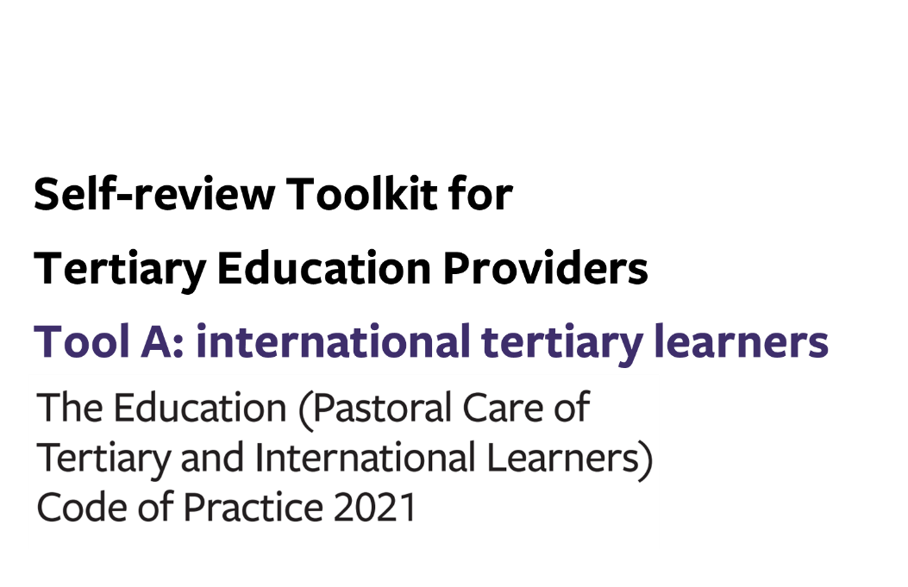
Contents
Tool A: gap analysis – international tertiary learners 3
Additional wellbeing and safety practices for tertiary providers (signatories) enrolling international learners 4
Outcome 8: Responding to the distinct wellbeing and safety needs of international tertiary learners 4
Outcome 9: Prospective international tertiary learners are well informed 5
Outcome 10: Offer, enrolment, contracts, insurance and visa 9
Outcome 11: International learners receive appropriate orientations, information and advice 17
Outcome 12: Safety and appropriate supervision of international tertiary learners 20

Tool A: gap analysis – international tertiary learners

This optional tool sets out the areas of practice you need to review to check your compliance with the Code.
You can use this tool to help you:
- Prepare for a gap analysis, by identifying the information you need to evidence your compliance with the Code at each clause
- Make sense of your gathered information, by noting any gaps in your current practice and/or evidence of current practice.

KEY
COMPLIANT | - We have the required practices in place  - We have sufficient evidence on which to make judgements about the effectiveness of our practices
GAP (in evidence) | - We have the required practices in place but…  - …we have limited evidence on which to make judgements about the effectiveness of those practices
GAP (in practice) | - We do not have the required practices in place

You may combine this part with the others of Tool A relating to All Tertiary Education Providers (Outcomes 1-4) and/or Student Accommodation (Outcomes 5-7).

Use the links below to download any additional pages as required:
- All Tertiary Education Providers
- Student Accommodation

Additional wellbeing and safety practices for tertiary providers (signatories) enrolling international learners

Outcome 8: Responding to the distinct wellbeing and safety needs of international tertiary learners
Signatories must ensure that practices under this code respond effectively to the distinct wellbeing and safety needs of their diverse international tertiary learners.
Phase in the gap analysis process: | PREPARE | MAKE SENSE
Key required processes | Information we can gather to use as evidence of our compliance with this clause | COMPLIANT | GAP  (in evidence) | GAP  (in practice)
Process 1:

Clause 35.
Signatories must engage with diverse international tertiary learners to understand their wellbeing and safety needs under the outcomes of Parts 3, 4 and 5 of this code.

Outcome 9: Prospective international tertiary learners are well informed
Signatories ensure that prospective international tertiary learners receive clear, accessible, accurate and sufficient information, and make informed choices about the study and services a signatory provides before they begin their study.

Phase in the gap analysis process: | PREPARE | MAKE SENSE
Key required processes | Information we can gather to use as evidence of our compliance with this clause | COMPLIANT | GAP  (in evidence) | GAP  (in practice)
Process 1: Marketing and promotion

Clause 37.
Each signatory must have marketing and promotion practices, that include –

- proactively seeking to understand the information needs of prospective international tertiary learners; and
- developing and providing information to prospective international tertiary learners and reviewing the information to ensure it is kept up to date; and
- ensuring that prospective international tertiary learners receive, as a minimum, up-to-date accessible and timely information about the following –

  - the signatory’s quality assurance evaluations; and
  - the educational instruction, staffing, facilities, and equipment available to international tertiary learners; and
  - the Dispute Resolution Scheme; and
  - potential learning outcomes for international tertiary learners, including pathways for further study, employment, and residency where applicable; and
  - estimated study and living costs for international tertiary learners, including any additional fees or levies that are on top of the basic tuition fee; and
  - accommodation and transport, or ways to obtain such information.
Process 2: Managing and monitoring education agents

Clause 38.
Signatories must have practices for effectively managing and monitoring the performance and conduct of education agents in relation to learner safety and wellbeing under this code, including –

- carrying out and recording reference checks on potential education agents to ensure as far as possible that they are not involved in any conduct that is false, misleading, deceptive, or in breach of the law; and
- entering into written contracts with each of its education agents; and
- during the term of a contract, monitoring the activities and performance of its education agents in relation to –
  - their obligations as specified in the contract; and
  - whether they provide prospective and enrolled international tertiary learners with reliable information and advice about studying, working, and living in New Zealand; and
  - whether they act with integrity and professionalism in their dealings with prospective and enrolled international tertiary learners; and
  - whether they have engaged in any activity or conduct that, in the opinion of the signatory, is or may be in breach of the law or that jeopardises the signatory’s compliance with this code; and
- managing the education agents by –

  - terminating contracts with an agent if there is evidence which, on balance of probabilities, shows that the education agent –
    - has been involved in any serious, deliberate, or ongoing conduct that is false, misleading, deceptive, or in breach of the law; or
    - has jeopardised the signatory’s compliance with this code; or
  - taking appropriate action to address misconduct by act or an omission by an education agent in relation to the other matters described in subclause (c); and
- ensuring that its education agents have access to, and maintain, up-to-date information relevant to their duties as specified in the contracts with the signatory.

Outcome 10: Offer, enrolment, contracts, insurance and visa
Signatories must have practices for enabling learners to make well-informed enrolment decisions in relation to the educational outcomes being sought by the learner and ensuring that all relevant parties are clear about their interests and obligations prior to entering into the enrolment contract.

Phase in the gap analysis process: | PREPARE | MAKE SENSE
Key required processes | Information we can gather to use as evidence of our compliance with this clause | COMPLIANT | GAP  (in evidence) | GAP  (in practice)
Process 1: Offer of educational instruction

Clause 40.
Signatories must ensure that the educational instruction offered to international tertiary learners is in accordance with the Act and is appropriate for international tertiary learners’ expectations, English language proficiency, academic ability, and the educational outcomes being sought.
Process 2: Information to be provided before entering contract

Clause 41 (1).
Signatories must have practices that ensure prospective international tertiary learners (or the parents or legal guardian of international students under 18 years) receive, as a minimum, accurate, timely and tailored information about the following before entering into a contract with the learner –

- the most recent results of their evaluations by education quality assurance agencies; and
- quality improvement or compliance notices and conditions imposed under the Act that the code administrator directs must be disclosed to prospective international tertiary learners; and
- the education provided and its outcome, for example, whether a qualification is granted; and
- refund conditions that comply with the process in clause 46; and
- staffing, facilities, and equipment; and
- available services and supports; and
- insurance and visa requirements for receiving educational instruction from the signatory; and
- this code and the relevant Dispute Resolution Scheme Rules; and
- full costs related to an offer of educational instruction.
Clause 41 (2).
Each signatory must ensure that, before entering into a contract of enrolment or enrolling with the signatory, each international tertiary learner (or the parents or legal guardian of international students under 18 years) is informed of the learner’s rights and obligations in relation to receiving educational instruction from the signatory, including the rights under this code.
Process 3: Contract of enrolment

Clause 42 (1).
Each signatory must ensure that a contract of enrolment is entered into between the signatory and each international tertiary learner (or the parents or legal guardian of international students under 18 years) that includes the following information and terms –

- clear information about the beginning and end dates of enrolment; and
- the grounds for terminating the contract of enrolment; and
- the circumstances under which the learner’s conduct may be in breach of the contract of enrolment; and
- the type of disciplinary action short of termination of the contract of enrolment, that may be taken by the signatory against the student (for example suspension or exclusion); and
- the process that the signatory must follow when seeking to terminate the contract of enrolment under paragraph (b) or to take disciplinary action under paragraph (d).

Clause 42 (2).
Each signatory must ensure that the contract of enrolment is fair and reasonable.
Process 4: Disciplinary action

Clause 43.
Any process undertaken under clause 42(1)(e) for terminating the contract of enrolment under clause 42(1)(b) or for taking disciplinary action under clause 42(1)(d) must be in accordance with the principles of natural justice (which includes those necessary to ensure the prompt, considered, and fair resolution of the matter that is the subject of the action).
Process 5: Insurance

Clause 44 (1).
Each signatory must have practices that ensure, as far as practicable, each international tertiary learner who is enrolled with the signatory for educational instruction of 2 weeks’ duration or longer has appropriate insurance covering –

- the international tertiary learner’s travel –
  - to and from New Zealand; and
  - within New Zealand; and
  - if the travel is part of the educational instruction, outside New Zealand; and
- medical care in New Zealand, including diagnosis, prescription, surgery, and hospitalisation; and
- repatriation or expatriation of the international tertiary learner as a result of serious illness or injury, including cover of travel costs incurred by family members assisting repatriation or expatriation; and
- death of the international tertiary learner, including cover of –
  - travel costs of family members to and from New Zealand; and
  - costs of repatriation or expatriation of the body; and
  - funeral expenses.
Clause 44 (2).
Subclause (1)(a)(i) and (ii) includes the international tertiary learner’s travel to and from their country of origin or citizenship before their educational instruction begins and after it ends (which may be outside of the enrolment period).
Clause 44 (3).
Subclause (1)(a)(i) does not include the international tertiary learner’s travel to other countries unless that travel is primarily for the purpose of embarking on connecting flights to and from New Zealand.
Process 6: Immigration matters

Clause 45.
Signatories must have practices that as far as possible will ensure that international tertiary learners are entitled to study in New Zealand under the Immigration Act 2009, including –

- ensuring that each international tertiary learner who enrols with the signatory has the necessary immigration status for study in New Zealand; and
- reporting to Immigration New Zealand known or suspected breaches of visa conditions by international tertiary learners; and
- notifying Immigration New Zealand of terminations of enrolment.
Process 7: Student fee protection and managing withdrawal and closure

Clause 46 (1).
Signatories must ensure that –

- fees paid by international tertiary learners are secure and protected in the event of student withdrawal or the ending of educational instruction or the closure of a signatory; and
- its refund policies are fair and reasonable; and
- it provides its international tertiary learners (or the parents or legal guardian of international tertiary learners under 18 years) with sufficient information to understand their rights and obligations under those refund policies.
Clause 46 (2).
A refund policy must include refund conditions for the following situations –

- failure by an international tertiary learner to obtain a study visa; and
- voluntary withdrawal by an international tertiary learner; and
- the signatory ceasing to provide a course of educational instruction as contracted with an international tertiary learner, whether as the result of a decision by the signatory or as required by an education quality assurance agency; and
- the signatory ceasing to be a signatory; and
- the signatory ceasing to be a provider.
Clause 46 (3).
In the situation in subclause (2)(c) or (d), the tertiary signatory must deal with fees paid for services not delivered or the unused portion of fees paid as follows –

- refund the amount in question to the international tertiary learner (or the learner’s parent or legal guardian); or
- if directed by the international tertiary learner or the code administrator or the agency responsible for fee protection mechanisms, transfer the amount agreed with the student (or the student’s parent or legal guardian if the student is under 18 years) to another signatory.

Outcome 11: International learners receive appropriate orientations, information and advice
Signatories must ensure that international tertiary learners have the opportunity to participate in well-designed and age-appropriate orientation programmes and continue to receive relevant information and advice to support achievement, wellbeing and safety.

Phase in the gap analysis process: | PREPARE | MAKE SENSE
Key required processes | Information we can gather to use as evidence of our compliance with this clause | COMPLIANT | GAP  (in evidence) | GAP  (in practice)
Process 1: Provision of information

Clause 48.
Signatories must –

- ensure that information and advice provided by the signatory to international tertiary learners is accurate, age-appropriate, up to date and presented in a way that meets the ongoing needs of diverse learners; and
- ensure that ongoing provision of information and advice is appropriate to the needs of the learner (or the parents or legal guardian of international learners under 18 years) within the particular learning, communal and residential context; and
- provide the names and contact details of designated staff members responsible for international tertiary learner support; and
- provide appropriate information relating to health and safety of international tertiary learners (including in relation to any disabilities or impairments a learner may have); and
- provide information about the termination of enrolment; and
- provide information to international tertiary learners (or the parents or legal guardian of international learners under 18 years) about their legal rights and obligations and, where possible, the risks when learners receive or accept advice or services; and
- provide information about the international tertiary learner’s rights and entitlements, including any entitlement to a fee refund, if the learner voluntarily withdraws from the educational instruction; and
- provide each international tertiary learner with full information and advice on –
  - all relevant policies of the signatory; and
  - the services, support, and facilities that the signatory offers; and
  - where applicable, how to adjust to a different cultural environment; and
  - where applicable –

    - minimum wages and labour conditions in New Zealand; and
    - maximum hours of work permitted under visa conditions; and
    - how to access information and support regarding employment; and
    - how to report misconduct by employers; and
- for an international tertiary learner under 18 years ensure where applicable, that any parent, legal guardian, or residential caregiver of the learner has access to the information, advice or programme that has been provided to the learner.

Outcome 12: Safety and appropriate supervision of international tertiary learners
Signatories ensure that international tertiary learners are safe and appropriately supervised in their accommodation and effectively communicate with the parents or legal guardian of learners under 18 years.

Phase in the gap analysis process: | PREPARE | MAKE SENSE
Key required processes | Information we can gather to use as evidence of our compliance with this clause | COMPLIANT | GAP  (in evidence) | GAP  (in practice)
Process 1: International tertiary learners under 18 years

Clause 50.
In relation to international tertiary learners under 18 years, each signatory must have additional practices including –

- not enrolling an international tertiary learner 10 years or older but under 18 years who does not live with a parent or legal guardian unless –

  - the learner is in a properly supervised group of learners whose educational instruction is not for more than 3 months; or
  - the learner is in the care of the manager of tertiary student accommodation covered in Part 5 of this code; or
  - the learner is in the care of a residential caregiver; and
- maintaining effective communications with the parents, legal guardian, or residential caregivers of international tertiary learners concerning their wellbeing and progress in study; and
- ensuring that at least 1 staff member is designated to proactively monitor and address any concerns about international tertiary learners under 18 years; and
- if the international tertiary learner is in the care of a residential caregiver, –

  - ensuring that a plan is in place for the transfer of care of the learner from the residential caregiver to the learner’s parent or legal guardian, or another person approved by the parent or legal guardian, for –

    - each transfer that occurs during the period of enrolment; and
    - the transfer that occurs at the end of enrolment; and
  - ensuring that the parent or legal guardian is notified of each transfer plan.
Process 2: International tertiary learners under 10 years

Clause 51 (1).
Each signatory must ensure that its international tertiary learners under 10 years live with a parent or legal guardian
Clause 51 (2).
The requirements in clauses 49 and 50 apply, in addition to this clause, to international tertiary learners who are under 10 years.
Process 3: Decisions requiring written agreement of parent or legal guardian

Clause 52.
Each signatory must ensure that, where appropriate, it obtains the written agreement of the parent or legal guardian of an international tertiary learner under 18 years with respect to decisions affecting the learner.
Process 4: Accommodation for international tertiary learners under 18 years

Clause 53 (1).
In relation to an international tertiary learner under 18 years who is in the care of a residential caregiver while living in accommodation that is not subject to Part 5 of this code, the signatory must –

- ensure that the learner’s accommodation is safe, is in acceptable condition, and meets all regulatory and legislative requirements; and
- ensure that the safety check referred to in clause 54 is completed and is up to date; and
- ensure that an appropriate check is completed and is up to date for each person who is 18 years or over and who resides at the residential caregiver’s accommodation, for the purpose of ensuring the safety of the learner; and
- have a written agreement with the residential caregiver that specifies the role and responsibilities of each party in relation to the care of the learner; and
- maintain effective communication with the learner and the learner’s parent or legal guardian when accommodation issues arise, and take responsibility for addressing those issues, including reporting them to relevant authorities and moving learners to appropriate accommodation; and
- conduct sufficient learner interviews and home visits to monitor and review the quality of residential care, taking into consideration the age of the learner, the length of the stay, and other relevant factors; and
- if the learner’s residential caregiver is a designated caregiver ensure that the parent or legal guardian of the learner has provided written agreement that the designated caregiver will be subject to the signatory’s approval and that the signatory is not responsible for the learner’s day-to-day care when the learner is in the custody of the designated caregiver; and
- if the learner’s residential caregiver is a supervisor described in clause 54(3), ensure that the parent or legal guardian of the learner has provided written agreement that the signatory is not responsible for the learner’s day-to-day care when the learner is in the custody of that supervisor; and
- ensure that there is appropriate separation of international tertiary learners from others of different ages in the accommodation; and
- ensure that the learner is appropriately supervised in the accommodation.
Clause 53 (2).
For the purposes of clause 53(1)(c), a person who is 18 years or over and who resides at the residential caregiver’s accommodation includes a person of that age who –

- temporarily resides at that accommodation; or
- is or will be residing at that accommodation for 1 or more periods in any month (whether or not for valuable consideration), each period of which is 5 or more consecutive nights.
Clause 53 (3).
To avoid doubt, if the residential caregiver is a supervisor described in clause 54(3) or a designated caregiver, the signatory must meet the requirements of this clause and ensure the safety, health, and wellbeing of the international tertiary learner.
Process 5: Safety checks and appropriate checks for learners under 18 years

Clause 54 (1).
The safety check for the residential caregiver referred to in clause 53(1)(b) must include –

- a confirmation of identity; and
- a reference check that includes contacting at least 1 of the following persons or bodies for the purpose of obtaining information that the signatory considers relevant to a risk assessment –

  - the residential caregiver’s current or previous employer, professional body, or registration authority; and
  - the licensing authority that is relevant to the residential caregiver’s business or professional activities; and
  - a person who is not related to the residential caregiver; and
- a police vet, to obtain information that is relevant to a risk assessment; and
- an interview with the residential caregiver, to obtain information that the signatory considers relevant to a risk assessment; and
- a risk assessment that takes into account all of the information that was obtained under paragraphs (a) to (d), to determine whether the residential caregiver poses a risk to the safety of the international tertiary learner; and
Clause 54 (2).
The safety check for the residential caregiver referred to in clause 53(1)(b) is up to date if it is completed within 3 years after the date of the latest safety check.
Clause 54 (3).
Subclause 53(1)(b) to (e) does not apply to a residential caregiver who –

- is a supervisor referred to in paragraph (e) of the definition of residential caregiver in clause 5(1); and
- is not a resident of New Zealand; and
- is travelling with, and accompanying, the international tertiary learner for the purpose of supervising them during the learner’s educational instruction.
Clause 54 (4).
An appropriate check referred to in clause 53(1)(c) is up to date if it is completed within 3 years after the date of the latest check.

Process 6: Accommodation for international tertiary learners 18 or over

Clause 55 (1).
In relation to an international tertiary learner 18 years or over who lives in accommodation provided or arranged by a signatory and not subject to Part 5, the signatory must –

- ensure that the learner’s accommodation is safe, is in acceptable condition, and meets all regulatory and legislative requirements; and
- maintain effective communication with the learner when accommodation issues arise, and must take responsibility for addressing those issues, including reporting them to relevant authorities.
Clause 55 (2).
In this clause, accommodation issues include issues of health and wellbeing arising from a learner’s accommodation or connected with it.

