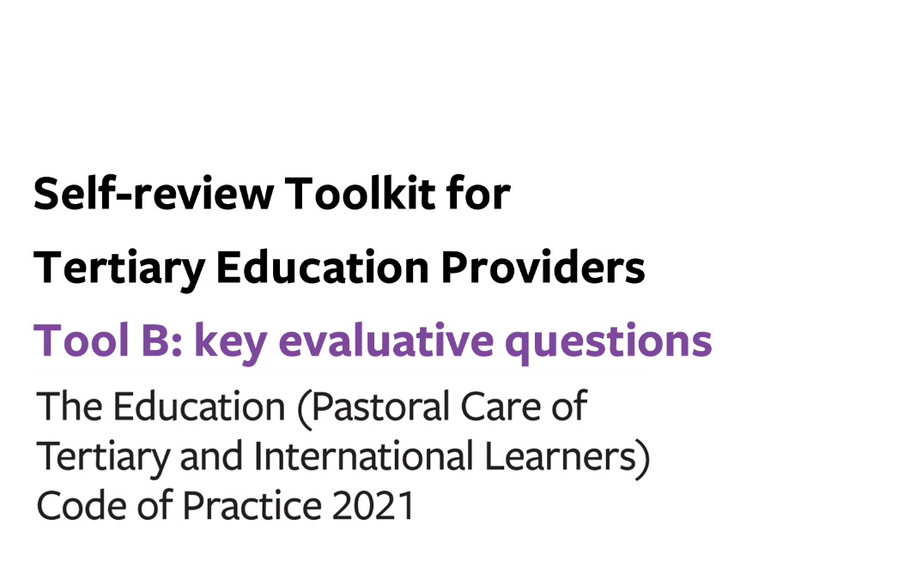
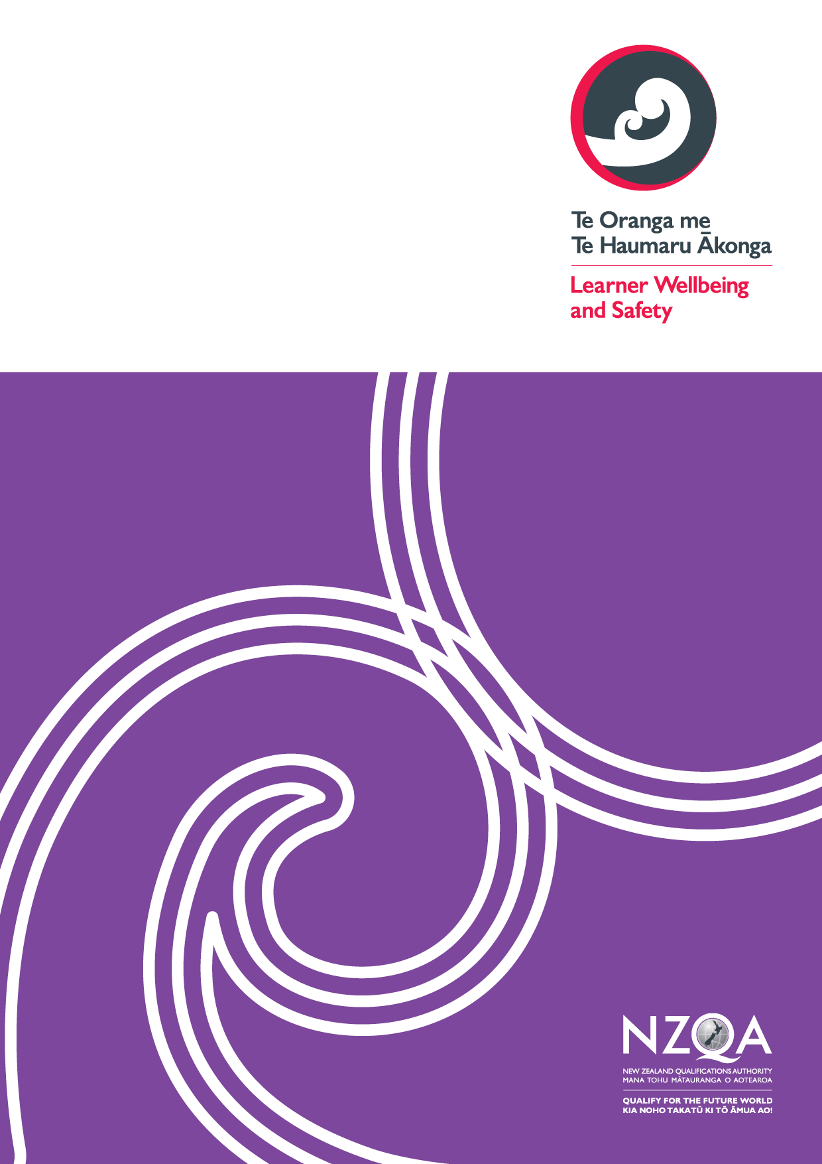
Contents

Tool B: key evaluative questions (the Code) 3
Organisational structures to support a whole-of-provider approach to learner wellbeing and safety 4
Outcome 1: A learner wellbeing and safety system 4
Outcome 2: Learner voice 7
Wellbeing and safety practices for all tertiary providers 9
Outcome 3: Safe, inclusive, supportive, and accessible physical and digital learning environments 9
Outcome 4: Learners are safe and well 11

Tool B: key evaluative questions (the Code)

Use this optional tool to help you make sense of your gathered information in terms of what it tells you about the effectiveness of your current practice in relation to the Code outcomes sought for your learners.
Consider how effectively your organisation is achieving the overarching outcomes, your current strengths, and any opportunities for development.
Indicate what stage your Code implementation is at under each outcome using the continuum of Code implementation in Appendix 1.
If you are a provider with student accommodation or Code signatory, you can insert additional pages into this tool relating to Student Accommodation (Outcomes 5-7) and/or International Tertiary Learners (Outcomes 8-12) after Outcome 4.

Use the links below to download any additional pages as required:
- Student Accommodation
- International Tertiary Learners

Organisational structures to support a whole-of-provider approach to learner wellbeing and safety

Outcome 1: A learner wellbeing and safety system
Providers must take a whole-of-provider approach to maintain a strategic and transparent learner wellbeing and safety system that responds to the diverse needs of their learners.
Stage of implementation for outcome | Well implemented / Implemented / Developing implementation / Early implementation

Process: Strategic goals and strategic plans

KEQ | How effectively? | How do we know? | How can we improve?
How effectively do we work proactively with our learners and stakeholders in the development and review of our learner wellbeing and safety strategic goals and strategic plans?
Process: Self-review of learner wellbeing and safety practices

KEQ | How effectively? | How do we know? | How can we improve?
How effectively do we review the effectiveness of our learner wellbeing and safety practices?

Process: Publication requirements

KEQ | How effectively? | How do we know? | How can we improve?
How effectively do our current practices ensure that we are meeting our Code publication requirements for this outcome?

Process: Responsive wellbeing and safety systems

KEQ | How effectively? | How do we know? | How can we improve?
How effectively do we gather and communicate relevant information across our organisation to accurately identify emerging concerns about learners’ wellbeing and safety or behaviour and quickly connect them to appropriate support services?
How effectively do we provide our staff with ongoing training and resources tailored to their roles in the organisation in relation to the topics required by this process?
How effectively do we assist learners and respond in emergency situations in our learning and/or residential communities?
How effectively do we record, and report information on critical incidents and emergences at our organisation to the relevant stakeholders?

Overall self-review - Outcome 1: A learner wellbeing and safety system

KEQ | How effectively? | How do we know? | How can we improve?
How effectively do we take a whole-of-provider approach to maintain a strategic and transparent learner wellbeing and safety system that responds to the diverse needs of our learners?
How effectively do we access and use learner voice to understand the impact of our learner wellbeing and safety practices for this outcome?
How effectively does our organisation uphold the principles of Te Tiriti o Waitangi throughout our learner wellbeing and safety practices for this outcome?
How effectively do our current practices for this outcome align with our organisational learner wellbeing and safety strategic goals and strategic plans?

Outcome 2: Learner voice
Providers understand and respond to diverse learner voices and wellbeing and safety needs in a way that upholds their mana and autonomy.
Stage of implementation for outcome 2 | Well implemented / Implemented / Developing implementation / Early implementation

Process: Learner voice

KEQ | How effectively? | How do we know? | How can we improve?
How effectively do our current practices facilitate engagement with and development of the diverse range of learner voices across our organisation?
Process: Learner complaints

KEQ | How effectively? | How do we know? | How can we improve?
How effectively do we work with learners to effectively respond to, and process complaints?
How effectively do our current practices ensure that our complaints process is easily accessible to learners?
How effectively do our current practices ensure we record, report, and publicise information on complaints and complaints procedures at our organisation?

Process: Compliance with the Dispute Resolution Scheme

KEQ | How effectively? | How do we know? | How can we improve?
How effectively do our current practices ensure we are familiar and compliant with the relevant DRS?

Overall self-review - Outcome 2: Learner voice

KEQ | How effectively? | How do we know? | How can we improve?
How effectively do we understand and respond to diverse learner voices and wellbeing and safety needs in a way that upholds their mana and autonomy?
How effectively do we access and use learner voice to understand the impact of our learner wellbeing and safety practices for this outcome?
How effectively does our organisation uphold the principles of Te Tiriti o Waitangi throughout our learner wellbeing and safety practices for this outcome?
How effectively do our current practices for this outcome align with our organisational learner wellbeing and safety strategic goals and strategic plans?

Wellbeing and safety practices for all tertiary providers

Outcome 3: Safe, inclusive, supportive, and accessible physical and digital learning environments
Providers must foster learning environments that are safe and designed to support positive learning experiences of diverse learner groups.
Stage of implementation for outcome 3 | Well implemented / Implemented / Developing implementation / Early implementation

Process: Safe and inclusive communities

KEQ | How effectively? | How do we know? | How can we improve?
How effectively do our learner wellbeing and safety practices maintain safe and inclusive communities for all learners?
Process: Supporting learner participation and engagement

KEQ | How effectively? | How do we know? | How can we improve?
How effectively do our learner wellbeing and safety practices support learner participation and engagement for all learners?

Process: Physical and digital spaces and facilities

KEQ | How effectively? | How do we know? | How can we improve?
How effectively do our learner wellbeing and safety practices maintain healthy, safe, and accessible physical and digital spaces and facilities for all learners?

Overall self-review - Outcome 3: Safe, inclusive, supportive, and accessible physical and digital learning environments

KEQ | How effectively? | How do we know? | How can we improve?
How effectively do we foster learning environments that are safe and designed to support positive learning experiences of diverse learner groups?
How effectively do we access and use learner voice to understand the impact of our learner wellbeing and safety practices for this outcome?
How effectively does our organisation uphold the principles of Te Tiriti o Waitangi throughout our learner wellbeing and safety practices for this outcome?
How effectively do our current practices for this outcome align with our organisational learner wellbeing and safety strategic goals and strategic plans?

Outcome 4: Learners are safe and well
Providers must support learners to manage their physical and mental health through information and advice and identify and respond to learners who need additional support.
Stage of implementation for outcome 4 | Well implemented / Implemented / Developing implementation / Early implementation

Process: Information for learners about assistance to meet their basic needs

KEQ | How effectively? | How do we know? | How can we improve?
How effectively do we enable all learners and prospective learners to identify and manage their basic needs through accurate, timely and tailored information?
Process: Promoting physical and mental health awareness

KEQ | How effectively? | How do we know? | How can we improve?
How effectively do we assist our learners to manage their physical and mental health and to access support when needed?

Process: Proactive monitoring and responsive wellbeing and safety practices

KEQ | How effectively? | How do we know? | How can we improve?
How effectively do our proactive monitoring and wellbeing and safety practices identify and respond to the support needs of individual learners?

Overall self-review - Outcome 4: Learners are safe and well

KEQ | How effectively? | How do we know? | How can we improve?
How effectively do we support learners to manage their physical and mental health through information and advice?
How effectively do our current practices identify and respond to learners who need additional support?
How effectively do we access and use learner voice to understand the impact of our learner wellbeing and safety practices for this outcome?
How effectively does our organisation uphold the principles of Te Tiriti o Waitangi throughout our learner wellbeing and safety practices for this outcome?
How effectively do our current practices for this outcome align with our organisational learner wellbeing and safety strategic goals and strategic plans?

Appendix 1: Continuum of implementation for the Code
Well-implemented
The Code is well-implemented
 |  | Implemented  The Code is implemented | - Thorough understanding of Code outcomes and requirements across the organisation  - Diverse range of multiple perspectives sought, including robust practices, to reflect learner voice  - Full consideration of Te Tiriti o Waitangi/Treaty of Waitangi and the Treaty principles (including partnership, protection, and participation) when implementing the Code.  - Well-established practices in place to monitor against all Code outcomes and requirements  - Highly effective reporting processes from self-review
 | Developing implementation  Implementation of the Code is underway, yet requires further work | - Sufficient understanding of Code outcomes and requirements across the organisation  - Multiple perspectives sought, including sound practices, to reflect student voice  - Good consideration of Te Tiriti o Waitangi/Treaty of Waitangi and the Treaty principles (including partnership, protection, and participation) when implementing the Code.  - Relevant practices in place to monitor against all Code outcomes and requirements  - Effective reporting processes from self-review
Early stages of implementation  Implementation of the Code has not yet started or requires significant work | - Some understanding of Code outcomes and requirements across the organisation  - Some perspectives sought, including adequate practices, to reflect learner voice  - Some consideration of Te Tiriti o Waitangi/Treaty of Waitangi and the Treaty principles (including partnership, protection, and participation) when implementing the Code.  - Some practices in place to monitor against all Code outcomes and requirements  - Adequate reporting processes from self-review
- No or limited understanding of Code outcomes and requirements across the organisation
- No or limited perspectives sought. Practices to reflect learner voice non-existent or underway
- No or limited consideration of Te Tiriti o Waitangi/Treaty of Waitangi and the Treaty principles (including partnership, protection, and participation) when implementing the Code.
- No or limited practices in place to monitor against all Code outcomes and requirements
- No or limited reporting processes from self-review

