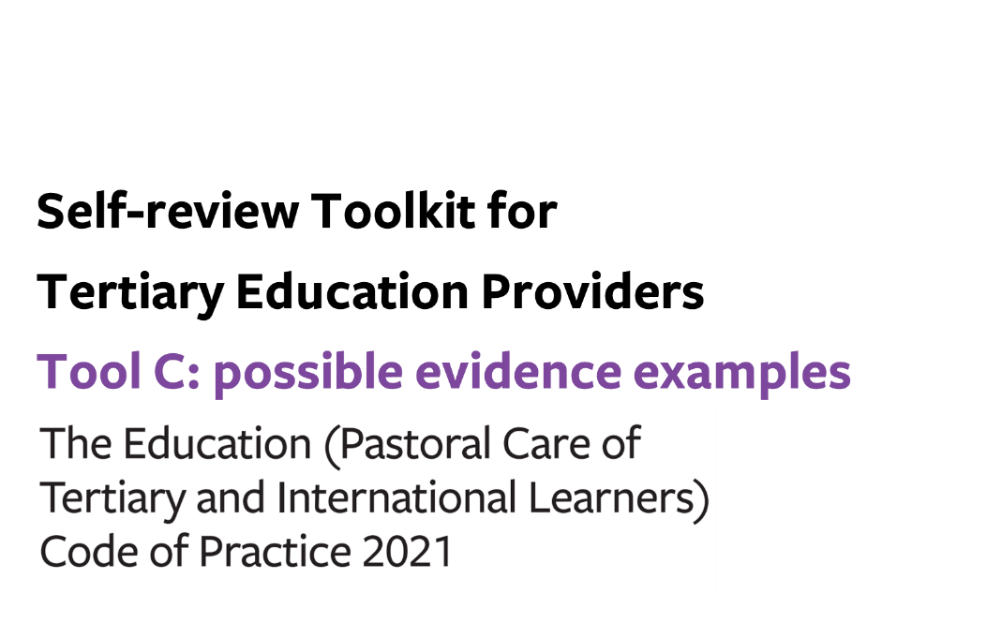

Tool C: possible evidence examples

You can use this optional tool to help you:
- prepare for a gap analysis, by identifying information that could be used to evidence compliance
- gather information to inform your analysis, to ensure that you collect relevant information
Good quality evidence is:
- quantitative and qualitative information gathered systematically from multiple, diverse sources within and connected to your organisation
- directly relevant to the questions your organisation is trying to answer
- vital for evaluating your current practices against the requirements of the Code
- information that enables you to support your rationale for improvement action plans to stakeholders, including Government and learners
Examples of possible evidence are, but not limited to:
- Policies and/or procedures for relevant outcomes, which are regularly reviewed
- Targeted surveys for each outcome from learners and all other relevant stakeholders (e.g. survey outcomes)
- Records of anecdotal feedback gathered from learners and all other relevant stakeholders (e.g. feedback log)
- Plans and records of meetings with learners and/or student leaders (e.g. student union meeting) and all other relevant stakeholders
- Records showing that gathered data and/or feedback are analysed and utilised to improve the implementation of the Code (e.g. annual programme evaluation report)
- Usage log or statistical analysis of services, training, or workshops such as a medical centre, counselling service, and sports facilities (e.g. attendance log, counselling service report)
- Records of staff participation of staff training (e.g. schedule of staff training and attendance)
- Incident register and records of learner/parent complaints with result
- Information provided to learners for relevant outcomes (e.g. learner handbook, house rules, promotional materials and available services (internal and external))
- Emergency procedures / Critical incident plan
- Processes to manage your 24/7 contact and live-in accommodation staff for learners
- Records of monitoring and review of learners’ academic achievement and graduates’ pathways (e.g. end of term course report)
- Relevant contracts (e.g. student accommodation contracts)
- Role descriptions and CVs of relevant staff
- Official documents or certificates issued by government agencies (e.g. building warrant of fitness (BWoF) and code compliance certificates (CCC)

