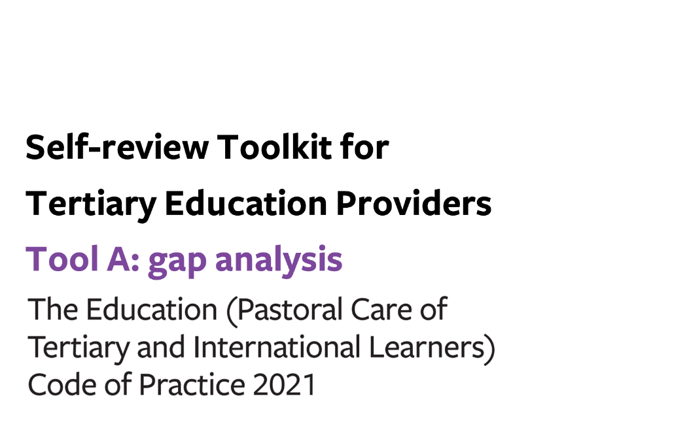
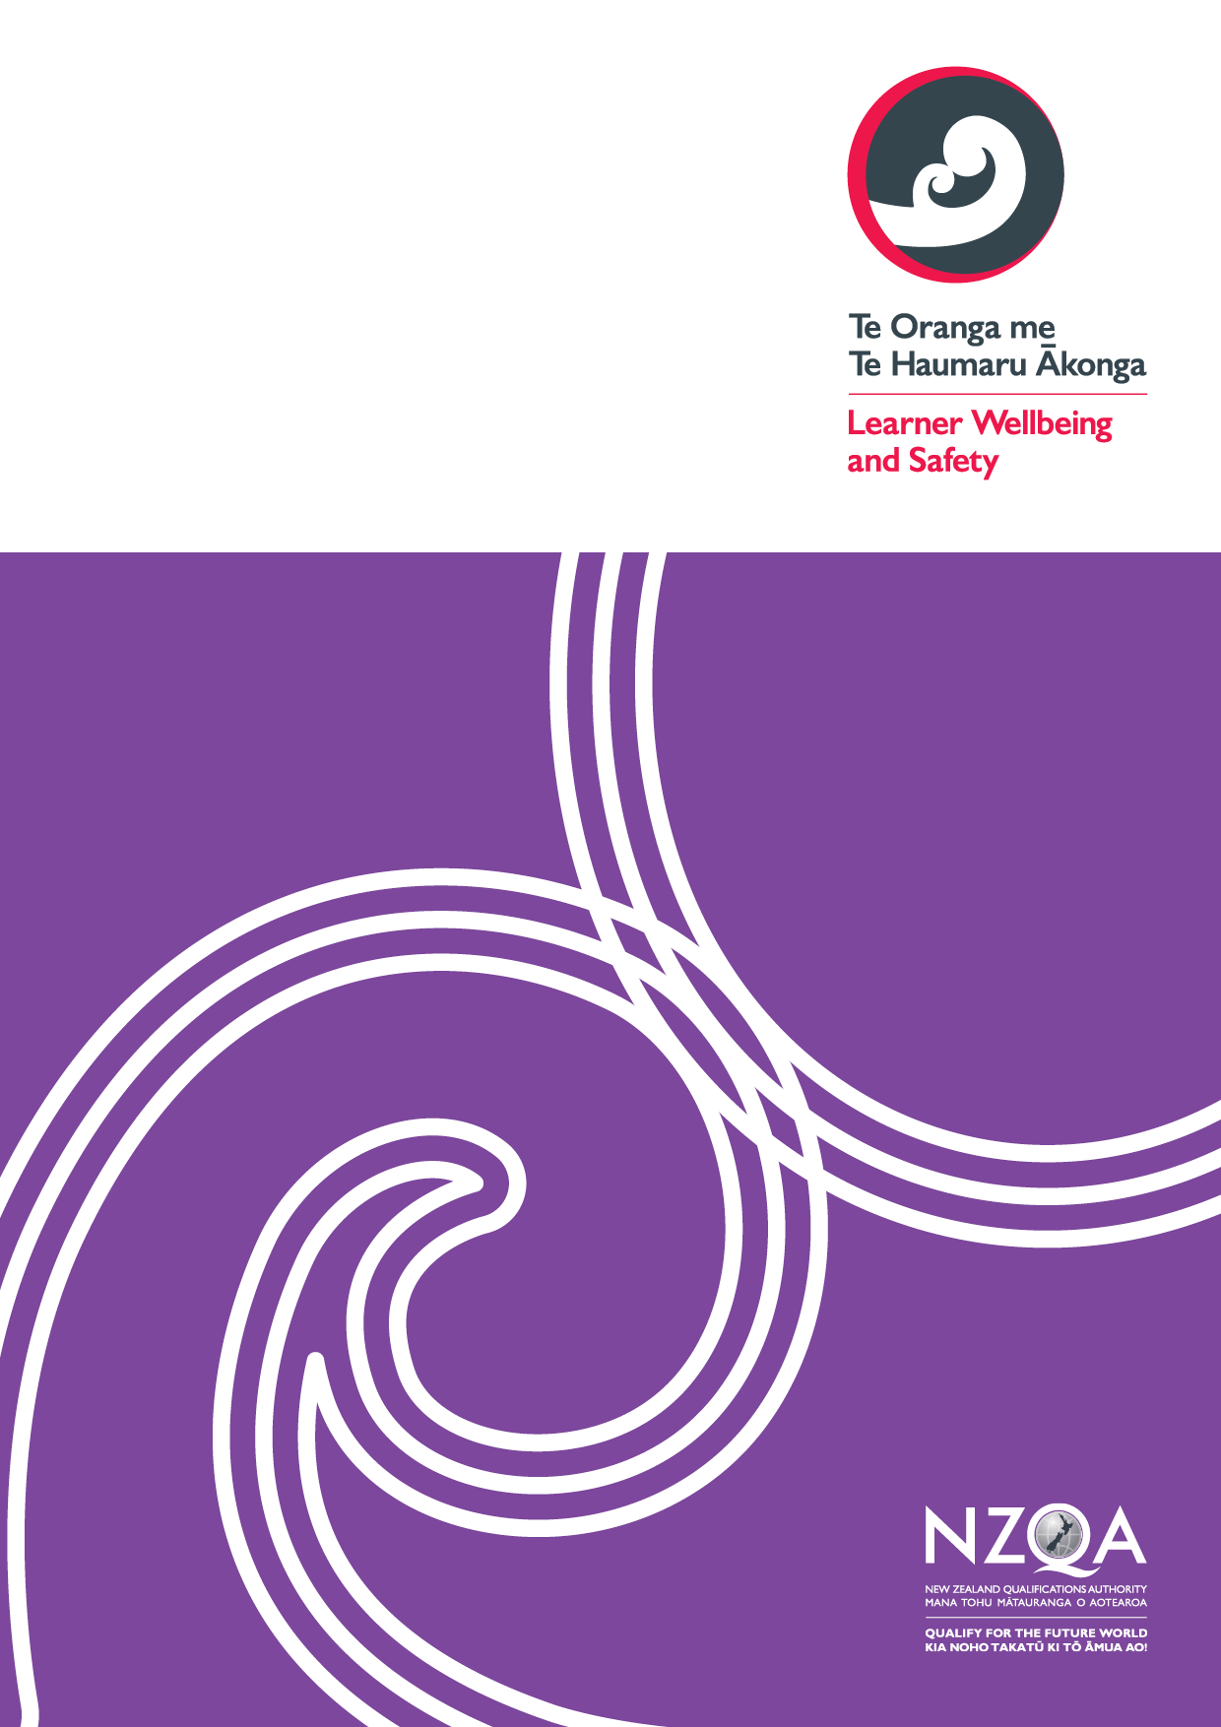
Contents
Tool A: gap analysis 3
Organisational structures to support a whole-of-provider approach to learner wellbeing and safety 4
Outcome 1: A learner wellbeing and safety system 4
Outcome 2: Learner voice 10
Wellbeing and safety practices for all tertiary providers 15
Outcome 3: Safe, inclusive, supportive, and accessible physical and digital learning environments 15
Outcome 4: Learners are safe and well 18

Tool A: gap analysis

This optional tool sets out the areas of practice you need to review to check your compliance with the Code.
You can use this tool to help you:
- Prepare for a gap analysis, by identifying the information you need to evidence your compliance with the Code at each clause
- Make sense of your gathered information, by noting any gaps in your current practice and/or evidence of current practice.

KEY
COMPLIANT | - We have the required practices in place  - We have sufficient evidence on which to make judgements about the effectiveness of our practices
GAP (in evidence) | - We have the required practices in place but…  - …we have limited evidence on which to make judgements about the effectiveness of those practices
GAP (in practice) | - We do not have the required practices in place

If you are a provider with student accommodation or Code signatory, you can insert additional pages into this tool relating to Student Accommodation (Outcomes 5-7) and/or International Learners (Outcomes 8-12) after Outcome 4.

Use the links below to download any additional pages as required:
- Student Accommodation
- International Tertiary Learners

Organisational structures to support a whole-of-provider approach to learner wellbeing and safety

Outcome 1: A learner wellbeing and safety system
Providers must take a whole-of-provider approach to maintain a strategic and transparent learner wellbeing and safety system that responds to the diverse needs of their learners.

Phase in the gap analysis process: | PREPARE | MAKE SENSE
Key required processes | Information we can gather to use as evidence of our compliance with this clause | COMPLIANT | GAP  (in evidence) | GAP  (in practice)
Process 1: Strategic goals and strategic plans

Clause 7 (1).
Providers must have strategic goals and strategic plans for supporting the wellbeing and safety of their learners across their organisation, including student accommodation, describing how they will –
- give effect to the outcomes sought and processes required by this code; and
- contribute to an education system that honours Te Tiriti o Waitangi and supports Māori–Crown relations.
Clause 7 (2).
Providers must –

- regularly review their learner wellbeing and safety strategic goals and strategic plans as described in subclause (1); and
- make amendments to their learner wellbeing and safety strategic goals and strategic plans within a reasonable timeframe following the review.
Clause 7 (3).
Providers must work proactively with learners and stakeholders (and document this work) when –

- developing their learner wellbeing and safety strategic goals and strategic plans described in subclause (1); and
- reviewing their learner wellbeing and safety strategic goals and strategic plans described in subclause (2).
Process 2: Self review of learner wellbeing and safety practices

Clause 8 (1).
Providers must use strategic goals and strategic plans described in clause 7(1) to regularly review the quality of their learner wellbeing and safety practices to achieve the outcomes and practices of this code, at a frequency or by a date determined by the code administrator.
Clause 8 (2).
Providers must review their learner wellbeing and safety practices using –

- input from diverse learners and other stakeholders; and
- relevant quantitative and qualitative data (including from learner complaints) that is, as far as practicable, and consistent with the provider’s obligations under current privacy legislation, disaggregated by diverse learner groups.
Clause 8 (3).
Providers must, in a timely manner, following a review described in subclauses (1) and (2) take appropriate action to address any deficiencies in learner wellbeing and safety practices.
Process 3: Publication requirements

Clause 9.
Providers must make the following information readily available, in accessible formats, to learners, staff and the general public, including on their websites (where available) –

- strategic goals and strategic plans for supporting the wellbeing and safety of learners described in clause 7(1); and
- revisions to strategic goals and strategic plans for supporting the wellbeing and safety of learners described in clause 7(2); and
- self-review reports on the quality of their learner wellbeing and safety practices described in clause 8.
Process 4: Responsive wellbeing and safety systems

Clause 10 (1).
Providers must gather and communicate relevant information across their organisation (including student accommodation) and from relevant stakeholders to accurately identify emerging concerns about learners’ wellbeing and safety or behaviour and take all reasonable steps to connect learners quickly to culturally appropriate social, medical, and mental health services.
Clause 10 (2).
Providers must provide staff with ongoing training and resources tailored to their roles in the organisation, in relation to –

- Te Tiriti o Waitangi; and
- the provider’s obligations under this code; and
- understanding the welfare issues of diverse learner groups and appropriate cultural competencies; and
- identifying and timely reporting of incidents of racism, discrimination, and bullying; and
- physical and sexual violence prevention and response, including how to support a culture of disclosure and reporting; and
- privacy and safe handling of personal information; and
- referral pathways (including to local service providers) and escalation procedures; and
- identifying and timely reporting of incidents and concerning behaviours; and
- wellbeing and safety awareness and promotion topics including –
  - safe health and mental health literacy and support; and
  - suicide and self-harm awareness; and
  - promoting drug and alcohol awareness; and
  - promoting healthy lifestyles for learners.
Clause 10 (3).
Providers must have plans for assisting learners, and responding effectively, in emergency situations in the learning or residential community (whether localised or more widespread), including –
- making these plans readily available to learners when they begin their study; and
- ensuring that there are suitably prepared staff members available to be contacted by a learner, or learners, in the event of an emergency; and
- co-ordinating decision-making across the provider when responding to emergencies; and
- disseminating timely, accurate, consistent, and accessible information to learners and staff during emergencies; and
- ensuring all relevant staff are aware of the indicators of imminent danger to a learner or others and what action they can reasonably provide to help make them safe; and
- keeping a regularly updated critical incident and emergencies procedures manual which guides staff involved in emergency situations which contains the immediate and ongoing actions required including –
  - engaging with relevant government agencies (e.g. the New Zealand Police, Ministry of Health, New Zealand Qualifications Authority, Tertiary Education Commission); and
  - the follow-up de-briefing processes to support all learners and relevant staff; and
- recording critical incidents and emergencies and reporting these back annually (at an aggregate level and, as far as practicable, disaggregated by diverse learner groups) to provider management, learners, other stakeholders, and the code administrator.

Outcome 2: Learner voice
Providers understand and respond to diverse learner voices and wellbeing and safety needs in a way that upholds their mana and autonomy.
Phase in the gap analysis process: | PREPARE | MAKE SENSE
Key required processes | Information we can gather to use as evidence of our compliance with this clause | COMPLIANT | GAP  (in evidence) | GAP  (in practice)
Process 1: Learner voice

Clause 12.
Providers must have practices for –

- proactively building and maintaining effective relationships with diverse learner groups within their organisation; and
- working with diverse learners and their communities to develop, review, and improve learner wellbeing and safety strategic goals, strategic plans and practices; and
- providing formal and informal processes for actively hearing, engaging with, and developing the diverse range of learner voices and those of their communities; and
- providing timely and accessible resources to learners to support them and their learner communities to develop the necessary skills to enable them to participate fully in decision-making processes; and
- providing timely and accessible information to learners to increase transparency of providers’ decision-making processes.
Process 2: Learner complaints

Clause 13.
Providers must –

- work with learners to effectively respond to, and process complaints (including appropriate engagement with support people); and
- inform learners on how the complaint will be handled and how it is progressing; and
- handle complaints in a timely and efficient way, including having practices that –
  - are appropriate to the level of complexity or sensitivity of the complaint; and
  - consider the issues from a cultural perspective; and
  - include the provision of culturally responsive approaches that consider traditional processes for raising and resolving issues (for example, restorative justice); and
  - comply with the principles of natural justice; and
- ensure that the complaints process is easily accessible to learners (and those supporting them), including having practices for –
  - providing learners with clear information on how to use the internal complaints processes (including the relevant people to contact), and the scope and possible outcomes of the processes; and
  - addressing barriers to accessing this information (for example, due to language, lack of internet access, fear of reprisal, desire for anonymity), such as providing alternative ways of raising a complaint; and
  - providing an opportunity for a support person or people (who can be chosen by the learner) to guide and support the learner through the complaints process; and
  - providing the opportunity for groups of learners to make joint complaints; and
- record complaints; and
- report annually to provider management, learners, other stakeholders, and the code administrator (including on provider websites where available) on –
  - the number and nature of complaints made and their outcomes (at an aggregate level and, as far as practicable, disaggregated by diverse learner groups); and
  - learner experience with the complaints process and the outcome of their complaint; and
- promote and publicise complaint and dispute resolution processes available to learners including, but not limited to, the provider’s internal complaints process, the education quality assurance agency complaints process, the code administrator’s complaints process, and the Dispute Resolution Schemes; and
- advise learners, on the next steps available to them if the provider does not accept the complaint (or the learner or provider perceives that the provider does not have the cultural competency to deal with it), or the learner is not satisfied that the provider has made adequate progress towards resolving the complaint, or the learner is not satisfied with the provider’s internal complaints process or outcome, including –
  - how to seek resolution of a contractual or financial dispute by way of a complaint or referral to an appropriate body or agency depending on the subject matter of the dispute, for example, the code administrator, the Dispute Resolution Scheme, the Disputes Tribunal, the Human Rights Commission or the Ombudsman; and
  - how to make a complaint to the code administrator if a learner believes that the provider is failing to meet the outcomes or requirements of this code.
Process 3: Compliance with the Dispute Resolution Scheme

Clause 14.
Providers must ensure they are familiar with the relevant Dispute Resolution Scheme rules for domestic and international learners and ensure compliance with those rules in a dispute to which it is party.

Wellbeing and safety practices for all tertiary providers

Outcome 3: Safe, inclusive, supportive, and accessible physical and digital learning environments
Providers must foster learning environments that are safe and designed to support positive learning experiences of diverse learner groups.
Phase in the gap analysis process: | PREPARE | MAKE SENSE
Key required processes | Information we can gather to use as evidence of our compliance with this clause | COMPLIANT | GAP  (in evidence) | GAP  (in practice)
Process 1: Safe and inclusive communities

Clause 16 (1).
Providers must have practices for –

- reducing harm to learners resulting from discrimination, racism (including systemic racism), bullying, harassment and abuse; and
- working with learners and staff to recognise and respond effectively to discrimination racism (including systemic racism), bullying, harassment and abuse; and
- promoting an inclusive culture across the learning environment; and
- upholding the cultural needs and aspirations of all groups throughout the learning environment; and
- providing all learners with information –
  - that supports understanding, acceptance, and connection with all learners, and collective responsibility for an inclusive learning environment; an
  - about the cultural, spiritual, and community supports available to them; and
- providing learners with accessible learning environments where they can connect with others, build relationships, support each other, and welcome their friends, families, and whānau.
Process 2: Supporting learner participation and engagement

Clause 17 (1).
Providers must provide learners with opportunities to –

- actively participate and share their views safely in their learning environment; and
- connect, build relationships and develop social, spiritual and cultural networks; and
- use te reo and tikanga Māori to support Māori learners’ connection to identity and culture.
Clause 17 (2).
Providers must have practices for supporting learners through their studies, including –

- enabling learners to prepare and adjust for tertiary study, and
- maintaining appropriate oversight of learner achievement and engagement; and
- providing the opportunity for learners to discuss, in confidence, any issues that are affecting their ability to study and providing learners with a response to their issues; and
- providing learners with advice on pathways for further study and career development, where appropriate.
Process 3: Physical and digital spaces and facilities

Clause 18.
Providers must have practices for–

- providing healthy and safe learning environments; and
- identifying and, where possible, removing access barriers to provider facilities and services; and
- involving learners in the design of physical and digital environments when making improvements; and
- engaging with Māori and involving Māori in the design of physical and digital environments where appropriate.

Outcome 4: Learners are safe and well
Providers must support learners to manage their physical and mental health through information and advice, and identify and respond to learners who need additional support.
Phase in the gap analysis process: | PREPARE | MAKE SENSE
Key required processes | Information we can gather to use as evidence of our compliance with this clause | COMPLIANT | GAP  (in evidence) | GAP  (in practice)
Process 1: Information for learners about assistance to meet their basic needs.

Clause 20 (1).
Providers must have practices for enabling all learners and prospective learners to identify and manage their basic needs (the essential material requirements to support wellbeing and safety including housing, food and clothing), including providing accurate, timely and tailored information on how they can –

- access services through the provider or through community and public services that will help them maintain reasonable standards of material wellbeing and safety; and
- access suitable accommodation and understand their rights and obligations as a tenant in New Zealand; and
- maintain a healthy lifestyle.

Clause 20 (2).
If food is made available by the provider on campus or in student accommodation, the provider must ensure that the food available includes a range of healthy food options that is obtainable at a reasonable cost.
Process 2: Promoting physical and mental health awareness

Clause 21.
Providers must have practices for –

- providing opportunities and experiences for learners that improve their physical and mental health and wellbeing and safety; and
- promoting awareness of practices that support good physical and mental health that are credible and relevant to learners; and
- supporting learners’ connection to their language, identity, and culture; and
- providing accurate, timely information and advice to learners about –

  - how they can access medical and mental health services through the provider or through community and public services, including culturally responsive services; and
  - how they can report health and safety concerns they have for their peers; and
  - how to respond to an emergency and engage with relevant government agencies; and
  - how they can make positive choices that enhance their wellbeing.
Process 3: Proactive monitoring and responsive wellbeing and safety practices.

Clause 22 (1).
Providers must have practices for –

- requesting that domestic learners 18 years and over provide a name and up-to-date contact details of a nominated person; and
- describing the circumstances in which the nominated person referred to in paragraph (a) should be contacted in relation to their wellbeing and safety; and
- contacting the person nominated by domestic learners 18 years and over, in the circumstances described in accordance with paragraph (b), or where the provider has reasonable grounds for believing that the disclosure is necessary to prevent or lessen a serious threat to the student’s life or health; and
- enabling learners to communicate health and mental health needs with staff in confidence, including accommodation staff, so that the provider can proactively offer them support; and
- providing opportunities for learners to raise concerns about themselves or others in confidence; and
- identifying learners at risk and having clear and appropriate pathways for assisting them to access services when they need it; and
- identifying learners who are at risk of harming others, and
  - having clear and appropriate pathways for assisting them to access services when they need it; and
  - protecting learners and staff who experience harm from other learners and/or staff, including sexual assault; and
- making arrangements with disabled learners or those affected by health and wellbeing difficulties to accommodate learning needs, including for study off-campus; and
- responding to disruptive and threatening behaviour in a way that is sensitive to a learner’s situation; and
- supporting learners whose study is interrupted due to circumstances outside their control, and providing inclusive, accessible re-entry processes for their transition back into tertiary study.
Clause 22 (2).
Providers must have up-to-date contact details and next of kin for domestic tertiary learners under 18 and international tertiary learners.
Clause 22 (3).
Providers must contact the next of kin for domestic tertiary learners under 18 years and international tertiary learners if there is concern regarding the wellbeing or safety of a learner.
Clause 22 (4).
Providers must maintain a record of reported risks, including any concerns raised in relation to the effective administration of this code.

