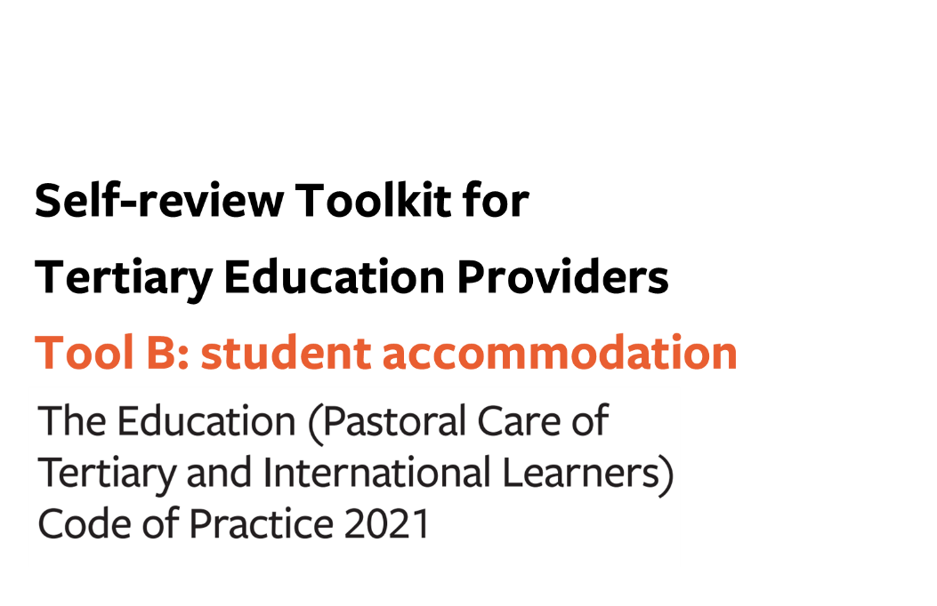
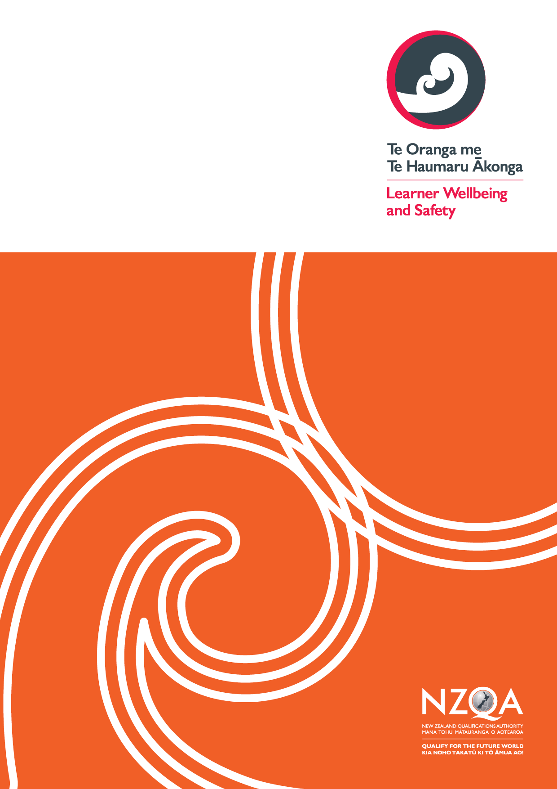
Contents

Tool B: key evaluative questions (the Code) 3
Outcome 5: A positive, supportive and inclusive environment in student accommodation 4
Outcome 6: Accommodation administrative practices and contracts 7
Outcome 7: Student accommodation facilities and services 9

Tool B: key evaluative questions – student accommodation

Use this optional tool to help you make sense of your gathered information in terms of what it tells you about the effectiveness of your current practice in relation to the Code outcomes sought for your learners.
Consider how effectively your organisation is achieving the overarching outcomes, your current strengths, and any opportunities for development.
Indicate what stage your Code implementation is at under each outcome using the continuum of Code implementation in Appendix 1.
You may combine this part with the others of Tool B relating to All Tertiary Education Providers (Outcomes 1-4) and/or International Learners (Outcomes 8-12).

Use the links below to download any additional pages as required:
- All Tertiary Education Providers
- International Tertiary Learners

Additional wellbeing and safety practices in tertiary student accommodation (in relation to domestic and international tertiary learners)

Outcome 5: A positive, supportive and inclusive environment in student accommodation
Providers must ensure that student accommodation promotes and fosters a supportive and inclusive community which support the wellbeing and safety of residents.
Stage of implementation for outcome 5 | Well implemented / Implemented / Developing implementation / Early implementation

Process: Information and promotional activities

KEQ | How effectively? | How do we know? | How can we improve?
How effectively do we develop and provide the information and promotional activities required by this process?
Process: Accommodation staff

KEQ | How effectively? | How do we know? | How can we improve?
How effectively do we ensure appropriate training, resources, placement, oversight and wellbeing support for accommodation staff?

Process: Accommodation staff must be fit and proper persons

KEQ | How effectively? | How do we know? | How can we improve?
How effectively do we ensure that each member of our accommodation staff is suitable for employment in our student accommodation?

Process: Proactive monitoring of residents’ wellbeing and safety and responsive wellbeing and safety practices

KEQ | How effectively? | How do we know? | How can we improve?
How effectively do our proactive monitoring and responsive wellbeing and safety practices identify and meet the support needs of individual residents, especially those at risk?

Process: A safe and inclusive residential community

KEQ | How effectively? | How do we know? | How can we improve?
How effectively do we work with our residents in the development, improvement, and communication of our house rules and other initiatives to promote and encourage a safe and inclusive community?

Overall self-review - Outcome 5: A positive, supportive and inclusive environment in student accommodation

KEQ | How effectively? | How do we know? | How can we improve?
How effectively do we ensure that our student accommodation promotes and fosters a supportive and inclusive community which supports the wellbeing and safety of residents?
How effectively do we access and use learner voice to understand the impact of our learner wellbeing and safety practices for this outcome?
How effectively does our student accommodation uphold the principles of Te Tiriti o Waitangi throughout our learner wellbeing and safety practices for this outcome?
How effectively do our student accommodation practices for this outcome align with our organisational learner wellbeing and safety strategic goals and strategic plans?

Outcome 6: Accommodation administrative practices and contracts
Providers must ensure that student accommodation contracts and practices are transparent, reasonable, and responsive to the wellbeing and safety needs of residents.
Stage of implementation for outcome 6 | Well implemented / Implemented / Developing implementation / Early implementation

Process: General principles

KEQ | How effectively? | How do we know? | How can we improve?
How effectively do our current practices ensure that our student accommodation providers disclose the requisite information on their websites and have a human resource strategy that meets the requirements of this process?
Process: Student accommodation contracts

KEQ | How effectively? | How do we know? | How can we improve?
How effectively do we ensure that student accommodation contracts with residents are clear, accessible, and concise, and provide the information required by this process?
How effectively do we ensure that student accommodation contracts used with residents are regularly reviewed with learners and updated to remain fit for purpose?
How effectively do our current practices ensure that our student accommodation providers keep a complaints log and make it available to residents?

Overall self-review - Outcome 6: Accommodation administrative practices and contracts

KEQ | How effectively? | How do we know? | How can we improve?
How effectively do we ensure that our student accommodation contracts and practices are transparent, reasonable and responsive to the wellbeing and safety needs of residents?
How effectively do we access and use learner voice to understand the impact of our learner wellbeing and safety practices for this outcome?
How effectively does our student accommodation uphold the principles of Te Tiriti o Waitangi throughout our learner wellbeing and safety practices for this outcome?
How effectively do our student accommodation practices for this outcome align with our organisational learner wellbeing and safety strategic goals and strategic plans?

Outcome 7: Student accommodation facilities and services
Providers must ensure that student accommodation facilities and services are maintained to a standard sufficient to support residents’ wellbeing and safety and educational success.
Stage of implementation for outcome 7 | Well implemented / Implemented / Developing implementation / Early implementation

Overall self-review - Outcome 7: Student accommodation facilities and services

KEQ | How effectively? | How do we know? | How can we improve?
How effectively do our current practices ensure that our student accommodation facilities and services are maintained to a standard sufficient to support residents’ wellbeing and safety and educational success?
How effectively do we access and use learner voice to understand the impact of our learner wellbeing and safety practices for this outcome?
How effectively does our student accommodation uphold the principles of Te Tiriti o Waitangi throughout our learner wellbeing and safety practices for this outcome?
How effectively do our student accommodation practices for this outcome align with our organisational learner wellbeing and safety strategic goals and strategic plans?

Appendix 1: Continuum of implementation for the Code
Well-implemented
The Code is well-implemented
 |  | Implemented  The Code is implemented | - Thorough understanding of Code outcomes and requirements across the organisation  - Diverse range of multiple perspectives sought, including robust practices, to reflect learner voice  - Full consideration of Te Tiriti o Waitangi/Treaty of Waitangi and the Treaty principles (including partnership, protection, and participation) when implementing the Code.  - Well-established practices in place to monitor against all Code outcomes and requirements  - Highly effective reporting processes from self-review
 | Developing implementation  Implementation of the Code is underway, yet requires further work | - Sufficient understanding of Code outcomes and requirements across the organisation  - Multiple perspectives sought, including sound practices, to reflect student voice  - Good consideration of Te Tiriti o Waitangi/Treaty of Waitangi and the Treaty principles (including partnership, protection, and participation) when implementing the Code.  - Relevant practices in place to monitor against all Code outcomes and requirements  - Effective reporting processes from self-review
Early stages of implementation  Implementation of the Code has not yet started or requires significant work | - Some understanding of Code outcomes and requirements across the organisation  - Some perspectives sought, including adequate practices, to reflect learner voice  - Some consideration of Te Tiriti o Waitangi/Treaty of Waitangi and the Treaty principles (including partnership, protection, and participation) when implementing the Code.  - Some practices in place to monitor against all Code outcomes and requirements  - Adequate reporting processes from self-review
- No or limited understanding of Code outcomes and requirements across the organisation
- No or limited perspectives sought. Practices to reflect learner voice non-existent or underway
- No or limited consideration of Te Tiriti o Waitangi/Treaty of Waitangi and the Treaty principles (including partnership, protection, and participation) when implementing the Code.
- No or limited practices in place to monitor against all Code outcomes and requirements
- No or limited reporting processes from self-review

