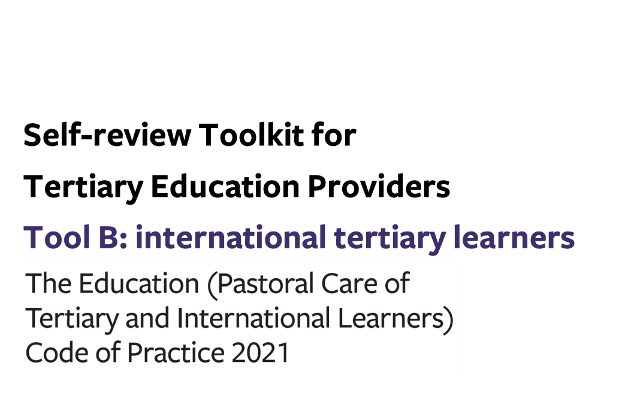
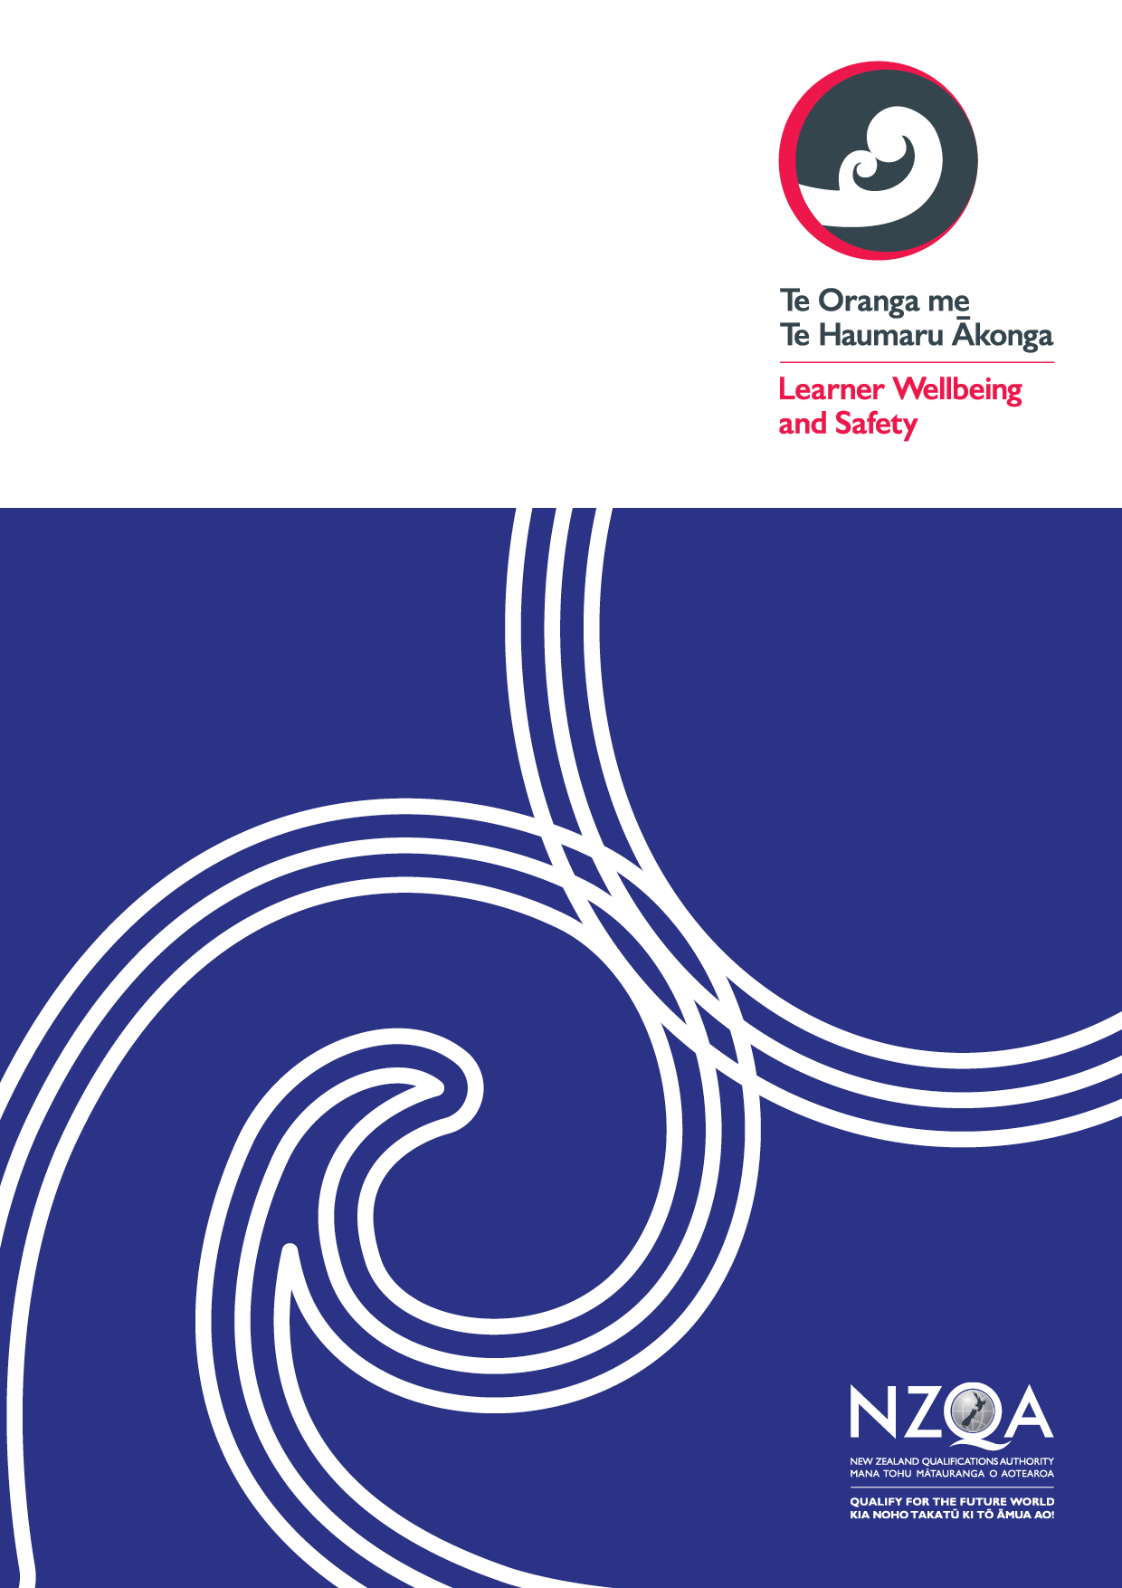
Contents

Tool B: key evaluative questions (the Code) 3
Additional wellbeing and safety practices for tertiary providers (signatories) enrolling international learners 4
Outcome 8: Responding to the distinct wellbeing and safety needs of international tertiary learners 4
Outcome 9: Prospective international tertiary learners are well informed 5
Outcome 10: Offer, enrolment, contracts, insurance and visa 7
Outcome 11: International learners receive appropriate orientations, information and advice 11
Outcome 12: Safety and appropriate supervision of international tertiary learners 13

Tool B: key evaluative questions – international tertiary learners

Use this optional tool to help you make sense of your gathered information in terms of what it tells you about the effectiveness of your current practices in relation to the Code outcomes sought for your learners.
Consider how effectively your organisation is achieving the overarching outcomes, your current strengths, and any opportunities for development.
Indicate what stage your Code implementation is at under each outcome using the continuum of Code implementation in Appendix 1.
You may combine this part with the others of Tool B relating to All Tertiary Education Providers (Outcomes 1-4) and/or Student Accommodation (Outcomes 5-7).

Use the links below to download any additional pages as required:
- All Tertiary Education Providers
- Student Accommodation

Additional wellbeing and safety practices for tertiary providers (signatories) enrolling international learners

Outcome 8: Responding to the distinct wellbeing and safety needs of international tertiary learners
Signatories must ensure that practices under this code respond effectively to the distinct wellbeing and safety needs of their diverse international tertiary learners.
Stage of implementation for outcome 8 | Well implemented / Implemented / Developing implementation / Early implementation

Overall self-review - Outcome 8: Responding to the distinct wellbeing and safety needs of international tertiary learners

KEQ | How effectively? | How do we know? | How can we improve?
How effectively do our practices under this Code respond to the distinct wellbeing and safety needs of our diverse international tertiary learners?
How effectively do we access and integrate international tertiary learner voice into decisions around the planning and provision of our learner support services?
How effectively does our organisation uphold the principles of Te Tiriti o Waitangi throughout our learner wellbeing and safety practices for this outcome?

Outcome 9: Prospective international tertiary learners are well informed
Signatories ensure that prospective international tertiary learners receive clear, accessible, accurate and sufficient information, and make informed choices about the study and services a signatory provides before they begin their study.
Stage of implementation for outcome 9 | Well implemented / Implemented / Developing implementation / Early implementation

Process: Marketing and promotion

KEQ | How effectively? | How do we know? | How can we improve?
How effectively does our marketing and promotion material provide clear, sufficient and accurate information?
Process: Managing and monitoring education agents

KEQ | How effectively? | How do we know? | How can we improve?
How effectively do we manage and monitor our education agents?

Overall self-review - Outcome 9: Prospective international tertiary learners are well informed

KEQ | How effectively? | How do we know? | How can we improve?
How effectively do current practices ensure that prospective international tertiary learners can make informed choices about the study and services we provide?
How effectively do we access and use learner voice to understand the impact of our learner wellbeing and safety practices for this outcome?
How effectively does our organisation uphold the principles of Te Tiriti o Waitangi throughout our learner wellbeing and safety practices for this outcome?
How effectively do our current practices for this outcome align with our organisational learner wellbeing and safety strategic goals and strategic plans?

Outcome 10: Offer, enrolment, contracts, insurance and visa
Signatories must have practices for enabling learners to make well-informed enrolment decisions in relation to the educational outcomes being sought by the learner and ensuring that all relevant parties are clear about their interests and obligations prior to entering into the enrolment contract.
Stage of implementation for outcome 10 | Well implemented / Implemented / Developing implementation / Early implementation

Process: Offer of educational instruction

KEQ | How effectively? | How do we know? | How can we improve?
How effectively do our current practices ensure the educational instruction offered to international tertiary learners is appropriate for their:
• expectations
• English language proficiency,
• academic ability and
• desired educational outcomes?
Process: Information to be provided before entering contract

KEQ | How effectively? | How do we know? | How can we improve?
How effectively do our current practices ensure that international tertiary learners receive, as a minimum, the information outlined in this process before entering a contract?
How effectively do our current practices ensure that this information is accurate, timely and tailored to the needs of prospective international tertiary learners?

Process: Contract of enrolment

KEQ | How effectively? | How do we know? | How can we improve?
How effectively do we ensure that our contracts of enrolment are fair and reasonable and contain the information and terms required by this process?

Process: Disciplinary action

KEQ | How effectively? | How do we know? | How can we improve?
How effectively do our current practices ensure terminations of enrolments and disciplinary actions are in accordance with the principles of natural justice?

Process: Insurance

KEQ | How effectively? | How do we know? | How can we improve?
How effectively do our current practices ensure that each of our international tertiary learners has the appropriate insurance for study in New Zealand?

Process: Immigration matters

KEQ | How effectively? | How do we know? | How can we improve?
How effectively do our current practices ensure that each of our international tertiary learners has the necessary immigration status for study in New Zealand?

Process: Student fee protection and managing withdrawal and closure

KEQ | How effectively? | How do know? | How can we improve?
How effectively do our current practices ensure that our international tertiary learners’ fees are protected and that our refund policies are fair and reasonable?

Overall self-review - Outcome 10: Offer, enrolment, contracts, insurance and visa

KEQ | How effectively? | How do we know? | How can we improve?
How effectively do our current practices enable international tertiary learners to make well-informed enrolment decisions and to understand their enrolment contract prior to entering into it?
How effectively do we access and use learner voice to understand the impact of our learner wellbeing and safety practices for this outcome?
How effectively does our organisation uphold the principles of Te Tiriti o Waitangi throughout our learner wellbeing and safety practices for this outcome?
How effectively do our current practices for this outcome align with our organisational learner wellbeing and safety strategic goals and strategic plans?

Outcome 11: International learners receive appropriate orientations, information and advice
Signatories must ensure that international tertiary learners have the opportunity to participate in well-designed and age-appropriate orientation programmes and continue to receive relevant information and advice to support achievement, wellbeing and safety.
Stage of implementation for outcome 11 | Well implemented / Implemented / Developing implementation / Early implementation

Overall self-review - Outcome 11: International learners receive appropriate orientations, information and advice

KEQ | How effectively? | How do we know? | How can we improve?
How effectively do we ensure that our orientation programmes and ongoing advice to international tertiary learners support their achievement, wellbeing and safety?
How effectively do we access and use learner voice to understand the impact of our learner wellbeing and safety practices for this outcome?
How effectively does our organisation uphold the principles of Te Tiriti o Waitangi throughout our learner wellbeing and safety practices for this outcome?
How effectively do our current practices for this outcome align with our organisational learner wellbeing and safety strategic goals and strategic plans?

Outcome 12: Safety and appropriate supervision of international tertiary learners
Signatories ensure that international tertiary learners are safe and appropriately supervised in their accommodation and effectively communicate with the parents or legal guardian of learners under 18 years.
Stage of implementation for outcome 12 | Well implemented / Implemented / Developing implementation / Early implementation

Overall self-review - Outcome 12: Safety and appropriate supervision of international tertiary learners

KEQ | How effectively? | How do we know? | How can we improve?
How effectively do our current practices ensure that our international tertiary learners under 18 years are safe and appropriately supervised in their accommodation?
How effectively do we communicate with the parents or legal guardians of our learners under 18 years?
When we provide or arrange accommodation for learners 18 years or over (that is not subject to Part 5 of the Code):
- how effectively do our current practices ensure that this accommodation is a safe, acceptable, and lawful living environment?
- how effectively do we communicate with the learner and ensure accommodation issues arising are addressed?
How effectively do we access and use learner voice to understand the impact of our learner wellbeing and safety practices for this outcome?
How effectively does our organisation uphold the principles of Te Tiriti o Waitangi throughout our learner wellbeing and safety practices for this outcome?
How effectively do our current practices for this outcome align with our organisational learner wellbeing and safety strategic goals and strategic plans?

Appendix 1: Continuum of implementation for the Code
Well-implemented
The Code is well-implemented
 |  | Implemented  The Code is implemented | - Thorough understanding of Code outcomes and requirements across the organisation  - Diverse range of multiple perspectives sought, including robust practices, to reflect learner voice  - Full consideration of Te Tiriti o Waitangi/Treaty of Waitangi and the Treaty principles (including partnership, protection, and participation) when implementing the Code.  - Well-established practices in place to monitor against all Code outcomes and requirements  - Highly effective reporting processes from self-review
 | Developing implementation  Implementation of the Code is underway, yet requires further work | - Sufficient understanding of Code outcomes and requirements across the organisation  - Multiple perspectives sought, including sound practices, to reflect student voice  - Good consideration of Te Tiriti o Waitangi/Treaty of Waitangi and the Treaty principles (including partnership, protection, and participation) when implementing the Code.  - Relevant practices in place to monitor against all Code outcomes and requirements  - Effective reporting processes from self-review
Early stages of implementation  Implementation of the Code has not yet started or requires significant work | - Some understanding of Code outcomes and requirements across the organisation  - Some perspectives sought, including adequate practices, to reflect learner voice  - Some consideration of Te Tiriti o Waitangi/Treaty of Waitangi and the Treaty principles (including partnership, protection, and participation) when implementing the Code.  - Some practices in place to monitor against all Code outcomes and requirements  - Adequate reporting processes from self-review
- No or limited understanding of Code outcomes and requirements across the organisation
- No or limited perspectives sought. Practices to reflect learner voice non-existent or underway
- No or limited consideration of Te Tiriti o Waitangi/Treaty of Waitangi and the Treaty principles (including partnership, protection, and participation) when implementing the Code.
- No or limited practices in place to monitor against all Code outcomes and requirements
- No or limited reporting processes from self-review

