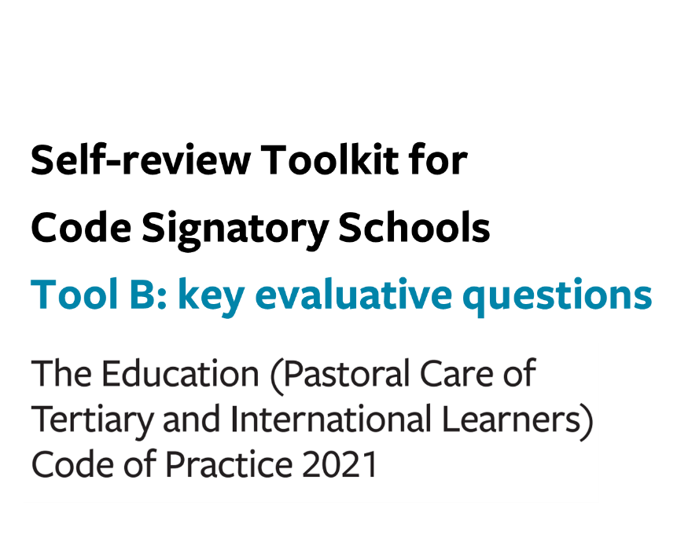

Tool B: key evaluative questions (the Code)

Use this optional tool to help you make sense of your gathered information in terms of what it tells you about your current practice in relation to the Code outcomes sought for your learners.
Consider how effectively your organisation is achieving the overarching outcomes, your current strengths, and any opportunities for development.

Outcome 13: Marketing and promotion
Signatories must ensure that the marketing and promotion to prospective international school learners of services provided by signatories includes clear, sufficient, and accurate information enabling those learners to make informed choices about the services provided.
KEQ | How effectively? | How do we know? | How can we improve?
How effectively do our current practices ensure our international school learners and where relevant, their parents or legal guardians, can make informed choices about the services we provide?
How effectively do we identify the information needs of international learners we intend to enrol?
How effectively does our marketing and promotion material provide clear, sufficient and accurate information?

Outcome 14: Managing and monitoring education agents
Signatories must effectively manage and monitor their education agents to ensure that those education agents –

(a) provide international school learners with reliable information and advice about studying, working, and living in New Zealand; and
(b) act with integrity and professionalism towards prospective international school learners; and
(c) do not breach the law or jeopardise the signatory’s compliance with this code.

KEQ | How effectively? | How do we know? | How can we improve?
Before entering a written contract, how effectively do we appropriately assess prospective education agents?
How effectively do we manage and monitor the conduct of our education agents and the quality of the services they provide?
How effectively do we support and enable our education agents to perform their duties?

Outcome 15: Offer, enrolment, contracts, and insurance
Signatories must –
- support international school learners (or the parents or legal guardian of international school learners under 18 years) to make well-informed enrolment decisions that are appropriate to the educational outcomes sought; and
- ensure that international school learners (or the parents or legal guardian of international school learners under 18 years) have the information required to understand their interests and obligations before entering into a legally binding contract with a signatory; and
- ensure that each contract of enrolment is fair and reasonable; and
- ensure that any disciplinary action is taken in accordance with the principles of natural justice; and
- ensure that international school learners have the appropriate insurance coverage, including insurance covering travel costs, medical care, and costs associated with repatriation, expatriation, and funeral expenses; and
- ensure that proper documentation is kept and, where appropriate, provided to international school learners (or the parents or legal guardian of international school learners under 18 years).
KEQ | How effectively? | How do we know? | How can we improve?
How effectively do our current practices support international school learners and where relevant, their parents or legal guardians, to make well-informed enrolment decisions?
How effectively do we ensure that international students and where relevant, their parents or legal guardians, have the required information prior to entering an enrolment contract?
How effectively do we ensure that our enrolment contract is fair and reasonable?
How effectively do our current practices ensure that any disciplinary action is taken in accordance with the principles of natural justice?
How effectively do our current practices ensure that each of our international learners have the appropriate insurance for study in New Zealand?
How effectively do our current practices ensure that proper documentation is kept and provided to international students and, where relevant their parents or legal guardians, when appropriate?

Outcome 16: Immigration matters
Signatories must –
- ensure that they do not allow or continue to allow a person to undertake educational instruction if that person is not entitled under the Immigration Act 2009 to undertake the educational instruction; and
- take reasonable precautions and exercise due diligence in ascertaining whether international school learners are entitled under the Immigration Act 2009 to undertake the educational instruction for which they enrol.
KEQ | How effectively? | How do we know? | How can we improve?
How effectively do our current practices ensure that each of our international school learners has the necessary immigration status for study in New Zealand?
How effectively do our current practices ensure we are compliant with the reporting requirements for terminations of enrolment and known or suspected breaches of visa conditions by international school learners?

Outcome 17: Orientation
Signatories must ensure that international school learners have the opportunity to participate in a well-designed and age-appropriate programme that provides the information and advice necessary for a learner at the outset of their educational instruction.
KEQ | How effectively? | How do we know? | How can we improve?
How effectively do we ensure our international student orientation provides the information and advice that learners and their families need at the onset of their studies?
How effectively do we ensure that orientation programmes for our international school learners are well-designed, age-appropriate and effective?

Outcome 18: Safety and wellbeing
Signatories must –
(a) provide a safe study environment for international school learners; and
(b) provide adequate support for the wellbeing of international school learners; and
(c) as far as practicable, ensure that international school learners live in a safe environment.

Process: General

KEQ | How effectively? | How do we know? | How can we improve?
How effectively do our current practices ensure that instances of inappropriate behaviour by, or impacting on, an international school learner are responded to fairly and effectively?
How effectively do our current practices ensure that international school learners are advised how to report and address health and safety issues, respond to emergencies, access health and counselling services, and engage with relevant government agencies?
How effectively do our current practices ensure that there is always (24/7) at least 1 staff member available to be contacted by our international learners in an emergency?
How effectively do our current practices ensure the contact details for each international school learner and their next of kin are recorded, up-to-date and accessible to the staff responsible for international learners?

Process: International school learners under 18 years (and under 10 years)

KEQ | How effectively? | How do we know? | How can we improve?
How effectively do our current practices ensure that all our international learners under 18 years of age, are not enrolled unless they are living with their parent(s) or legal guardian(s); or are
- part of a properly supervised group in New Zealand for less than 3 months; or
- in the care of a residential caregiver?)
How effectively do our current practices ensure that there are transfer of care plans in place for each learner, as appropriate?

Process: International school learners at risk or with additional learning needs

KEQ | How effectively? | How do we know? | How can we improve?
How effectively do we ensure appropriate measures are put in place to address the needs and issues of international school learners at risk or with additional learning needs?

Process: Accommodation

KEQ | How effectively? | How do we know? | How can we improve?
How do we ensure that international school learners under 18 years in the care of a residential caregiver have a safe living environment?
When we provide or arrange accommodation for international school learners 18 years or over, how effectively do our current practices ensure that this accommodation is a safe living environment?

Process: Safety checks and appropriate checks

KEQ | How effectively? | How do we know? | How can we improve?
How effectively do our current practices ensure we maintain up-to-date appropriate checks and safety checks for all residential caregivers?

Overall self-review - Outcome 18: Safety and wellbeing

KEQ | How effectively? | How do we know? | How can we improve?
How effectively do our current practices ensure we provide a safe study environment for international school learners?
How effectively do our current practices ensure that international school learners wellbeing needs are adequately supported?
How effectively do our current practices ensure that international school learners have a safe living environment?

Outcome 19: Learner support, advice and services
International school learners are fully informed by, and receive relevant advice from, their signatories on services to support their educational outcomes.

KEQ | How effectively? | How do we know? | How can we improve?
How effectively do we ensure that our international learners are fully informed about the relevant advice and services available to support their educational outcomes?
How effectively do we ensure that our advice and information is accurate, appropriate, and effective?

Outcome 20: Managing withdrawal and closure
Signatories must ensure that the fees paid by international learners for educational instruction in New Zealand are secure and protected in the event of learner withdrawal or the ending of educational instruction or the closure of a signatory.

KEQ | How effectively? | How do we know? | How can we improve?
How effectively do our current practices ensure that refund policies are reasonable and in accordance with legal requirements?
How effectively do our current practices ensure that student fees are protected in the event of a course cancellation, loss of Code signatory status or closure as an education provider?

Outcomes 21: Dealing with complaints
Signatories must ensure that all international school learners have access to proper and fair procedures for dealing with complaints.

KEQ | How effectively? | How do we know? | How can we improve?
How effectively do our current practices ensure that all our international learners have access to proper and fair procedures for dealing with complaints?
How effectively do we ensure that international school learners (and/or their parents or legal guardians) are informed about the availability of recourse to NZQA, the DRS or any other relevant authority if they cannot access our internal complaints process and/or are dissatisfied with the outcome or experience of using our process?

Outcome 22: Compliance with international student contract Dispute Resolution Scheme (DRS)
Signatories must comply with the relevant Dispute Resolution Scheme rules.

KEQ | How effectively? | How do we know? | How can we improve?
How effectively do our current practices ensure we are compliant with the DRS?

