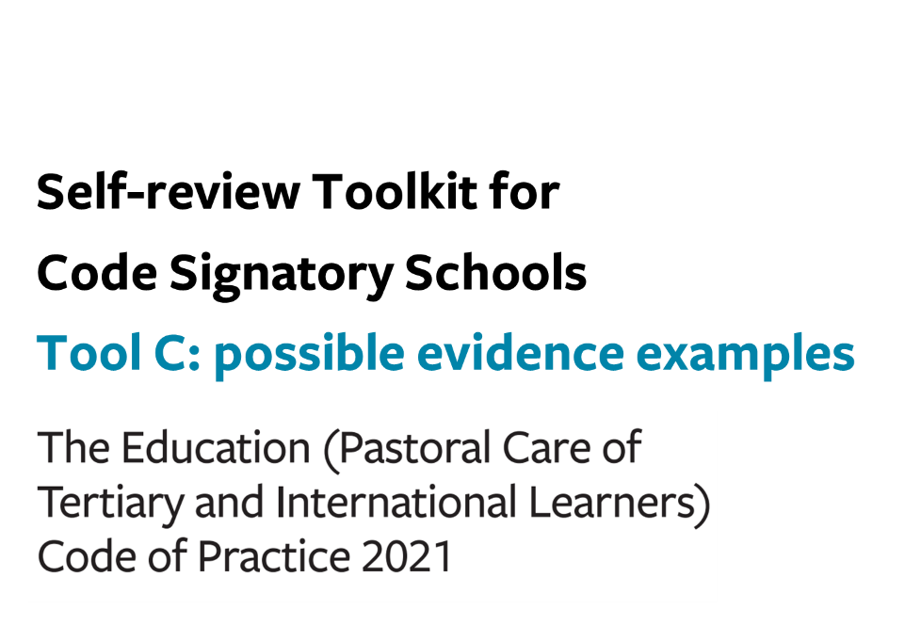

Tool C: possible evidence examples (the Code)
You can use this optional tool to help you:
- prepare for a gap analysis, by identifying information that could be used to evidence compliance
- gather information to inform your analysis, to ensure that you collect relevant information
Good quality evidence is:
- quantitative and qualitative information gathered systematically from multiple, diverse sources within and connected to your organisation
- directly relevant to the questions your organisation is trying to answer
- vital for evaluating your current practices against the requirements of the Code
- information that enables you to support your rationale for improvement action plans to stakeholders, including Government and learners

Examples of possible evidence are, but not limited to:

Outcome 13:
- Surveys to analyse needs and whether they are being met (with learners/parents/agents/other relevant parties, incl. in-house surveys, marketing surveys, iGraduate Student Barometer, other external surveys)
- Other forms of feedback from learners/parents/agents
- Copies of any prospectuses, marketing or promotional material
- Self-review procedures for ensuring marketing and promotional information (both in print and online) is accurate, current and comprehensive

Outcome 14:
- Procedures for and records of reference checking potential agents, entering written contracts with each agent, monitoring contracts and taking action to address any agent misconduct, terminating contracts with agents, ensuring agents have access to up-to-date information
- Student/parent satisfaction surveys and other forms of feedback
- Agent surveys and feedback
- Immigration NZ data (i.e. visa approval rates, agent information)

Outcome 15:
- Suggested evidence as outlined in Outcome 13 above
- Enrolment form and/or application form and evidence of form in use
- Contract template (sometimes referred to as a tuition agreement) and/or actual current contracts
- Offer of place (template or actual)
- Written agreement from the parent(s) or legal guardian of any international student aged 10 to 17 years of age to decisions affecting the student
- Procedure/process for (and records of) testing and placement of an international student (including English language requirements)
- Records of insurance checks / reviews
- Staff responsible for processes / job descriptions
- Records of specific communications / parental approval statements
- Complaints register
- Learner/parent/agent/staff surveys on programme fit with educational outcomes
- Information referencing ERO / EER / AQA reports
- Records of monitoring and review of success of learner placements (i.e. offer to enrolment conversions, learner retention and completion rates, graduate outcomes)

Outcome 16:
- Procedures for monitoring immigration status, visa expiry and reporting termination of enrolment
- Records of procedures implemented
- Records of any identified breaches and actions taken
- Information from Immigration NZ external audits

Outcome 17:
- Orientation information (and/or international student handbook)
- Records of orientation sessions held
- Records of student/parent attendance at orientation
- Orientation checklists
- Student support contacts
- International student guides
- Information in welcome packs / orientation bags
- Designated staff for under-18s
- Orientation evaluation results (i.e. from internal and external surveys and quizzes, including International Student Barometer)
- Procedures for and/or records of reviewing and updating orientation information
- Peer observation records

Outcome 18:
- Student behaviour expectations policies (including attendance and possible consequences of misbehaviour)
- Processes to manage your 24/7 contact for students
- Critical incident plan for international students, or emergency plan
- Template for student record keeping and communication with the parents, legal guardians, or residential caregivers
- Records of student/parent complaints
- Feedback from students/parents/residential caregivers/staff
- Documentation of response to actual issues and incidents arising
- Records of welfare monitoring / special needs /students at risk register
- Records of testing / support given
- Health and safety records
- Procedures for and records of when contact details and other key required information was last updated and by whom
- Records of relevant interaction with external agencies (i.e. police, NZQA, peak bodies)
- Records of student referrals to cross-campus or external support services
- Information provided to students
- Campaigns, workshops
- Designated services / staff

And if applicable:
- Group student visits including sample agreements between you and any third party involved in a group visit
- Residential caregiver agreements (e.g. homestay, designated caregiver agreement, temporary caregiver) – templates or actual
- Procedures for and records of monitoring and review of quality of residential care (including records of police-vetting)
- Templates for or actual written agreements from parents or legal guardians who wish to provide residential care for their child through a designated caregiver
- Procedures for or actual written records of each student’s transfer of care, where applicable
- Records of communications with parents/agents/residential caregivers
- Accommodation policies/support/staff training

Outcome 19:
- Student/parent/homestay surveys
- Documentation of response to issues arising
- Other forms of feedback from students/parents/homestays/staff/the local community
- Documentation of academic and welfare monitoring
- Websites, international student guides and handbooks, orientation information, email communications with students/parents/agents
- Designated international student support staff
- Use of Customer Relationship Management (CRM) to monitor and report on student access of services
- Activities, programmes, workshops on e.g. intercultural communication, study and career development
- Training/support material for staff

Outcome 20:
- Refund policies and withdrawals procedures
- Procedure or policy for protection of fees paid by students
- Evidence of funds safely held
- Procedure for notifying students/parents of requirements
- Information provided on websites, in offer letters, etc.
- Documentation of actual cases/refund applications
- Documentation showing review of refund policies
- External audit of income advance
- Student online services for students to access their tuition balance

Outcomes 21 and 22:
- Your grievance procedures/policies, showing inclusion of iStudent Complaints/DRS
- Student/parent/staff surveys demonstrating comprehension of procedures
- Actual cases / response to identified issues
- Staff meeting minutes / presentation notes re: professional development on DRS
- Information provided on websites, International Student Handbook, orientation material
- Requirements for staff to read and understand the Code and DRS Rules
- Processes for managing DRS complaints
- Informational poster displayed in key student areas
- Enrolment/offer forms and letters
- Student advocacy services

