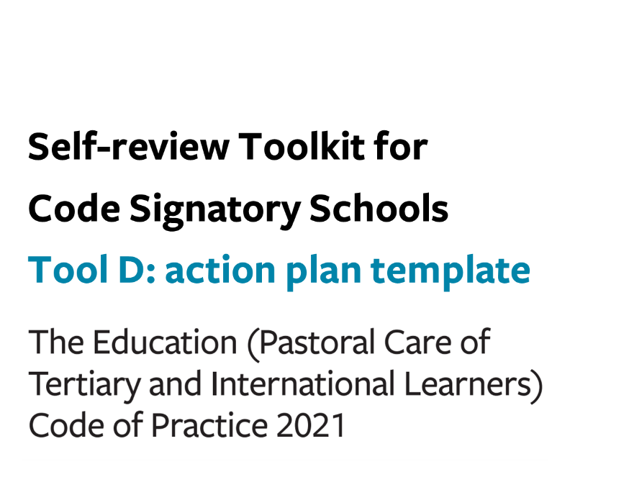

Tool D: action plan template (the Code)
For the period: DD/MM/YYYY to DD/MM/YYYY
- Based on our analysis, what do we need to do differently in the coming year?
- Who is responsible for implementing the planned next steps, and by when?
- How will we monitor our plan to ensure that it is implemented?
- How will we know that the actions we took were successful?

 | Action/s to be taken | Owner | Due date | Plan for monitoring implementation | Measures of success
Outcome 13:
Marketing and promotion

Outcome 14:
Managing and monitoring education agents

Outcome 15:
Offer, enrolment, contracts, and insurance

Outcome 16: Immigration matters

Outcome 17: Orientation

Outcome 18:
Safety and wellbeing

Outcome 19:
Learner support, advice and services

Outcome 20:
Managing withdrawal and closure

Outcomes 21 and 22: Dealing with complaints
AND
Compliance with international learner contract Dispute Resolution Scheme

