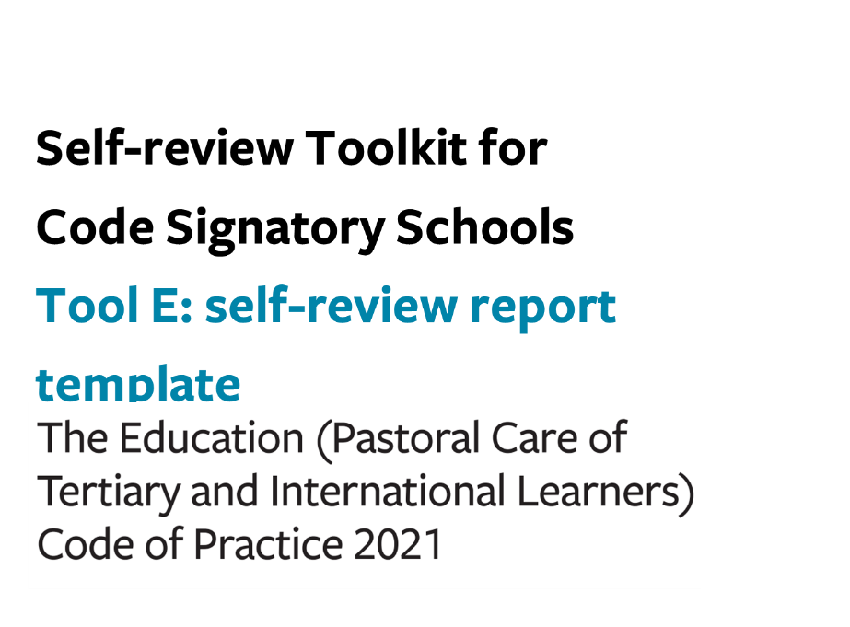

Tool E: self-review report template

Use this optional template to shape your summary self-review report on your self-review of performance against the requirements of the Code.

School information
School Name |  |  | MoE number
Code contact | Name |  | Job title
 | Email |  | Phone number
Current international learner enrolments | Total # | # |  | 18 y/o or older |  | #
 |  |  |  | Under 18 y/o |  | #
Report author(s)

Summary of performance under each outcome
 | Summary of performance based on gathered information (i.e. how effectively is our organisation doing what it needs to be doing?) | How do we know? (i.e. note supporting evidence with analysis to make sense of what it means)
Outcome 13:
Marketing and promotion

Outcome 14:
Managing and monitoring education agents
Outcome 15:
Offer, enrolment, contracts, and insurance

Outcome 16:
Immigration matters

Outcome 17:
Orientation

Outcome 18:
Safety and wellbeing

Outcome 19:
Learner support, advice and services
Outcome 20:
Managing withdrawal and closure
Outcomes 21 and 22:
Dealing with complaints and compliance with international learner contract Dispute Resolution Scheme (DRS)

Findings from gap analysis of compliance with key required processes

Identified gaps in compliance with key required processes
Outcome 13:
Marketing and promotion

Outcome 14:
Managing and monitoring education agents
Outcome 15:
Offer, enrolment, contracts, and insurance

Outcome 16:
Immigration matters

Outcome 17:
Orientation

Outcome 18:
Safety and wellbeing

Outcome 19:
Learner support, advice and services
Outcome 20:
Managing withdrawal and closure
Outcomes 21 and 22:
Dealing with complaints and compliance with international learner contract Dispute Resolution Scheme (DRS)

Summary of action plan
Include information on how actions will be monitored for implementation and success.
 | Action/s to be taken | Owner | Due date | Plan for monitoring implementation | Measures of success
Outcome 13:
Marketing and promotion

Outcome 14:
Managing and monitoring education agents
Outcome 15:
Offer, enrolment, contracts, and insurance

Outcome 16:
Immigration matters

Outcome 17:
Orientation

Outcome 18:
Safety and wellbeing

Outcome 19:
Learner support, advice and services
Outcome 20:
Managing withdrawal and closure
Outcomes 21 and 22:
Dealing with complaints and compliance with international learner contract Dispute Resolution Scheme (DRS)

